Microbial fermentation :-
Fermentation : can be defined as a metabolic process in which cheap raw materials such as carbohydrates are converted into economically important products by microorganisms (such as fungi, bacteria, algae) , these processes are carried out in equipments called as fermenter.
Some microorganisms and their fermentation products
Carbon Source
Carbon Source
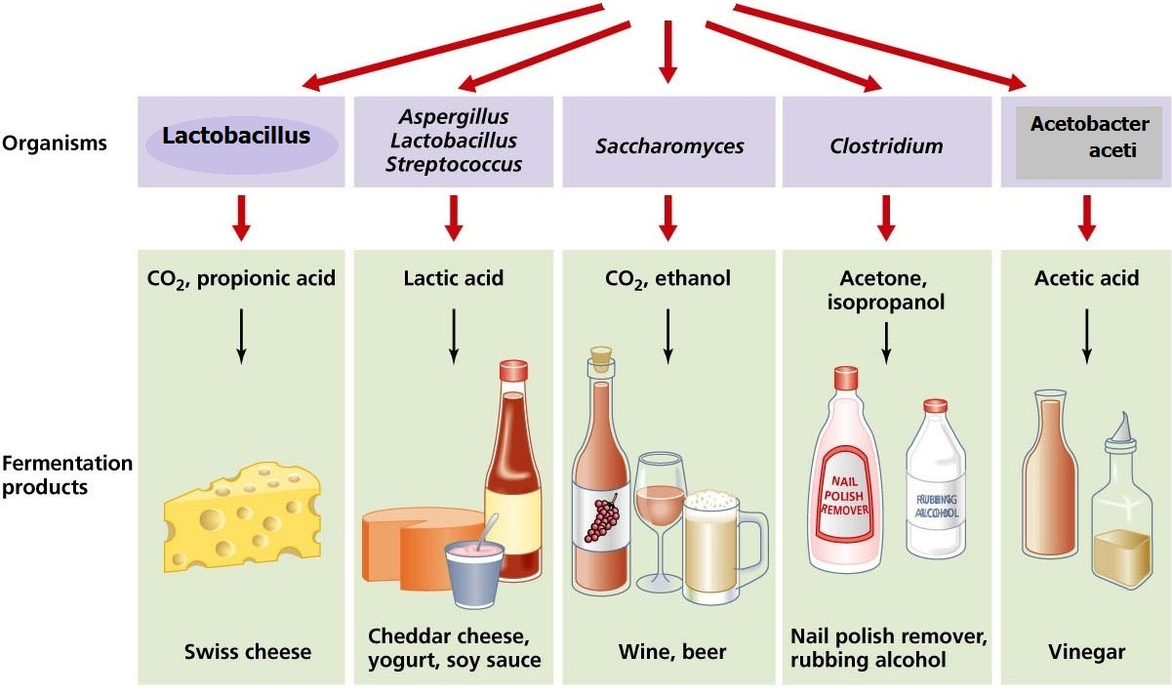

* Examples of the most important fermentation products:
The bakery and pastry , Vinegar , Some detergents, dairy products , production of alcohol , Alcoholic beverages .
**Some microorganism that contribute in the fermentation processes :
1- Lactobacillus bulgaricus & Streptococcus thermophilus . yogurt starter ----- ( Lactic acid bacteria)
2- Saccharomyces cerevisiae . (Yeasts)
3- Acetobacter aceti . (Acetic acid bacteria)
4- Clostridium.
All microorganisms require carbon, carbon sources are metabolized to formation of biomass . carbohydrate sources are the most common substrate of fermentation like lactose , sucrose, starch, fructose and glucose as carbon sources. So we used the Molasses as the cheapest carbohydrate sources.
Molasses syrup : is a byproduct of cane or beet juice , or even the dates which is that remaining after separates the sugar crystals .

