Microbial Fermentation by Yeast :
Anaerobic fermentation involves the breakdown of carbohydrates in the absence of oxygen , in biological process convert glucose , fructose and sucrose to ethanol & CO₂ .
*Uses of alcohol :
In pigments, pharmaceuticals, detergents and cosmetics can be used as fuel for cars.
If the rate of alcohol between ( 6-14%) the product called the wine. but if the alcohol concentration was ( 3-6%) the product called beer .
**Microorganisms:
Saccharomyces cerevisiae : is the first choice in commercial production under anaerobic conditions , also the Saccharomyces uvarum is used because it is very soluble and this is easy to extract .
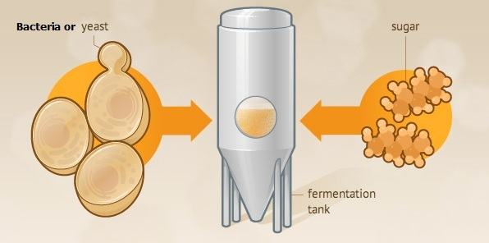
Alcohol was produced when the percentage of sugar in molasses ( waste of dates or vegetables ) should be between 10-25% . So the molasses are media for ethanol production.
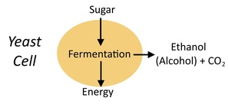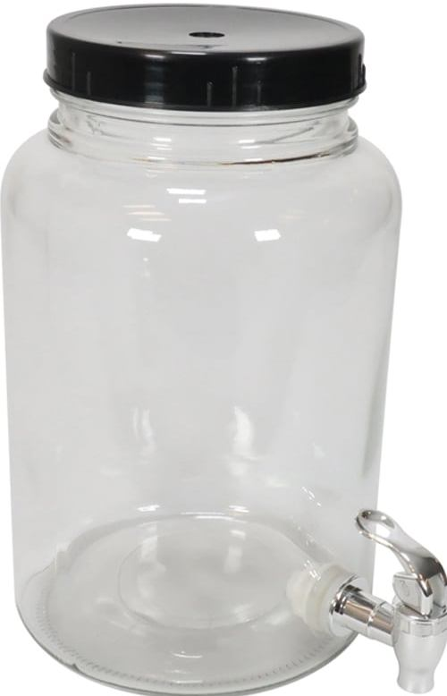
***Experimental fermentation method in lab :
Equipments and tools we need to
1- Glass fermentation vessels .
2- Condenser :a glass condenser is an apparatus used to condense (change the physical state of a substance from its gaseous (hot steam) to its liquid state by cooling in a process called distillation Process.
3- Refractometer: A refractometer is a simple device it used for measuring concentrations of aqueous solutions. It requires only a few drops of liquid, and is used throughout the food, agricultural, chemical, and manufacturing industries.

4- Glass tools of measuring : beakers , pycnometer , round flask , cylinder et cetera.
****Media components:
1- Source of sugar (sugar concentration about 15-25%), Dates, Date syrup (Dibbis), Sugar cane syrup, Molasses, Crystal sugar, Glucose …etc.
2- Distilled water.
3- Inoculum ( Yeast * Saccharomyces cerevisie = 0.25%).
4- salts ( Ammonium phosphate or Ammonium sulphate = 0.1% ) as source of nitrogen.
*****Fermentation conditions :
Anaerobic conditions ,temperature = 30 C , PH= 5 - 6
The first six hours of fermentation should be aerobic conditions to formation the biomass.
There are two experiments performed per week:
1- Total soluble solid (TSS %) : measured by refractometer, drop of solution is placed by pasteur pipette.
2- Ethanol concentration EOH % : performed by distillation Process.
Procedure:
1- put such as 50 ml from sample ( sugary solution) in distillation flask .
2- Connect the rest of glass tools with Flask for the completion the distillation process by boiling .
3- The resulting from the distillation process collected in pycnometer (its volume ranges between 15-25 ml) .
4- determine the specific gravity of ethanol concentration at every-time after distillation process of the sample, calculate the specific gravity by the following formula :
Specific gravity = Weight of pycnometer plus distillate _ Weight of empty pycnometer.
Weight of pycnometer plus D.W _ Weight of empty pycnometer.

W= Weight of empty pycnometer.
W₁= Weight of pycnometer plus D.W.
W₂= Weight of pycnometer plus distillate.

Specific gravity = W₂ - W
W₁ - W
5- compare the results of specific gravity each week in Lab. With the previous concentrations of sugary solution sample.
every week taking the sample and recording the readings.

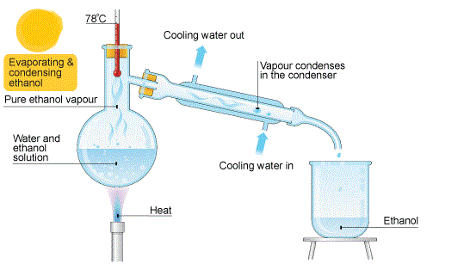
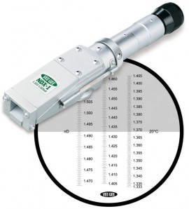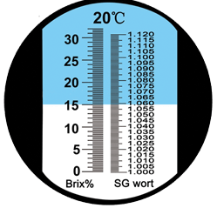
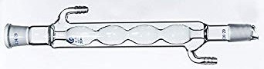

week | TSS% | EOH %
0
1 Type of fermentation
2 …………………
3
4
5 Type of fermentation
6 …………………….

