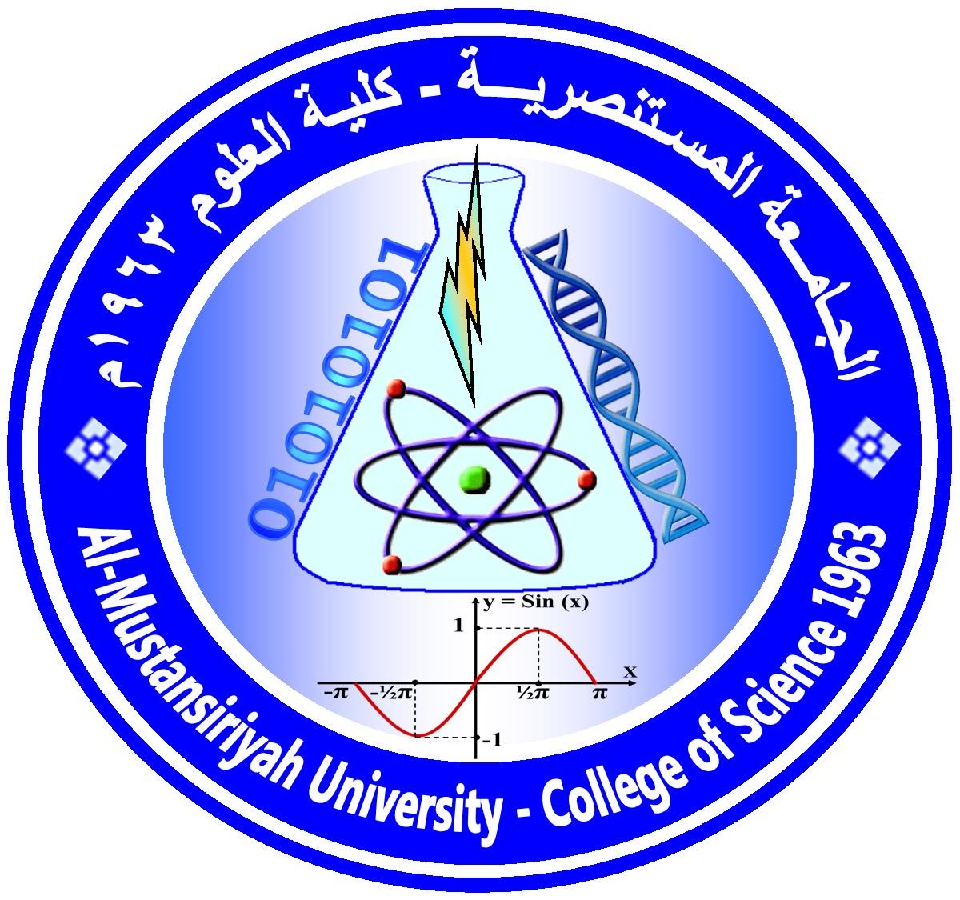Ministry Of Higher Education and Scientific Research
AL-Mustansaria University/College of Science/Department of Chemistry
Timing Table

Dr.Sadeem Albarody اسم عضو هيئة التدريس :
أيام | 8:30-10:00 | 10:00-11:30 |  | 11:30-1:00 | 1:00-2:30
الأحد | Time Out
الاثنين |  |  | Chemistry Department  Undergraduate Inorganic Chemistry Lab
الثلاثاء | Chemistry Department  Undergraduate (Grade 1) Inorganic Chemistry (Room 101)
الأربعاء | Chemistry Department  (Grade 1) Inorganic Chemistry (Room 101) + (Grade 3) Inorganic Chemistry Lab
الخميس |  | Graduation students project
e-Mail: Sadeemaaa@yahoo.com
Website: https://www.facebook.com/groups/Dr.Sadeem.M.Albarody/ Lecture note Dr.Sadeem M.Al-barody
https://www.facebook.com/groups/1476590625939762/ Graduate projects Dr.Sadeem.M.AL-barody

توقيع التدريسي توقيع رئيس القسم

