Insulin and Glucagon
The pancreas, in addition to its digestive functions, secretes two important hormones, insulin and glucagon, that are crucial for normal regulation of glucose, lipid, and protein metabolism.
Although the pancreas secretes other hormones, such as amylin, somatostatin, and pancreatic polypeptide, their functions are not as well established.

Physiologic Anatomy of the Pancreas.
The pancreas is composed of two major types of tissues:(1) the acini, which secrete digestive juices into the duodenum, and (2) the islets of Langerhans, which secrete insulin and glucagon directly into the blood.
The pancreas is a long, slender organ, most of which is located posterior to the bottom half of the stomach (Figure 1). Although it is primarily an exocrine gland, secreting a variety of digestive enzymes, the pancreas has an endocrine function. Its pancreatic islets—clusters of cells formerly known as the islets of Langerhans—secrete the hormones glucagon, insulin, somatostatin, and pancreatic polypeptide (PP).

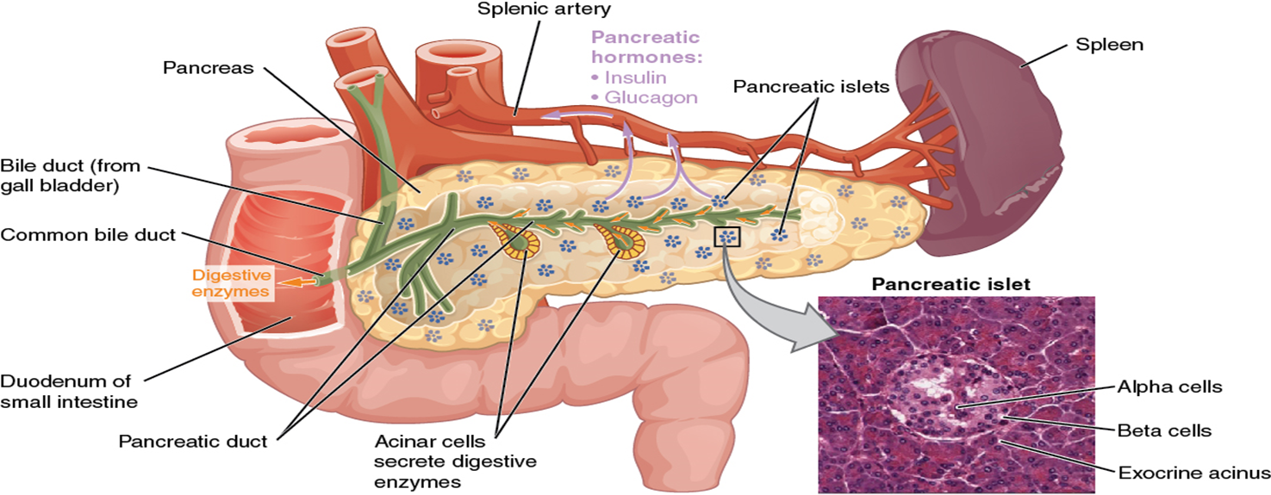
Figure 1. Pancreas. The pancreatic exocrine function involves the acinar cells secreting digestive enzymes that are transported into the small intestine by the pancreatic duct. Its endocrine function involves the secretion of insulin (produced by beta cells) and glucagon (produced by alpha cells) within the pancreatic islets. These two hormones regulate the rate of glucose metabolism in the body. The micrograph reveals pancreatic islets.

Most islets (islets of Langerhans) that collectively comprise the endocrine pancreas are too small to be seen by gross examination,Islets vary greatly in size; ~70% are in the size range of 50-250 μm in diameter in humans with an average in the range of 100-150 μm . Smaller islets are dispersed throughout the acinar lobules and most larger islets lie along the main and interlobular ducts of the pancreas. Most islets are spherical or ellipsoid, but they can be irregular in shape--sometimes reflecting the pressure of an adjacent structure, often a duct, or limitation by a tissue plane. Several reports provide support for the presence of a higher population density of islets in the tail of the pancreas than in the head and body although others find no difference. In adult humans the number of islets is calculated to be 500,000-1 million whereas there are far fewer in smaller animals. Islets comprise 1-2% of the pancreas in adults of most mammalian species. In addition to the islets, isolated islet cells may be found dispersed in the acinar lobules or in association with ducts.

Cells and Secretions of the Pancreatic Islets
The pancreatic islets each contain four varieties of cells:
The alpha cell produces the hormone glucagon and makes up approximately 20 percent of each islet. Glucagon plays an important role in blood glucose regulation; low blood glucose levels stimulate its release.
The beta cell produces the hormone insulin and makes up approximately 75 percent of each islet. Elevated blood glucose levels stimulate the release of insulin. Amylin, another hormone secreted by beta cells it is often secreted in parallel with insulin, although its function is unclear.
The delta cell accounts for four percent of the islet cells and secretes the peptide hormone somatostatin. Recall that somatostatin is also released by the hypothalamus (as GHIH), and the stomach and intestines also secrete it. An inhibiting hormone, pancreatic somatostatin inhibits the release of both glucagon and insulin.
The PP cell accounts for about one percent of islet cells and secretes the pancreatic polypeptide hormone. It is thought to play a role in appetite, as well as in the regulation of pancreatic exocrine and endocrine secretions. Pancreatic polypeptide released following a meal may reduce further food consumption; however, it is also released in response to fasting.
The close interrelations among these cell types in the islets of Langerhans allow cell-to-cell communication and direct control of secretion of some of the hormones by the other hormones. For instance, insulin inhibits glucagon secretion, amylin inhibits insulin secretion, and somatostatin inhibits the secretion of both insulin and glucagon.
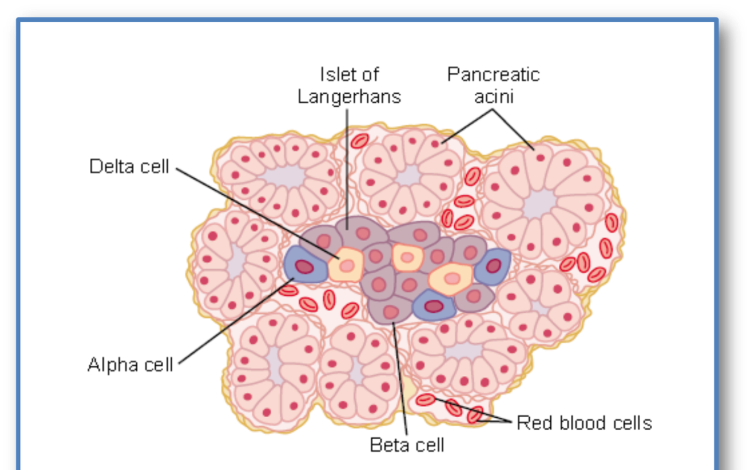
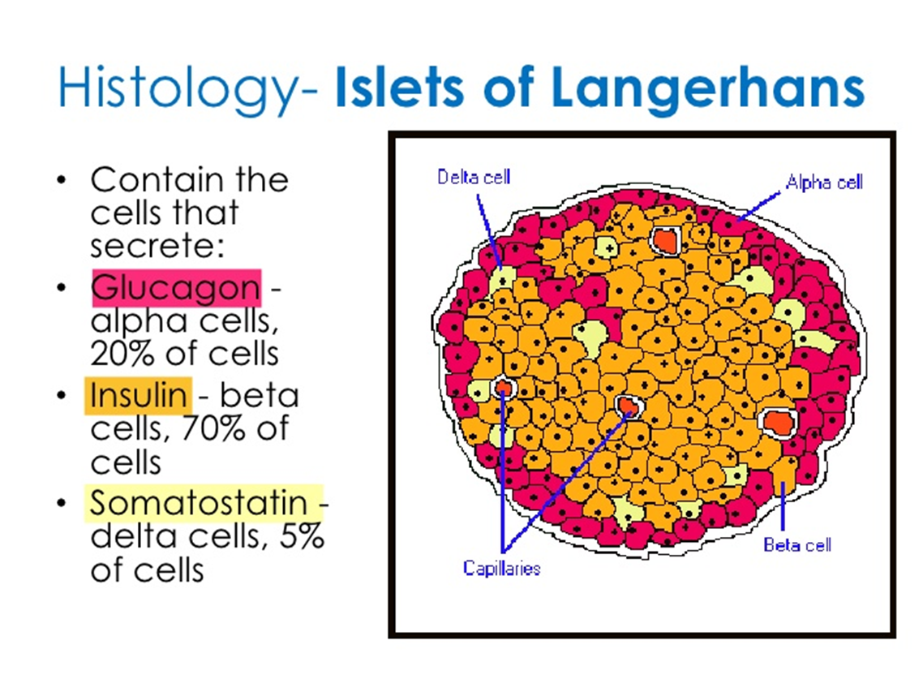

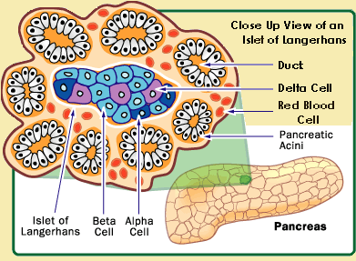
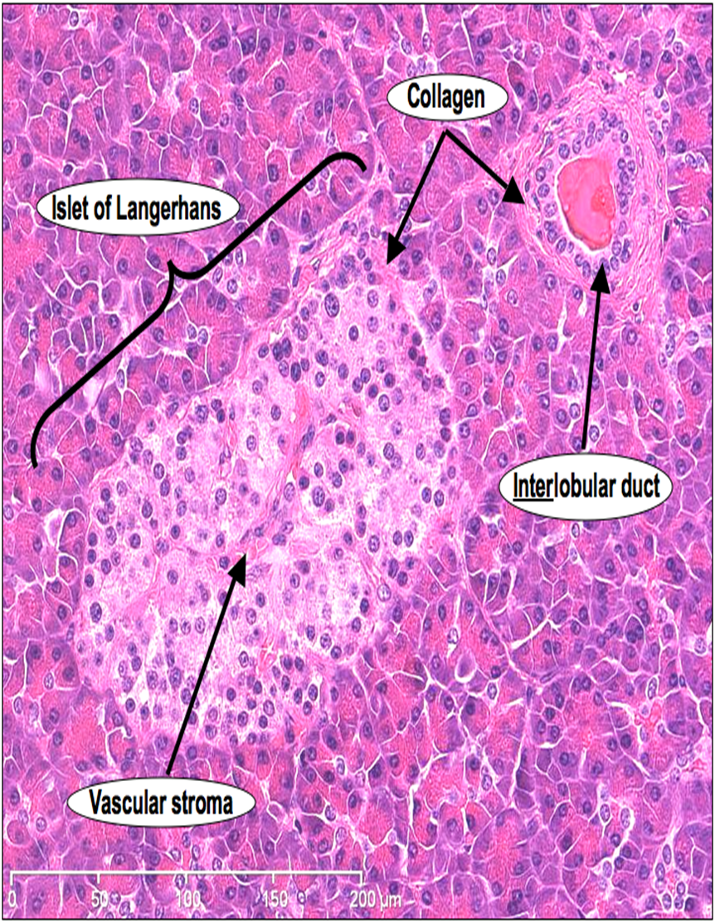

Insulin and Its Metabolic Effects
Insulin was first isolated from the pancreas in 1922 by Banting and Best, and almost overnight the outlook for the severely diabetic patient changed from one of rapid decline and death to that of a nearly normal person. Historically, insulin has been associated with “blood sugar,” and true enough, insulin has profound effects on carbohydrate metabolism. Yet it is abnormalities of fat metabolism, causing such conditions as acidosis and arteriosclerosis, that are the usual causes of death in diabetic patients. Also, in patients with prolonged diabetes, diminished ability to synthesize proteins leads to wasting of the tissues as well as many cellular functional disorders. Therefore, it is clear that insulin affects fat and protein metabolism almost as much as it does carbohydrate metabolism.

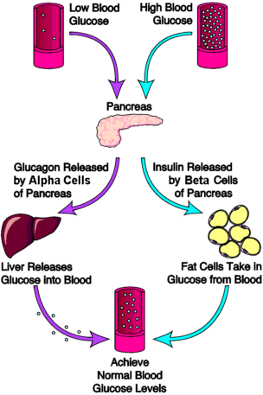
Regulation of Blood Glucose Levels by Insulin and Glucagon
Glucose is required for cellular respiration and is the preferred fuel for all body cells. The body derives glucose from the breakdown of the carbohydrate-containing foods and drinks we consume. Glucose not immediately taken up by cells for fuel can be stored by the liver and muscles as glycogen, or converted to triglycerides and stored in the adipose tissue. Hormones regulate both the storage and the utilization of glucose as required. Receptors located in the pancreas sense blood glucose levels, and subsequently the pancreatic cells secrete glucagon or insulin to maintain normal levels.
Glucagon
Receptors in the pancreas can sense the decline in blood glucose levels, such as during periods of fasting or during prolonged labor or exercise (Figure 2). In response, the alpha cells of the pancreas secrete the hormone glucagon, which has several effects:
- It stimulates the liver to convert its stores of glycogen back into glucose. This response is known as glycogenolysis. The glucose is then released into the circulation for use by body cells.
- It stimulates the liver to take up amino acids from the blood and convert them into glucose. This response is known as gluconeogenesis.
- It stimulates lipolysis, the breakdown of stored triglycerides into free fatty acids and glycerol. Some of the free glycerol released into the bloodstream travels to the liver, which converts it into glucose. This is also a form of gluconeogenesis.
Taken together, these actions increase blood glucose levels. The activity of glucagon is regulated through a negative feedback mechanism; rising blood glucose levels inhibit further glucagon production and secretion.
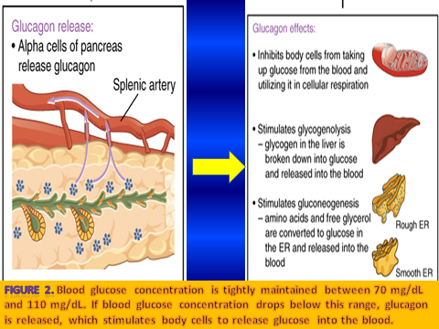

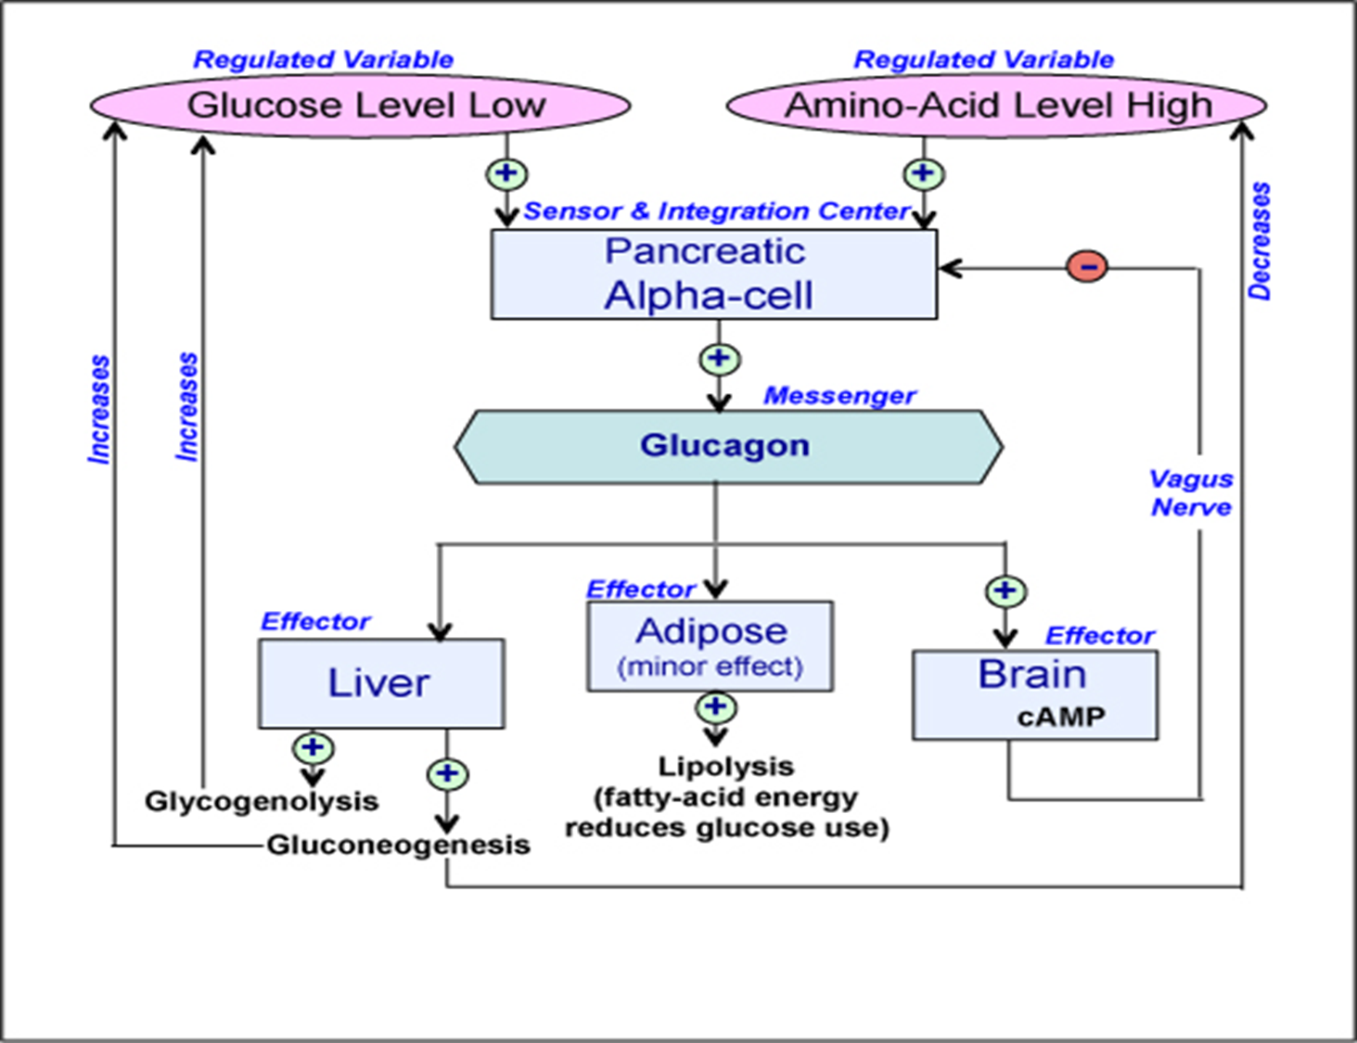
Insulin
The primary function of insulin is to facilitate the uptake of glucose into body cells. Red blood cells, as well as cells of the brain, liver, kidneys, and the lining of the small intestine, do not have insulin receptors on their cell membranes and do not require insulin for glucose uptake. Although all other body cells do require insulin if they are to take glucose from the bloodstream, skeletal muscle cells and adipose cells are the primary targets of insulin.(Figure 3)
The presence of food in the intestine triggers the release of gastrointestinal tract hormones such as glucose-dependent insulinotropic peptide (previously known as gastric inhibitory peptide). This is in turn the initial trigger for insulin production and secretion by the beta cells of the pancreas. Once nutrient absorption occurs, the resulting surge in blood glucose levels further stimulates insulin secretion.

Precisely how insulin facilitates glucose uptake is not entirely clear. However, insulin appears to activate a tyrosine kinase receptor, triggering the phosphorylation of many substrates within the cell. These multiple biochemical reactions converge to support the movement of intracellular vesicles containing facilitative glucose transporters to the cell membrane. In the absence of insulin, these transport proteins are normally recycled slowly between the cell membrane and cell interior. Insulin triggers the rapid movement of a pool of glucose transporter vesicles to the cell membrane, where they fuse and expose the glucose transporters to the extracellular fluid. The transporters then move glucose by facilitated diffusion into the cell interior.

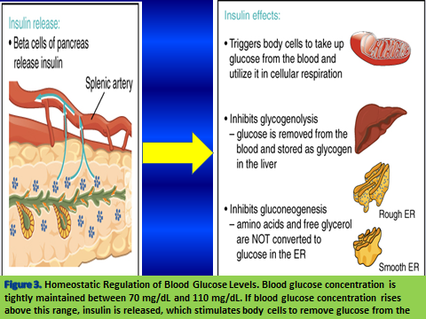
Insulin also reduces blood glucose levels by stimulating glycolysis, the metabolism of glucose for generation of ATP. Moreover, it stimulates the liver to convert excess glucose into glycogen for storage, and it inhibits enzymes involved in glycogenolysis and gluconeogenesis. Finally, insulin promotes triglyceride and protein synthesis. The secretion of insulin is regulated through a negative feedback mechanism. As blood glucose levels decrease, further insulin release is inhibited.

