***General Circulation of the Atmosphere***

The circulation of wind in the atmosphere is driven by the rotation of the earth and the incoming energy from the sun. Wind circulates in each hemisphere in three distinct cells which help transport energy and heat from the equator to the poles. The winds are driven by the energy from the sun at the surface as warm air rises and colder air sinks.

Lines of constant latitude are called parallels, and winds parallel to the parallels are identified as zonal flows. Lines of constant longitude are called meridians, and winds parallel to the meridians are known as meridional flows.

Between latitudes of 30° and 60° are the midlatitudes.

High latitudes are 60° to 90°, and low

latitudes are 0° to 30°. Each 1° of latitude = 111 km.

Regions not in the tropics are called extratropical; namely, poleward of about 30°N and about 30°S.

The global circulation can be described as the world-wide system of winds by which the necessary transport of heat from tropical to polar latitudes is accomplished.

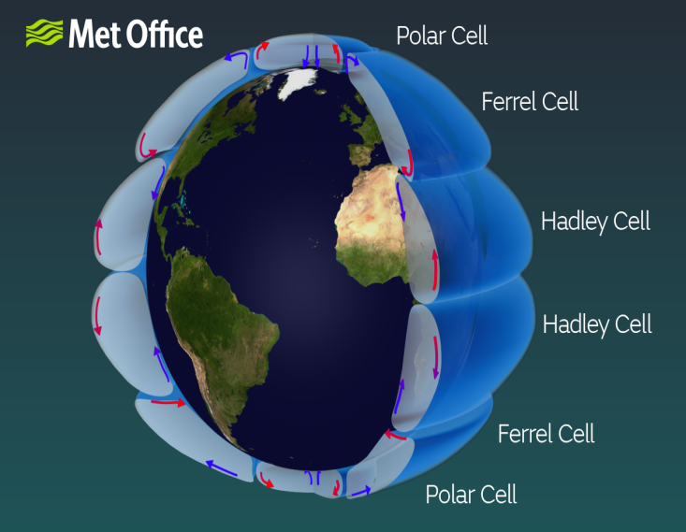In each hemisphere there are three cells (***Hadley cell***, ***Ferrel cell*** and ***Polar cell***) in which air circulates through the entire depth of the troposphere.

The troposphere is the name given to the vertical extent of the atmosphere from the surface, up to between 10 and 15 km high. It is the part of the atmosphere where most of the weather takes place.

Each cell has prevailing winds associated with it and jet streams within them, which are influenced by the Coriolis effect. Without the Coriolis effect, winds would run north to south or south to north in each of the cells, but the Coriolis effect 'drags' the winds, giving an east or west component to the wind direction, depending on the hemisphere you are in.

***Hadley cell***

The largest cells extend from the equator to between 30 and 40 degrees north and south, and are named Hadley cells, after English meteorologist George Hadley.

Within the Hadley cells, the trade winds blow towards the equator, then ascend near the equator as a broken line of thunderstorms, which forms the Intertropical Convergence Zone (ITCZ). From the tops of these storms, the air flows towards higher latitudes, where it sinks to produce high pressure regions over the subtropical oceans and the world's hot deserts, such as the Sahara desert in North Africa.

***Ferrel cell***

In the middle cells, which are known as the Ferrel cells, air converges at low altitudes to ascend along the boundaries between cool polar air and the warm subtropical air that generally occurs between 60 and 70 degrees north and south. This often occurs around the latitude of the UK, which gives us our unsettled weather. The circulation within the Ferrel cell is complicated by a return flow of air at high altitudes towards the tropics, where it joins sinking air from the Hadley cell.

The Ferrel cell moves in the opposite direction to the two other cells (Hadley cell and Polar cell) and acts rather like a gear. In this cell the surface wind would flow from a southerly direction in the northern hemisphere. However, the spin of the Earth induces an apparent motion to the right in the northern hemisphere and left in the southern hemisphere. This deflection is caused by the Coriolis effect (caused by the spin of the Earth) and leads to the prevailing westerly and southwesterly winds often experienced over the UK.

***Polar cell***

The smallest and weakest cells are the Polar cells, which extend from between 60 and 70 degrees north and south, to the poles. Air in these cells sinks over the highest latitudes and flows out towards the lower latitudes at the surface.