THE FIRST LECTURER

INTRODUCTION
Hydrology is a branch of Earth Science. The importance of hydrology in the assessment, development, utilization and management of the water resources, of any region is being increasingly realized at all levels. It was in view of this that the United Nations proclaimed the period of 1965-1974 as the International Hydrological Decade during which, intensive efforts in hydrologic education research, development of analytical techniques and collection of hydrological information on a global basis, were promoted in Universities, Research Institutions, and Government Organizations.

1-1 Definition of hydrometeorology
Hydrometeorology is a branch of meteorology and hydrology that studies the transfer of water and energy between the land surface and the lower atmosphere. UNESCO has several programmers and activities in place that deal with the study of natural hazards of hydro meteorological origin and the mitigation of their effects. Among these hazards are the results of natural processes or phenomena of atmospheric, Hydrological or oceanographic nature such as floods, tropical cyclones, drought and desertification. Many countries have established an operational hydro meteorological capability to assist with forecasting, warning and informing the public of these developing hazards.
A detailed hydro-meteorological study for the study area has been carried out using data obtained from the National Meteorological Agency (NMA). Data has been collected from seven stations in and around the sub-basin.

1-2 Importance and applications of hydrometeorology
This book describes recent developments in hydro meteorological forecasting, with a focus on water-related applications of meteorological observation and forecasting techniques. The topic includes a wide range of disciplines, such as rain gauge, weather radar, satellite, and river and other monitoring techniques, rainfall-runoff, flow routing and hydraulic models, and now casting and Numerical Weather Prediction. Applications include flood forecasting, drought forecasting, climate change impact assessments, reservoir management, and water resources and water quality studies. The book examines how recent developments in meteorological forecasting techniques have significantly improved the lead times and spatial resolution of forecasts across a range of timescales. These improvements are increasingly reflected in the performance of the operational hydrological models used for forecasting the impacts of floods, droughts and other environmental hazards. This has led to improvements in operational decision-making, which can range from decisions within the next few hours on whether to evacuate people from properties at risk from flooding, to longer-term decisions such as on when to plant and harvest crops, and to operate reservoirs and river off-takes for water supply and hydropower schemes. The book provides useful background for civil engineering, water resources, and meteorology and hydrology courses for post-graduate students, but is primarily intended as a review of recent developments for a professional audience.
Key themes: floods, droughts, meteorological forecasts, hydrological forecasts, demand forecasts, reservoirs, water resources, water quality, decision support, data assimilation, probabilistic forecasts. Kevin Sene is a civil engineer and researcher with wide experience in flood forecasting, water resources and hydro meteorological studies. He has published some 45 scientific and conference papers on topics in hydrology, hydrometeorology and hydraulics, and a book Flood Warning, Forecasting and Emergency Response.
Fresh water is one of our nation's most precious and valuable natural resources. The management of this resource requires accurate and timely information on precipitation and surface processes for water managers to make appropriate decisions regarding infrastructure and resources. Knowledge of both the amount and uncertainty of precipitation and stream flow information is also required by forecasters to produce robust hydrologic simulations of stream discharge, to issue flood warnings to the public, and improve overall awareness related to incoming storms. Recent studies have shown that climate change will increase the occurrence of extreme precipitation events over time, further highlighting the need for reliable information.
PSD's Hydrometeorology Modeling and Applications Team is focused on advancing hydrometeorology methods, models and applications to address weather and climate extremes. This information is used to provide guidance on observing network design, modeling assimilation and analysis, and predictions that can be applied in National Weather Service operations as well as informing local, regional, and national communities, planners, and decision makers.

WATER CYCLE
The water cycle, also known as the hydrological cycle, describes the continuous movement of water on, above and below the surface of the Earth. The mass of water on Earth remains fairly constant over time but the partitioning of the water into the major reservoirs of ice, fresh water, saline water and atmospheric water is variable depending on a wide range of climatic variables. The water moves from one reservoir to another, such as from river to ocean, or from the ocean to the atmosphere, by the physical processes of evaporation, condensation, precipitation, infiltration, surface runoff, and subsurface flow. In doing so, the water goes through different phases: liquid, solid (ice) and vapor.
The water cycle involves the exchange of energy, which leads to temperature changes. For instance, when water evaporates, it takes up energy from its surroundings and cools the environment. When it condenses, it releases energy and warms the environment. These heat exchanges influence climate.
The evaporative phase of the cycle purifies water which then replenishes the land with freshwater. The flow of liquid water and ice transports minerals across the globe. It is also involved in reshaping the geological features of the Earth, through processes including erosion and sedimentation. The water cycle is also essential for the maintenance of most life and ecosystems on the planet.
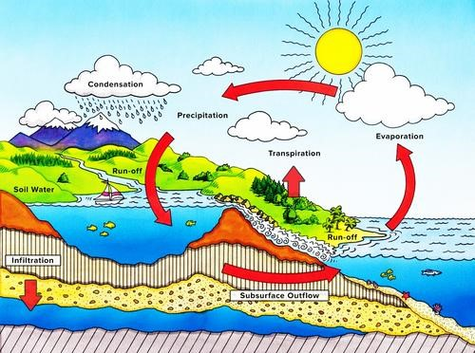
Figure 1. Water cycle

