Chapter four
Wind profile
4.1 The Nature of Airflow over the surface:
The fluid moving over a level surface exerts a horizontal force on the surface in the direction of motion of the fluid, such a drag force is usually expressed per unit area of surface and termed shearing stress. conversely, the surface exerts an equal and opposite retarding force on the fluid this force does not act on the bulk of the fluid ( at least in the first instance ) but only on its lower boundary and on a region of more or less restricted extent immediately above , known as the fluid boundary layer . The shearing stress exerted on a surface by fluid flow is generated within the boundary layer and transmitted downwards to the surface in the form of a momentum flux.
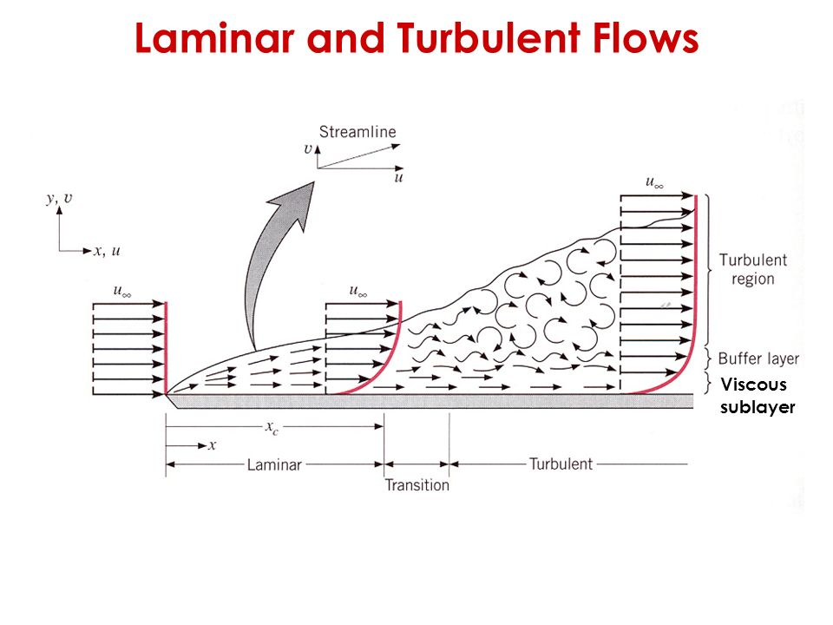
momentum flux (𝜏)
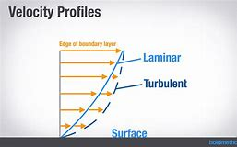
4.2 Aerodynamic Roughness Length:
the aerodynamic roughness length, z₀, is defined as the height where the wind speed becomes zero. the aerodynamic roughness length is determined for a particular surface, it does not change with wind speed, stability, or stress. it can change if the roughness elements on the surface change such as caused by changes in the height and coverage of vegetation, manufacture of fences, construction of houses, deforestation or lumbering, etc. Letta (1969) suggested a method for estimating the aerodynamic roughness length based on the average vertical extent of the roughness elements (𝒉∗), the average vertical cross –section area obtainable to the wind by one element (S𝒔), and the size per element [ S_{L} = (total ground surface area / number of elements)].
𝑧₀ = 0.5 ℎ∗ (S𝑠/ 𝑆_{𝐿}) ………………………………… (4.1)
This relationship is acceptable when the roughness elements are evenly spaced, not too close together, and have similar height and shape. Kondo and Yamazawa (1986) proposed a similar relationship, where variations in individual roughness elements were accounted for. (S_{i}) represent the actual horizontal surface area occupied by element (i), and (h_{i}) be the height of that element. if (n) elements occupy a total area of (S_{t}), then the roughness length can be approximated by:
$$Z_{0} = \frac{0.25}{s_{t}} \sum_{i=1}^{n }{h_{i}s_{i} ……………………………………(4.2) }$$
these expressions have been applied successfully to buildings in cities.

4.3 Displacement Distance:
Over land, if the individual roughness elements are packed very closely together, then the top of those elements begins to act like a displaced surface. for example, in some forest canopies the trees are close enough together to make a solid – looking mass of leaves, when viewed from the air. in some cities the houses are packed close enough together to give a similar effect, namely, the average roof – top level begins to act on the flow like an above the canopy top, the wind profile increases logarithmically with height, as show in figure. thus, we can define both a displacement distance, (d), and a roughness length, (z₀), such equation:
$u\left(z\right)=\frac{u^{*}}{k}ln({\frac{z-z_{d}}{z_{o}}})$ ……………………………(4.3)

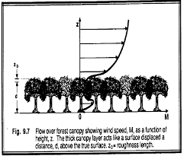
Fig: flow over forest canopy showing wind speed, M, as a function of height z.
4.4 Friction Velocity:
The momentum flux (i.e. momentum transfer per unit area) is also known as the shear stress or the drag force. The dimensions of drag are in [N m-2]. In the atmospheric surface layer, wind always increases with height and the momentum transfer is always downwards. While the momentum flux is downward, the drag is a force on the surface along the direction of the wind. The friction velocity, (𝑢∗), is defined as
𝑢∗ =$\sqrt{\frac{τ}{ρ}}$ …………………………. (4.4)
shear stress, (𝜏). (𝑢∗) is not the speed of the flow but simply another expression for the momentum flux at the surface. As (𝑢∗) is a convenient description of the force exerted on the surface by wind shear.
4.5 Shearing Stress via the mixing length concept:
The lump of fluid originally at the level (𝑧 +𝑙) and having the appropriate mean velocity] 𝑢 (𝑧 +𝑙) [ is displaced to the level (𝑧) by the action of turbulence, the instantaneous velocity at (𝑧) then exceeds the mean value by an amount (𝑢′) given by ]𝑢(𝑧+𝑙) −𝑢(𝑧)[, i.e. to a first approximation.
𝑢′ = 𝑙 (𝜕𝑢 /𝜕𝑧) ………………………………………….. (4.5)
The merging of this lump of fluid with its surroundings results in a quantity of momentum (𝜌𝑢′) per unit volume being contributed to the flow at the level (𝑧). moreover, if the magnitude of the transient vertical velocity imparted to the lump of fluid is (𝑤) then the rate at which momentum is conveyed downwards across unit horizontal area by such a motion must be (𝜌𝑢′𝑤′). assuming that a constant momentum flux of this magnitude is communicated by like process to the top of the laminar sub-layer, whence by molecular means to the surface itself, we may write:
𝜏 = 𝜌 𝑢′𝑤′ ……………………………………………………… (4.6)
It is convenient, however to express shearing stress in term of the friction velocity, (𝑢∗), such that
𝜏 = 𝜌 𝑢∗² …………………………………………………… (4.7)
Where (𝑢∗), like the product 𝑢′𝑤′, is constant throughout a region of constant momentum flux, or shearing stress, 𝜏. if we assume that 𝑢′ and 𝑤′ are merely comparable in size we may deduce that (𝑢∗) is representative of the magnitude of the velocity fluctuations in turbulent boundary – layer flow. it is however justifiable to assume equality of 𝑢′ and 𝑤′, so that.
𝑢′ = 𝑤′ = 𝑢∗ …………………………………………..(4.8)
The apparently motion of fluid in a turbulent boundary layer may be visualized on which large numbers of eddies are superimposed, each eddy moves with the mean flow velocity 𝑢(𝑧), it is with the scale of these individual eddies that mixing length can be identified. we expect this scale to decrease downwards through the boundary layer, at the surface itself, all turbulent motions are inhibited and 𝑙 = 0.
The simplest possible deduction from this reasoning is that (𝑙) is directly proportional to distance above the surface, so that:

𝑙 = 𝑘𝑧……………………………………………. (4.9)
𝑘 = 0.4 the von karman constant. , k , is supposedly a universal constant that is not a function of the flow nor of the surface .From equation (4.5), ( 4.8), (4.9) the parameter A in equation (𝜕𝑢/ 𝜕𝑧 = 𝐴 *1/𝑧) can be equated to 𝑢∗ 𝑘 i.e. :
𝜕𝑢 /𝜕𝑧 = $\frac{u*}{k z}$ ………………………………………(4.10)
By integration
𝑢(𝑧) = $\frac{u*}{k }$ ln𝑧 + 𝐵 …………………………………….. (4.11)
Equation (4.11) describes the shape of the wind profile in turbulent boundary layer flow down to the level of the laminar sub-layer, where at this layer wind speed which it predicts at 𝑧 = 0, namely 𝑢 (0) = −∞. this shortcoming is avoided in practice by restricting the zone of application of equation (4.11) to the region above a level 𝑧₀, where 𝑧₀ is defined by the requirement that 𝑢(𝑧₀) = 0. equation (4.12) then takes the practical form:
𝑢(𝑧) = $\frac{u*}{k }$ ln $\frac{z}{z0}$ ……………………………………… (4.12)
In which 𝑧₀ includes the role of constant of integration previously held by B.

4.6 Wind Profile in Statically Neutral and Non-Neutral Conditions:
To estimate the mean wind speed u(z), as a function of height, z, above the ground, we speculate that the following variables are relevant: surface stress (represented by the friction velocity, u*, and surface roughness (represented by the aerodynamic roughness length, z₀. To determine wind speed $(u)$ at a height $\left(z\right),$ it is commonly expressed as follows:

$$u\left(z\right)=(\frac{u_{*}}{ĸ})\ln{(\frac{z}{z_{o}}}) ------- 4.13$$
Where $(z)$ is the elevation above the ground,${(z}_{o})$ is the surface roughness length, and ($ĸ$ =0.4) is von Karman constant .$( u_{*}={\left(\left.\frac{τ}{ρ}\right)\right.}^{\frac{1}{2}})$ is defined as the friction velocity, where (ρ) is the density of the air and (τ) is the surface value of the shear stress. The roughness length${(z}_{o})$ describes the roughness of the ground or terrain where the wind is blowing. There are cases where wind speed $(u_{1})$ is known at a reference height${(z}_{1}$) and required at another ${(z}_{2})$ in a case that can be derived from equation (4.13): (in neutral conditions)

$$u_{2}=u_{1}\frac{\ln{{(z}_{2})-} \ln{{(z}_{o})}}{\ln{{(z}_{1})-} \ln{{(z}_{o})}} ------- 4.14$$
The Businger –Dyer Relationships can be integrated with height to yield the wind speed profiles
$$u\left(z\right)=\frac{u^{*}}{k}ln({\frac{z}{z_{o}}})-Ψ (z/L) ------- 4.15$$

Where the function Ψ (𝑧/𝐿) is given for stable conditions (z/L > 0) by:
Ψ (𝑧/𝐿) = 4.7 (𝑧/ 𝐿) …………………….……………4.16
And for unstable (z/L < 0) by:
Ψ (𝑧/𝐿) = −2ln[(1+𝑥)/ 2] −ln[(1+𝑥²)/ 2] +2𝑡𝑎𝑛⁻¹(𝑥)-𝜋 /2……………….4.17
Where 𝑥 = [1− (15 𝑧/𝐿)]^{1/4}.

4.8 Power Law
The power law equation is a simple, yet useful model of the vertical wind profile which was first proposed by Hellman (1916) [16]. The power law profile assumes that the ratio of wind speeds at different heights can be found by the following equation:
$$u_{2}=u_{1}{\left(\left.\frac{z_{2}}{z_{1}}\right)\right.}^{α} 4.17$$
Where ${(u}_{1})$ is the wind speed at a reference height ${(z}_{1})$(anemometer height), ${(u}_{2})$ is the wind speed at a height ${(z}_{2})$(hub height), and (α) is the shear exponent (dimensionless parameter).

Problems
1- when we putting anemometers to measured wind speed over surface coated with grass and at two level 4m and 12m, the mean record wind speed is u(4m) =5.5m/s, u(12m) =8.5m/s. find Drag coefficient and shear stress at the level 4m. (used k= 0.4, z₀=0.065m, 𝜌 = 1.2 𝑘𝑔 𝑚3, assumed neutral condition).
2- through the field measurement in the rural area and at neutral condition, wind speed at the height 5m and 10m was u(5m) =9m/s and u(10m) = 15m/s, find the roughness length of surface in (mm), at wind speed 5m, taken the eddy height l=0.5m.
3- through the logarithmic equation to change wind speed with height, at two level z₁ and z₂ state that:
𝑙𝑛𝑧₀ = 𝑢₂𝑙𝑛𝑧₁ −𝑢₁ ln𝑧₂ / 𝑢₂ −𝑢₁
4- state that when the friction velocity is constant at two levels , the friction velocity can putting in :
𝑢∗ = 𝑘 ( 𝑢(𝑧₂) − 𝑢(𝑧₁)) / ln( 𝑧₂ /𝑧₁)
5- through the use of logarithms wind speed at two level 𝑧₁, 𝑧₂, state that roughness length is equal to:
𝑧₀ = 𝑧₁ /( 𝑧₂ / 𝑧₁ )^{𝑥}
𝑤ℎ𝑒𝑟𝑒 𝑥 = 𝑢(𝑧₁) / 𝑢(𝑧₂) − 𝑢(𝑧₁)

6- If an orchard is planted with 1000 trees per square kilometer, where each tree is 4m tall and has a vertical cross-section area ( effective silhouette to the wind ) of 5m2 , what is the aerodynamic roughness length ? assume d=0 .
7- Given the following wind speed data for a neutral surface layer, find the roughness length (z₀), displacement distance (d), and friction velocity (u*):
z (m) | 5 | 8 | 10 | 20 | 30 | 50
U(z) | 3.48 | 4.43 | 4.66 | 5.5 | 5.93 | 6.45

8- Use the definition of the drag coefficient along with the neutral log- wind profile equation to prove that 𝐶𝐷 = 𝑘²𝑙𝑛⁻² (𝑧 /𝑧₀ ) .
9- Using the Businger – Dyer flux – profile relationship for statically stable conditions :

