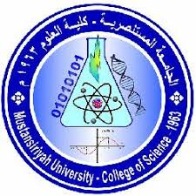
Mustansiriyah University – Collage of Science
Department of Chemistry – First Grade – First Term (2018 – 2019)
Subject: - Analytical Chemistry Examiner: - Dr: KHITAM JABER NABHAN

Q₁ – Define Five of the following terms: -
- Saturated Solution, 2- ($\frac{wt}{wt})$%, 3- Density, 4- Quantitative Analysis,
5-Molality, 6- Mole Fraction (X).

Q₂ – Answer the questions:-

- Calculate the volume of a 0.232 N solution contains (a.) 3.17 milliequvalent of solute (b.) 6.5 equivalent of solute?
- A solution contains (10 gm) Iodic Acid and (125 gm) Water, Calculate the concentration of solution expressed as: -
(a-) Mole fraction (X) of Iodic Acid. (b-) Molality.
Q₃ – Answer the questions:-

a. How many (cm³) of concentrated sulfuric acid, of density 1.84 gm/ cm³ and containing 98 % by weight , should be taken to make 1 L of 2 N solution?
b. Calculate the formal concentration of: (a) an aqueous solution that contains (1.80 gm) of ethanol in 750 mL. (b) An aqueous solution that contains (0.365 gm) of Hydrochloric Acid in (50.0 mL) (the acid is 75.0 % ionized in this solution).
Q₄ – Answer the questions:-

a. Calculate the hydrogen ion concentration of the solutions, pH values (3.47)?
b. Calculate the millimoles of (0.5 L) Sodium Sulfate in (1000 ppm)?
c. Calculate the weight in gram for (25 mL) dilute Nitric Acid (200 gm\mL)?

A.wt: - O =16, Na = 23, P = 31, Ca = 40, N = 14, Cl = 35.5, I = 127, H = 1, C = 12, and S = 32.

(WITH MY BEST WISHES)

