Tissue processing
* Histology:
It is the branch of science which deals with the gross &microscopic study of normal tissue
*Histopathology:
It is the branch of science which deals with the gross & microscopic study of tissue affected by disease.
Histotechniquse :
The techniques for processing the tissue , whether biopsies,larger specimen removed at surgery, or tissue from autopsy so as at to enable the pathologist to study them under the microscope .
Protocols followed in Histotechniquse
1- Recept & Identification
2- labeling of the specimen with numbering.
3- fixation .
4- Washing .
5- dehydration .
6- clearing .
7- impregnation .
8- Embedding :
9- section cutting .
10- staining .
11- mounting .

protocols followed in Histotechniquse
- 1- Recept & Identification
Tissue specimen received in the surgical pathology laboratory have a request form that list the patient information and history along with a description of the site of origin .
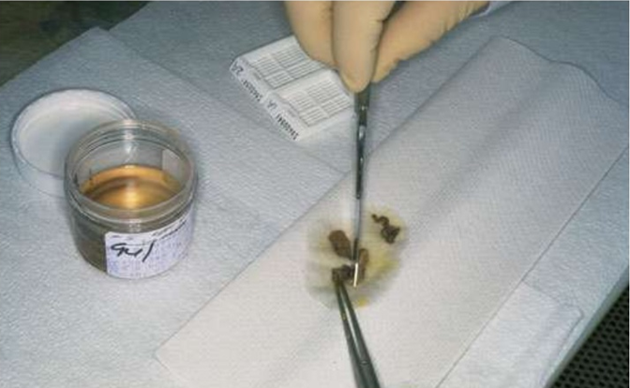
2-labeling of the specimen with numbering.
The specimen are accessioned by giving them a number that will identify each specimen for each patient .
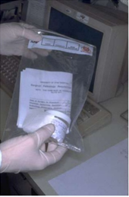

3- fixation .
* It is a process in which aspecimen is treated by exposing it to afixative for aparticular period of time in order to facilitate the succeeding step .
* The puropose of fixation is to preserve tissue permanently in as life-like astate as possible .
The fixative should be 15-20 times more in volume then the specimen *
* Mechanism of action . it forms cross linke between amino acide of proteins thereby making them insoluble .
* The bite should of size of approximately 2x2 cm & 4-6 micrometer in thickness for optimum fixation to take place .
* Tiny biopsies or small specimen can be wrapped in filter paper and then put in a cassette & fixed .
Aim of fixation
1- It should prevent autolysis & putrefaction of the cell .
2- It should penetrate evenly and rapidly .
3- It should harden the tissues .
4- Increase the optical density .
5- Should not cause shrinkage or swelling of the cells .
6- Must not react with the receptor sites & thus must not interefere with the staining procedure .
7- It must be cheap and easily avaible .

Properties of an ldeal fixative
1- Prevents autolysis and bacterial decomposition .
2-Preserves tissue in their natural state and fix all components .
3- Make the cellular components insoluble to reagent used in tissue processing .
4- Preserves tissue volume .
5- Avoid excessive hardness of tissue .
6- Allows enhanced staining of tissue .
7- Should be non toxic and non-allergic for user .
8- should not be very expensive .
Classification of fixatives
A) Physical fixatives : heat , freezing …… etc .
B) Chemical fixatives : 1- simple fixatives .
2- compound fixative .

1-simple fixatives :
The most commonly used fixative is Formalin . it is prepared by mixing 40% formaldehyde gas in 100 w/v of distilled water . the resultant mixture is 100% formalin .routinely , 10% formalin is used which is prepared by mixing 10 ml of 100% formalin in 90 ml of distilled water .
Other simple fixative :
1-Picric acid .
2-Osmic acid .
3- Mercuric chloride.

DIS ADVANTAGES FORMALIN | ADVANTAGES FORMALIN
1-Irritant to the nose ,the eyes and mucous membranes .  2- Formation of precipitate of para –formaldehyde which can be prevented by adding 11-16% methanol .  3- Formation of black formalin pigment ,Acid formaldehyde hematin. | 1- Rapid penetration 2- Easy availability&cheap 3- Dose not overharden tissue  4- Fix lipids for frozen section  5- Ideal for mailing

2- Compound fixatives :
a) Microanatomical fixatives :these are used to preserve the anatomy of the tissue like ,10%formalin saline, Zenker's fluid ,Bouin's fluid .
b) Cytological fixatives : these are used to fix intracellular structures it two type
Cytoplasmic fixative | Nuclear fixative
Champy's fluid , Regaud's fluid | Carnoy's fluid , Clarke's fluid

C) Histochemical fixatives :These are used to demonstrate the chemical constituents of the cell like Cold acetone , Ethanol
4- Dehydration .
It is the process in which the water content in the tissue to be processed is completely reduced by passing the tissue through increasing concentration of dehydrating agents .
The various dehydration agents used are : Ethyl alcohol , Acetone , Isopropyl alcohol ,Dioxane .
The duration of the procedure can be noted down as :
1-30% alcohol – 1 hour .
2- 50% alcohol – 1 hour.
3-70% alcohol – 1 hour .
4-70% alcohol – 1 hour
5- 90% alcohol – 1 hour .
6- 95 % alcohol – 1 hour .
7-Absolute alcohol – 1 hour .
8- Absolute alcohol – 1 hour .
Dehydration is done so that the wax i.e Paraffin wax , which is used for impregnation, can be easily miscible as it is immiscible with water.

5- Clearing (Dealcoholization) .
It is the procedure where in the alcohol in the tissue is replaced by fluid which will dissolve the wax used for impregnating the tissues .
The various clearing agents used are :
* Cedar wood oil : the best agent but is expensive .
Benzene : it is carcinogenic .*
Xylene : it is most commonly used .*
chloroform : tixic and expensive .*
6- Impregnation :

In this the tissue is kept in a wax bath containing molten paraffin wax foe 6-8 hours .the wax is infiltrated in the interices of the tissue which increases the optical differentiation & hardens the tissue & helps in easy sectioning of the tissue .
The various waxes which used are : (paraffin wax ,paraplast , Gelatin )
Embedding : 7-
It is done by transferring the tissue which has been cleared of the alcohol to a mould filled with molten wax & is allowed to cool & solidify .after solidification , awax block is obtained which is then sectioned to obtain ribbons .
* Type of moulds : A) Leuckhart's Moulds : L-shaped brass pieces which is placed in opposing positions & can be manipulated to increase or decrease the size of the block be prepared .
B) Glass or Metal petri dishes
C) Watch glass .
D) Paper boats .

8- Section cutting
It is the procedure in which the blocks which have been prepared are cut or sectioned and thin strips of varying thickness are prepared .
The instrument by which this is done is called as a Microtome
Type of Microtome : sliding , rotary , rocking , freezing , base sledge
Rotary microtome :
It is the most commonly used . Also known as Minnot, s Rotary microtom
In this the Blok holder moves up and down while the knife remains fixed
It is suitable for cutting of small tissues & serial sections can be taken on it.
Parts of a Microtome (Rotary)
A. Block holder .
B. Knife clamp screws
C. Knife clamps
D. Block adjustment
E. Thickness gauge
F. Angle of tilt adjustment
G. Operating handle
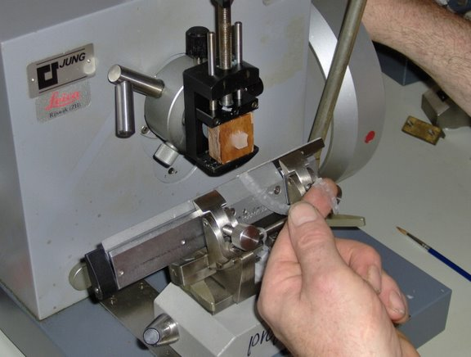
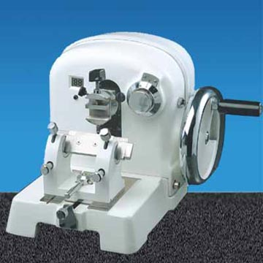
Tissue floatation bath
It is thermostatically controlled water both with the inside colored black.
It is maintained at a temperature maintained 5-6 degree paraffin wax.
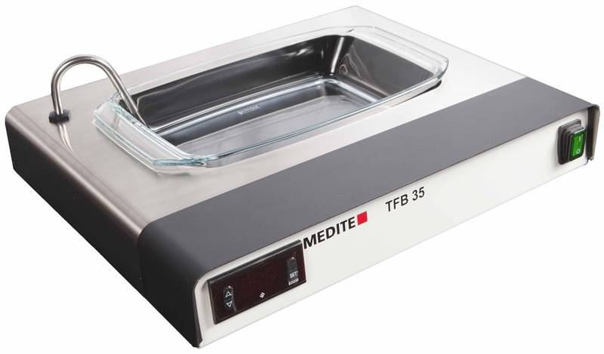
9- Staining :
Is process by which we give colour to asection , there are hundred of stains available , and can be classification to : Acid stains , Basic stains , Neutral stains .
Acid stains :In an acid dye the basic component is colored and the acid component is colorless , Acid dyes stain basic components e.g. eosin stains cytoplasm , the color imparted is shade of red .
Basic stains : In an basic dye the acide component is colored and the basic component is colorless , Basic dyes stain acidic components e.g. basic fuchsin stains nucleus , the color imparted is shade of blue .
Neutral stains : When an acid dye is combined with abasic dye aneutral dye is formed , As it contains both colored radicals , it gives different colors to cytoplasm and nucleus simultaneously .this is the basis of Leishman stain .
10- Mounting :
Adhesives used for fixing the sections on the slides , the adhesives like : Albumin solution(mayor's egg albumin) , Starch paste , Gelatin .
Mountants permanent agent : Canada balsam , Dpx , Terpene resin ,

