- zATMOSPHERIC ENVIRONMENT
Biometeorology involves the study of interactions between the physical environment and all of Life's forms, including terrestrial and marine vertebrates, invertebrates, plants, fungi and bacteria .There is a growing awareness of the linkages between human health and the weather and climate that should be incorporated into the content of national public weather services programs.
The atmosphere is a part of the environment with which the human organism is permanently faced in maintaining, the balance of life functions. Reactions of the organism can therefore be interpreted and comprehended as its response to changes in the physical and chemical state of the atmosphere. As a result, to more fully understand the effects of atmospheric conditions on human health, well-being and performance, it is necessary to transform the “primary” meteorological information so that it becomes biologically relevant. In analyzing those aspects of the environment relevant for health issues, three major complexes of effects can be distinguished :-

1- The complex conditions of heat exchange i.e. the thermal environment
2- The direct biological effects of solar radiation, i.e. the Radiative conditions, especially in the visible and UV-range, and
3- air pollution including allergens such as pollen.

Human biometeorology is part of environmental meteorology. It covers a series of questions relevant to environmentally applied medical science. In investigating the spectrum of effects biometeorology uses almost the same epidemiological methodology to ascertain damaging potentials, to give information about limits of exposures which may affect human health, to discover the relationship between atmospheric conditions , diseases, and indisposition, and to define the importance of atmospheric environmental factors for the transition between health and disease. Complexity is inherent in research into these effects. There are also many confounding variables such as smoking, socio-economic factors, individual health behavior, living conditions, etc., which are often dominant. Epidemiological research investigates the occurrence of effects on morbidity and mortality due to heat ,cold, air pollution and changes in the weather.

Aims of biometeorology:-

- Research in human biometeorology has the task of finding out which clinical manifestations and other disturbances in human well-being are influenced by atmospheric environmental factors, and precisely which factors exert an influence on health and well-being, and to what extent.
- As regards risk factors biometeorology has to inform and advise the public and decision makers in politics and administration with the aim of recognizing and averting health risks at an early stage, in the framework of preventive planning, for example by making recommendations for ambient standards, by evaluation of site decisions, and by consultation on adaptive behavior.

- The state of knowledge in the field of weather and human health allows for the delivery of a number of advisory services. Products and services such as pollen information service, UV-information service, forecasts of perceived temperature (heat load, cold stress) can help people to better handle atmospheric loads .These services are based on the specific adaptation of synoptically products to meet the needs of the users.
It is a fact that the benefits of meteorological information are usually not realized before their application .Human biometeorology already possesses numerous tools to meet the needs of the users ,Even if further improvements and adaptations are still needed. The general aim is always to avoid or at least diminish unfavorable effects, to take advantage of positive effects, and to improve the quality of life of the general public.

2-THERMAL ENVIRONMENT
2.1 Thermal indices
The aim of thermoregulation is to keep an organism’s core temperature constant at 37 °C. Under steady-state conditions heat production by activity and heat loss must be balanced. For warm conditions they usually consist of combinations of air temperature and some measure for humidity (due to the relevance of evaporative heat loss).
Fundamentally, we know the mechanism of heat exchange between the human body and its thermal environment that is defined by air temperature (ta), water vapor pressure (vp),wind velocity (v), and mean radiant temperature (tmrt) that applies to all shortwave and long wave radiant fluxes reaching a human being
Thermo physiologically relevant assessment procedures that combine the above listed meteorological variables with metabolic rate and with due consideration of the insulation of clothing, require the application of complete heat budget models (VDI, 1998).
Only such complete approaches are able to fulfill the condition that the same value of an index must always mean the same to the organism, and independently form the mixture of values of the input variables. There are some such state-of-the-art approaches available as SET*
Where :(VDI: Validation of Modelled Mean Radiant Temperature )

A graphical representation of the PMV assessment equation is shown in (Figure 1) where:
M is the metabolic rate,
I is direct solar radiation,
D is diffuse solar radiation,
R is reflected solar radiation,
A is atmospheric long wave radiation.
E is long wave emission of the ground.
QH is turbulent flux of sensible heat.
QSw is turbulent flux of latent heat due to sweating
QRe is turbulent respiratory heat flux (sensible and latent).
EkM is long wave radiation from the surface of the human body,
QL is turbulent flux of latent heat due to water vapor diffusion.

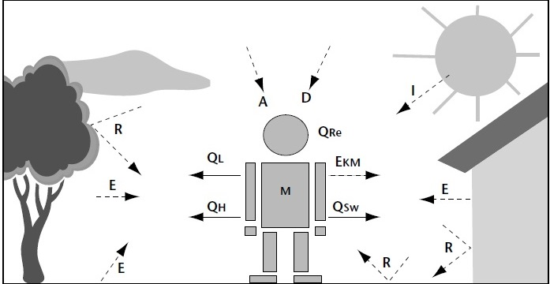

Perceived Temperature or PT compares the actually existing outside conditions with the temperature that would prevail in a standard environment in order to experience an identical feeling of warmth, comfort or cold.
The standard environment is deep shade, e.g. a forest, where the temperature of the surrounding surfaces, i.e. the leaves, is the same as the air temperature and where there is only a slight breath of air of 0.1 m/s.As the human being is usually active in the open air, an activity that corresponds to walking at 4 km/h is assumed.

2.2 Heat Index
The human body dissipates heat by varying the rate and depth of blood circulation, by losing water through the skin and sweat glands, and as the last extremity is reached, by panting ,when blood is heated above 98,6 degrees. The heart begins to pump more blood, blood vessels dilate to accommodate the increased flow,and the bundles of tiny capillaries threading through the upper layers of skin are put into operation. The body’s blood is circulated closer to the skin’s surface, and excess heat drains off into the cooler atmosphere. At the same time, water diffuses through the skin as perspiration. The skin handles about 90 percent of the body’s heat dissipating function.
Heat kills by taxing the human body beyond its abilities. For example, in a normal year, about 175 Americans succumb to the demands of summer heat. Among the large continental family of natural hazards, only the cold of winter – not lightning, hurricanes, tornadoes, floods, or earthquakes – takes a greater toll. In the 40-year period from 1936 through 1975,nearly 20 000 people were killed in the United States by the effects of heat and solar radiation. In the disastrous heat wave of 1980,more than 1 250 people died. During the exceptionally hot summer of 2003 in Europe, an estimated 13 000 to 15 000 elderly people died as a result in France alone.

These are the direct casualties. No one can know how many more deaths are advanced by heat wave weather; how many diseased or aging hearts surrender, that under better conditions would have continued functioning. North American Summers are hot; most summers see heat waves in one section or another of the USA. East of the Rockies, they tend to combine both high temperatures and high humidity although some of the worst have been catastrophically dry.

Considering this tragic death toll, the US National Weather Service (NWS) has stepped up its efforts to alert more effectively the general public and appropriate authorities to the hazards of heat waves –those prolonged excessive heat/humidity episodes.

Based on the latest research findings, the US NWS has devised the “Heat Index” (HI), (sometimes referred to as the “apparent temperature”) .The HI, given in degrees Fahrenheit , is an accurate measure of how hot it really feels when the relative humidity (RH) is added to the actual air temperature.
For example, if the air temperature is 95°F and the relative humidity is 55 per cent, the HI –or how hot it really feels– is 110°F. This is important since HI values were devised for shady, light wind conditions ,exposure to full sunshine can increase HI values by up to 15°F. Also, strong winds, particularly with very hot, dry air, can be extremely hazardous.

The NWS will initiate alert procedures (advisories or warnings) when the Heat Index (HI) is expected to have a significant impact on public safety. The expected of the heat determines whether advisories or warnings are issued.
A common guideline for the issuance of excessive heat alerts is when the maximum daytime HI is expected to equal or exceed 105°F and a night-time minimum HI of 80°F or above for two or more consecutive days. Some regions are more sensitive to excessive heat than others. As a result, alert thresholds may vary substantially from these guidelines.

The NWS alert procedures are:
• Include HI values in zone and city forecasts;
• Issue Special Weather Statements and/or Public Information Statements presenting a detailed discussion of :
(1)The extent of the hazard including HI values .
(2)Who is most at risk,
(3)Safety rules for reducing the risk;
• Assist state and local health officials in preparing Civil Emergency Messages in severe heat waves. Meteorological information from Special Weather Statements will be included as well as more detailed medical information , advice, and names and telephone numbers of health officials;
• Release to the media and over NOAA’s own Weather.
Net effective temperature (NET)
As another example of a heat index suited to local weather conditions and requirements by public, the net effective temperature (NET), routinely monitored by the Hong Kong Observatory can be considered . The NET takes into account the effect of air temperature ,wind speed and relative humidity on human beings .For example, heat loss by a human body will be faster under lower temperature, higher wind speed and higher relative humidity conditions in winter and, as such, the feeling of coldness will also be more pronounced.
NET is calculated as follows:
NET = 37 - (37-T)/(0.68 - 0.0014RH + 1/(1.76+1.4v0.75) )
- 0.29T (1-0.01RH)
where T= the air temperature (°C), v = the wind speed (m/s), and RH = the relative humidity (%), and has a higher value when the temperature is higher, but its value will be lower at higher wind speed and relative humidity.

Wind chill:
Wind chill is the chilling effect of the wind in combination with a low temperature .Humans do not sense the temperature of the air directly .When humans feel that it is cold, they are actually sensing the temperature of their skin .Because the skin temperature is lower when it is windy (humans lose heat from the skin faster than the body can warm it),humans feel that it is colder when there is wind .This sensation is what the wind chill index attempts to quantify.
Each year, in Canada, more than 80 people die from overexposure to the cold, and many more suffer injuries from hypothermia and frostbite. Wind chill can play a major role in such health hazards because it speeds up the rate at which the body loses heat. A recent survey indicated that 82 per cent of Canadians use wind chill information to decide how to dress before going outside in the winter. Many groups and organizations also use the system to regulate their outdoor activities.
The new index is expressed in temperature-like units, the format preferred by most Canadians as determined through public opinion surveys. It must be noted that although the wind chill index is expressed on a temperature scale (the Celsius scale in Canada), it is not a temperature: it only expresses a human sensation. The index likens the way human skin feels to the temperature on a calm day.
For example, if the outside temperature is -10°C and the wind chill is -20, it means that the exposed face will feel as cold as it would on a calm day when the temperature is -20°C.
The equation to determine the new index is the following:
W = 13.12 + 0.6215*T_{air} – 11.37*V10 _{metre} 0.16 + 0.3965* T_{air} * V10 _{metre} 0.16
In addition, specifically, the new wind chill index has the following features:
• It uses wind speed calculated at the average height of the human face (about 1.5 metres) instead of the standard anemometer height of 10 metres. The correction is effected by multiplying the 10-metre value (what is indicated in weather observations) by a factor of 2/3;

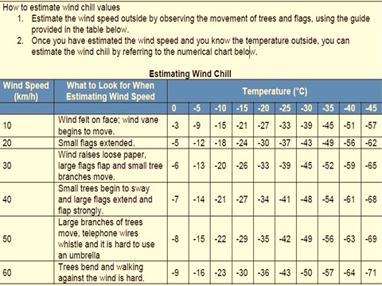

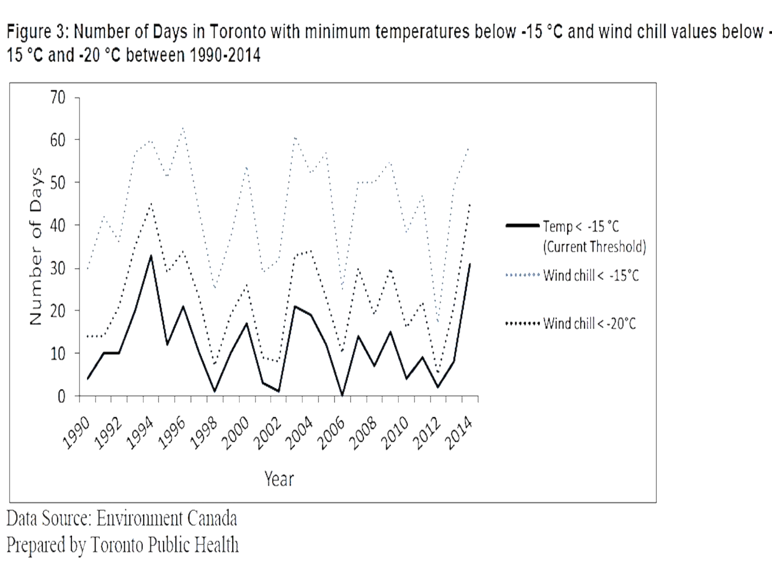

With regards to biometeorology, turbulence is responsible for:
- transferring heat, momentum and mass (water vapor, carbon dioxide, biogenic gases, pollutants) between the biosphere and the atmosphere and diffuses pollutants in the atmosphere.
- imposing drag forces on plants, causing them to wave, bend and break.
- mixing the air and diffusing air parcels with different properties, thereby forming spatial gradients.
- gusts associated with turbulence place loads on the surface, which can erode soils and eject dust, spores and insect eggs into the atmosphere.

Health Impacts of Cold Weather
The health impacts of cold weather include:
- cold weather injuries
- impacts on mortality and
- other chronic health conditions

Cold Weather Injuries
Cold injuries can be classified as
- hypothermia, freezing injuries,
- and non-freezing injuries.
Effects are relatively immediate for most cold weather injuries.
Hypothermia occurs:
when the body’s core temperature drops below 37 ºC. A body temperature that is too low affects the brain, making the victim unable to think clearly or move well.
This makes hypothermia particularly dangerous because a person may not know it is happening and will not be able to do anything about it.
Hypothermia is characterized by shivering, confusion and loss of muscular control (e.g., difficulty walking), and can progress to a life-threatening condition where shivering stops or the person loses consciousness. Cardiac arrest may occur.

Freezing injuries include:
frostnip and frostbite and occur when body tissues freeze.
Frostnip is the milder of the two and involves freezing of the skin only. Frostbite is more severe and occurs when both the skin and the underlying tissue such as fat, muscle, and bone are frozen.
In cold weather, blood vessels near the skin’s surface constrict in order to protect the body’s core temperature. With long periods of exposure to cold, this can lead to reduced blood flow to extremities such as hands, feet, nose, and ears. These areas are then most likely to be affected by frostnip or frostbite. While frostnip 0 is typically only associated with discomfort, untreated severe frostbite can lead to permanent nerve damage, blisters, and even to infection and loss of limbs. Trench foot is an example of a non-freezing cold injury. Trench foot is often described as a "wet cold disease" and results from prolonged exposure in a damp or wet environment from above the freezing point to about 10 ºC. Injury occurs because wet feet lose heat 25-times faster than dry feet.

RADIATION
UV-index
Depletion of stratospheric ozone has led to an increased exposure to ultraviolet-B (UV-B) radiation that in turn has affected the environment and human health. UV-B radiation is responsible for a wide range of potentially damaging human and animal health effects, particularly to the skin, eyes and the immune system.

Human exposure to UV-B depends upon the location, the duration and timing of outdoor activities and precautionary attire such as sunglasses, long-sleeved clothing , sunscreen lotions, etc. UV-B contributes to severe damage of the cornea, lens and retina of the human eye . Long exposures to UV-B radiation can result in photo keratitis or “snow-blindness”.
Lifetime cumulative exposures contribute to the risk of cataracts and other forms of ocular damage.

In addition, excessive exposure may have consequences ranging from premature ageing of the skin to skin cancer, which has become one of the most common types of cancer.
Frequent and intense exposure to sunlight with sunburn, especially in infancy and childhood, encourages the formation of malignant melanoma . The number of new growths of malignant melanoma has doubled every 7 to 8 years over the past 40 years.

Nevertheless,
ultraviolet rays also have positive properties.
They stimulate the formation of vitamin D3,which is important for formation of bones . A very low dose of ultraviolet rays is , however, sufficient for this and lies far below the threshold of sunburn.

WEATHER AND HEALTH ( BIO TROPY )
impact of weather, in particular of weather changes on human beings, resulting in deterioration in cardio-vascular and respiratory diseases , occurrence of blood clotting, aggravating inflammation and increased risks of occupational and traffic accidents. Other effects are subsumed under the term subjective impairment in wellbeing and include sleep disturbances, problems with concentration, headache and fatigue.

References of the lecture
- Wolfgang Kusch, Hwang Yung Fong, Gerd Jendritzky , Ingo Jacobsen ''GUIDELINES ON BIOMETEOROLOGYAND AIR QUALITY FORECASTS'' WMO/TD No. 1184 Geneva, Switzerland 2004.
- ESPM/EPS 129,
Biometeorology MWF 11-12
- Wheeler Hall
University of California, Berkeley
- Instructor: Dennis Baldocchi Professor of Biometeorology Ecosystem Science Division Department of Environmental Science, Policy and Management 345 Hilgard Hall University of California, Berkeley Berkeley, CA 94720
Email: Baldocchi@berkeley.edu

