latitude records, whereas that of obliquity (41ka) is represented in high latitudes. However, the 100ka orbital eccentricity signal is generally dominant overall.
The basic idea is that onset of glacial conditions is initiated by Milankovich forcings that yield summer cooling over the northern land masses. This favors survival of snow cover through summer, a feedback promoting further cooling and ice sheet growth, leading to even further cooling through slow feedbacks in the carbon cycle discussed earlier. Onset of an interglacial works the other way, with Milankovich forcings promoting initial warming over the northern land masses, setting feedbacks into motion to give further warming and ice melt.

The past 1000 years
Temperature reconstructions for the Northern Hemisphere over the past millennium are based on several types of proxy data, but especially dendrochronology, ice cores and historical records. Figure 3 shows a reconstruction based on such proxies for the past millennium. Until about AD 1600 there is still considerable disparity in different estimates of decadal mean values and their range of variation. Conditions appear to have been slightly warmer between AD 1050 and 1330 than between 1400 and 1900. There is evidence in Western and Central Europe for a warm phase around AD 1300. Icelandic records indicate mild conditions up until the late twelfth century, and this phase was marked by the Viking colonization of Greenland and the occupation of Ellesmere Island in the Canadian Arctic by the Inuit. Deteriorating conditions followed. This cool period, known as the ‘Little Ice Age’, was associated with extensive Arctic sea ice and glacier advances in some areas to maximum positions since the end of the last glacial cycle. These advances occurred at dates ranging from the mid-seventeenth to the late nineteenth century in Europe, as a result of the lag in glacier response and regional variability. The coldest interval of the Little Ice Age in the Northern Hemisphere was AD 1570–1730. What caused the Little Ice Age is not entirely clear. Reduced solar output associated with the Maunder Minimum in sunspot activity (1645–1715) likely played a role, as did increased volcanic activity.
Long instrumental records for stations in Europe and the eastern United States indicate that the warming trend that ended the Little Ice Age began at least by the mid-nineteenth century. The time series of global annual averaged surface air temperature from instrumental records shows a significant temperature rise of about 0.7°C from 1880 through 2007. Both hemispheres have participated in this warming, but it is most pronounced in the Northern Hemisphere (Figure 4). Warming in turn encompasses both land and ocean regions, being stronger over land (Figure 5). Warming has been smallest in the tropics and largest in northern high latitudes. Warming is in turn strongest during winter. The general temperature rise has not been continuous, however, and four basic phases may be identified in the global record:
- 1880–1920, during which there was an oscillation within extreme limits of about 0.3°C but no trend.
- 1920–mid-1940s, during which there was considerable warming of approximately 0.4°C; this warming was most strongly expressed in northern high latitudes.
- Mid-1940s–early 1970s, during which there were oscillations within extreme limits of about 0.4°C, with the Northern Hemisphere cooling slightly on average and the Southern Hemisphere remaining fairly constant in temperature. Regionally, northern Siberia, the eastern Canadian Arctic and Alaska experienced a mean lowering of winter temperatures by 2–3°C between 1940 and 1949 and 1950 and 1959; this was partly compensated by a slight warming in the western United States, Eastern Europe and Japan.
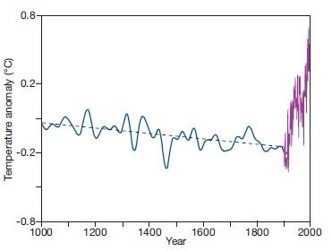
Figure 3: Variation in surface air temperature for the Northern Hemisphere over the past millennium.

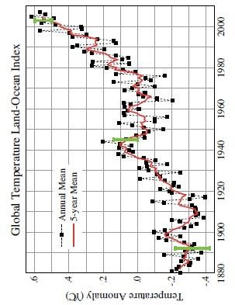
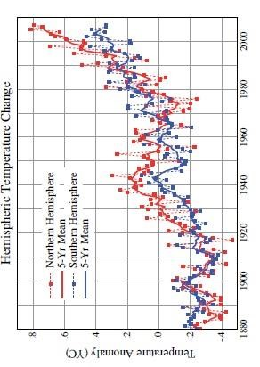
Figure 4 Long-term instrumental records of annual average surface air temperature, expressed as anomalies with respect to the base period 1951–1980. A: Global average. B: Averages for the Northern and Southern Hemispheres. The red lines depict the time series smoothed with five year means.

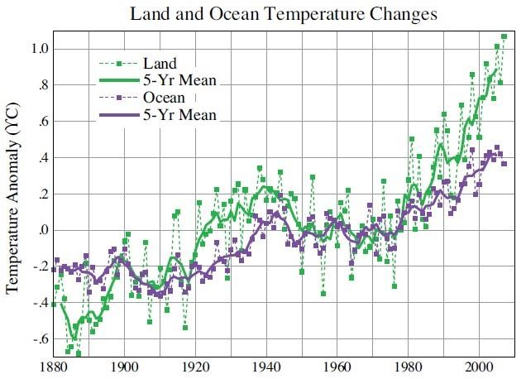

Figure 5 Long-term instrumental records of annual average surface air temperature, expressed as anomalies with respect to the base period 1951–1980 for the global land and ocean areas. The solid lines depict the time series smoothed with five-year means.
4- Mid-1970s–2008, during which there was a marked overall warming of about 0.5°C, but with strong regional variability.

UNDERSTANDING RECENT CLIMATIC CHANGE
While the evidence is strong that much of the global warming over the past 100 years is a response to rising concentrations of atmospheric greenhouse gases, we have seen that the global temperature time series is characterized by fluctuations from inter-annual to decadal and even longer timescales (Figure 4). As just discussed, variability is in turn very pronounced at regional scales. Regional fluctuations and shorter term global fluctuations may be viewed as expressions of natural climate variability – a term which allows for the influence of non-anthropogenic radiative forcing. It is useful to review some of the causes of recent climate fluctuations embedded in the overall global warming trend, helping to set the stage for more focused discussion of anthropogenic- induced change.

1 Circulation changes
One immediate cause of climatic fluctuations is variability in the global and regional atmospheric circulation and associated heat transports. The first 30 years of the twentieth century saw a pronounced increase in the vigor of the westerlies over the North Atlantic, the northeast trades, the summer monsoon of South Asia and the Southern Hemisphere westerlies (in summer). Over the North Atlantic, these changes consisted of an increased pressure gradient between the Azores high and the Icelandic low as the latter deepened, and also between the Icelandic low and the Siberian high, which spread westward. These changes were accompanied by more northerly depression tracks, and this resulted in a significant increase in the frequency of mild southwesterly airflow over the British Isles between about 1900 and 1930, as reflected by the average annual frequency of Lamb’s westerly airflow type . For 1873–1897, 1898–1937, 1938–1961 and 1962–1995 the figures are 27, 38, 30 and 21 percent, respectively. Coinciding with the westerly decline, cyclonic and anticyclonic types increased substantially. The decrease in westerly airflow during the last 30- year interval, especially in winter, is linked with greater continentality in Europe. These regional indicators reflect a general decline in the overall strength of the mid-latitude circumpolar westerlies, accompanying an apparent expansion of the polar vortex. a general upward trend to strong positive values in the mid-1990s (giving enhanced westerly flow).

2 Solar variability
The ultimate driver of the climate system is of course the sun. The wellknown solar cycle of approximately 11 years is usually measured with reference to the period between sunspot maxima and minima. As shown in satellite records available since 1980 and as discussed earlier, irradiation varies by a modest 1W m^{–2} over the 11-year cycle (the radiation flux averaged across the top of the atmosphere is only 25 percent as large). the explanation is that sunspot darkening is accompanied by increased emission from faculae that is 1.5 times greater than the darkening effect. The 11-year cycle corresponds to global air temperature fluctuation of <0.1°C. What of longer term variations? Strong global warming since 1980 cannot be attributed to solar activity, since the satellite data show no discernible trend. On the other hand, based on reconstructions, solar variability may account for perhaps half of the warming between 1860 and 1950. Variations in solar irradiance may also offer a partial explanation of the Little Ice Age.
It is suggested by David Rind of NASA that the direct solar forcing on climate may pale in comparison with the potential for solar forcing to trigger interactions involving a variety of feedback processes. There appear to be regional patterns in the temperature response to solar variability with the largest signals in low latitudes where there are large insolation totals and over oceans where the albedo is low. Hence, maximum responses are likely to occur over eastern tropical ocean areas. A statistical relationship has also been found between the occurrence of droughts in the western United States over the past 300 years, determined from tree ring data and the approximately 22-year double (Hale) cycle of the reversal of the solar magnetic polarity. Drought areas are most extensive in the two to five years following a Hale sunspot minimum (i.e., alternate 11-year sunspot minima). A clear mechanism is not established, however.

