Digestive Hormonal Functions
The second of the two systems that control digestive function is the endocrine system, which regulates function by secreting hormones. Hormones are chemical messengers secreted into blood that modify the physiology of target cells. A target cell for a particular hormone is a cell that has receptors for that hormone and can thus respond to it. Digestive function is affected by hormones produced in many endocrine glands, but the most profound control is exerted by hormones produced within the gastrointestinal tract. The gastrointestinal tract is the largest endocrine organ in the body, releasing more than 20 different peptide hormones, some of which target the brain to regulate appetite and influence the pleasure of eating. Like all endocrine cells, cells in enteric endocrine system do not simply secrete their hormone continuously, which would not be very useful as a control system. Rather, they secrete hormones in response to fairly specific stimuli and stop secreting their hormone when those stimuli are no longer present. Endocrinocytes (endocrine cells) in the enteric endocrine system respond to changes in the environment within the lumen of the digestive tube, because these cells are part of the epithelium, their apical border is in contact with the contents of the lumen, which allows them to continually "taste" or sample the lumenal environment and respond appropriatelyThere are different hormones related to gastrointestinal system which plays important role in digestion of the food and energy expenditure.
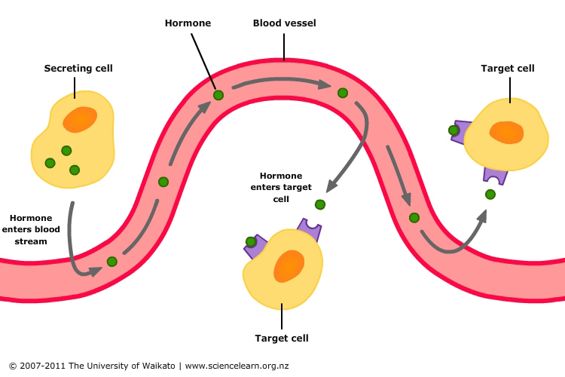
There are five main hormones that aid in regulation of the digestive system in mammals:
1. Gastrin is in the stomach when it is stretched and stimulates the gastric glands to secrete gastric juice rich in pepsinogen (an inactive form of the enzyme pepsin) and hydrochloric acid. Secretion of gastrin is stimulated by food arriving in the stomach. The secretion is inhibited by low pH.
2. Secretin is peptide hormone (27 amino acids) produced and secreted by the S cells in the duodenum and signals the secretion of sodium bicarbonate in the pancreas and it stimulates the bile secretion in the liver. This hormone responds to the acidity of the chyme (in response to meals and to the presence of acid in the duodenum). Secretin secretion is enhanced by amino acids, bile acid, fats, increased duodenal acidity and it is inhibited by Somatostatin.
3. Cholecystokinin (CCK) is is peptide hormone produced by I cells in the duodenum, and stimulates the release of digestive enzymes in the pancreas and stimulates the emptying of bile in the gall bladder (it reduces appetite). This hormone is secreted in response to fat in chyme. CCK secretion in enhanced by lipid , peptones, amino acids, CCK releasing factors.
4. Gastric inhibitory peptide (GIP) is secreted by the K cells in the duodenum and decreases the stomach churning in turn slowing the emptying in the stomach. Another function is to enhances insulin secretion in response to a high concentration of blood sugar, and it inhibits the absorption of water and electrolytes in the small intestine. The cell numbers are increased in persons with duodenal ulcer, chronic inflammation of the pancreas, and diabetes resulting from obesity.
5. Motilin is 22 amino acids polypeptide in the duodenum and increases the migrating myoelectric complex component of gastrointestinal motility and stimulates the production of pepsin. A high level of motilin in the blood stimulates the contraction of the fundus and antrum and accelerates gastric emptying. It contracts the gallbladder and increases the squeeze pressure of the lower esophageal sphincter. Motilin is secreted between meals.

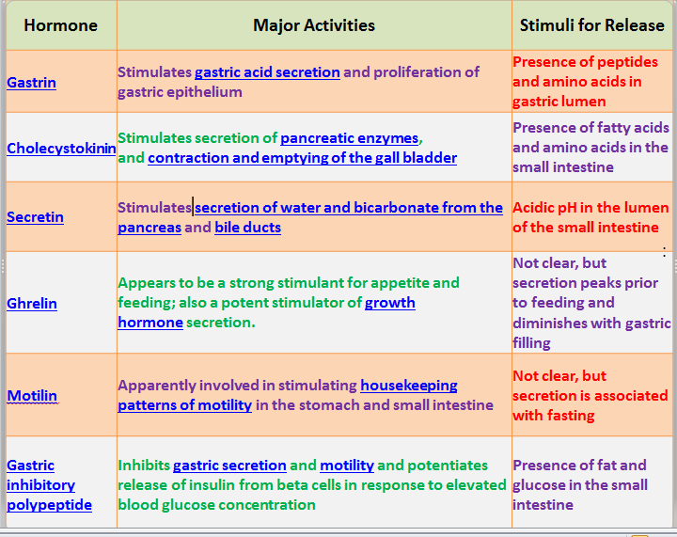
Glucose Hemostasis
1. Insulin
Insulin is secreted by the beta (B) cells of the pancreas in response to a rise in plasma glucose concentration and a fall in glucagon level. It stimulates the absorption of carbohydrates (glucose) into stores in muscle and adipose (fatty) tissue.
2. Glucagon
Glucagon is produced by pancreatic alpha (A) cells in response to a drop in plasma glucose concentration; the effects of glucagon are opposite to those of insulin. Glucagon stimulates the breakdown of glycogen and the production of new glucose (gluconeogenesis) in the liver. It also decreases the production of gastric and pancreatic secretions.
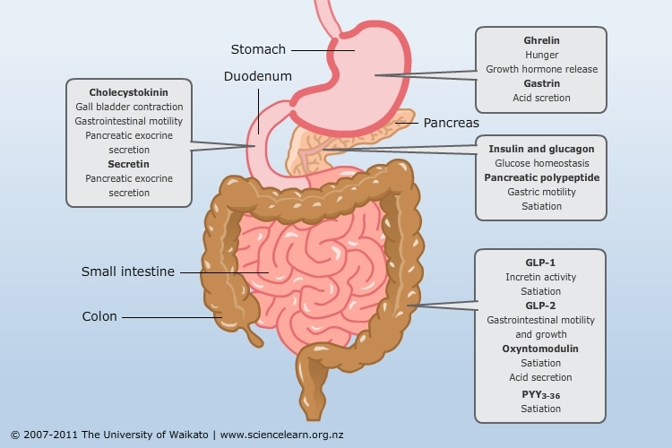
Appetite Regulating Hormones
There are hormones secreted by tissues and organs in the body that are transported through the bloodstream to the satiety center, a region in the brain that triggers impulses that give us feelings of hunger or aid in suppressing our appetite. Ghrelin is a hormone that is released by the stomach and targets the pituitary, signaling to the body that it needs to eat (It increases appetite). PYY is produced in the last part of the small intestine known as the ileum as well as parts of the large intestine, It plays a role in slowing down the passage of food along the gut, which increases the efficiency of digestion and nutrient absorption after meal(helps to suppress our appetite). The pancreas releases the hormone insulin, which targets the hypothalamus and also aids in suppressing our appetite after we have just eaten and there is a rise in blood glucose levels. The last hormone is leptin which also helps to suppress appetite. Leptin is produced by adipose fat tissue and targets the hypothalamus.
Phases of Digestion
A. Cephalic Phase
The cephalic phase of gastric secretion occurs before food enters the stomach due to neurological signals.
1. Thinking of food (i.e., smell, sight) stimulates the cerebral cortex.
2. The cerebral cortex sends messages to the hypothalamus, the medulla, and the parasympathetic nervous system via the vagus nerve, and to the stomach via the gastric glands in the walls of the fundus and the body of stomach.
3. The gastric glands secrete gastric juice.
4. When food enters the stomach, the stomach stretches and activates stretch receptors.
5. The stretch receptors send a message to the medulla and then back to the stomach via the vagus nerve.
6. The gastric glands secrete more gastric juice.
7. Chemical stimuli (i.e., partially digested proteins, caffeine) directly activate G cells (enteroendocrine cells) that are located in the pyloric region of the stomach to secrete gastrin; this in turn stimulates the gastric glands to secrete gastric juice.
B. Gastric Phase
The gastric phase is a period in which swallowed food activates gastric activity in the stomach. Gastric secretion is stimulated chiefly by three chemicals:
1. Acetylcholine (ACh). This is secreted by the parasympathetic nerve fibers of both the short and long reflex pathways.
2. Histamine. This is a paracrine secretion from the enteroendocrine cells in the gastric glands.
3. Gastrin. This is a hormone produced by enteroendocrine G cells in the pyloric glands.
All three of these stimulate parietal cells to secrete hydrochloric acid and intrinsic factor. The chief cells secrete pepsinogen in response to gastrin and especially ACh, and ACh also stimulates mucus secretion.
As dietary protein is digested, it breaks down into smaller peptides and amino acids that directly stimulate the G cells to secrete even more gastrin: this is a positive feedback loop that accelerates protein digestion.
Small peptides also buffer the stomach acid so the pH does not fall excessively low. As digestion continues and these peptides empty from the stomach, the pH drops lower and lower. Below pH of 2, stomach acid inhibits the parietal cells and G cells: this is a negative feedback loop that winds down the gastric phase as the need for pepsin and HCl declines.
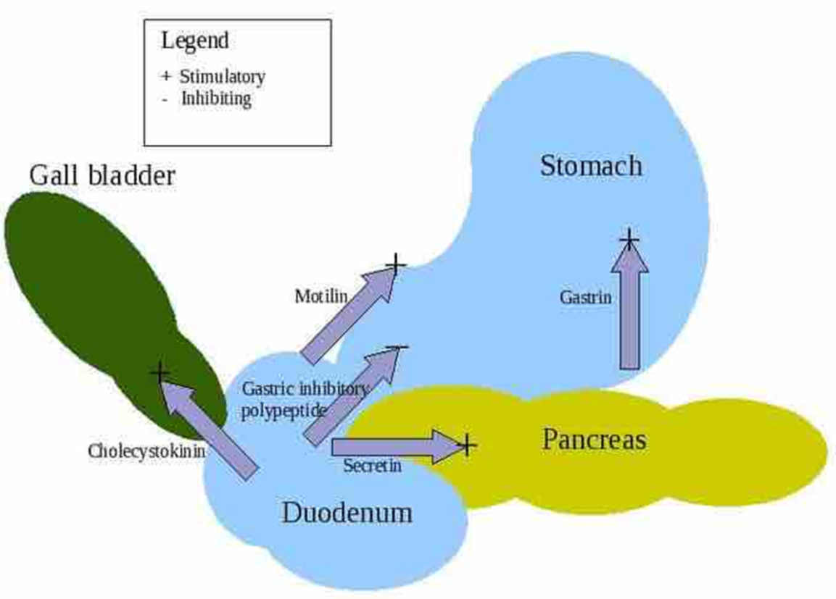
The gastric phase of digestion: During the gastric phase, gastrin is secreted. The stomach stretches and churns while enzymes break down proteins.

C. IntestinalPhase
The intestinal phase occurs in the duodenum as a response to the arriving chyme, and it moderates gastric activity via hormones and nervous reflexes. The duodenum initially enhances gastric secretion, but soon inhibits it. The stretching of the duodenum accentuates vagal reflexes that stimulate the stomach, and peptides and amino acids in the chyme stimulate the G cells of the duodenum to secrete more gastrin, which further stimulates the stomach.
Soon, however, the acid and semi-digested fats in the duodenum trigger the enterogastric reflex. That is, the duodenum sends inhibitory signals to the stomach by way of the enteric nervous system, while also sending signals to the medulla that inhibit the vagal nuclei. This reduces vagal stimulation of the stomach and stimulates sympathetic neurons that send inhibitory signals to the stomach.
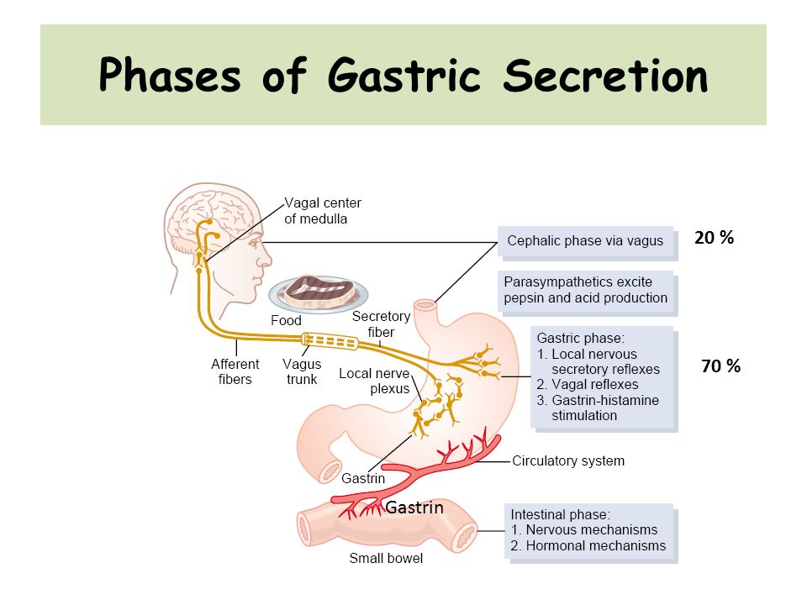

Chyme
Chyme also stimulates duodenal enteroendocrine cells to release secretin and cholecystokinin. These hormones primarily stimulate the pancreas and gallbladder, but they also suppress gastric secretion and motility. The effect of this is that gastrin secretion declines and the pyloric sphincter contracts tightly to limit the admission of more chyme into the duodenum. This gives the duodenum time to work on the chyme it has received before being loaded with more.
The enteroendocrine cells also secrete glucose -dependent insulinotropic peptide. Originally called gastric-inhibitory peptide, it is no longer thought to have a significant effect on the stomach. Rather, it probably stimulates insulin secretion in preparation for processing the nutrients that are about to be absorbed by the small intestine.

Individual hormones

Somatostatin
Somatostatin is a peptide secreted by the delta (D) cells in response to eating, especially when fat enters the duodenum. It is an inhibitory modulator of the secretion of acid and pepsin and of the release of gastrin, insulin, and other intestinal hormones. It inhibits motility of the gallbladder and intestines and suppresses the secretion of lipase by the pancreas.

Serotonin
Serotonin, or 5-hydroxytryptamine, is an amine that is formed from amino acid 5-hydroxytrytophan in the enterochromaffin cells (EC) and in other similar cells called enterochromaffin-like cells (ECL). These cells also secrete histamine and kinins, which likewise have important messenger functions in glandular secretions and on blood vessels. Serotonin acts in paracrine fashion. Both EC and ECL cells are widely distributed in the gastrointestinal tract.

Neurotensin
Secreted by the N cells of the ileum in response to fat in the small intestine, neurotensin modulates motility, relaxes the lower esophageal sphincter, and blocks the stimulation of acid and pepsin secretion by the vagus nerve.

Pancreatic polypeptide
Special endocrine cells, “PP” cells, secrete pancreatic polypeptide in response to protein meals. Their function is intimately related to vagal and cholinergic activity. The level of pancreatic polypeptide is frequently raised in diabetes.

Secretin
Secreted by the S cells of the duodenum in response to meals and to the presence of acid in the duodenum, secretin stimulates the production of bicarbonate by the pancreas.

Vasoactive intestinal peptide
Secreted locally by endocrine cells or nerve endings, vasoactive intestinal peptide is located almost exclusively in nerves distributed throughout the gastrointestinal tract. It inhibits the release of gastrin and the secretion of acid, is a mild stimulant of bicarbonate secretion from the pancreas, and is a powerful stimulant of the secretion of water and electrolytes by the small and large intestines. It relaxes the sphincters and slows intestinal transit time. There is another group of peptide messengers that is found in quantity within the brain and in the nerves of the gastrointestinal tract. These include substance P, endorphins, enkephalins, and bombesin.

Substance P
Present in significant amounts in the vagus nerves and the myenteric plexus, substance P stimulates saliva production, contraction of smooth muscle cells, and inflammatory responses in tissues, but it is uncertain whether it is anything other than an evolutionary vestige.

Endorphins and enkephalins
Endorphins and enkephalins, each comprising five amino acids in the molecule, are present in the vagus nerves and the myenteric plexus. They have the properties of opiate (opium-derived) substances such as morphine; they bind to the same receptors and are neutralized by the opiate antagonist naloxone. There is no evidence that endorphins and enkephalins are circulating hormones, but the enkephalins may have a physiological paracrine role in modulating smooth muscle activity in the gastrointestinal tract, and endorphins may serve in modulating the release of other peptides from endocrine cells in the digestive system.

Bombesin
A peptide that is found in the intrinsic nerves of the gastrointestinal tract, bombesin stimulates the release of gastrin and pancreatic enzymes and causes contraction of the gallbladder. These functions may be secondary, however, to the release of cholecystokinin, a hormone secreted by the mucosa of the intestine that has similar effects. It is uncertain if bombesin has a physiological role or if it is an evolutionary vestige.

Prostaglandins

Prostaglandins are hormonelike substances involved in the contraction and relaxation of the smooth muscle of the gastrointestinal tract. Prostaglandins are also able to protect the mucosa of the alimentary tract from injury by various insults (boiling water, alcohol, aspirin, bile acids, stress) by increasing the secretion of mucus and bicarbonate from the mucosa, which in turn stimulates the migration of cells to the surface for repair and replacement of the mucosal lining.

References
  - "Enteric Endocrine System". www.vivo.colostate.edu. Retrieved 2016-09-16.
  - Vella A and Drucker DJ (2011)Chapter 39 Gastrointestinal Hormones and Gut Endocrine Tumors, pp 1697-1707. In Williams Textbook of Endocrinology (2011, 12th edition)
  - Burtis CA, Ashwood ER, Bruns DE (2012-10-14). Tietz Textbook of Clinical Chemistry and Molecular Diagnostics, 5th edition. Elsevier Saunders. ISBN 978-1-4160-6164-9.

