Hormonal regulation of kidney function :
The function of kidney is regulated by three important hormones. These hormones are aldosterone (from adrenal cortex), parathormone (from parathyroid), and vasopressin (from hypophyseal posterior lobe).
1.Aldosterone restricts the excretion of Na⁺ and stimulates the excretion of K⁺.
2.Parathormone stimulates excretion of phosphate. 3.Vasopressin, the antidiuretic hormone, is held responsible mainly for the reabsorption of water. In the absence of this hormone, a large amount of very dilute urine is excreted.
What is aldosterone?
Aldosterone is a hormone produced in the outer section (cortex) of the adrenal glands, which sit above the kidneys. It plays a central role in the regulation of blood pressure mainly by acting on organs such as the kidney and the colon to increase the amount of salt (sodium) reabsorbed into the bloodstream and to increase the amount of potassium excreted in the urine. Aldosterone also causes water to be reabsorbed along with sodium; this increases blood volume and therefore blood pressure.

How is aldosterone controlled?
Aldosterone is part of a group of linked hormones, which form the renin–angiotensin–aldosterone system. Activation of this system occurs when there is decrease in blood flow to the kidneys following loss of blood volume or a drop in blood pressure (e.g. due to a haemorrhage). Renin is an enzyme that leads to a series of chemical reactions resulting in the production of angiotensin II, which in turn stimulate aldosterone release. Aldosterone causes an increase in salt and water reabsorption into the bloodstream from the kidney thereby increasing the blood volume, restoring salt levels and blood pressure.thereby increasing the blood volume, restoring salt levels and blood pressure.
What happens if I have too much aldosterone?
The most common cause of high aldosterone levels is excess production, frequently from a small benign adrenal tumour (primary hyperaldosteronism). The symptoms include high blood pressure, low blood levels of potassium and an abnormal increase in blood volume.
What happens if I have too little aldosterone?
Low aldosterone levels are found in a rare condition called Addison's disease. In Addison's disease, there is a general loss of adrenal function resulting in low blood pressure, lethargy and an increase in potassium levels in the blood.

Alternative names for parathyroid hormone
PTH; parathormone; parathyrin
What is parathyroid hormone?
Parathyroid hormone is secreted from four parathyroid glands, which are small glands in the neck, located behind the thyroid gland. Parathyroid hormone regulates calcium levels in the blood, largely by increasing the levels when they are too low. It does this through its actions on the kidneys, bones and intestine:
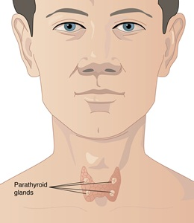
1.Bones – parathyroid hormone stimulates the release of calcium from large calcium stores in the bones into the bloodstream. This increases bone destruction and decreases the formation of new bone.
2.Kidneys – parathyroid hormone reduces loss of calcium in urine. Parathyroid hormone also stimulates the production of active vitamin D in the kidneys.
3.Intestine – parathyroid hormone indirectly increases calcium absorption from food in the intestine, via its effects on vitamin D metabolism.
How is parathyroid hormone controlled?
Parathyroid hormone is mainly controlled by the negative feedback of calcium levels in the blood to the parathyroid glands. Low calcium levels in the blood stimulate parathyroid hormone secretion, whereas high calcium levels in the blood prevent the release of parathyroid hormone.
What happens if I have too much parathyroid hormone?
A primary problem in the parathyroid glands, producing too much parathyroid hormone causes raised calcium levels in the blood (hypercalcaemia) and this is referred to as primary hyperparathyroidism. There is a similar but much rarer condition called tertiary hyperparathyroidism that causes hypercalcaemia due to excess parathyroid hormone production on the back drop of all four glands being overactive. Secondary hyperparathyroidism occurs in response to low blood calcium levels and is caused by other mechanisms, for example, kidney disease and vitamin D deficiency.
Mild primary hyperparathyroidism often causes few if any symptoms and is frequently diagnosed by finding a high calcium concentration on a routine blood test. Treatment may be by surgical removal of the affected gland(s) (parathyroidectomy).

What happens if I have too little parathyroid hormone?
Too little parathyroid hormone or hypoparathyroidism, is a rare medical condition. It can result in low levels of calcium in the blood (hypocalcaemia). It is usually treated medically with oral calcium and vitamin D analogues but the availability of parathyroid hormone replacement therapy may change the approach to treatment for some patients.

Alternative names for anti-diuretic hormone
Vasopressin; arginine vasopressin; AVP; ADH
What is anti-diuretic hormone?
Anti-diuretic hormone is made by special nerve cells found in an area at the base of the brain known as the hypothalamus. The nerve cells transport the hormone down their nerve fibres (axons) to the pituitary gland where the hormone is released into the bloodstream. Anti-diuretic hormone helps to control blood pressure by acting on the kidneys and the blood vessels. Its most important role is to conserve the fluid volume of your body by reducing the amount of water passed out in the urine. It does this by allowing water in the urine to be taken back into the body in a specific area of the kidney. Thus, more water returns to the bloodstream, urine concentration rises and water loss is reduced. Higher concentrations of anti-diuretic hormone cause blood vessels to constrict (become narrower) and this increases blood pressure. A deficiency of body fluid (dehydration) can only be finally restored by increasing water intake.
How is anti-diuretic hormone controlled?
The release of anti-diuretic hormone from the pituitary gland into the bloodstream is controlled by a number of factors. A decrease in blood volume or low blood pressure, which occurs during dehydration or a haemorrhage, is detected by sensors (receptors) in the heart and large blood vessels. These stimulate anti-diuretic hormone release. Secretion of anti-diuretic hormone also occurs if the concentration of salts in the bloodstream increases, for example as a result of not drinking enough water on a hot day. This is detected by special nerve cells in the hypothalamus which simulate anti-diuretic hormone release from the pituitary. If the concentration of salts reaches abnormally low levels, this condition is called hyponatraemia. Anti-diuretic hormone is also released by thirst, nausea, vomiting and pain, and acts to keep up the volume of fluid in the bloodstream at times of stress or injury. Alcohol prevents anti-diuretic hormone release, which causes an increase in urine production and dehydration.

What happens if I have too much anti-diuretic hormone?
High levels of anti-diuretic hormone cause the kidneys to retain water in the body. There is a condition called Syndrome of Inappropriate Anti-Diuretic Hormone secretion (SIADH; a type of hyponatraemia) where excess anti-diuretic hormone is released when it is not needed ,with this condition, excessive water retention dilutes the blood, giving a characteristically low salt concentration. Excessive levels of anti-diuretic hormone might be caused by drug side-effects and diseases of the lungs, chest wall, hypothalamus or pituitary. Some tumours (particularly lung cancer), can produce anti-diuretic hormone.
What happens if I have too little anti-diuretic hormone?
Low levels of anti-diuretic hormone will cause the kidneys to excrete too much water. Urine volume will increase leading to dehydration and a fall in blood pressure. Low levels of anti-diuretic hormone may indicate damage to the hypothalamus or pituitary gland, or primary polydipsia (compulsive or excessive water drinking). In primary polydipsia, the low level of anti-diuretic hormone represents an effort by the body to get rid of excess water. Diabetes insipidus is a condition where you either make too little anti-diuretic hormone (usually due to a tumour, trauma or inflammation of the pituitary or hypothalamus), or where the kidneys are insensitive to it. Diabetes insipidus is associated with increased thirst and urine production.
Role of Hormones in Urinary System
Hormones in Urinary system is that the kidneys produce and interact with several hormones that are involved in the control of systems outside of the urinary system.

Role of Hormones in Urinary System
1.Erythropoietin
EPO is a 193-amino acid protein which stimulates the formation of red blood cells in the bone marrow. The kidney produces 85 percent of circulating EPO; and remaining 15 percent in the liver.
Erythropoietin, also known as EPO, is a hormone which is produced by the kidneys to stimulate the production of red blood cells.
The kidneys monitor the condition of the blood that passes through their capillaries, including the oxygen-carrying capacity of the blood. When the blood becomes hypoxic, which mean carrying low level of oxygen, cells lining the capillaries begin producing EPO and release it into the bloodstream.
EPO travels through the blood to the red bone marrow, where it stimulates hematopoietic cells to increase their rate of red blood cell production.
Red blood cells contain hemoglobin, which increases the blood’s oxygen-carrying capacity and which helps to ends the hypoxic conditions.
If you move to a higher altitude, the partial pressure of oxygen is lower, and because of that there is less pressure to push oxygen across the alveolar membrane and into the red blood cell.
If you start an aerobic exercise, your tissues will need more oxygen to cope with situation, and the kidney will produce more EPO. If erythrocytes are lost due to severe or prolonged bleeding, or under produced due to disease or severe malnutrition, the kidneys come to the rescue by producing more EPO.
Renal failure (loss of EPO production) is associated with anemia, which makes it difficult for the body to cope with increased oxygen demands or to supply oxygen adequately even under normal conditions. In this cases EPO supplement to be given to the person.
2. Calcitriol
Calcitriol is the active form of vitamin D in the human body. It is produced by the kidneys from precursor molecules produced by UV radiation striking the skin.
Calcitriol works together with parathyroid hormone (PTH), it helps to raise the level of calcium ions in the bloodstream. When the level of calcium ions in the bloodstream drops below a threshold level, the parathyroid glands release PTH, which in turn stimulates the kidneys to release calcitriol.
Calcitriol promotes the small intestine to absorb calcium from food and deposit it into the bloodstream. It also stimulates the osteoclasts of the skeletal system to break down bone matrix to release calcium ions into the blood.
3. Renin
Renin is not a hormone itself, but an enzyme that the kidneys produce to start the renin-angiotensin system (RAS). The RAS increases blood volume and blood pressure in response to low blood pressure, blood loss, or dehydration.
Renin is released into the blood where it catalyzes angiotensinogen from the liver into angiotensin I. Angiotensin I is further catalyzed by another enzyme into Angiotensin II.
Angiotensin II stimulates several processes, including stimulating the adrenal cortex to produce the hormone aldosterone.
Aldosterone use changes the function of the kidneys to increase the reabsorption of water and sodium ions into the blood, increasing blood volume and raising blood pressure.
Negative feedback from increased blood pressure finally turns off the RAS to maintain healthy blood pressure levels.
Regulation of Water Reabsorption
There are two main hormones that regulate the rate of excretion of water.
The first hormone is aldosterone which acts on the collecting duct and causes the body to retain more water. Blood pressure increases when the body retains more water. This system is triggered when there is low blood pressure or low sodium ion concentration in the blood. Aldosterone is part of the renin-angiotensin aldosterone system(RAAS).
The second hormone is antidiuretic hormone (ADH) which causes increase water reabsorption at the collecting duct by increasing the water permeability of the collecting ducts. Water then moves back into the blood by osmosis. More ADH is secreted when the body needs to retain more water and this will lead to a concentrated urine.
The renin-angiotensin-aldosterone system is one of the most complex and important systems in controlling the blood pressure in your body. As we go over this system, you'll also learn about the many hormones involved in the control of your body's glomerular filtration rate and blood pressure.

The Control of Blood Pressure
I'm pretty sure you have seen or heard a commercial touting a new drug that helps to regulate something known as systemic hypertension, or high blood pressure all over the body. Your body has an entire system that regulates blood pressure as well. It is actually built to counteract low blood pressure, or hypotension, instead of hypertension. You'll find out in this lesson that the main ways by which we can increase blood pressure is by constricting our blood vessels, increasing the amount of fluid in them, or both. Our body has a great way of doing the latter. Let's see how.

The Renin-Angiotensin-Aldosterone System (RAAS)
Your body has a huge system involved in the sensation and control of blood pressure, not only within the kidneys, but all over the body - especially in times of great need. This is in contrast to a smaller system called tubuloglomerular feedback, which you can think of as the system that senses and controls blood pressure and glomerular filtration rate within the kidneys on a moment-by-moment basis. When called upon, this smaller system can also rev up the really big system I'm about to get into. So, what is this really big system?
Could I get a drumroll? The most important system involved in the regulation of systemic blood pressure, renal blood flow and glomerular filtration rate is called the renin-angiotensin-aldosterone system, or (RAAS) for short.
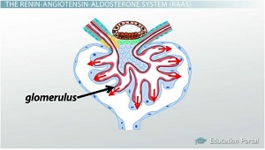
The smaller system that controls blood pressure is the tubuloglomerular feedback system

The Release of Renin
When systemic hypotension, or low blood pressure throughout the body, occurs, receptors in your blood vessels called baroreceptors sense this change. Cells of the kidney's juxtaglomerular apparatus get involved as well. Detection by one or both of these mechanisms leads juxtaglomerular cells in the kidneys to release an enzyme called renin. Renin is an enzyme released by the juxtaglomerular cells of the kidneys in response to low blood pressure, causing the transformation of angiotensinogen to angiotensin I.

Angiotensinogen & Angiotensin I
Angiotensinogen is a precursor protein made in the liver for a hormone called angiotensin I. Essentially, renin catalyzes a reaction that converts the angiotensinogen protein into angiotensin I, which is a precursor hormone that is converted to an active hormone called angiotensin II by an enzyme known as angiotensin-converting enzyme in the lungs. Wow, that was a mouthful! Let's break this down.
Here's how to remember what becomes what. Angiotensinogen's purpose is to serve as a precursor to angiotensin I. Angiotensinogen is cleaved, or broken apart, by renin. Since it's broken apart, it gets smaller and becomes shorter in name as well. Therefore, it's now called plain old angiotensin I. Angiotensin I decides to have a little kid and name it after itself. Therefore, when angiotensin I is converted in the lungs by an enzyme called ACE, it becomes angiotensin junior - or more technically, angiotensin II.

Angiotensin-Converting Enzyme (ACE) & Angiotensin II
It bears repeating that the angiotensin-converting enzyme, or ACE for short, is an enzyme located mainly in the lungs that converts angiotensin I into angiotensin II. Once angiotensin II is made, it can have a big effect on the body. Namely, angiotensin II is a vasoconstrictive hormone that increases systemic blood pressure, renal perfusion pressure and the glomerular filtration rate.
Angiotensin II not only constricts blood vessels all over the body in order to increase systemic blood pressure, it also works in the kidneys in order to maintain blood pressure in the glomerulus so that the glomerular filtration rate stays normal even in the face of low blood pressure.

Control of the Glomerular Filtration Rate (GFR) by the RAAS
Let's see how this works with a familiar example. If you connect a hose to a faucet and turn the faucet on, a certain pressure will be exerted by the water on the walls of the hose. Likewise, blood running through the glomerulus (our hose) does the same thing. If the faucet is turned down a bit due to hypotension, there is less water running through the hose and therefore less pressure being exerted on the hose. If this were to happen in our glomerulus due to hypotension, this would be very bad. We need to maintain pressure in the glomerulus at a certain level if we want to filter our blood enough to stay alive.
To maintain pressure in the glomerulus and therefore keep the glomerular filtration rate steady, angiotensin II constricts both the efferent and afferent arteriole, but with a much greater effect on the efferent arteriole. Remember, the effect of angiotensin II is greater on the efferent arteriole. This means that the blood entering the glomerulus has a much harder time leaving it because the exit is far smaller than the entrance. This causes a backup of blood in the glomerulus, increases the pressure within it and, therefore, keeps the GFR at an appropriate rate.
In addition, angiotensin II increases the absorption of sodium in the renal tubule. Since water follows sodium, it increases the amount of fluid in the blood vessels, further causing an increase in blood pressure in addition to the vasoconstriction that already occurred.
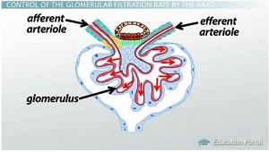
Angiotensin II constricts the afferent and efferent arterioles.

Aldosterone
Angiotensin does some other important things that you must remember. It causes the release of a hormone called aldosterone from the adrenal glands. Aldosterone is a hormone that increases the absorption of water from the distal convoluted tubule and collecting duct of the kidney's nephrons.
Aldosterone has many other functions, including the secretion of potassium into urine. However, for this lesson, you should understand that aldosterone causes the absorption of sodium out of the renal tubule's filtrate and into the blood. Since water follows sodium, more water is reabsorbed back into the blood in order to increase the blood pressure.

Anti-Diuretic Hormone (ADH)
As if constricting blood vessels and releasing aldosterone to retain water and sodium weren't enough, angiotensin II also causes the release of a hormone called anti-diuretic hormone, commonly called vasopressin, or ADH for short.
ADH is a hormone released from the posterior pituitary gland that causes an increase in blood pressure. ADH vasoconstricts our blood vessels, which causes increased blood pressure. It also increases water absorption from the distal tubule and collecting ducts. Now that you know what it does, it's easy to remember this because 'anti' in 'anti-diuretic' means 'against,' and 'diuretic' means 'excess urine production' that occurs thanks to water loss. Hence, ADH is against the loss of water in urine from your body!
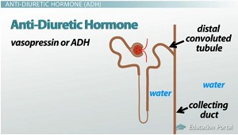
anti-diuretic hormone raises blood pressure by vasoconstricting blood vessels and increasing water absorption

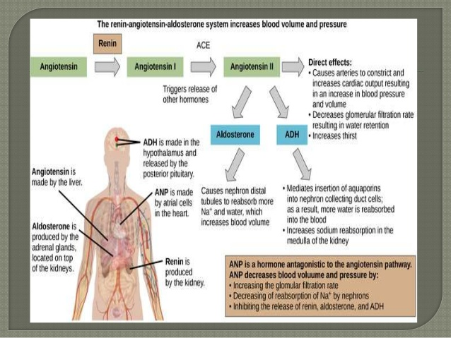

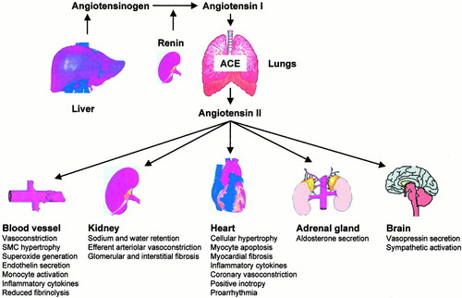
Pathophysiology of the RAS. SMC indicates smooth muscle cell.

Refrences
1.Taal MW, Brenner BM. Renoprotective benefits of RAS inhibition: from ACEI to angiotensin II antagonists. Kidney Int. 2000; 57: 1803–1817.
2.Brown NJ, Vaughan DE. Angiotensin-converting enzyme inhibitors. Circulation. 1998; 97: 1411–1420.
3. Weir MR, Dzau VJ. The renin-angiotensin-aldosterone system: a specific target for hypertension management. Am J Hypertens. 1999; 12: 205S–213S.
4.Brunner HR, Laragh JH, Baer L, et al. Essential hypertension: renin and aldosterone, heart attack and stroke. N Engl J Med. 1972; 286: 441–449

