**Applications of Immunology**

***Ass.Pro. Dr. Aklas N.***

***L.Dr. Mohanad A.K.***

**Lac. 6**

**Vaccine**

A vaccine is a substance that is introduced into the body to prevent infection or to control disease due to a certain pathogen (a disease-causing organism, such as a virus, bacteria or parasite). The vaccine “teaches” the body how to defend itself against the pathogen by creating an immune response. Unlike traditional pharmaceuticals, vaccines are biologics since they are made from living organisms (biological sources). Specifically, vaccines are preparations of components derived from (or related to) a pathogen; they can typically induce a protective effect through one to three very small doses, in the range of micrograms to milligrams. Immunity lasts for an extended period, from one year up to lifetime protection, including prevention of disease and/or related sequelae.

***Vaccination*** *is the administration of antigenic material (a vaccine) to stimulate an individual's immune system to develop adaptive immunity to a pathogen.*

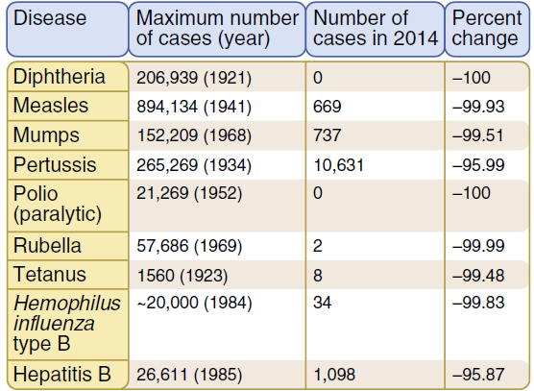

Immunity may be induced in an individual by infection or vaccination (active

immunity) or conferred on an individual by transfer of antibodies or lymphocytes from an actively immunized individual (passive immunity). So the Acquired immunity may be brought about two main ways.

**In active immunity**, (natural or artificial) an individual exposed to the antigens of a microbe mounts an active response to eradicate the infection and develops resistance to later infection by that microbe. Such an individual is said to be immune to that microbe, in contrast with a naive individual, not previously exposed to that microbe’s antigens.

**In passive immunity**, (natural or artificial) a naive individual receives antibodies or cells (e.g., lymphocytes, feasible only in animal experiments) from another individual already immune to an infection. The recipient acquires the ability to combat the infection for as long as the transferred antibodies or cells last. Passive immunity is therefore useful for rapidly conferring immunity even before the individual is able to mount an active response, but it does not induce long-lived resistance to the infection. The only physiologic example of passive immunity is seen in newborns, whose immune systems are not mature enough to respond to many pathogens but who are protected against infections by acquiring antibodies from their mothers through the placenta and breast milk. Clinically, passive immunity is limited to treatment of some immunodeficiency diseases with antibodies pooled from multiple donors, and for emergency treatment of some viral infections and snakebites using serum from immunized donors.

Active passive

|  |  |
| --- | --- |
| Natural exposure to Ag induced an immune response ; immunity following an attack of measles  Natural | Transfer of Abs or cells produced by others temporary immunity from Abs of the mother transferred to infant across the placenta or in milk |
| Deliberate exposure to Ag induced an immune response ; immunization children  Artificial | Abs in immune serum are introduced into the body ; injection of rabies immune globulin after a dog bite. |

**How do Vaccines Work in the Body?**

Disease-causing organisms have at least two distinct types of effects on the body. The first are the obvious effects manifested by symptoms such as fever, nausea, vomiting, diarrhea, rash and many others. The second, less obvious, effects are those underlying the immune system’s response to the infection. As the immune response increases in strength over time, the infectious agents are slowly reduced in number until symptoms disappear and recovery is complete. In general, vaccines are designed to imitate the second effect without the consequences of the first.

The following steps summarize how a preventive vaccine can protect an individual from infection or disease

1. The vaccine introduces a small component or a non-harmful form of the pathogen into the body. This is called the foreign antigen or immunogen.

• “Foreign” indicates that the antigen is not from the person’s own body.

• An antigen is defined as any substance that is recognized by a component of the immune system, i.e. antibodies, cells. Antigens are often agents such as invading bacteria or viruses.

• Similarly, immunogens are substances capable of provoking an immune response.

2. The body’s immune system produces an immune response to the pathogen by generating antibodies, killer cells, or both.

• In the first type of immune response (known as the humoral response), the body’s B-cells produce antibodies that neutralize and help eliminate antigens in the blood, on epithelial surfaces, and in the fluid that bathes tissues.

• In the second type of immune response (termed the cell-mediated response), specific killer cells called cytotoxic T-cells attack cells in the body that have become infected.

3. A small group of “memory” B-cells and T-cells remain in the body and can quickly initiate a strong immune response, i.e. by producing antibodies, and helping the production of killer T-cells or antibodies, respectively. The next time the real pathogen is encountered, the immune system remembers it and mounts a much larger, quicker response than it would have if the individual had never received the vaccine. This is called “immune memory”.

4. This larger, quicker immune response can act in several ways to fight infection and/or disease:

• by stopping replication of the pathogen, so it cannot infect more cells, or

• by producing antibodies that attach to the pathogen, rendering it harmless (humoral

response), or

• by producing immune cells that attack and kill other cells that have been infected with the pathogen (cell-mediated response).

Once a person's immune system is “trained” to resist a specific disease, the person is said to be immune to that disease. Specific immunity refers to a response that is initiated by an antigen (e.g. derived from a pathogen), and in which the immune system remembers each antigen it has previously encountered. Thus, unlike nonspecific defense mechanisms (such as the skin barrier or mucus production), which do not distinguish one infectious pathogen from another, specific immunity permits the body to recognize and defend against invading pathogens. Specific immunity can result from either active or passive immunization, and both modes of immunization can occur by natural or artificial processes.



**Immunization,** is the process by which an individual's immune system becomes fortified against an agent .

**Vaccination** immunization with antigens administered for the prevention of infection disease

**Types of vaccines according to the type of antigen;**

A live, virulent organism cannot be used as a vaccine because it would induce the very disease it is being used to prevent. Hence, the first step in making a vaccine is to isolate or create an organism (or component thereof) that is unable to cause full-blown disease, but that still retains the antigens responsible for inducing the host’s immune response.

1. **Live Attenuated vaccines**

Attenuated vaccines are based on organisms that are living but have had their virulence and ability to replicate reduced by treatment with heat, chemicals, or other techniques. Attenuated vaccines typically cause only subclinical or mild forms of the disease at worst, but they do carry the possibility that mutation might enable the organisms in the vaccine preparations to revert to wild type.

1. **Killed vaccines**

Killed vaccines include organisms that are dead because of treatment

with physical or chemical agents. In the case of toxins, they will have been inactivated (toxoids). They should be incapable of infection, replication, or function but still able to provoke immunity. It must be understood, however, that it might be difficult to guarantee that every organism in a preparation is dead .

**3-Subunit vaccines,**

like inactivated whole-cell vaccines do not contain live components of the pathogen. They differ from inactivated whole-cell vaccines, by containing only the antigenic parts of the pathogen,( microbial proteins and polysaccharides). These parts are necessary to elicit a protective immune response.

1. **conjugate vaccine**

is created by covalently attaching a poor antigen to a strong antigen thereby eliciting a stronger immunological response to the poor antigen. Most commonly, the poor antigen is a polysaccharide that is attached to strong protein antigen. However peptide/protein and protein/protein conjugates have also been developed.

1. **synthetic vaccine**

is a vaccine consisting mainly of synthetic peptides, carbohydrates, or antigens. They are usually considered to be safer than vaccines from bacterial cultures. Creating vaccines synthetically has the ability to increase the speed of production. This is especially important in the event of a pandemic.

1. **DNA vaccination**

is a technique for protecting against disease by injection with genetically engineered DNA so cells directly produce an antigen, producing a protective immunological response. DNA vaccines have potential advantages over conventional vaccines, including the ability to induce a wider range of immune response types.

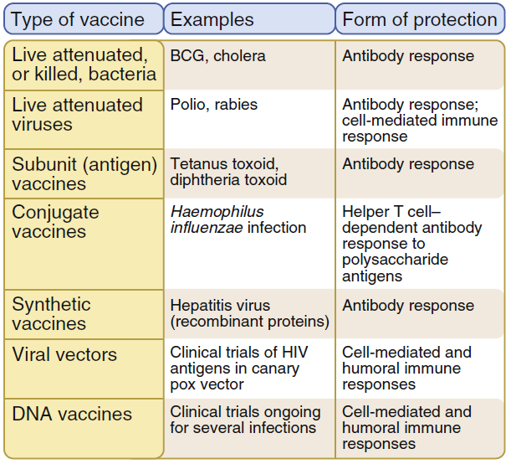

**Adjuvants**

Adjuvants are bacterial components or other substances, typically suspended in a medium such as oil that prolongs their dispersal into the tissues, administered together with vaccines to heighten the effectiveness of the vaccination . The bacterial (or other) material provokes a mild inflammation that attracts phagocytes and accelerates their activation and antigen presentation to T cells for development of specific adaptive immune responses. Some vaccine components themselves can serve as adjuvants. The pertussis component (from Bordetella pertussis) in DTP (Diphtheria-Tetanus-Pertussis) vaccine is also an effective adjuvant. Other adjuvants include alum and BCG (Bacillus Calmette-G uerin). BCG includes material derived from Mycobacterium and is in wide use around the world as a vaccine against tuberculosis, particularly in areas of high incidence. Its use has declined in some

areas where the incidence of tuberculosis has significantly declined. In the United States (and several other countries) , BCG is not used routinely for human vaccinations because it interferes with the use of skin testing (creating false positives) in tuberculosis studies and because of adverse reactions (e. g . , disseminated BCG infection) . However, BCG is still used in the United States for certain high-risk individuals or populations.

**Which are the main effectors of vaccine responses?**

The nature of the vaccine exerts a direct influence on the type of immune effectors that are predominantly elicited and mediate protective efficacy. Capsular polysaccharides (PS) elicit B cell responses in what is classically reported as a T-independent manner although increasing evidence supports a role for CD4 T cells in such responses. The conjugation of bacterial PS to a protein carrier (e.g., glycoconjugate vaccines) provides foreign peptide antigens that are presented to the immune system and thus recruits antigen-specific CD4 Th cells in what is referred to as T-dependent antibody responses A hallmark of T-dependent responses, which are also elicited by toxoid, protein, inactivated or live attenuated viral vaccines , is to induce both higher-affinity antibodies and immune memory. In addition, live attenuated vaccines usually generate CD8 cytotoxic T cells. The use of live vaccines/vectors or of specific novel delivery systems (e.g. DNA vaccines) appears necessary for the induction of strong CD8 T cell responses.

Most current vaccines mediate their protective efficacy through the induction of vaccine-specific antibodies, whereas BCG-induced T cells produce cytokines that contribute to macrophage activation and control of M. tuberculosis. The induction of antigen-specific immune effectors (and/or of immune memory cells) by an immunization process does not imply that these antibodies, cells or cytokines represent surrogates—or even correlates—of vaccine efficacy. This requires the formal demonstration that vaccine-mediated protection is dependent—in a vaccinated individual—upon the presence of a given marker such as an antibody titer or a number of antigen-specific cells above a given threshold. Antigen-specific antibodies have been formally demonstrated as conferring vaccine-induced protection against many diseases Passive protection may result from the physiological transfer of maternal antibodies (e.g., tetanus) or the passive administration of immunoglobulins or vaccine-induced hyper immune serum (e.g., measles, hepatitis, varicella, etc.). Such antibodies may neutralize toxins in the periphery, at their site of production in an infected wound (tetanus) or throat (diphtheria). They may reduce binding or adhesion to susceptible cells/receptors and thus prevent viral replication (e.g., polio) or bacterial colonization (glycoconjugate vaccines against encapsulated bacteria) if present at sufficiently high titers on mucosal surfaces. The neutralization of pathogens at mucosal surfaces is mainly achieved by the transudation of vaccine-induced serum IgG antibodies. It requires serum IgG antibody concentrations to be of sufficient affinity and abundance to result in ‘protective’ antibody titers in saliva or mucosal secretions. As a rule, such responses are not elicited by PS bacterial vaccines but achieved by glycoconjugate vaccines, which therefore prevent nasopharyngeal colonization in addition to invasive diseases.

