Lec.6 Biotechnology Dr. Sahira Nsayef
Separation of bioproducts (Downstream)
The extraction and purification of a biological product from the fermentation broth is called as downstream processing (DSP) or product recovery. DSP is quite complex and variable depending upon the type of the product. Broadly it can be divided into five stages:
1) Cell harvesting
2) Lyses/breakage of cells
3) Concentration
4) Purification
5) Formulation
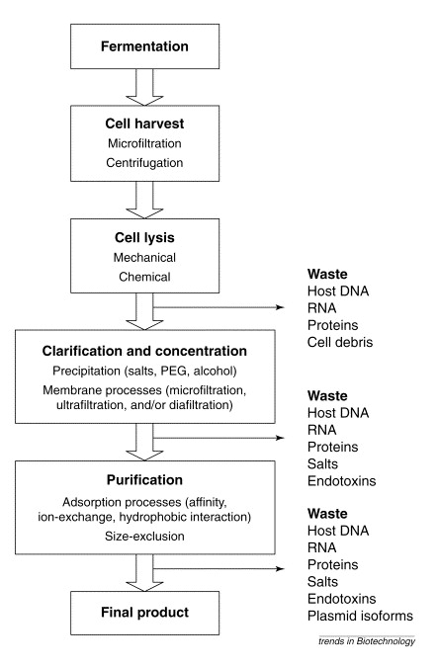

1- Cell harvesting
Once the fermentation is complete, the solid phase (i.e. cell bio-mass) is separated from the liquid phase by any of the following methods:Settling,Flotation, Flocculation, Filtration and Centrifugation.

Settling: it depends on size and weight; it descends cells down by gravity and uses in alcohol industry and waste treatment.

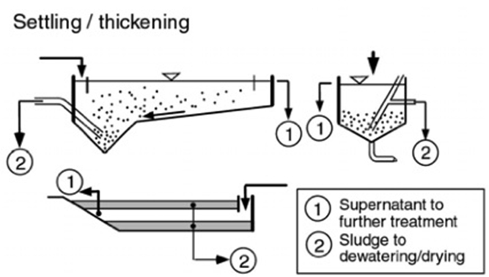

Different types of settling tanks

Flotation: A gas is passed through the fermentation broth. This gas forms tiny bubbles to which cells get adsorbed. These bubbles rise to the surface of the broth and form foam. Sometimes along with the gas, collector substances (fatty acids) are added which facilitates foam fermentation. The foam containing the cells is removed.

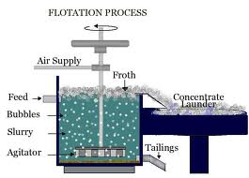
Flocculation: At high cell density some cells (yeast cells) aggregate and thus settle down at the bottom of the fermentors. This process can be accelerated by the addition of flocculating agent like salts, organic polyelectrolyte and mineral hydrocolloid.

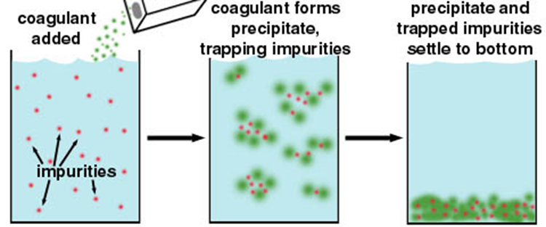

Conceptual illustration of the flocculation process
Filtration: used to separate suspended solids parts from liquids through membranes as a result of pressure difference and concentration, and is widely used to separate molds and filamentous bacteria from the fermentation medium and also to separate the yeasts.

Centrifugation: Centrifuge used to separate bacteria, and can be used efficiently in the case of significant differences in density between the solid particles and liquid portion.
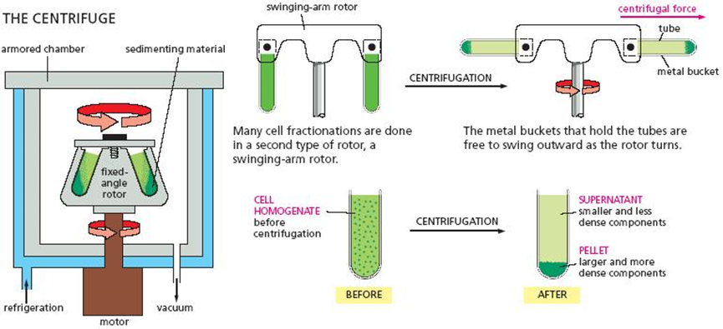

Centrifugation process

2-Lyses/breakage of cells
If the desired product is located inside the cell, the cells are first recovered from the fermentor by any of the cell harvestingmethods.

Methods that usedto breakthe cellsare:
- Physical methods:
- Ultrasonication: The cells are disrupted by passing ultra-waves through samples. This technique is ideal in laboratory where sample size is small.
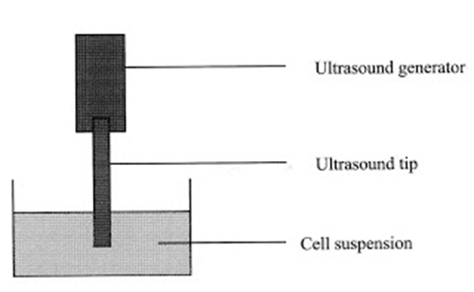
Cell disruption by sonication
- Osmotic shock: The cells are suspended in a viscous solution like 20% (w/v) sucrose or glucose. The cell suspension is then transferred to the cold water (4°C) which results in cell lyses.
- Heat shock (Thermolysis): The cells are exposed to heat which results in disintegration of the cells. It is an economical method but the product has to be heat stable.
- Freeze-Thaw method: It is commonly used to lyse bacterial and mammalian cells. The technique involves freezing a cell suspension in a dry ice/ethanol bath or freezer and then thawing the material at room temperature or 37C. This method of lysis causes cells to swell and ultimately break as ice crystals form during the freezing process and then contract during thawing.
- High pressure homogenization: The cell suspension is forced to pass through a narrow pore at a high pressure which results in breakage of cells.

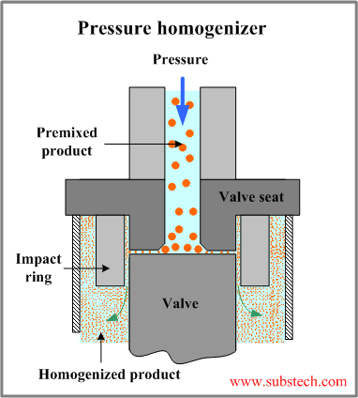

6. Grinding with glass beads: The cell suspension containing glass beads is subjected to a very high speed in a vessel. The cells break as they are forced against the walls of the vessel by the beads.
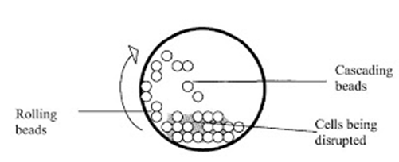

Cell disruption by Bead Milling

- Chemical methods:
1- Detergents: disrupt the structure of cell membranes by solubilizing their phospholipids disrupting lipid:lipid, lipid:protein and protein:protein interactions. These chemicals are mainly used to rupture mammalian cells. For disrupting bacterial cells, detergents have to be used in conjunction with lysozyme. With fungal cells (i.e. yeast and mould) the cell walls have to be similarly weakened before detergents can act.
2- Organic solvents: mainly act on the cell membrane by solubilizing its phospholipids and by denaturing its proteins. Some solvents like toluene are known to disrupt fungal cell walls. Others are ether, phenylethly alcohol, DMSO, benzene, Methanol, chloroform etc.
3- Acid/Alkali treatment: It is the easiest and least expensive method available in general lab. The method is fast, reliable and relatively clean way to isolates DNA from cells. It can be used for both laboratory and industrial scale.
4- Enzymatic lysis: The cells are broken with the help of enzymes. Bacterial cells are lysed by the addition of lysozyme. This enzyme hydrolyses β-1,4glycosidic linkage of peptidoglycan layer of bacterial cell wall. Fungal cells are lysed by the addition of chitnases, cellulases and mannases.

3- Concentration
More than 90% of the cell free supernatant is water and the amount of desired product is very less. Methods of concentration are:
a- Evaporation process: concentrates the requisite product. Water is evaporated by applying heat to the supernatant with/without vacuum. The amount of heat applied is decided by the heat stability of the product.
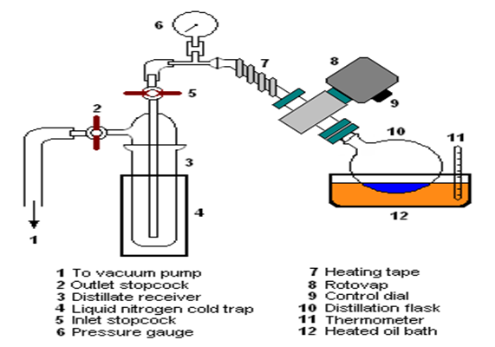
Rotary evaporation laboratory setup
b- Liquid-liquid extraction: A desired product (solute) can be concentrated by the transfer of the solute from one liquid to another liquid. This process also results in partial purification of the product. Liquid-liquid extraction is basically of two types:
1- Extraction of low molecular weight products: This is primarily applied for extraction of lipid soluble compounds.
2- Extraction of high molecular weight: This technique is applied to compounds like proteins, which get inactivated in the presence of organic solvents like ethanol, methanol, chloroform, hexane etc. The solubility of the desired product is dependent on various properties of the protein e.g. ionic character, hydrophobicity, size etc.
c- Membrane filtration: This technique involves the use of semi-permeable membrane. Many kinds of membranes are available based on the size of the pores and their chemical nature (polyether sulfone or polyvinyl difluoride). Unfortunately, these filters cannot be sterilized. Now membranes made up of ceramics and steel are being introduced which can be easily autoclaved.
d- Membrane adsorber: The membrane contains charged groups or ligands to which a desired product can combine specifically once the aqueous solvent, containing the product, is passed through this. The adsorbed material is then eluted using various buffers and salts.
e- Precipitation: This is the most commonly used procedure for concentration of compounds especially proteins and polysaccharides. The agents commonly used in the process of precipitation are neutral salts (ammonium sulphate), organic solvents (ethanol, acetone, propanol), non-ionic polymers (PEG) and ionic polymers (polyacrylic acid, polyethylene amine).
4- Purification by:
a- Chromatography: It is a procedure for separating molecules based on their sizes, charge, hydrophobicity and specific binding to ligands. The chromatography techniques used are as follows:
1- Gel Filtration chromatography (size exclusive chromatography): The matrix is made up of tiny beads having many pores in them. Many types of beads are available having different porosity. Small molecules enter the beads whereas large molecules cannot enter and therefore come out of the column first. By this technique protein of variable sizes can be purified.

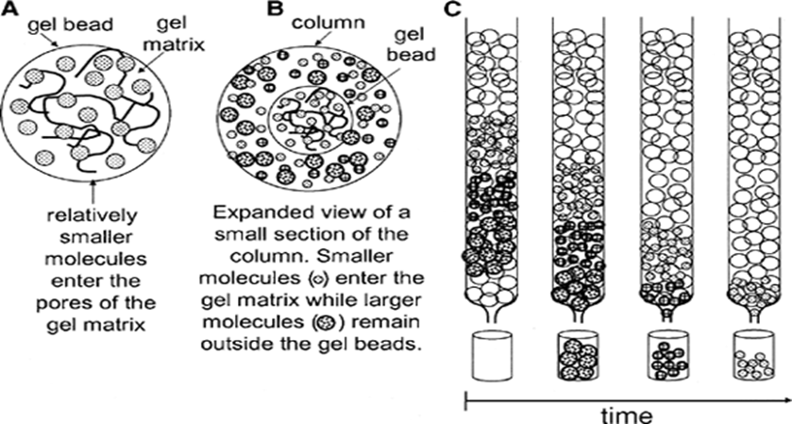
2- Ion exchange chromatography: Most of the proteins have a net positive or negative charge. This property of the proteins is exploited for the purification of proteins by passing protein solutions through columns of charged resins. Two types of resins are used in the industry:
- Cation exchangers (carboximethyl cellulose) have negative charged groups.
- Anion exchangers (diethyl aminoethyl) have positive charged groups.
Proteins carrying net positive charge bind to cation exchangers whereas proteins carrying net negative charge bind to anion exchangers.
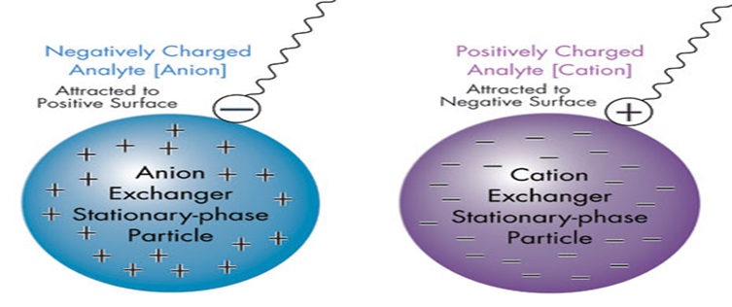

Ion Exchange Chromatography Principle

3- Affinity chromatography: the proteins are separated based on their affinity for a product compound i.e. ligand (Table 23). Once the protein is bound to the affinity matrix, it is eluted by changing the pH of the eluting buffer or alteration of ionic strength etc.

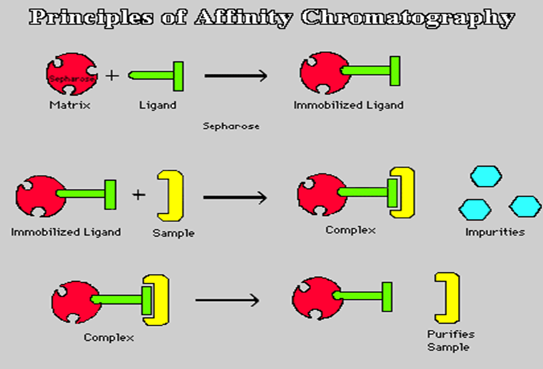
b- Crystallization: It uses mainly for purification of low molecular weight products, such as antibiotics and organic acids.
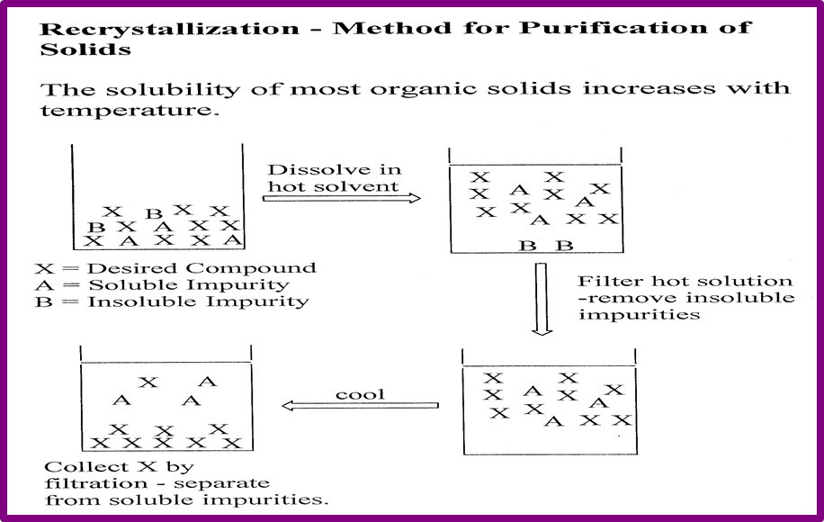
Crystallization process
5- Formulation
It is a common practice to formulate products as dry powders to achieve sufficient stability for the desired shelf life of it. The principle objective for any drying process is the removal of water, which is achieved either by sublimation or by evaporative drying at high temperatures and/or at low vacuum pressures.
Technologies of formulation include: lyophilization, spray-drying, spray-freeze drying, bulk crystallization, supercritical fluid technology, and vacuum drying. All these processes have several limitations.

