Several genes are critical to immune function. These include genes encoding various enzymes and structural molecules needed for the activation and function of B and T cells. The encoded molecules fall into three groups or classes known as MHC (or H LA) class I, II, and III molecules. MHC class III molecules include complement components C4, Bf, and C2. MHC class I and II molecules serve entirely different functions. The products of histocompatibil ity genes are codominantly expressed. Codominance means that they are expressed whether present as a single copy (heterozygous or hemizygous) or two copies (homozygous).
Major histocompatibility complex (MHC) is the cluster of gene arranged within a long continuous stretch of DNA on chromosome number 6 in Human which encodes MHC molecules.
In Human, MHC is known as Human Leucocyte antigen (HLA) complex and the genes of MHC are recognized in three classes, consequently, there are three types of MHC molecules (Class I MHC, Class II MHC, Class III MHC).
Two separate properties of the MHC make it difficult for pathogens to evade immune responses in this way. First, the MHC is polygenic: it contains several different MHC class I and MHC class II genes, so that every individual possesses a set of MHC molecules with different ranges of peptide-binding specificities. Second, the MHC is highly polymorphic. The MHC genes display the greatest degree of polymorphism in the human genome. There are multiple variants of each gene within the population as a whole.

MHC class | MHC I |  |  | MHC II |  |  | MHC III
Region | A | B | C | DP | DQ | DR | C4, C2, BF
Gene products | HLA-A | HLA-B | HLA-C | DP, αβ | DQ, αβ | DR, αβ | C’ Protein | TNF-α  TNF-β
The MHC is located on chromosome 6 in humans, extends over some 4 centimorgans of DNA, about 4-7 × 106 base pairs. In humans, it contains more than 200 genes. The genes encoding the α chains of MHC class I molecules and the α and β chains of MHC class II molecules are linked within the complex; the genes for β2-microglobulin and the invariant chain are on different chromosomes (chromosomes 15 and 5, respectively, in humans).
The principal function of the MHC is to present antigen to T cells to discriminate between self (our cells and tissues) and nonself (the invaders or modified self).
All the MHC class I and class II molecules can present peptides to T cells, but each protein binds a different range of peptides. Thus, the presence of several different genes of each MHC class means that any one individual is equipped to present a much broader range of peptides than if only one MHC molecule of each class were expressed at the cell surface.
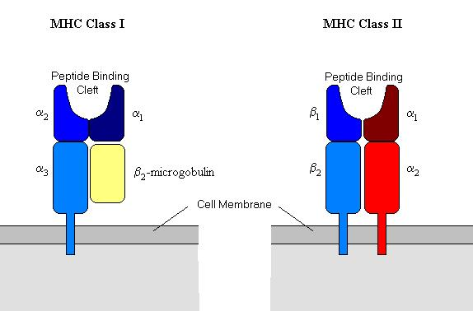
MHC I
MHC-I molecule contains a 45KDa α-chain associated non-covalently with a 12KDa β2 microglobulin molecule, a single non-polymorphic molecule
The α-chain is a transmembrane glycoprotein encoded by a polymorphic gene within A, B and C region of Human HLA complex.
The α-chain is anchored in the plasma membrane by its hydrophobic transmembrane segment and a hydrophilic cytoplasmic tail, α-chain is made up of 3 domains (α1,α2, and α3), each domain-containing approximately 90 amino acids, a transmembrane domain of about 25 hydrophobic amino acids followed by a short stretch of charged (hydrophilic) aminoacids of cytoplasmic tails of 30 amino acids.
α1 and α2 domains interact to form a deep groove on the top which is a peptide-binding clift. It can bind antigen of 8-10 amino acids long, peptides, which share a particular sequence of amino acids with similar spacing and charge, will bind to the same Class I molecule. The groove is lined by pockets, which vary in size, this specific pockets bind particular amino acids (anchor residues) and mediate binding of the peptide via hydrogen bonds and van der Waals forces.
The majority of the differences which distinguish the Class I antigens from each other, result from amino acid differences in the a1 and a2 domains, and this differences known as polymorphism. Most of the polymorphism of Class I molecules is found within the antigenbinding cleft. These differences affect the ability of a particular MHC Class I molecule to bind a specific processed antigen and restrict the range of antigens presented. HLA-A alleles differ from each other by 20 to 30 amino acids.
α3 and β2 are organized into β-pleated sheets, each formed by antiparallel β-strand of amino acids, this structure is known as immunoglobulin fold. Because of this structure α-chain and β2 microglobulin are classified as a member of the immunoglobulin superfamily receptor.
β2 microglobulin is similar in size and organization to α3 domain.
Β2 microglobulin does not contain transmembrane region , and this molecule plays a vital role in transporting newly synthesized MHC proteins to the cell surface.
The folding of the a1 and a2 domains creates a long cleft or groove that is the site at which peptide antigens bind to the MHC-I molecule and are presented to the CD8 lymphocyte.
Antigen receptors on white blood cells will recognise a particular viral peptide only in the context of a particular Class I molecule. This phenomenon is termed HLA-restriction.
MHC II
MHC-II molecules are heterodimeric membrane-bound glycoprotein that contains external domains, a transmembrane segment, and a cytoplasmic tail,
Structurally, the class II molecules are similar to class I molecules and are expressed as heterodimers on the cell surface with one heavy α- chain (molecular weight 34 kDa) and one β-chain (molecular weight 29 kDa), are made up of two domains (α1 and α2) and (β1 and β2) respectively. The folding of the α1 and β1 domains creates a groove into which peptides can bind. The groove is open at both ends which allowing longer peptides to bind. Peptides bound by HLA class II molecules are typically longer than peptide bound by HLA class I molecules, the cleft can bind antigenic peptide of 13-18 amino acids long.
The vast majority of the polymorphism of the HLA class II gene codes for amino acids that line this peptide binding groove, mainly in the β chain but also in the α chain.
The main function of HLA class II molecules is to present extracellular derived peptide to the T cell receptor of CD4+ helper T cells thereby eliciting an immune response.
The MHC class II region on the short arm of chromosome 6 (6p21.3). MHC class II region extends over 1000–1200 kb with at least six sub regions, termed DR, DQ, DP, DO, DN and DM. The DR region contains multiple, highly polymorphic β genes and only one invariant a gene. The conventional serologically defined DR molecules (DR1–DR18) are coded for by the DRB1 gene, whereas the DR52 and DR53 specificities are encoded by the DRB3 and DRB4 genes respectively. DRB2, DRB6, DRB7, DRB8 and DRB9 are pseudogenes without a first domain exon. The DQ subregion contains five genes, DQA1, DQA2, DQB1, DQB2 and DQB3, of which DQA2, DQB2 and DQB3 are not known to be expressed. In contrast, both DQA1 and DQB1 are functional and polymorphic, expressing four different types ofDQmolecules by different ‘cis’ and ‘trans’ combinatorial events. The DP subregion contains two α and two β genes, withDPA2andDPB2being pseudogenes. DPB1 shows extensive polymorphism, while DPA1 displays limited polymorphism. DO, DM and DN lie between the DQ and DP loci, and have very limited polymorphism,

Thymus epithelial cells have to express both MHC I and II to allow selection of useful developing T cells in the thymus
Selection of useful t cells
Progenitors of mature T cells in the thymus are called thymocytes. Arriving from the bone marrow, progenitor cells rearrange their T cell receptors (TCR) and proceed to mature in an interaction process with thymic epithelial cells that is thought to involve two aspects: positive and negative selection.
Positive selection: The random rearrangement generator produces a large number of thymocytes, each of which with a unique TCR. Generally, a T cell is only useful if its TCR can be activated by our own MHC (the peptide for now remaining out of consideration). If random generation causes an interface unable to interact with one of our MHC molecules, the cell is a priori useless. How to get rid of it? The solution is straightforward: successful docking of the TCR to one of the MHC molecules on thymic epithelial cells delivers a survival signal to the nascent T cell, "positively selecting" it. Thymocytes with TCR that do not fit any of the MHC molecules fail to get this survival signal and after a short time die (non-selection; death by neglect). Positive selection therefore results in self-MHC-restriction: all thymocytes surviving this step are able to recognize at least one of our own MHC molecules.
Negative selection: Among all the thymocytes that are positively selected for recognizing our own MHC to a greater or lesser extent, some are bound to recognize some combination of MHC-molecule and presented self-peptide just perfectly. These are objectionable, as they are auto-reactive and dangerous. The solution: very strong and continuous binding results in a qualitatively different signal, inducing the thymocyte to undergo apoptosis. Autoreactive T cell clones are therefore eliminated by negative selection.
The goal of this entire process is to select T cells that are able to work with our own MHC, and have the potential to come to full speed with some yet-to-define pathogen-derived peptide, but cannot be activated by self-peptides.

Feature | MHC-I | MHC-II
Polypeptide chains | A single a chain (44–47 kD) noncova-lently linked to the b2-microglobulin chain (12 kD) | A single a chain (32–34 kD) non-covalently linked to a single b chain (29–32 kD)
Distribution | All nucleated cells | Antigen-presenting cells
Composition of antigen-binding clefts | a1 and a2 domains | a1 and b1 domains
Binding site for T cell co-receptor | CD8 binds to the a3 region | CD4 binds to the b2 region
Size of peptide-binding cleft | Accommodates peptides of 8–11 residues | Accommodates peptides of 10–30 residues or more
Nomenclature in the human | HLA-A, HLA-B, HLA-C | HLA-DR, HLA-DQ, HLA-DP

Cell-mediated response molecules
When disease associated proteins occur in a cell they are broken into pieces by the cells proteolytic machinery. Cell proteins become attached to antigen fragments and transport them to the surface of the cell, where they are "presented" to the body’s defense mechanisms, And without this presentation, other aspects of the immune response cannot occur. That mean, MHC molecules directing the adaptive immune system. And Major Histocompatibility Complex (MHC) proteins allow T cells to distinguish between self from non-self.
There are two major classes of MHC molecules are similar in function: they transport peptides to the cell surface to be recognized by immune cells, the difference between 2 classes, peptides originate from different sources – endogenous, or intracellular, for MHC class I; and exogenous, or extracellular for MHC class II, (Endogenous antigens can also be presented by MHC class II when they are degraded through autophagy).
MHC I glycoproteins are present on all of the nucleated cells in the body and platelets (they are not present on red blood cells), present antigens on the cell surface to cytotoxic T lymphocytes (CTLs). Most CTLs possess both T-cell receptors (TCR) and CD8 molecules on their surfaces.
In the event of a viral infection, peptides from viral proteins and malignant transformation, proteins (may be expressed that normally are only expressed in early fetal development and thus unknown to the immune system), in both cases, CD8+ T cells recognize that something is wrong and kill the suspicious cells. This surveillance mechanism makes sense in all cells, and MHC I is expressed by all nucleated cells, although at different levels depending on cell type. How are peptides loaded onto MHC I? By its leader peptide, MHC I is synthesized directly into the endoplasmic reticulum. There, it is backed up by supporting proteins and coupled to a peptide transporter, TAP (transporter associated with antigen processing). In normal protein turnover, cellular proteins are subject to proteasome degradation, resulting in cytoplasmic peptides. Some of these are transported by TAP into the endoplasmic reticulum and, if they fit, insert into the binding cleft of a waiting MHC I-protein. The insertion process releases MHC I from its supportive frame, and the peptide-loaded MHC I is transported by vesicle to the cell membrane.
There are exceptions to the rule that MHC I present material synthesized within the cell.
All important parts of MHC-I molecules are formed by a single protein chain encoded by a single gene in the MHC locus. These include a transmembrane domain and all of the peptide binding cleft. To complete the molecule, the small extracellular β2-microglobulin is added, which is encoded outside of the MHC. Humans express three types of MHC-I molecules: HLA-A, HLA-B and HLA-C. While the term MHC can be used for all species, HLA (human leukocyte antigens) is used only for human MHC-molecules.
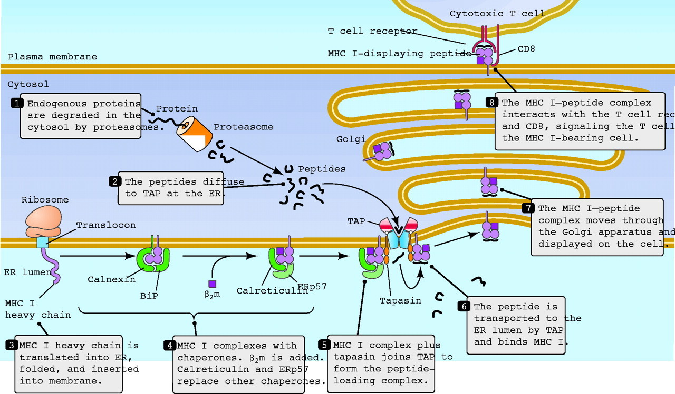
The MHC Class II proteins (found only on B lymphocytes, macrophages, and other cells that present antigens to T cells), which primarily present peptides which have been digested from external sources, are needed for T-cell communication with B-cells and macrophages.
MHC II presents extracellular material taken up by antigen-presenting cells (APC). This is intended to activate CD4+ T cells, mainly helper cells. MHC II is therefore expressed by a small minority of cells, mainly "professional" APC: dendritic cells, macrophages and B cells. In addition, some cells "aberrantly" express MHC II when stimulated by specific cytokines (especially interferon-γ). Thymus epithelial cells have to express both MHC I and II to allow selection of useful developing T cells in the thymus. MHC-II molecules are synthesized into the endoplasmic reticulum. Their peptide binding cleft is blocked by a separate protein chain, the invariant chain, to prevent endogenous peptides from being inserted. Vesicles containing MHC-II fuse with endosomes/phagolysosomes containing pathogens or other extracellular material. Concomitant acidification leads to breakdown of the invariant chain with exception of a small part, the CLIP peptide, still blocking the cleft. This is removed with the help of a specialized molecule, HLA-DM, allowing a peptide of extracellular origin to take its place. This MHC-extracellular peptide combination is then transported to the surface.
MHC-II molecules, while very similar in overall shape, consist of two equivalent protein chains, α and β, that are encoded by two separate genes in the MHC. Each chain has a transmembrane domain and contributes half of the peptide binding cleft. Again, there are three types: HLA-DR, HLA-DQ and HLA-DP. Having more than one type of MHC-I and –II molecules is probably advantageous as it allows accommodating more different antigenic peptides.
Transplantation
- orthotopic grafts transplanted tissues or organs that are placed in their normal anatomic location.
- heterotopic grafts that are placed into a site other than their normal location.

Classification of grafts
- Autografts are those transferred from one part of an individual to another location on that same individual.
- Syngeneic grafts are those transferred between different individuals who are genetically identical or nearly so (e.g. , identical twins or members of an inbred strain) .
- Allogeneic grafts (or allografts) are transferred between two genetically disparate individuals of the same species (e.g . , brother and sister, parent and child, or totally un related individuals) .
- xenogeneic grafts (or xenografts) are those exchanged between members of different species (e.g . , the placement of primate hearts into human recipients).

