**Lec7: Precipitation methods(1)**

|  |
| --- |
|  |

The precipitation step is widely used in [downstream processing](https://en.wikipedia.org/wiki/Downstream_processing) of biological products in order to concentrate proteins and [purify](https://en.wikipedia.org/wiki/Protein_purification) them from various contaminants. The underlying mechanism of precipitation is to alter the [solvation potential](https://en.wikipedia.org/w/index.php?title=Solvation_potential&action=edit&redlink=1) of the solvent, more specifically, by lowering the [solubility](https://en.wikipedia.org/wiki/Solubility) of the solute by addition of a reagent.

**1. Isoelectric precipitation**

Acids and bases to change the pH of a solution until the isoelectric point of the compound is reached and pH equals pI, when there is then no overall charge on the molecule and its solubility is decreased.

**2. Salting out** **precipitation**

Salts such as ammonium and sodium sulfate are used for the recovery and fractionation of proteins. The salt removes water from the surface of the protein revealing hydrophobic patches, which come together causing the protein to precipitate. The most hydrophobic proteins will precipitate first, thus allowing fractionation to take place. This technique is also termed “salting out.”

1- At low concentrations of salt → the solubility increases. This could be explained by the following:

• Salt molecules stabilize protein molecules by decreasing the electrostatic energy between the protein molecules which increase the solubility of proteins.

2- High concentration of salts → the solubility decreases, and protein precipitates. This could be explained by the following:

• because the excess ions (not bound to the protein) compete with proteins for the solvent.  The decrease in solvation allows the proteins to aggregate and precipitate.

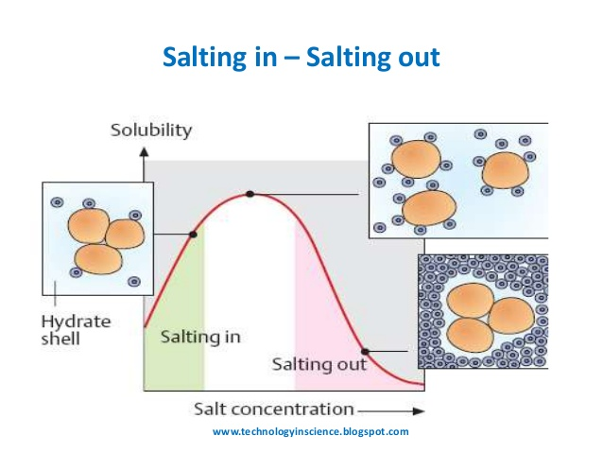

Ammonium sulfate (NH4)2SO4 is commonly used because it is highly soluble and very effective. NaCl or KCl may be also be used to “salt out” proteins. Precipitate from solution as ionic strength is increased.

Ionic Strength = ½ S MiZi2

* Mi = Molarity of ion
* Zi = Charge of ion
* 1M NaCl = ½ S (1 X 12) + (1 X 12)= 1
* 1M CaCl2 = ½ S (1 X 22) + (2 X 12) = 3
* 1M (NH4)2SO4 = ½ S (2 X 12) + (1 X 22) = 3

**Lec8: Precipitation methods(2)**

**3. Organic solvents precipitation**

Addition of [miscible](https://en.wikipedia.org/wiki/Miscible) solvents such as [ethanol](https://en.wikipedia.org/wiki/Ethanol) or [methanol](https://en.wikipedia.org/wiki/Methanol) to a solution may cause proteins in the solution to precipitate. The solvation layer around the protein will decrease as the organic solvent progressively displaces water from the protein surface and binds it in hydration layers around the organic solvent molecules.The principal causes of aggregation are likely to be electrostatic and dipolar van der Waals forces.



**4. Nonionic polymers precipitation**

Nonionic polymerssuch as polyethylene glycol (PEG) and [dextrans](https://en.wikipedia.org/wiki/Dextrans) can be used in the precipitation of proteins and are similar in behavior to organic solvents.

**5. Polyelectrolyte's precipitation**

It can be used in the precipitation of a range of compounds. [Alginate](https://en.wikipedia.org/wiki/Alginate), carboxymethyl cellulose, polyacrylic acid, [tannic acid](https://en.wikipedia.org/wiki/Tannic_acid) and polyphosphates can form extended networks between protein molecules in solution.

• Polyanions and polycations interact with proteins below or above the isoelectric points.

• These interactions may result in soluble complexes or formation of amorphous precipitates.

• Protein precipitation by polyelectrolytes may lead to closely packed aggregates that are conveniently separated by settling or can generate open textured aggregates that can be separated by filtration.

• The precipitated proteins are recovered from the insoluble protein-polyelectrolyte complex aggregates by redissolution achieved by pH or ionic strength adjustment.

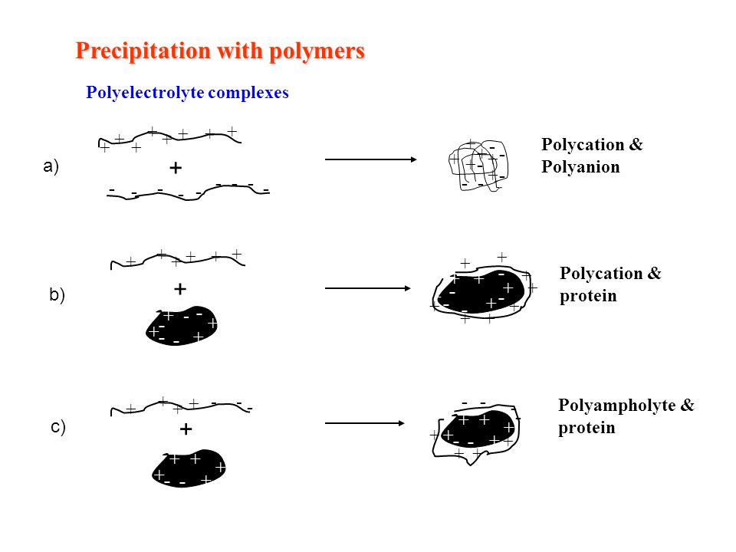

**6-** **Protein binding dyes** (triazine dyes) bind to and precipitate certain classes of protein.

**7**- **Affinity precipitants** are an area of much current interest in that they are able to bind to, and precipitate, compounds selectively

**8- Thermal precipitation**

Heat treatment as a selective precipitation and purification step for various thermostable products and in the deactivation of cell proteases. In this method, cell extracts are heated to a temperature at which many proteins denature and precipitate, where the protein of interest is more stable and stays soluble.

**9- Heavy metals salts precipitation**

Heavy metal salts usually contain Hg+2, Pb+2, Ag+1, Cd+2 and other metals with high atomic weights. Since salts are ionic they disrupt salt bridges in proteins. The reaction of a heavy metal salt with a protein usually leads to an insoluble metal protein salt.