Introduction
The metabolism can be defined as the sum of all the biochemical reactions carried out by an organism. Metabolites are the intermediates and products of metabolism and are usually restricted to small molecules. The term “secondary” introduced by A. Kossel in 1891 implies that while primary metabolites are present in every living cell capable of dividing, the secondary metabolites are present only incidentally and are not of paramount significance for organism’s life. Though secondary metabolites are derived from primary metabolism, they do not make up basic molecular skeleton of the organism. Its absence does not immediately curtail the life of an organism, a feature contrary to primary metabolite. Its presence and synthesis are observed in ecologically disadvantaged species within a phylogenetic group
The difference between primary and secondary metabolite is ambiguous since many of the intermediates in primary metabolism is overlapping with the intermediates of secondary metabolites . Amino acids though considered a product of primary metabolite are definitely secondary metabolite too. Contrary to the observation that sterols are secondary metabolites that are indispensable part of many structural framework of a cell. The mosaic nature of an intermediate indicates common biochemical pathway being shared by primary and secondary metabolism. The secondary metabolites serve as a buffering zone into which excess C and N can be shunted into to form inactive part of primary metabolism. The stored C and N can revert back to primary metabolite by the metabolic disintegration of secondary metabolite when on demand.There is dynamism and a delicate balance between the activities of the primary and secondary metabolism (Figure 1) being influenced by growth, tissue differentiation and development of the cell or body, and also external pressures.

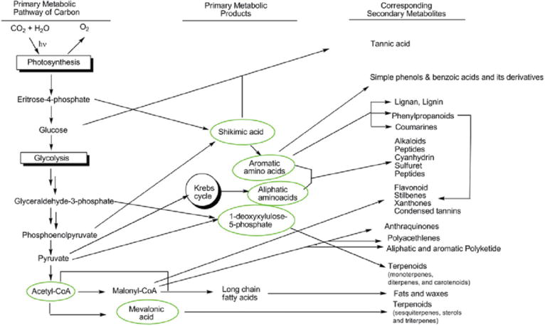
Schematic diagram representing integration of primary and secondary metabolism.
The multitude of secondary metabolite secretions is harvested by human kind to improve their health (antibiotics, enzyme inhibitors, immunomodulators, antitumor agents, and growth promoters of animals and plants), widen the pyramid of healthy nutrition (pigments and nutraceuticals), enhancing agricultural productivity (pesticides, insecticides, effectors of ecological competition and symbiosis and pheromones), and hence impacting economics our society in a certain positive way.
- Classification of secondary metabolites
Over 2,140,000 secondary metabolites are known and are commonly classified according to their vast diversity in structure, function, and biosynthesis.
- There are five main classes of secondary metabolites: such as terpenoids and steroids, fatty acid-derived substances and polyketides, alkaloids, nonribosomal polypeptides, and enzyme cofactors
1.Terpenoids and steroids
They are major group of substances derived biosynthetically from isopentenyl diphosphate. Currently, over 35,000 known terpenoid and steroid compounds are identified. Terpenoids have different variety of unrelated structures, while steroids have a common tetracyclic carbon skeleton and are modified terpenoids that are biosynthesized from the triterpene lanosterol.
2. Alkaloids
There are over 12,000 known compounds of alkaloids, and their basic structures consist of basic amine group and are derived biosynthetically from amino acids.
3. Fatty acid-derived substances and polyketides
Around 10,000 compounds are identified and are biosynthesized from simple acyl precursors such as propionyl CoA, acetyl CoA, and methylmalonyl CoA.
4. Nonribosomal polypeptides
These amino acids derived compounds are biologically synthesized by a multifunctional enzyme complex without direct RNA transcription.
5. Enzyme cofactors
Enzyme cofactors are nonprotein, low-molecular enzyme component
2. Functions of secondary metabolites
The major functions of the secondary metabolites including antibiotics are:
1. competitive weapons against other livings such as animals, plants, insects, and microorganisms
2. metal transporting agents
3. agents for symbiotic relation with other organisms
4. reproductive agent
5. differentiation effectors
6. agents of communication between organisms
The other functions include interference in spore formation (not obligatory) and germination. Predominantly, the secondary metabolites are used for variety of biological activities like antimicrobial and antiparasitic agents, enzyme inhibitors.

