The lecture two

WATER CYCLE

The water cycle, also known as the hydrological cycle, describes the continuous movement of water on, above and below the surface of the Earth. The mass of water on Earth remains fairly constant over time but the partitioning of the water into the major reservoirs of ice, fresh water, saline water and atmospheric water is variable depending on a wide range of climatic variables. The water moves from one reservoir to another, such as from river to ocean, or from the ocean to the atmosphere, by the physical processes of evaporation, condensation, precipitation, infiltration, surface runoff, and subsurface flow. In doing so, the water goes through different phases: liquid, solid (ice) and vapor.

The water cycle involves the exchange of energy, which leads to temperature changes. For instance, when water evaporates, it takes up energy from its surroundings and cools the environment. When it condenses, it releases energy and warms the environment. These heat exchanges influence climate.

The evaporative phase of the cycle purifies water which then replenishes the land with freshwater. The flow of liquid water and ice transports minerals across the globe. It is also involved in reshaping the geological features of the Earth, through processes including erosion and sedimentation. The water cycle is also essential for the maintenance of most life and ecosystems on the planet.
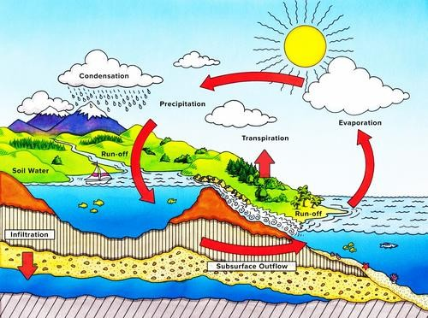

Figure 1. Water cycle

Nature of water cycle

The sun, which drives the water cycle, heats water in oceans and seas. Water evaporates as water vapor into the air. Ice and snow can sublimate directly into water vapor. Evapotranspiration is water transpired from plants and evaporated from the soil. The water vapor molecule H2O has less density compared to the major components of the atmosphere, nitrogen and oxygen, N2 and O2. Due to the signiﬁcant diﬀerence in molecular mass, water vapor in gas form gains height in open air as a result of buoyancy. However, as altitude increases, air pressure decreases and the temperature drops. The lowered temperature causes water vapor to condense into a tiny liquid water droplet which is heavier than the air, such that it falls unless supported by an updraft. A huge concentration of these droplets over a large space up in the atmosphere become visible as cloud. Fog is formed if the water vapor condenses near ground level, as a result of moist air and cool air collision or an abrupt reduction in air pressure. Air currents move water vapor around the globe, cloud particles collide, grow, and fall out of the upper atmospheric layers as precipitation. Some precipitation falls as snow or hail, sleet, and can accumulate as ice caps and glaciers, which can store frozen water for thousands of years. Most water falls back into the oceans or onto land as rain, where the water flows over the ground as surface runoff. A portion of runoff enters rivers in valleys in the landscape, with stream flow moving water towards the oceans. Runoff and water emerging from the ground (groundwater) may be stored as freshwater in lakes. Not all runoff flows into rivers, much of it soaks into the ground as infiltration. Some water infiltrates deep into the ground and replenishes aquifers, which can store freshwater for long periods of time. Some infiltration stays close to the land surface and can seep back into surface-water bodies (and the ocean) as groundwater discharge. Some groundwater finds openings in the land surface and comes out as freshwater springs. In river valleys and floodplains, there is often continuous water exchange between surface water and ground water in the hyporheic zone. Over time, the water returns to the ocean, to continue the water cycle.

Elements of water cycle

Many different processes lead to movements and phase changes in water

Precipitation
Condensed water vapor that falls to the Earth's surface. Most precipitation occurs as rain, but also includes snow, hail, fog drip, grapple, and sleet. Approximately 505,000 km³ (121,000 cu mi) of water falls as precipitation each year, 398,000 km³ (95,000 cu mi) of it over the oceans. The rain on land contains 107,000 km³ (26,000 cu mi) of water per year and a snowing only 1,000 km³ (240 cu mi). 78% of global precipitation occurs over the ocean.

Canopy interception
The precipitation that is intercepted by plant foliage eventually evaporates back to the atmosphere rather than falling to the ground.

Snowmelt
The runoff produced by melting snow.

Runoff
The variety of ways by which water moves across the land. This includes both surface runoff and channel runoff. As it flows, the water may seep into the ground, evaporate into the air, become stored in lakes or reservoirs, or be extracted for agricultural or other human uses.

Infiltration
The flow of water from the ground surface into the ground. Once infiltrated, the water becomes soil moisture or groundwater.^{[5]} A recent global study using water stable isotopes, however, shows that not all soil moisture is equally available for groundwater recharge or for plant transpiration.^{[6]}

Subsurface flow
The flow of water underground, in the vases zone and aquifers. Subsurface water may return to the surface (e.g. as a spring or by being pumped) or eventually seep into the oceans. Water returns to the land surface at lower elevation than where it infiltrated, under the force of gravity or gravity induced pressures. Groundwater tends to move slowly and is replenished slowly, so it can remain in aquifers for thousands of years.

Evaporation
The transformation of water from liquid to gas phases as it moves from the ground or bodies of water into the overlying atmosphere.^{[7]} The source of energy for evaporation is primarily solar radiation. Evaporation often implicitly includes transpiration from plants, though together they are specifically referred to as evapotranspiration. Total annual evapotranspiration amounts to approximately 505,000 km³ (121,000 cu mi) of water, 434,000 km³ (104,000 cu mi) of which evaporates from the oceans.^{[2]} 86% of global evaporation occurs over the ocean.^{[4]}

Sublimation
The state change directly from solid water (snow or ice) to water vapor.^{[8]}

Deposition
This refers to changing of water vapor directly to ice.

Advection
The movement of water — in solid, liquid, or vapor states — through the atmosphere. Without advection, water that evaporated over the oceans could not precipitate over land.^{[9]}

Condensation
The transformation of water vapor to liquid water droplets in the air, creating clouds and fog.[10]

Transpiration
The release of water vapor from plants and soil into the air. Water vapor is a gas that cannot be seen.

Percolation
Water flows vertically through the soil and rocks under the influence of gravity

Plate tectonics
Water enters the mantle via seduction of oceanic crust. Water returns to the surface via volcanism.

Water cycle thus involves many of the intermediate processes.
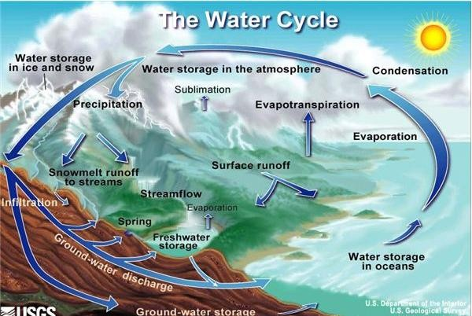

Figure 2. Elements of water cycle

