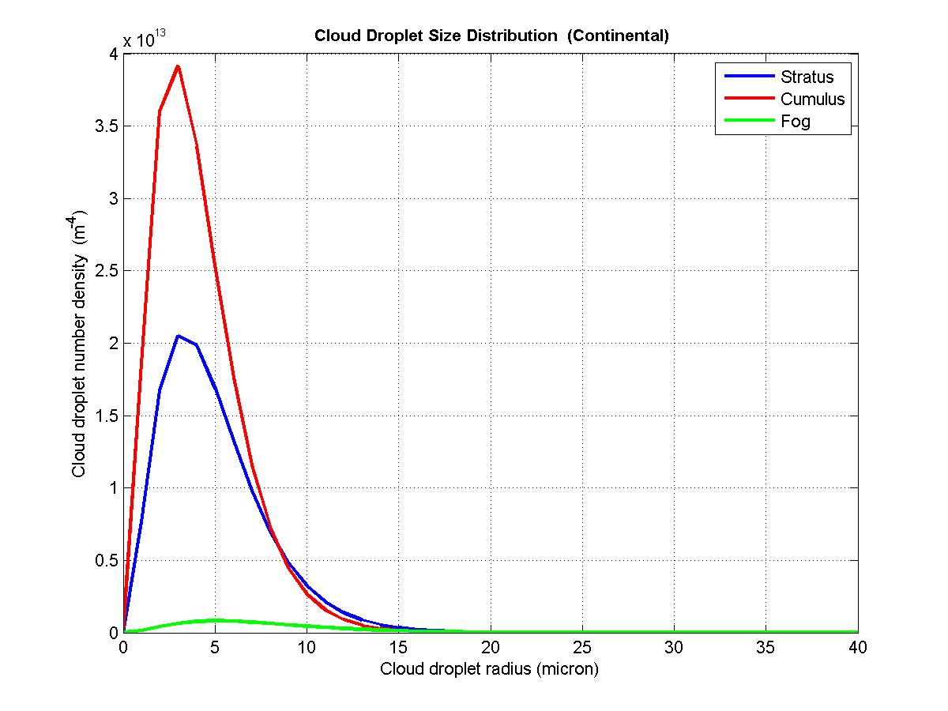
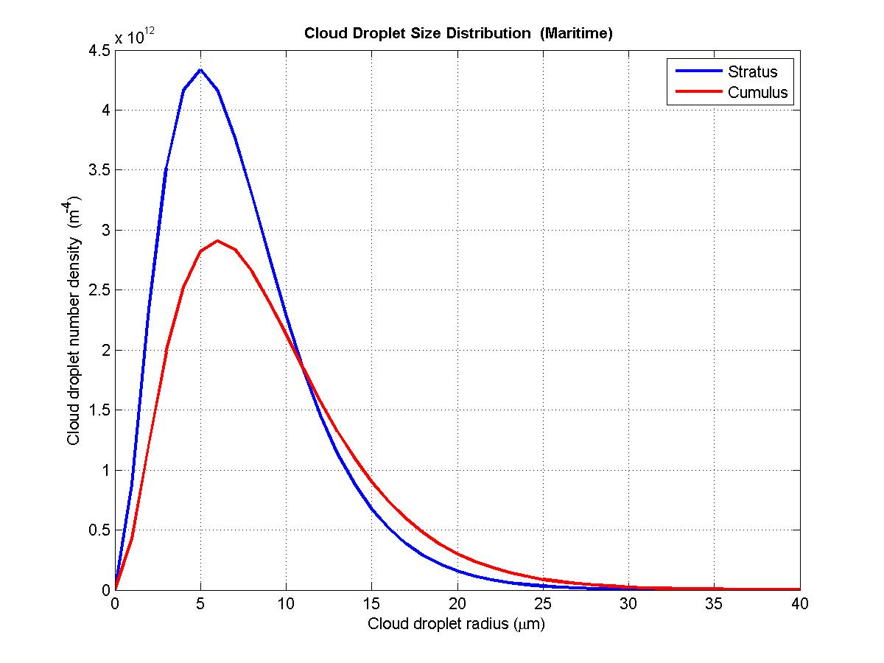
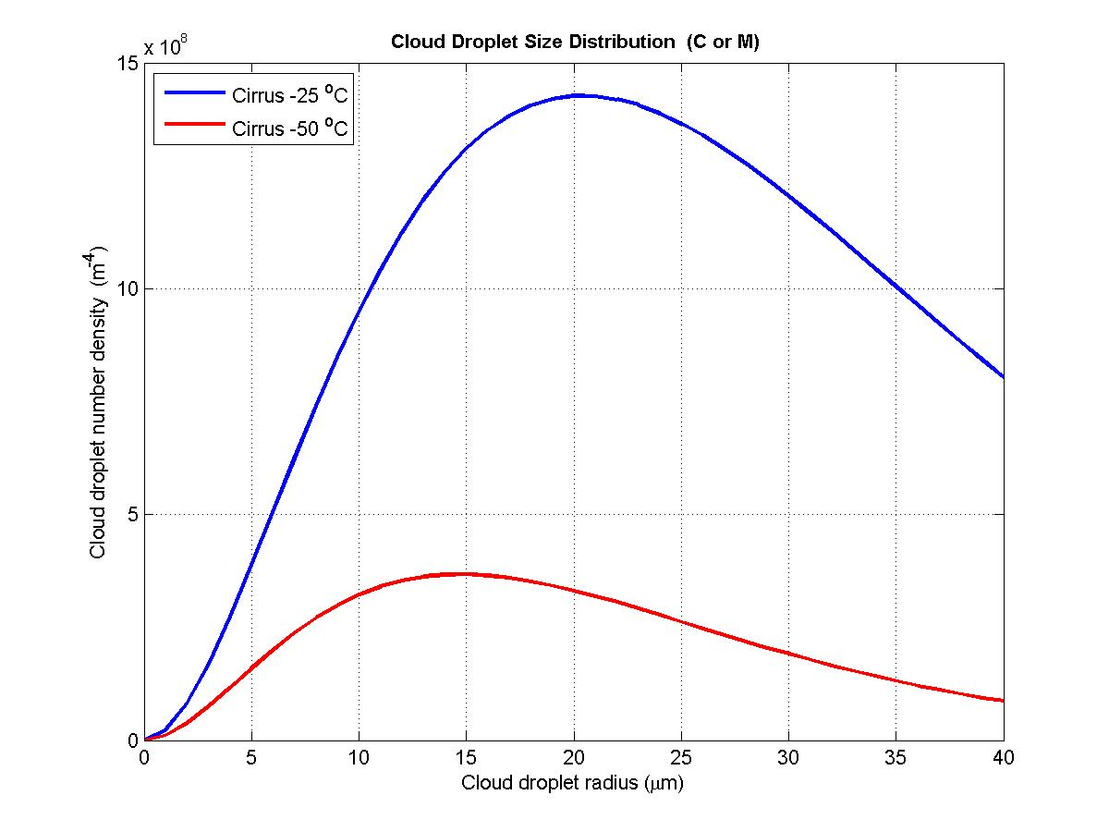
Cloud Type Area (cm2/m3) distance (mm)
Continental Stratus 1025.10 0.98
Continental cumulus 1139.81 0.84
Continental fog 144.96 2.51
Maritime stratus 721.76 1.44
Maritime cumulus 870.70 1.54
C or M cirrus -25 C 16.90 12.94
C or M cirrus -50 C 1.63 22.84

