Lect. 2

**Nomenclature of human chromosome**

A successful attempt to count the number of human chromosomes was made in 1912 by **Winiwarter** who proposed that human chromosomes are 48 in women and 47 in man; men having one X chromosome and women having two X chromosomes. **Painter**, in 1923, while examining the testicular material of man, observed a heteromorphic pair of sex chromosomes and proposed the XY mechanism of sex determination in man. **Tjio** and **Levan** (1956) cultured somatic cells from fibroblasts of human embryos and counted the human chromosome number as 46. This chromosome number was confirmed by **Ford** and **Hamerton** while working with testicular material in the same year. **Tjio** and **Levan** provided greatly improved techniques for chromosome preparations. **Moorhead** *et al.,* (1960) described a simple method of culturing of lymphocytes from human blood. **Karyotyping human chromosomes.** For karyotyping of human chromosomes venous blood is taken and blood leucocytes are stimulated to divide (by mitosis) *in vitro* by the addition of **phytohaemagglutinin**. Colchicine is added to arrest cell division at metaphase stage. It is further treated with hypotonic saline solution which results in swelling of cells and dispersal and better clarity of chromosomes for counting and morphological study. There after, the material is stained (*e.g.,* with Giemsa technique) to demonstrate the banding patterns of chromosomes. Finally, a suitable metaphase spread is photographed through a high power microscope. The individual chromosomes are cut out from the photograph. The chromosomes are then arranged in an orderly fashion in homologous pairs, to produce a standard arrangement, the karyotype.

To characterize a chromosome in the karyotype, the following parameters are used :

1. Shape of chromosome ;

2. Length of chromosome ;

3. Centromeric index, *i.e.,* this index is expressed in the form of ratio of the short arm length to

the total chromosome length :

Centromeric index = Short arm length

Total chromosome length For example, centromeric index in a metacentric chromosome is 0.5.

4. Proportion of the arms, *i.e.,* it is ratio between the long arm and short arm of the chromosome. This ratio is 1 : 1 in a typical metacentric chromosome.

**Classification.** The human were first of all classified by a conference of cytogeneticists at Denver, Colorado in 1960 and is known as the **Denver classification**. To follow this classification, each of the 22

pairs of autosomes has been numbered from 1 to 22 according to their decreasing size. **Patau** (1960)

divided the human chromosomes into the following seven groups designated A to G :

1. A group : 1 to 3 pairs — Metacentric (large metacentric)

2. B group : 4 to 5 pairs — Submetacentric (Large submetacentric)

3. C group : 6 to 12 pairs — Submetacentric ( Medium

Submetacentric)

4. D group : 13 to 15 pairs — Acrocentric (Medium acrocentric)

5. E group : 16 to 18 pairs — Submetacentric (16 is metacentric) Short

sub metacentric)

6. F group : 19 to 20 pairs — Metacentric (Short metacentric)

7. G group : 21 to 22 pairs — Acrocentric (Short acrocentric)

Group A consists of longest metacentric chromosomes.

Group G consists of the shortest acrocentric chromosomes. These chromosomes have satellites

that correspond to nucleolar organizers. Chromosomes of group D also contains satellites. In males,

group G includes a variable Y chromosome which lacks the satellites.

The X chromosome is the member of group C and can be identified by special banding or staining

methods.



**Banding Techniques**

Recently banding techniques reveals structural details of chromosomes. The main banding

techniques are identified by letters such as Q, G, C, R, T, F and N bands:

1. **Q banding.** It uses fluorescent dyes(such as quinacrine mustard) and identifies the so called **Q bands.( in this method regions of the genome which relatively rich in the bases adenine and thymidine fluoresce brightly with Q – banding and each human chromosome pair gives a uinqe pattern of band.**

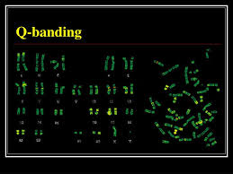

**2. G banding.** It uses Giemsa stain and identifies the G bands. With G banding three major types of chromatin can be recognized— euchromatin, centromeric and intercalary heterochromatin.( it is the most frequently used method of banding for human cytogenetic involve trypsin digestion of the metaphase chromosome followed by staninig with Giemsa a dark blue stain which can be easily seen

With standaered light microscope the dark regions tend to be heterochromatin, late replicating and AT rich . The light regions tend to be euchromatic early- replicating and GC rich .

The Q and G bands are generally similar and correspond to intercalary heterochromatin.

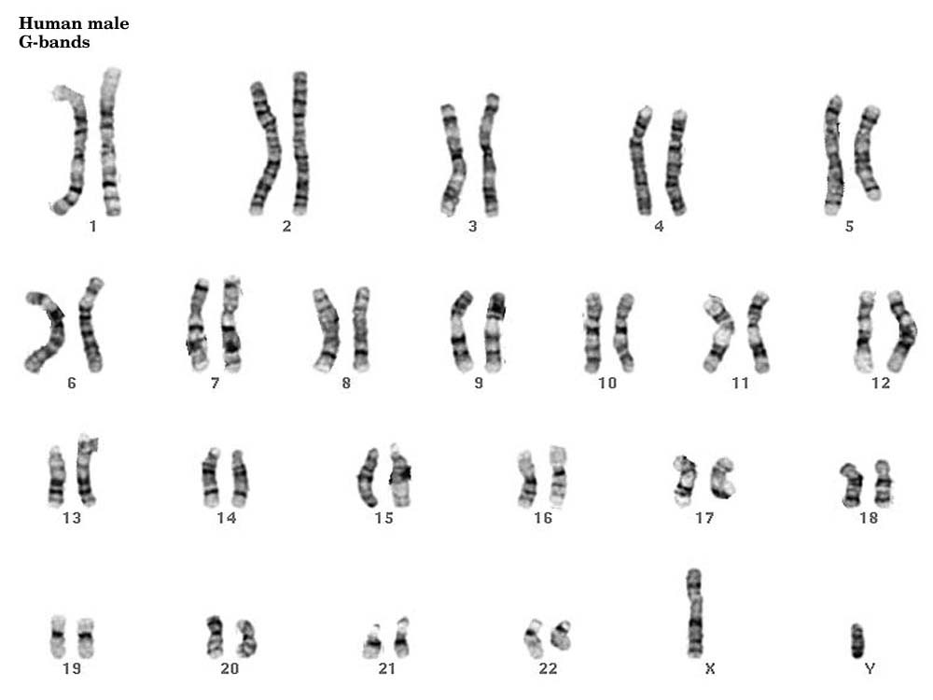

**Chromosome spread with chromosomes  
shown by bright  
field**[**G-banding**](http://www.pathology.washington.edu/galleries/Cytogallery/)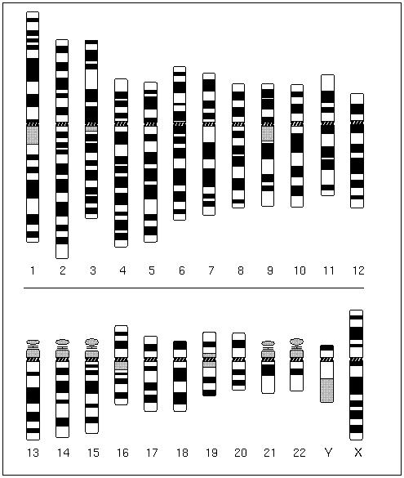

[**Idiogram**](http://www.pathology.washington.edu/galleries/Cytogallery/)**of G-banded chromosome**

**3. C banding.** It stains specifically centromeric constitutive heterochromatin.

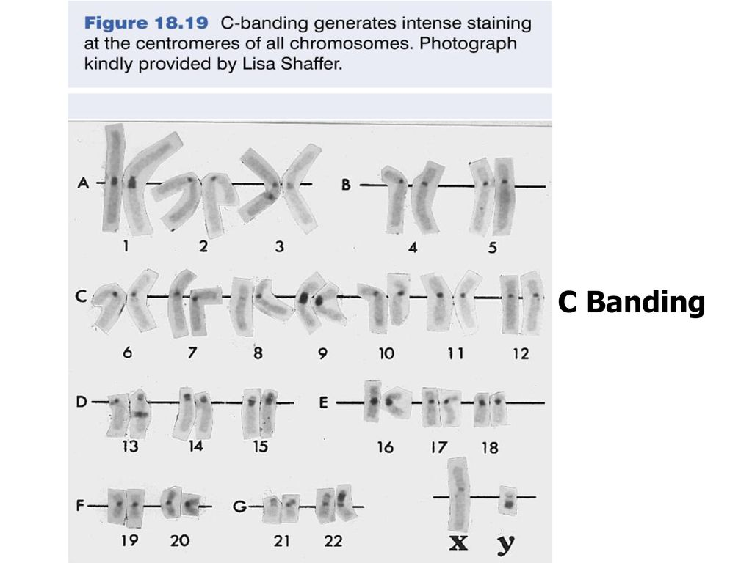

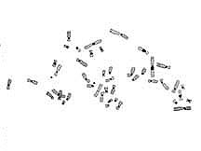

**4. R banding.** It gives a pattern that is the reverse of that of Q and G banding.( the dark regions are euchromatine and light region are heterochromatin )

**5. T banding.** It stains telomeres of chromosomes.

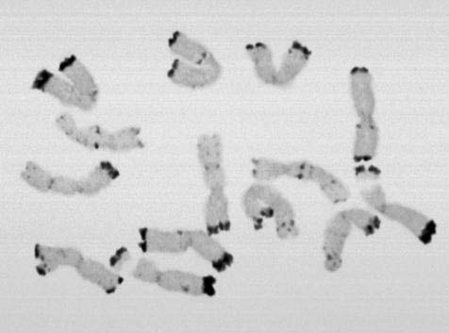

TELOMERE BAND

**Other banding techniques uses the Feulgen stain (F bands) and one selectively stains the Other banding techniques uses the Feulgen stain (F bands) and one selectively stains the nucleolar organizers (N bands) which are localized in the satellite of chromosomes 13, 14, 15, 21 and 22. G banding has become important tool in the analysis of mammalian, avian, reptilian and amphibian chromosomes; distinct G bands have not**

**been found in plant chromosomes.**

**Clinical importance of chromosome banding.** Since banding patterns are unique and constant

**for each normal chromosomes, in case of a large number of chromosomal abnormalities, such as loss of a very small part, insertion of an additional segment and addition of whole chromosome can be easily**

**recognized, *e.g.,* cat-cry syndrome due to loss of small part of chromosome 5 ; Down syndrome due**

**to an extra chromosome 21.**

Banding nomenclature

Each chromosome has a constriction point called the **centromere**, which divides the chromosome into two sections, or “arms.”

 The short arm of the chromosome is labeled the “p arm.”

 The long arm of the chromosome is labeled the “q arm



The location of the centromere on each chromosome gives the chromosome its characteristic shape, and can be used to help describe the location of specific genes. Each chromosome arm is divided into regions, or cytogenetic bands, that can be seen using a microscope and special stains. The cytogenetic bands are labeled p1, p2, p3, q1, q2, q3, etc., counting from the centromere out toward the telomeresAt higher resolutions, sub-bands can be seen within the bands. The sub-bands are also numbered from the centromere out toward the telomere.

For example, the cytogenetic map location of the CFTR gene is 7q31.2, which indicates it is on chromosome 7, q arm, band 3, sub-band 1, and sub-sub-band 2. The ends of the chromosomes are labeled ptel and qtel. For example, the notation 7qtel refers to the end of the long arm of chromosome 7.



