Cloud Physics Lab
LAB 6: Droplet Growth by Diffusion I

Introduction:
At the early stages of a cloud droplets development, it grows by diffusion of water molecules from the vapor onto its surface. Diffusion is the process of molecules moving from regions of higher concentrations to regions of lower concentrations.
In this Lab students investigate the process of cloud droplet growth by diffusion by analyzing the growth rate at different supersaturations and different temperatures for two types of solutes.

Objective:
- Plot and study growth rate for different supersaturations and solutes at given solute mass and temperature.
- Plot and study growth rate for different temperatures at given supersaturations.

Theory:
At the surface of a droplet, water vapor is simultaneously condensing and evaporating. When the concentration of water vapor molecules is higher some distance from the droplet than it is at the droplet surface, the water vapor in the air diffuses toward the droplet, condenses onto the droplet, and the net effect is droplet growth. Two phenomena, which influence the growth that occurs by diffusion, are the curvature effect and the solution effect.
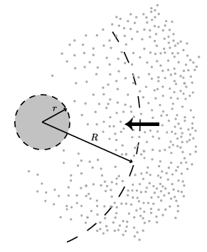
Fig. 1: Schematic diagram showing vapor diffusing toward a growing drop of radius r:
The droplet growth equation is given by:
the thermodynamics term (F_{k}) and the diffusion term (F_{d}) are given by:
and
where:
L is the latent heat of vaporization, ρ_{l} is the water density, R_{v} is the water vapor gas constant, K is thermal conductivity of air, T is the temperature, D is diffusivity of water vapor, and e_{s} is that saturation pressure for water vapor.
It may be shown that L/R_{v}T >> 1. As a close approximation, this term is sometimes written without the -1, which serves only as a small correction factor.

Evaporation of droplets
- Once a droplet falls from a cloud it enters an unsaturated environment$\left(S<1\right)$. In this case, the droplet will begin to evaporate.
- The shrinking of the droplet is also governed by equation (1). Only now $S$ is less than 1 so that ${dr}/{dt}$ is negative.
- A small droplet will evaporate very quickly and disappear. Larger droplets will last longer.
- Droplets larger than 0.1 mm in radius have a good chance of reaching the ground, while those that are smaller will likely evaporate. Therefore, the cutoff between cloud droplets and precipitation is taken as $r=0.1mm$.

Materials and Procedures:
- Run the Matlab script Lab6a.m to plot the droplet growth rate for NaCl.
- Run the Matlab script Lab6a.m again to plot the droplet growth rate for (NH₄)₂(SO₄).
- Run the Matlab script Lab6b.m to plot the droplet growth rate for NaCl at different temperatures.

Analysis and Conclusions:
- Use figure 1 to explain how does the droplet grow with time and discuss how does supersaturation ratio affect the growth rate.
- Compare the drop growth rate at SS=1.02 for NaCl case (fig. 1) and (NH₄)₂(SO₄) case (fig. 2).
- Use figure 3 to explain how temperature can affect the growth rate of cloud droplet?

Questions:
- What did you learn about cloud droplet growth by diffusion by completing the activity?
- Explain why does the change in supersaturation becomes more important when the cloud droplet grows to larger radius?
- Explain why the growth rate of droplet is faster at higher temperatures?

