ميكانيكية قتل البكتيريا بالفضة النانوية
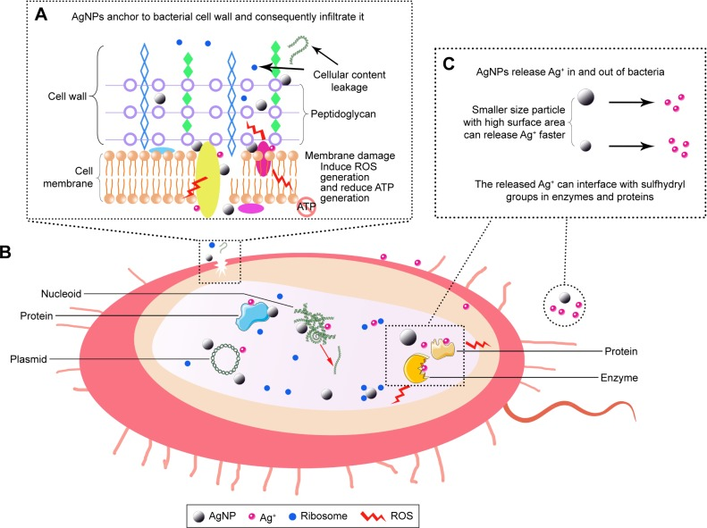
Antibacterial mechanisms of AgNPs. (A) The local enlarged picture shows that AgNPs can anchor to the bacterial cell wall and consequently infiltrate it. This action can lead to membrane damage and cellular content leakage. Furthermore, AgNPs or Ag+ can bind to the protein present in the cell membrane, which are involved in transmembrane ATP generation. (B) AgNPs can penetrate inside to microbial cell, and then AgNPs and the released Ag+ can interact with cellular structures and biomolecules such as proteins, enzymes, lipids, and DNA. The increased ROS lead to an apoptosis-like response, lipid peroxidation, and DNA damage. (C) AgNPs can sustainably release Ag+ in and out of bacteria, and Ag+ can interaction with proteins and enzymes.

