ECOLOGY
Lecture 4.

TROPHIC STRUCTURE AND ECOLOGICAL PYRAMIDS
The interaction of food chain phenomenon (energy loss at each transfer)and the size –metabolism relationship results in communities having a definite trophic structure which often characterizes aparticular type of ecosystem (lake ,forest, and so on). Trophic structure may be measured and described either in terms of the standing crop per unit area or in terms of the energy fixed per unit area per unit time at successive trophic levels. Trophic structure and trophic function may be shown graphically by ecological in which the first or producer level forms the base and successive levels form the tiers that make up the apex.
Ecological pyramids may be of the three general types:
- the pyramid of numbers, in which the number of individual organisms is depicted.
- the pyramid of biomass based on the total dry weight, caloric value or other measure of the total amount of living material.
- the pyramid of energy in which the rate of energy flow and or productivity at successive trophic levels is shown.
The numbers and biomass pyramid can be inverted? Why?
The form of the numbers will vary widely with different communities depending on weather producing individuals are mall (PHYTOPLANKTON OR GRASS) or large (OAK TREES).
For example, when producers are very small and consumers are large,the total weight of the latter may be greater at any one moment.
Inverted biomass pyramid are found most frequently in lakes and the sea. Why?
The plants (PHYYOPLANKTON) USUALLY OUTWEIGHT THEIR GRAZERS(ZOOPLANKTON) during periods of high primary productivity as during the spring bloom but at other times as in winter the reverse may be true.
Of the three types of ecological pyramids the energy pyramid gives by far the best overall picture of the functional nature of communities.

Why the energy pyramid is the best?
The form of the numbers will vary widely with different communities depending on weather producing individuals are small(PHYTOPLANKTON OR GRASS) or large(OAK TREES).
For example, when producers are very small and consumers are large, the total weight of the latter may be greater at any one moment.

Why inverted biomass pyramid are found most frequently in lakes and the sea?
The plants (PHYYOPLANKTON) USUALLY OUTWEIGHT THEIR GRAZERS(ZOOPLANKTON) during periods of high primary productivity as during the spring bloom but at other times as in winter the reverse may be true.
Of the three types of ecological pyramids the energy pyramid gives by far the best overall picture of the functional nature of communities.

Why the energy pyramid is the best?
the energy pyramid depicts the rates of passage of food mass through the food chain. Its shape is not affected by radiations in the size and metabolic rate of individuals and if all sources of energy are considered, it must alwas be right side up because of the second law of thermodynamics.

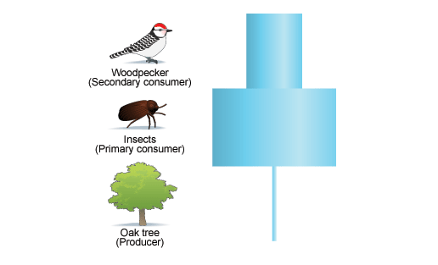
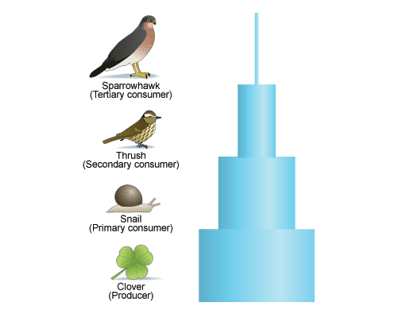

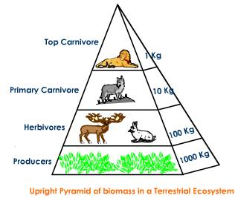

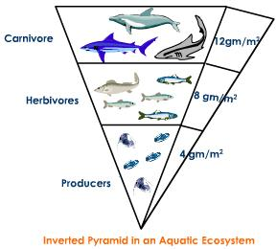

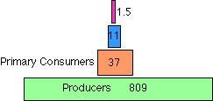

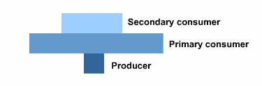

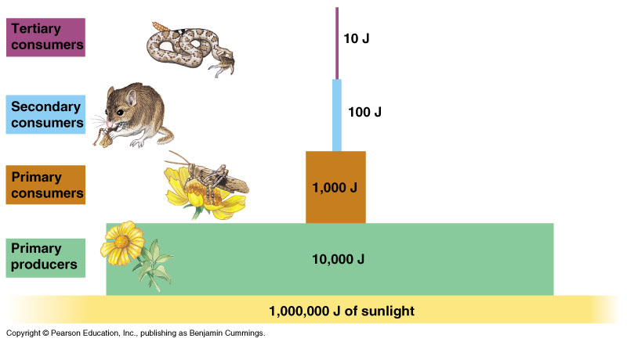

ECOLOGICAL EFFICIENCIES
Ratios between energy flow at different points along the food chain are of considerable ecological interest.Such ratios when expressed as percentage are often called ecological efficiencies.

METABOLISM AND SIZE OF INDIVIDUALs
The standing crop biomass (expressed as the total dry weight or total caloric content of organisms present at any one time) that can be supported by a steady flow energy in a food chain depends considerably on the size of the individual organisms .The smaller the organism the greater its metabolism per gram(or per caloric) of biomass and the smaller the biomass that can be supported at a particular trophic level in the ecosystem .Conversely the larger the organism the larger the standing crop biomass. Thus ,the amount of bacteria present at any one time would by very much
smaller than the crop of fish or mammals even though the energy use might be the same for both groups.

