Bacterial Physiology Lec-7
Energy Release and Conservation
Metabolism: the total of all chemical reactions occurring in the cell, the flow of energy and the participation of enzymes make metabolism possible. Metabolism may be divided into two major parts:
Catabolism: larger and complex molecules are broken down into smaller and simpler molecules with the release of energy, some of this energy is trapped and made available for work, and the remainder is released as heat.
Anabolism: synthesis of complex molecules from simpler one with the input of energy (energy resulted from catabolism).
Microorganisms usually use one of the two sources of energy. Three major kinds of electron acceptors are used by chemotrophs. Energy yielding metabolism can make use of exogenous or externally derived electron acceptors this metabolic process is called respiration which may be divided into two different types: in aerobic respiration, the final electron acceptor is oxygen, whereas the electron acceptor in anaerobic respiration is a different exogenous acceptor, such as inorganic molecules (No₃, So₄, Co₂, Fe and SeO₄). In fermentation, the energy substrate is oxidized and degraded; the catabolic pathway produces an intermediate such as pyruvate that act as the electron acceptor. Fermentation occurs under anaerobic conditions, but sometimes occurs when oxygen is present. The amount of energy that resulted from respiration is high while limited energy released during fermentation, so fermentation can be defined: energy-yielding process in which organic molecules serve as both e – donors & acceptors.
Respiration: energy-yielding process in which the acceptor is an inorganic molecule either oxygen (aerobic respiration) or another inorganic acceptor (anaerobic respiration).
These processes are the catabolic reactions or catabolism which can be divided into 3 stages:
- First stage: Larger nutrient molecules (proteins, polysaccharides and lipids) are hydrolyzed or broken down into their constituent parts.
- Second stage: Amino acids ,monosaccharides, fatty acids ,glycerol products of stage 1 are degraded to a few simpler molecules, important intermediates are formed in this stage.
3. Third stage: Nutrient carbon is fed into the tricarboxylic acid cycle, molecules are oxidized completely to Co₂ with the production of ATP, NADH and FADH 2. The cycle operates aerobically and is responsible for the release of much energy .Oxygen or another inorganic sometimes is the final electron acceptor.

The Breakdown of Glucose to Pyruvate
Microorganisms employ several metabolic pathways to catabolize glucose and other sugars, we will focus on three routes only:
1-Glycolysis
2-Pentose phosphate pathway
3-Entner-Doudoroff pathway

The Glycolytic Pathway
The Embden- Meyerhof or glycolytic pathway or glycolysis ; is the most common pathway for glucose degradation to pyruvate in stage -2- of catabolism. It is found in all major groups of microorganisms and function in the presence or absence of O_{2.} The process is located in the cytoplasmic matrix. The pathway may be divided into two parts as in figure below.
In the initial six –carbon stage, glucose is phosphorylated twice and converted to fructose 1,6-biphosphate , energy doesn’t yield, two ATP molecules are expended for each glucose molecule.

The three-carbon stage of glycolysis begins when the enzyme fructose 1,6-biphosphat aldolase catalyzes the cleavage of fructose 1,6- biphosphate into two halves, each with a phosphate group ; one of the products is glyceraldehydes 3-phosphate which is converted directly to pyruvate in a five –step process, G -3-P is first oxidized with NAD⁺ as the electron acceptor and a phosphate is simultaneously incorporated to give a high energy molecule called 1,3- biphosphoglycerate.The high-energy phosphate on carbon 1 is donated to ADP to produce ATP; the synthesis of ATP is called substrate–level-phosphorylation because ADP phosphorylation is coupled with the exergonic breakdown of a high –energy substrate molecule.

The second ATP molecule that generated by the similar process is from the phosphate group on 3- phosphoglycerate shifts to carbon 2 , and 2-phosphoglycerate is dehydrated to form a second high energy molecule ,phosphoenolpyruvate which donates it’s phosphate to ADP forming a second ATP and pyruvate the final product of the pathway. The glycolytic pathway degrades 1 glucose to 2 pyruvates .
ATP and NADH are also produced. The yields of ATP and NADH may be calculated from the two stages separately. In six carbon stage 2 ATPs are used to form fructose 1,6 –biphosphate . For each G-3-P transformed into pyruvate, 1 NADH and 2 ATPs are formed. So 4 ATPs and 2 NADH are generates / glucose. Catabolism of glucose to pyruvate in glycolysis can be represented by this simple equation:

Glucose +2ADP +2Pi + 2NAD $→$ 2 pyruvate +2ATP +2NADH +2H

Fermentation
In the absence of aerobic or anaerobic respiration, NADH is not oxidized by the electron transport chain because no external electron acceptor is available, so that many microorganisms are using pyruvate or its derivatives as an electron and hydrogen acceptor for the re-oxidation of NADH in a fermentation process. This may lead to the production of more ATP. Two most important characters of fermentation:
- NADH is oxidized to NAD⁺.
- Electron acceptor is either pyruvate or a pyruvate derivative.
In fermentation the substrate is partially oxidized, ATP is formed by substrate –level phosphorylation only, and oxygen is not needed.
Many fungi and some bacteria, algae and protozoa ferment sugars to ethanol and CO₂ in:
- Alcoholic fermentation: pyruvate is decarboxylated to acetaldehyde which is then reduced to ethanol by alcohol dehydrogenase with NADH as the electron donor
- Lactic acid fermentation: the reduction of pyruvate to lactate as in lactic acid bacteria and Bacillus, it can be separated into 2 groups :
- Homolactic fermentation: reduction of all pyruvate to lactate
- Heterolactic fermentation ; the products are lactate ,ethanol and CO₂
Fermentation has an important role in food production like alcohol, yogurt and pickles.
- Formic acid fermentation; Enterobacteriaceae can metabolize pyruvate to formic acid which may be converted to H₂ & CO₂.
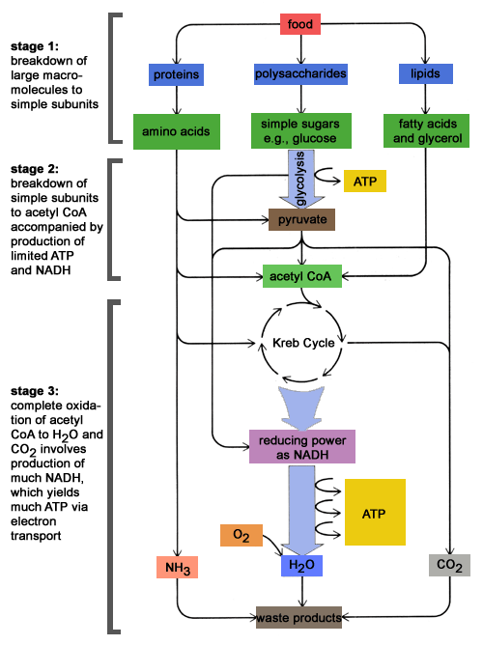
Figure 1: the three stages of catabolism
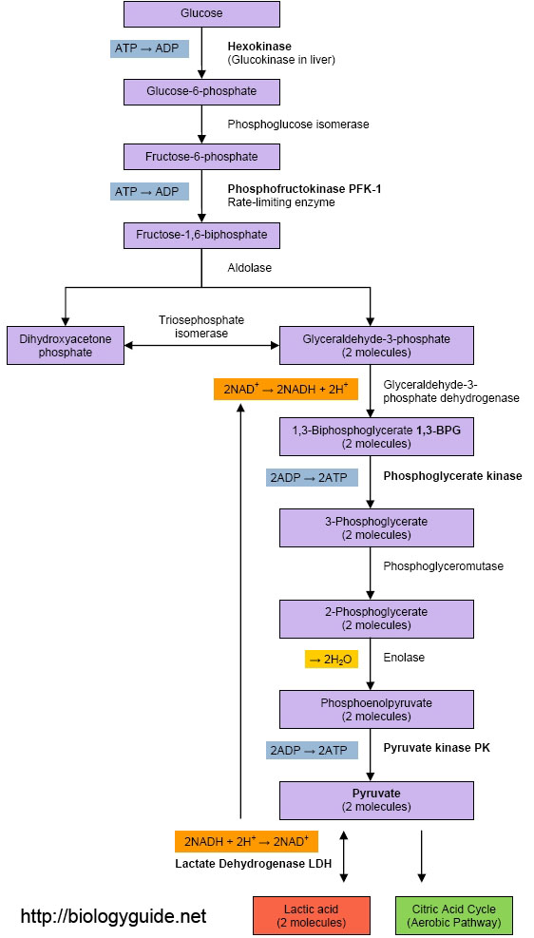
Figure 2 : Glycolysis pathway

