SUCCESSION

Ecological succession is the process of change in the species structure of an ecological community over time. The time scale can be decades (for example, after a wildfire), or even millions of years after a mass extinction.^{[1]}
The community begins with relatively few pioneering plants and animals and develops through increasing complexity until it becomes stable or self-perpetuating as a climax community. The ʺengineʺ of succession, the cause of ecosystem change, is the impact of established species upon their own environments. A consequence of living is the sometimes subtle and sometimes overt alteration of one's own environment.^{[2]}
It is a phenomenon or process by which an ecological community undergoes more or less orderly and predictable changes following a disturbance or the initial colonization of a new habitat. Succession may be initiated either by formation of new, unoccupied habitat, such as from a lava flow or a severe landslide, or by some form of disturbance of a community, such as from a fire, severe windthrow, or logging. Succession that begins in new habitats, uninfluenced by pre-existing communities is called primary succession, whereas succession that follows disruption of a pre-existing community is called secondary succession.
Succession was among the first theories advanced in ecology. The study of succession remains at the core of ecological science. Ecological succession was first documented in the Indiana Dunes of Northwest Indiana^{[3]} which led to efforts to preserve the Indiana Dunes.^{[3][4]} Exhibits on ecological succession are displayed in the Hour Glass, a museum in Ogden Dunes.^{[5]}

Primary, secondary and cyclic succession
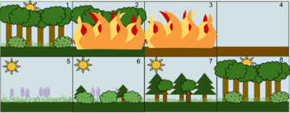
An example of Secondary Succession by stages:
1. A stable deciduous forest community
2. A disturbance, such as a wild fire, destroys the forest
3. The fire burns the forest to the ground
4. The fire leaves behind empty, but not destroyed, soil
5. Grasses and other herbaceous plants grow back first
6. Small bushes and trees begin to colonize the area
7. Fast growing evergreen trees develop to their fullest, while shade-tolerant trees develop in the understory
8. The short-lived and shade intolerant evergreen trees die as the larger deciduous trees overtop them. The ecosystem is now back to a similar state to where it began.
Successional dynamics beginning with colonization of an area that has not been previously occupied by an ecological community, such as newly exposed rock or sand surfaces, lava flows, newly exposed glacial tills, etc., are referred to as primary succession. The stages of primary succession include pioneer plants (lichens and mosses), grassy stage, smaller shrubs, and trees. Animals begin to return when there is food there for them to eat. When it is a fully functioning ecosystem, it has reached the climax community stage. For example, parts of Acadia National Park in Maine went through primary succession.
Successional dynamics following severe disturbance or removal of a pre-existing community are called secondary succession. Dynamics in secondary succession are strongly influenced by pre-disturbance conditions, including soil development, seed banks, remaining organic matter, and residual living organisms. Because of residual fertility and pre-existing organisms, community change in early stages of secondary succession can be relatively rapid. In a fragmented old field habitat created in eastern Kansas, woody plants "colonized more rapidly (per unit area) on large and nearby patches."^{[15]}
Secondary succession is much more commonly observed and studied than primary succession. Particularly common types of secondary succession include responses to natural disturbances such as fire, flood, and severe winds, and to human-caused disturbances such as logging and agriculture. As an example, secondary succession has been occurring in Shenandoah National Park following the 1995 flood of the Mormon River, which destroyed plant and animal life. Today, plant and animal species are beginning to return.

Causes of plant succession
Autogenic succession can be brought by changes in the soil caused by the organisms there. These changes include accumulation of organic matter in litter or humic layer, alteration of soil nutrients, change in pH of soil by plants growing there. The structure of the plants themselves can also alter the community. For example, when larger species like trees mature, they produce shade on to the developing forest floor that tends to exclude light-requiring species. Shade-tolerant species will invade the area.
Allogenic succession is caused by external environmental influences and not by the vegetation. For example, soil changes due to erosion, leaching or the deposition of silt and clays can alter the nutrient content and water relationships in the ecosystems. Animals also play an important role in allogenic changes as they are pollinators, seed dispersers and herbivores. They can also increase nutrient content of the soil in certain areas, or shift soil about (as termites, ants, and moles do) creating patches in the habitat. This may create regeneration sites that favor certain species.
Climatic factors may be very important, but on a much longer time-scale than any other. Changes in temperature and rainfall patterns will promote changes in communities. As the climate warmed at the end of each ice age, great successional changes took place. The tundra vegetation and bare glacial till deposits underwent succession to mixed deciduous forest. The greenhouse effect resulting in increase in temperature is likely to bring profound Allogenic changes in the next century. Geological and climatic catastrophes such as volcanic eruptions, earthquakes, avalanches, meteors, floods, fires, and high wind also bring allogenic changes.

Mechanisms
In 1916, Frederic Clements published a descriptive theory of succession and advanced it as a general ecological concept.^{[10]} His theory of succession had a powerful influence on ecological thought. Clements' concept is usually termed classical ecological theory. According to Clements, succession is a process involving several phases:^{[10][page needed]}
- Nudation: Succession begins with the development of a bare site, called Nudation (disturbance).^{[10]}
- Migration: It refers to arrival of propagules.^{[10]}
- Ecesis: It involves establishment and initial growth of vegetation.^{[10]}
- Competition: As vegetation becomes well established, grow, and spread, various species begin to compete for space, light and nutrients.^{[10]}
- Reaction: During this phase autogenic changes such as the buildup of humus affect the habitat, and one plant community replaces another.^{[10]}
- Stabilization: A supposedly stable climax community forms.^{[10]}

Climax concept
According to classical ecological theory, succession stops when the sere has arrived at an equilibrium or steady state with the physical and biotic environment. Barring major disturbances, it will persist indefinitely. This end point of succession is called climax.

Climax community
Main article: Climax community
The final or stable community in a sere is the climax community or climatic vegetation. It is self-perpetuating and in equilibrium with the physical habitat. There is no net annual accumulation of organic matter in a climax community. The annual production and use of energy is balanced in such a community.

Characteristics
- The vegetation is tolerant of environmental conditions.
- It has a wide diversity of species, a well-drained spatial structure, and complex food chains.
- The climax ecosystem is balanced. There is equilibrium between gross primary production and total respiration, between energy used from sunlight and energy released by decomposition, between uptake of nutrients from the soil and the return of nutrient by litter fall to the soil.
- Individuals in the climax stage are replaced by others of the same kind. Thus the species composition maintains equilibrium.
- It is an index of the climate of the area. The life or growth forms indicate the climatic type

Forest succession
- 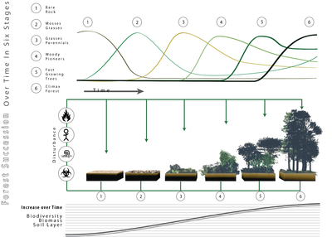
- The forests, being an ecological system, are subject to the species succession process.^{[19]} There are "opportunistic" or "pioneer" species that produce great quantities of seed that are disseminated by the wind, and therefore can colonize big empty extensions. They are capable of germinating and growing in direct sunlight. Once they have produced a closed canopy, the lack of direct sun radiation at soil makes it difficult for their own seedlings to develop. It is then the opportunity for shade-tolerant species to become established under the protection of the pioneers. When the pioneers die, the shade-tolerant species replace them. These species are capable of growing beneath the canopy, and therefore, in the absence of catastrophes, will stay. For this reason it is then said the stand has reached its climax. When a catastrophe occurs, the opportunity for the pioneers opens up again, provided they are present or within a reasonable range.
- An example of pioneer species, in forests of northeastern North America are Betula papyrifera (White birch) and Prunus serotina (Black cherry), that are particularly well-adapted to exploit large gaps in forest canopies, but are intolerant of shade and are eventually replaced by other shade-tolerant species in the absence of disturbances that create such gaps.
Ecological succession, the process by which the structure of a biological community evolves over time. Two different types of succession—primary and secondary—have been distinguished. Primary succession occurs in essentially lifeless areas—regions in which the soil is incapable of sustaining life as a result of such factors as lava flows, newly formed sand dunes, or rocks left from a retreating glacier. Secondary succession occurs in areas where a community that previously existed has been removed; it is typified by smaller-scale disturbances that do not eliminate all life and nutrients from the environment.
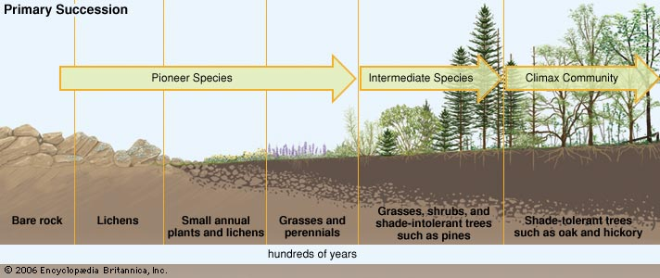

Primary and secondary succession both create a continually changing mix of species within communities as disturbances of different intensities, sizes, and frequencies alter the landscape. The sequential progression of species during succession, however, is not random. At every stage certain species have evolved life histories to exploit the particular conditions of the community. This situation imposes a partially predictable sequence of change in the species composition of communities during succession. Initially only a small number of species from surrounding habitats are capable of thriving in a disturbed habitat. As new plant species take hold, they modify the habitat by altering such things as the amount of shade on the ground or the mineral composition of the soil. These changes allow other species that are better suited to this modified habitat to succeed the old species. These newer species are superseded, in turn, by still newer species. A similar succession of animal species occurs, and interactions between plants, animals, and environment influence the pattern and rate of successional change.

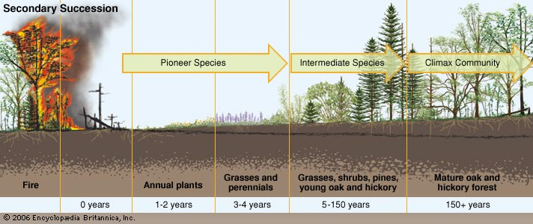

In some environments, succession reaches a climax, which produces a stable community dominated by a small number of prominent species. This state of equilibrium, called the climax community, is thought to result when the web of biotic interactions becomes so intricate that no other species can be admitted. In other environments, continual small-scale disturbances produce communities that are a diverse mix of species, and any species may become dominant.

