**Renewable Energy 2**

**The objectives of this lecture are**

* To, review the properties of the Sun.
* To, review the properties of the solar radiation.
* To, Recognition theoretical upper limit of solar radiation available at the earth’s surface;
* To, Recognition the position of the sun in the sky and the beam radiation direction that is incident on surfaces of various orientations and shading.
* The possibility of using this information to invest in solar energy.

References:

* Solar Engineering of Thermal Processes by Duffie & Beckman, John Wiley & Sons, 1991
* Reference: Principles of Solar Engineering, Goswami, Kreith and Kreider, Taylor & Francis, 2000.
* SOLAR ENERGY, Renewable Energy and the Environment. Robert Foster, Majid Ghassemi, Alma Cota, 2010 by Taylor and Francis Group, LLC, CRC Press is an imprint of Taylor & Francis Group, an Informa business.
* ENERGY HMVESfMG Solar, Wind, and Ocean Energy Conversion Systems. Alroza Khaligh and Omar G. Onar

2010 by Taylor and Francis Group, LLC, CRC Press is an imprint of Taylor & Francis Group, an Informa business

* Available from Source:
* <http://www.uwsp.edu/geo/faculty/ritter/geog101/textbook/energy/nature_of_electromagnetic_radiation.html> .

<http://www.physicalgeography.net>

**Solar Energy**

**2-1 The sun**

The Sun, our closest star, is a spherical gaseous self-gravitating body consisting mainly of hydrogen. It is located at the center of the solar system, on average 1:5 * 1011m from Earth. At the inner core of the Sun. The gravitational force creates a pressure that generates nuclear fusion that turns Hydrogen into Helium. The sun produces energy in a process called nuclear fusion. High pressure and temperature in the sun's core cause hydrogen atoms to split apart. Four Hydrogen nuclei combine or fuse, to form one helium atom, producing radiant energy in the process.

In this process, a portion of the mass converted into an abundant amount of electromagnetic radiation, which makes the Sun the dominant source of Radiative energy in the solar system. The Sun has a complex physical structure and consists of several regions, from the dense inner core to the outer atmospherically layer, the corona. Both the corona and the core are very hot, in the order of 106 - 107 K, while the intermediate regions that transport and emit energy as outgoing radiation are cooler (although hot by earthly standard).

**2-1-1 The solar** **interior:**

*Radiative and convective layers*: transport energy outward.

*Photosphere*: lower part of solar atmosphere surface (T ~ 5800 K).

*Chromosphere*: ~ 104 km thick layer above photosphere; characteristic red color.

*Corona*: faint, tenuous outermost layer of the solar atmosphere

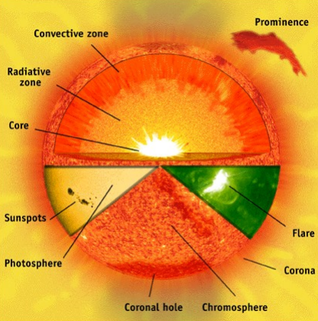

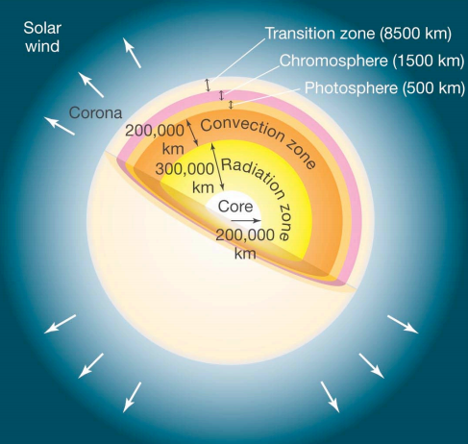

Fig.1 The sun interior.

***In general, nuclear fusion works like this****:*

***nucleus 1 + nucleus 2 → nucleus 3 + energy***

But, where does the energy come from?

• It comes from the mass; if you add up the masses of the initial nuclei, you will find that it is more than the mass of the final nucleus.

The relationship between mass and energy comes from Einstein’s famous equation: E = mc**2** where ,c is the speed of light, which is a very large number **What this equation is telling us**? is that a small amount of mass is the equivalent of a large amount of energy—tapping into that energy is how the Sun keeps shining so long. Scientists know that every square meter of the Earth receives about 1 kilowatt of energy when the sun is directly\ overhead. Gathering and converting this energy into usable form has been explored since burning mirrors were first used in China around 700 BC for ignition of firewood. Excluding photosynthesis, energy can be collected from sunlight in two ways. It can be converted directly into electricity using photoelectric materials or it can be converted into heat.

**2-1-2 Some facts about the Sun:**

* Mean distance from the Earth= 149 600 000 km (the astronomic unit, AU).
* Diameter: 1 392 000 km (10**9** _ that of the Earth).
* Volume: 1 300 000 _ that of the Earth.
* Density: (at its center): >10**5** kg/ m**3** (over 100 times that of water).
* Mass: 2.0 × 1030 kg = 300 Jupiter = 90,000 Earths
* Pressure (at its center): over 1 billion atmospheres
* Temperature (at its center): about 15 000 000 K
* Temperature (at the surface): 6000 K
* Energy radiation: 3.8 x 10**26** W
* The Earth receives: 1.7 x 10**18** W Solar Energy
* Approximately 650 Mio.t/s of hydrogen are converted into approximately 646 Mio. t/s of helium.
* The difference of approximately 4 Mio. t/s is converted into energy. The resulting mass loss converted into energy (E).
* According to Einstein, it can be calculated multiplying mass m and the square of the speed of light c. E = mc**2**.
* Luminosity— total energy radiated by the Sun— can be calculated from the fraction of that energy that reaches Earth, called the solar constant.
* Solar constant, GSC: is energy from the sun, per unit time, received on a unit area of surface perpendicular to the direction of propagation of the radiation, at mean earth-sun distance, outside of the atmosphere. The amount of Sun's energy incident on a square meter of the Earth per second is ≈ 1400 W/m**2**. As in (Figure 2a- b).

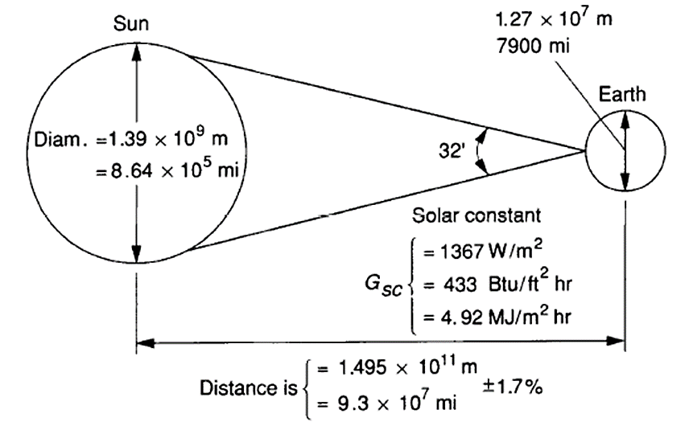

Fig.2a:

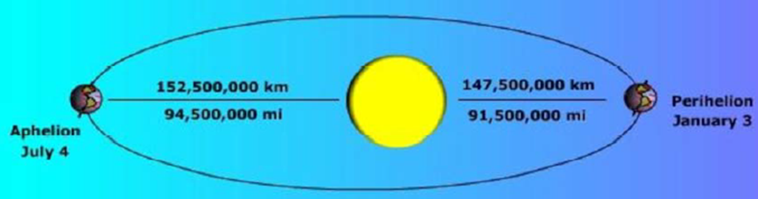

***Fig.2b: Earth’s elliptic orbit: The elliptical path causes only small variations for radiation reaching the earth***

**2-2 The Solar Resource:**

Solar resource is the electromagnetic radiation emitted by the sun. Sunlight is an excellent energy source in that the supply is consistent, widespread, and essentially inexhaustible. Solar energy also has several challenges, namely that it is only available during the day; it varies throughout the day and year, and is less energy dense than fossil fuels. Irradiance is the rate of energy falling on a surface per unit area, it is commonly measured in units of Watts per meters squared (W/m2), and measures the intensity of the sunlight at any given time.

The amount of solar radiation intercepted by the earth called extraterrestrial radiation. As it makes its way towards the ground, it is depleting when passing through the atmosphere. On average, less than half of extraterrestrial radiation reaches ground level. Even when the sky is very clear with no clouds, approximately 20 % to 30 % of extraterrestrial radiation is lost during the down welling path. A good knowledge of the optical properties of the atmosphere is necessary to model the depletion of the radiation. The role of the clouds is of paramount importance: optically thin clouds allow a small proportion of radiation to reach the ground; optically thick clouds create obscurity by stopping the radiation downwards. In clear skies, aerosols and water vapor are the main contributors to depletion. The description and modeling of the optical Processes affecting solar radiation’s interaction with the atmosphere called *Radiative transfer*.

Insolation is the total energy received on a surface over a specific time interval. It is commonly measured in units of kilowatt-hours per meters squared per day (kWh/m2/d), and measures the average amount of solar energy received in a day. The amount of solar irradiation that reaches the outer edge of the Earth’s atmosphere varies slightly around a value of 1366 W/m**2**. This value varies by ±3% as the earth orbits the sun, depending on how close the Earth is to the sun. The atmosphere scatters, reflects, and absorbs solar radiation so that only about 1000 W/m**2** reaches the surface when the sun is directly overhead.

Atmospheric effects result in two types of solar radiation: direct radiation, and diffuse radiation. As sunlight passes through the atmosphere, some of it is absorbed, scattered, and reflected by: Air molecules, Water vapor, Clouds, Dust, Pollutants, Forest fires and Volcanoes.This called diffuse solar radiation. The solar radiation that reaches the Earth's surface without being diffused called direct or beam solar radiation. The sum of the diffuse and direct solar radiation is called global solar radiation. Atmospheric conditions can reduce direct beam radiation by 10% on clear, dry days and by 100% during thick, cloudy days. Not all of the direct and diffused radiation is available at the Earth's surface. Some of the radiation received at the Earth's surface is redirected back to space by reflection. Of all the sunlight that passes through the atmosphere annually, only 51% is available at the Earth's surface; to heat the Earth's surface and lower atmosphere, evaporate water, and run photosynthesis in plants. Of the other 49%, 4% is reflected back to space by the Earth's surface, 26 % is scattered or reflected to space by clouds and atmospheric particles, and atmospheric gases, particles, and clouds absorb 19%. As in Fig.2

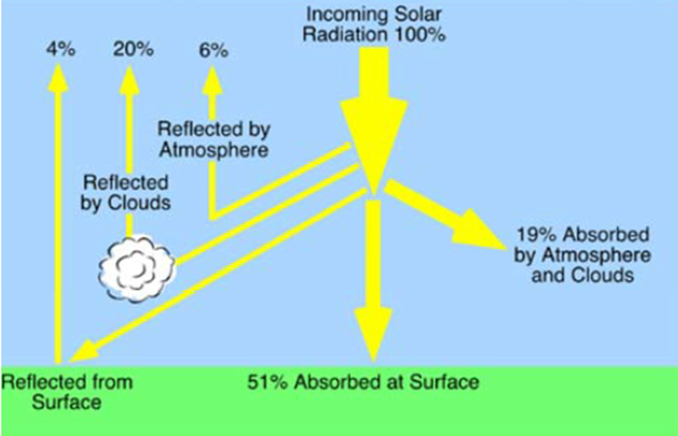

Fig. 3 Global solar energy balance

Most solar panels can collect both types of radiation, but any solar collector that concentrates or reflects sunlight will only be effective with the direct radiation component. That is why? concentrating and reflecting collectors are typically used in desert areas where most of the solar radiation is direct. They would be less effective when, on a sunny day, 10% to 20% of the solar radiation is diffuse, and on an overcast day, it is 100% diffuse. The Earth receives around 170,000 terawatts (10**12** watt), of solar energy continuously, which is roughly 10,000 times, what is needed to power the world.

The actual irradiance at any location depends on the latitude, the time of day and year, shading from adjacent buildings or trees, and the local weather. The latitude affects the angle that sunlight makes with the ground (Fig. 4). Generally, the angle is smaller as the distance from the equator increases. The axis through the North and South poles tilted relative to the plane in which the Earth revolves around the sun. This angle, called declination, is about 23.45 degrees and is the reason the Earth has different seasons. The northern hemisphere is tilted away from the sun on the winter solstice (Fig. 4) and toward the sun on the summer solstice resulting in the shortest and longest days of the year, respectively. This is why the sun is higher in the sky in the summer, and rises and sets north of an east/west line, while the opposite is true in the winter (Fig. 5). The optimum mounting angle of a flat solar collector determined by the height of the sun’s east/west path since the maximum amount of energy obtained when the collector is perpendicular to the incoming sunlight.

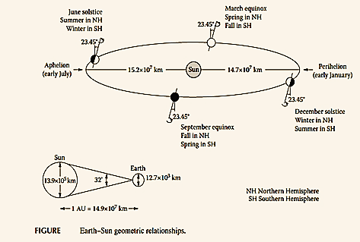

Figure 4. Earth Geometry

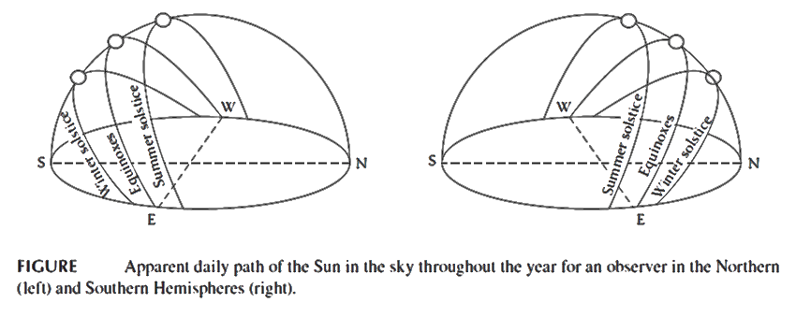

Figure 5. Seasonal Sun Paths

Tracking systems can be used to keep a panel directed at the sun. Single axis systems follow the east-west path of the sun during the day while dual axis systems can keep a panel directed at the sun at all times of the day and year. Using a single axis tracking system or a fixed panel requires a compromise between winter and summer performance. Typically, a fixed panel will be mounted facing south at an angle equal to the latitude which maximizes the energy collected over an entire year. A higher mounting angle will collect more energy in the winter months at the expense of summer performance. The opposite is true for a lower mounting angle. There are web-based tools that will calculate the annual insolation for different mounting configurations based on location.

**2-3 Applications of solar energy**

* Heating and Cooling of buildings
* Solar water and air heating
* Salt production by evaporation of seawater
* Solar distillation and Water desalination.
* Solar drying of agricultural products
* Solar cookers
* Solar water pumping
* Electricity generation through Photo voltaic cells
* Solar furnaces
* Industrial process heat
* Solar thermal power generation.

**2-4 Properties of solar irradiation**

The spectral distribution of extraterrestrial radiation is such that about half of it lies in the visible part of the electromagnetic spectrum. It produces daylight and well perceived by the human vision system. Other parts of it are in the near-infrared and ultraviolet ranges. This spectral distribution modified as the radiation crosses the atmosphere downwards;

changes are mainly due to gases and aerosols. The spectral distribution has an impact on photo energy systems, since the latter have a response in preferred ranges of the electromagnetic spectrum. The amount of radiation integrated over the whole spectrum called total radiation or broadband radiation.

**2-4-1 Basic principles**:

The amount of solar radiation that reaches any one spot on the Earth's surface varies according to:

Geographic location

Time of day

Season

Local landscape

Local weather.

Because the Earth is round, the sun strikes the surface at different angles, ranging from 0° (just above the horizon) to 90° (directly overhead). When the sun's rays are vertical, the Earth's surface gets all the energy possible.

The more slanted the sun's rays are, the longer they travel through the atmosphere, becoming more scattered and diffuse. So that, the frigid Polar Regions never get a high sun, and because of the tilted axis of rotation, these areas receive no sun at all during part of the year. The Earth revolves around the sun in an elliptical orbit and is closer to the sun during part of the year. When the sun is nearer the Earth, the Earth's surface receives a little more solar energy. The Earth is nearer the sun when it is *summer* in the southern hemisphere and *winter* in the northern hemisphere. However, the presence of vast oceans moderates the hotter summers and colder winters one would expect to see in the southern hemisphere as a result of this difference. The 23.5° tilt in the Earth's axis of rotation is a more significant factor in determining the amount of sunlight striking the Earth at a particular location. Tilting, results in longer days in the northern hemisphere from the spring (vernal) equinox to the fall (autumnal) equinox and longer days in the southern hemisphere during the other 6 months. Days and nights are both exactly 12 hours long on the equinoxes, which occur each year on or around March 23 and September 22. The rotation of the Earth is also responsible for hourly variations in sunlight. In the early morning and late afternoon, the sun is low in the sky. Its rays travel further through the atmosphere than at noon, when the sun is at its highest point. On a clear day, the greatest amount of solar energy reaches a solar collector around solar noon.

**2-5 Energy and Radiation**

Radiation: The transfer of energy via electromagnetic waves that travel at the speed of light. The velocity of light in a vacuum is approximately

3 x 10**8** m/s. The time it takes light from the sun to reach the Earth is 8 minutes and 20 seconds. Heat transfer by electromagnetic radiation can travel through empty space. Any object emits electromagnetic radiation, provided its temperature is above 0 K. The spectral radiance is entirely determined by temperature and the emitting properties of the surface of the object. The laws of Kirchhoff and Planck describe this process. Solar radiation is approximately that of a blackbody (i.e., a perfect Radiative body) at a temperature of 5780 K.

**2-5-1 Sun Radiation** **Spectrum**:

Solar radiation spans a spectrum from approximately 0.1 to 4.0 μm over a very large spectrum, from X-rays to far infrared. Approximately 99.9% of the radiation emitted is located between 0.2 μm and 8 μm and 98 % between 0.3 μm and 4 μm.

About 7 % of the sun's emission in 0.1 to 0.4 μm wavelength band UV. About 48 % of the sun's radiation falls in the region between 0.71 μm to 4.0 μm band Visible light wavelength. Near infrared: 0.71 to 1.5 μm. Far infrared: 1.5 to 4.0 μm. figures (6-7)

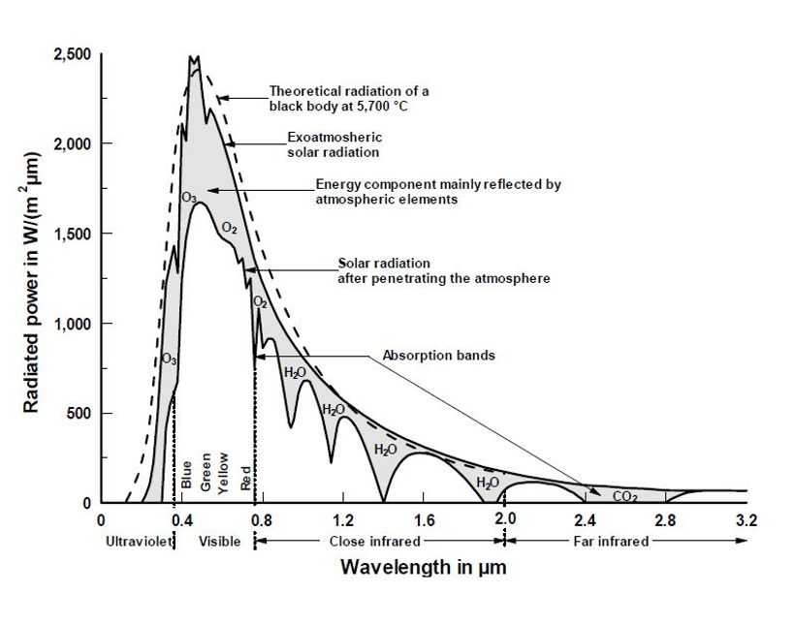

Fig.6 Extraterrestrial solar Spectrum.















Fig.7 Wavelength and solar radiation spectrum

**2-6 Some Laws that govern radiation:**

**2-6-1 *Stephan-Boltzmann Law:***

The amount of electromagnetic radiation emitted by a body directly related to its temperature. If the body is a perfect emitter (black body), the amount of radiation given off is proportional to the 4th power of its temperature as measured in degrees Kelvin. The Stephan-Boltzmann law describes this natural phenomenon:

E = σT**4** Where: σ = 5.67 x 10**-8** Wm**-2**k**-4** and T, in K

In general, good emitters of radiation are also good absorbers of radiation at specific wavelength bands. This is especially true of greenhouse gases. Some objects in nature have perfect abilities to absorb and emit radiation. We call these objects black bodies. The radiation characteristics of the sun and the Earth are very close to being black bodies.

**2-6-2 *Wien’s Law***

The wavelength of maximum emission of any body is inversely proportional to its absolute temperature. Thus, the higher the temperature, the shorter the wavelength, of maximum emission. This phenomenon is often called Wien’s law: λ max = $\frac{C}{T}$

Where: C is Wien’s *displacement constant* = 2897 *μm. k*

*where: T is in Kelvin. According to the above equation the wavelength of maximum emission for the sun (5800 K) is about 0.5 μm, while the wavelength of maximum emission for the Earth (288 K) is approximately 10.0 μm*. As in figure 8. The gases of the atmosphere are relatively good absorbers of long wave radiation and thus absorb the energy emitted by the Earth's surface. The absorbed radiation is emitted downward toward the surface as long wave atmospheric counter-radiation keeping near surfaces temperatures warmer than they would be without this blanket of gases. This is known as the “***greenhouse effect****”*

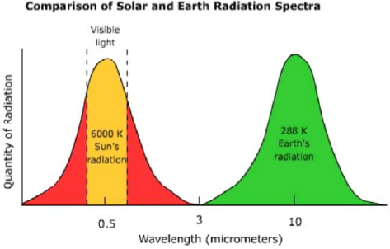

Fig. 8 comparison of Solar and Earth Radiation Spectrum

**2-6-3 *Inverse Square Law***

The amount of radiation passing through a specific area is inversely proportional to the square of the distance of that area from the energy source. This phenomenon called the inverse square law. Using this law, we can model the effect that distance traveled has on the intensity of emitted radiation from a body like the sun.

***Intensity* = $\frac{I}{d^{2}}$**

Where: I; is the intensity of radiation $d;$ is the distance traveled.

Radiation emits from the Sun is lessened by the inverse square law, as it reaches further and further away from the Sun. Therefore, the further away that a planet is from the Sun then the less radiation it receives.

What happens to that radiation depends on whether the planet has an atmosphere, whether the atmosphere contains clouds and how the clouds, or the surface, reflect the radiation.

For planets with no atmosphere all, the Sun's radiation will strike the surface. Some of this will be reflected away from the planet but the rest will be absorbed. The temperature of the surface will be raised until there is equilibrium between the energy radiated by the warm surface of the planet and the received solar radiation. For planets like Mercury, this results in a very hot surface where the Sun is shining (more than 400°C) but very cold on the night side, where the radiation from the surface rapidly cools it to -180°C.

**2-7 Atmospheric Effects on Incoming Solar Radiation**

The Earth is a planet with an atmosphere and is largely transparent to the incoming solar radiation. There are constituents in the atmosphere, which prevent some kinds of radiation from reaching the surface, such as ozone, which stops the ultraviolet. A fair proportion of the Earth covered by clouds, which reflect a lot of the Sun's radiation and thus affecting the surface temperature.

1-The process of scattering occurs when small particles and gas molecules diffuse part of the incoming solar radiation in random directions without any alteration to the λ of the electromagnetic energy. Scattering does, however, reduce the amount of incoming radiation reaching the Earth's surface. A significant proportion of scattered shortwave solar radiation is redirected back to space. The amount of scattering that takes place is dependent on two factors: λ of the incoming radiation and the size of the scattering particle or gas molecule. In the Earth's atmosphere, the presence of a large number of particles with a size of about 0.5 μm results in shorter wavelengths being preferentially scattered. This factor also causes our sky to look blue because this color corresponds to those wavelengths that are best diffused. If scattering did not occur in our atmosphere the daylight, sky would be black. If intercepted, some gases and particles in the atmosphere have the ability to absorb incoming insolation.2- Absorption is defined as a process in which solar radiation is retained by a substance and converted into heat. The creation of heat also causes the substance to emit its own radiation. In general, the absorption of solar radiation by substances in the Earth's atmosphere results in temperatures that get no higher than 1800° C. Bodies with temperatures at this level or lower would emit their radiation in the long wave band. Further, this emission of radiation is in all directions so a sizable proportion of this energy is lost to space.

3-The third process in the atmosphere that modifies incoming solar radiation is reflection. Reflection is a process where sunlight is redirect by 180° after it strikes an atmospheric particle. This redirection causes a 100 % loss of the insolation. Most of the reflection in our atmosphere occurs in clouds when light is intercepted by particles of liquid and frozen water. The reflectivity (albedo) of a cloud can range from 40 % Figure 9.

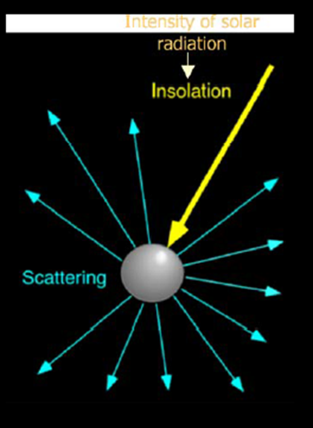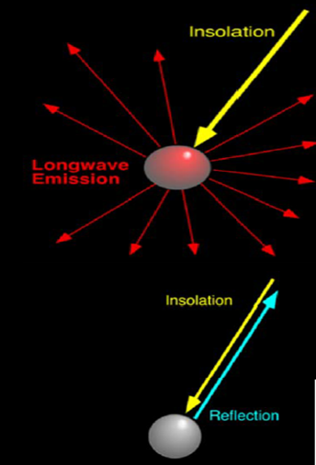

**Fig. 9 The process of scattering, Absorption and reflection Solar Radiation**

**2-8 Global Radiation:**

The global spectrum comprises the direct plus the diffused light.

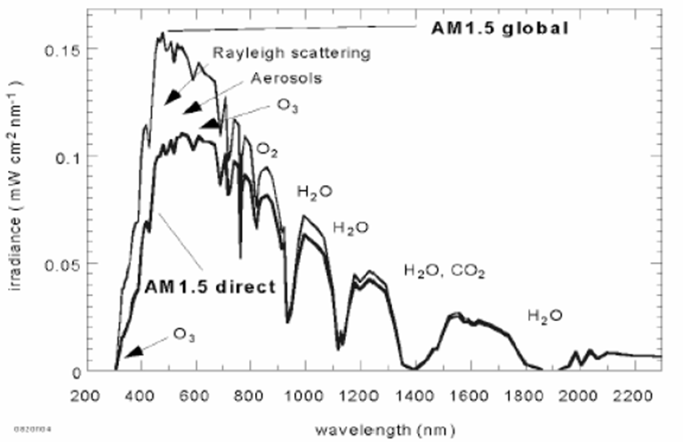

Fig. 10 global spectrum radiation

1. **Irradiance**: given in W/m2 and is represented by the symbol G.

The rate at which radiant energy is incident on a surface per unit area of surface. Or the flux of radiant energy per unit area (normal to the direction of flow of radiant energy through a medium).

1. **Irradiation**: given in J/m**2** and is the incident energy per unit area on a surface - determined by integration of irradiance over a specified time, usually an hour or a day.
2. **Insolation**: is a term used to solar energy irradiation
3. **Radiosity**: is the rate at which radiant energy leaves a surface, per unit area, by combined emission, reflection and transmission.
4. **Direction of Beam Radiation**: The geometric relationships between a plane of any particular orientation relative to the earth at any time and the incoming beam solar radiation can be described in terms of several angles: (Latitude(φ), Declination(δ), Slope(β), Surface azimuth angle(γ), Hour angle(ω), Angle of incidence(θ), Zenith angle(θz), Solar altitude angle (αs) and solar azimuth angle (γs)). Shown in figure 12 below.

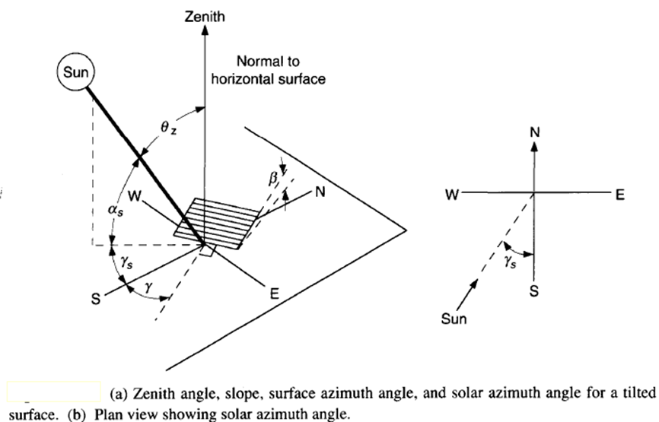

Fig.12 several angles described incoming beam solar radiation

**2-9 Air Mass**

The path length of the solar radiation through the Earth’s atmosphere in units of Air Mass (AM) increases with the angle from the zenith. The AM 1.5 spectrum is the preferred standard spectrum for solar cell efficiency measurements. The easiest way to estimate the air mass in practice is to measure the length of the shadow (***s*)** cast by a vertical structure of height (***h*)** using: *AM* = **2**

**2-10 Selective Absorption** **of the Atmosphere**

At the smallest scale, the electromagnetic radiation behaves as a particle, like when light is emitted by a single atom or molecule. When energy is given off there is a change in the orbital pattern of the electrons that surround the nucleus of an atom. As the orbit changes, a bundle of energy called, a "photon" is released. However, particles of light differ from particles of matter: they have no mass, occupy no space, and travel at the speed of light. The amount of energy carried by a photon varies inversely with wavelength, the shorter the wavelength the more energetic is the photon. Normally, light is formed from a large number of photons, with the intensity related to the number of them. The gasses that comprise our atmosphere absorb only particular wavelengths of light. Electrons orbit the nucleus of an atom at fixed orbital distances called orbital shells. The orbital shell for each atom is different and discrete. That is, for a given atom like hydrogen, its electrons can only orbit at particular distances and are different than those for atoms of other gases. The amount of energy carried by a photon depends on the wavelength. Thus, the atoms that comprise a gas can only absorb, or emit, particular wavelengths of energy (i.e. photons of energy). We can see this selective absorption by examining Figure 11 below. The graph shows very little absorption for atmosphere as a whole in the shortwave end of the spectrum, especially in the visible light band (the band of maximum emission for the Sun). The atmosphere absorbs far better in the long wave end of the electromagnetic spectrum, which is the region of maximum emission (10μm) for the Earth.

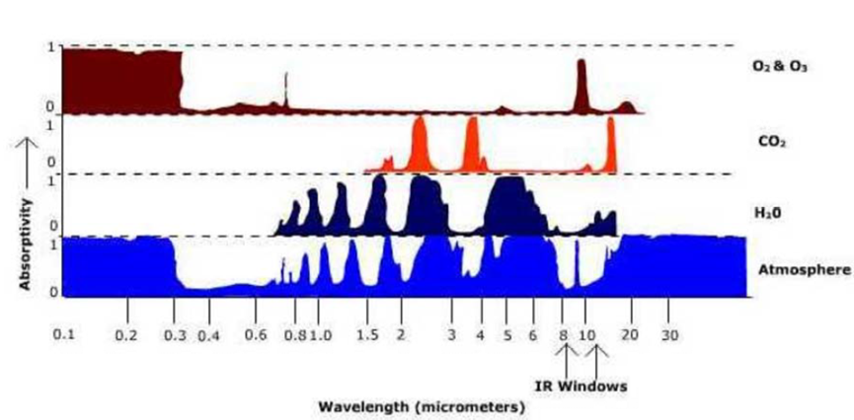

Fig.11 selective absorption of the Atmosphere.

