3-Thrust &Drag
Thrust is the force, which moves an aircraft through the air. Thrust used to overcome the drag of an airplane, and to overcome the weight of a rocket. Thrust generated by the engines of the aircraft through some kind of propulsion system.
Thrust is a mechanical force, so the propulsion system must be in physical contact with a working fluid to produce thrust. Thrust generated most often through the reaction of accelerating a mass of gas. Since thrust is a force, it is a vector quantity having both a magnitude and a direction. The engine does work on the gas and accelerates the gas to the rear of the engine; the thrust generated in the opposite direction from the accelerated gas. The magnitude of the thrust depends on the amount of gas that accelerated and on the difference in velocity of the gas through the engine.
The physics involved in the generation of thrust introduced in middle school and studied in some detail in high school and college. To accelerate the gas, we have to expend energy. The energy generated as heat by the combustion of some fuel. The thrust equation describes how the acceleration of the gas produces a force. The type of propulsion system used on an aircraft may vary from airplane to airplane and each device produces thrust in a slightly different way. We will discuss four principal propulsion systems at this web site; the propeller, the turbine, or jet, engine, the ramjet, and the rocket.
You can view a short movie of "Orville and Wilbur Wright" discussing the thrust force and how it affected the flight of their aircraft. The movie file can be saved to your computer and viewed as a Podcast on your podcast player .
4-Drag
Drag is the aerodynamic force that opposes an aircraft's motion through the air. Drag generated by every part of the airplane (even the engines!).As the airplane moves through the air, there is another aerodynamic force present. The air resists the motion of the aircraft and the resistance force called drag. Drag is directed along and opposed to the flight direction. Like lift, there are many factors that affect the magnitude of drag force including the shape of the aircraft, the "stickiness" of the air, and the velocity of the aircraft. Like lift, we collect all of the individual components' drags and combine them into a single aircraft drag magnitude. In addition, like lift, drag acts through the aircraft center of pressure.
Factors that affect drag
As with aircraft lift, there are many factors that affect drag. We can group these factors into (a) those associated with the object, (b) those associated with the motion of the object through the air, and (c) those associated with the air itself.
The Object
Geometry has a large effect on the amount of drag generated by an object. As with lift, the drag depends linearly on the size of the object moving through the air. The cross-sectional shape of an object determines the form drag created by the pressure variation around the object. The three dimensional plan form shape affects the induced drag of a lifting wing. If we think of drag as aerodynamic friction, the amount of drag depends on the surface roughness of the object; a smooth, waxed surface produces less drag than a roughened surface. This effect called skin friction and is usually included in the measured drag coefficient of the object.
Motion of the Air
Drag is associated with the movement of the aircraft through the air, so drag depends on the velocity of the air. Like lift, drag actually varies with the square of the relative velocity between the object and the air. The inclination of the object to the flow also affects the amount of drag generated by a given shaped object. If the object moves through the air at speeds near the speed of sound, shock waves are formed on the object which create an additional drag component called wave drag. The motion of the object through the air also causes boundary layers to form on the object. A boundary layer is a region of very low speed flow near the surface which contributes to the skin friction.
Properties of the Air
Drag depends directly on the mass of the flow going past the aircraft. The drag also depends in a complex way on two other properties of the air: its viscosity and its compressibility. These factors affect the wave drag and skin friction which are described above.
We can gather all of this information on the factors that affect drag into a single mathematical equation called the Drag Equation. With the drag equation we can predict how much drag force is generated by a given body moving at a given speed through a given fluid.
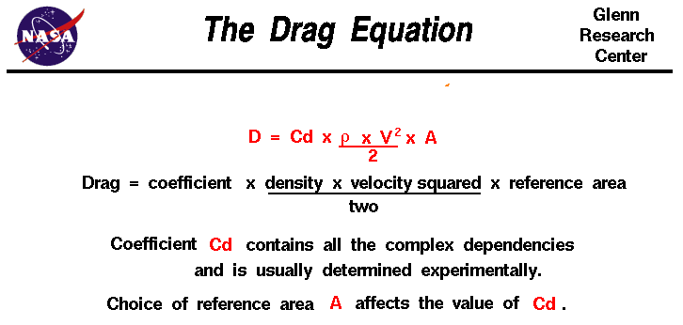
D = Cd x A x 0.5 x ρ x V ²

