7- Icing Hazards on Aviation
In the aviation world, ‘weather’ tends to be used to mean not only “what’s happening now?” but also “what’s going to happen during my flight?”. Based on the answer received, the pilot will opt to continue or cancel his flight. In this section we will examine some specific weather elements and how they affect flight.
- Icing
cloud droplets are in liquid form at temperatures warmer than 0°C and that they freeze into ice crystals within a few degrees below zero. In reality, however, 0°C marks the temperature below which water droplets become supercooled and are capable of freezing. While some of the droplets actually do freeze spontaneously just below 0°C, others persist in the liquid state at much lower temperatures.
Aircraft icing occurs when supercooled water droplets strike an aircraft whose temperature is colder than 0°C. The effects icing can have on an aircraft can be quite serious and include:
- Restriction of visibility as windshear glazes over.
- Increase in weight and drag thus increasing fuel consumption.
- partial or complete blockage of pitot heads and static ports giving erroneous instrument readings.
- disruption of the smooth laminar flow over the wings causing a decrease in lift and an increase in the stall speed. This effect is particularly dangerous, with an unknown stall speed.

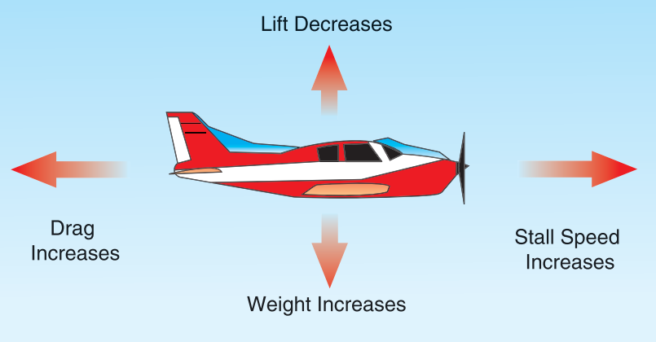
Figure 7-1 Effects of icing

- The Freezing Process
When a supercooled water droplet strikes an aircraft surface, it begins to freeze, releasing latent heat. This latent heat warms the remainder of the droplet to near 0°C, allowing the unfrozen part of the droplet to spread back across the surface until freezing is complete. The lower the air temperature and the colder the aircraft surface, the greater the fraction of the droplet that freezes immediately on impact. Similarly, the smaller the droplet, the greater the fraction of the droplet that freezes immediately on impact. Finally, the more frequent the droplets strike the aircraft surface, the greater the amount of water that will flow back over the aircraft surface. In general, the maximum potential for icing occurs with large droplets at temperatures just below 0°C.
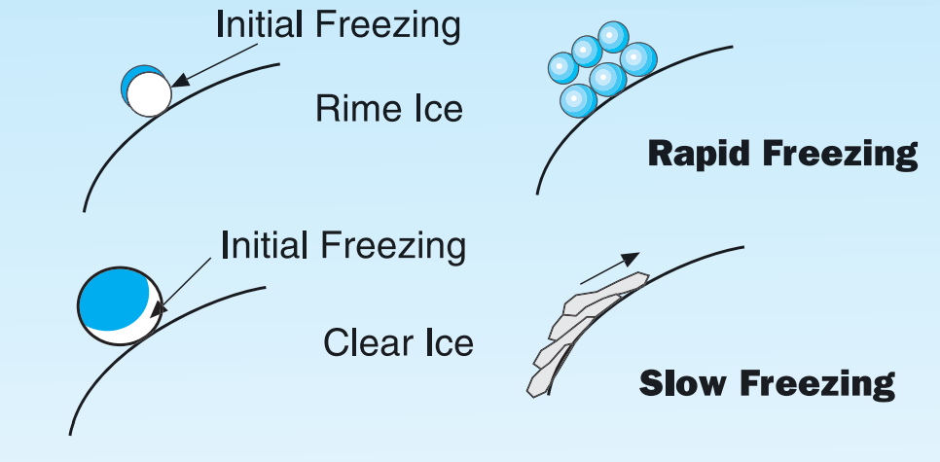
Figure 7-2 Freezing of supercooled droplets on impact
3-Types of Aircraft Ice
3-1 Rime Ice
Rime ice is a product of small droplets where each droplet has a chance to freeze completely before another droplet hits the same place. The ice that is formed is opaque and brittle because of the air trapped between the droplets. Rime ice tends to form on the leading edges of airfoils, builds forward into the air stream and has low adhesive properties.
3-2 Clear Ice
In the situation where each large droplet does not freeze completely before additional droplets become deposited on the first, supercooled water from each drop merges and spreads backwards across the aircraft surface before freezing completely to form an ice with high adhesive properties. Clear ice tends to range from transparent to a very tough opaque layer and will build back across the aircraft surface as well as forward into the air stream.

3-3 Mixed Ice
When the temperature and the range of droplet size vary widely, the ice that forms are a mixture of rime ice and clear ice. This type of ice usually has more adhesive properties than rime ice, is opaque in appearance, rough, and generally builds forward into the air stream faster than it spreads back over the aircraft surface.
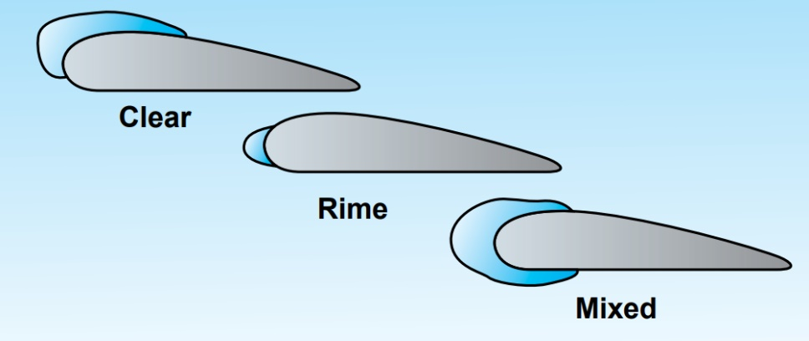
Figure 7-3 Accumulation patterns of different icing types
4 Meteorological Factors Affecting Icing
(a) Liquid Water Content of the Cloud
The liquid water content of a cloud is dependent on the size and number of droplets in a given volume of air. The greater the liquid water content, the more serious the icing potential. Clouds with strong vertical updrafts generally have a higher liquid water content as the updrafts prevent even the large drops from precipitating. The strongest updrafts are to be found in convective clouds, clouds formed by abrupt orographic lift, and in lee wave clouds. Layer clouds tend to have weak updrafts and are generally composed of small droplets.

(b)Temperature Structure in the Cloud
Warm air can contain more water vapor than cold air. Thus, clouds that form in warm air masses will have a higher liquid water content than those that form in cold air. The temperature structure in a cloud has a significant effect on the size and number of droplets. Larger supercooled droplets begin to freeze spontaneously around -10°C with the rate of freezing of all size of droplets increasing rapidly as temperatures fall below -15°C. By -40°C, virtually all the droplets will be frozen. The exceptions are clouds with very strong vertical updrafts, such as towering cumulus or cumulonimbus, where liquid water droplets can be carried to great heights before freezing.
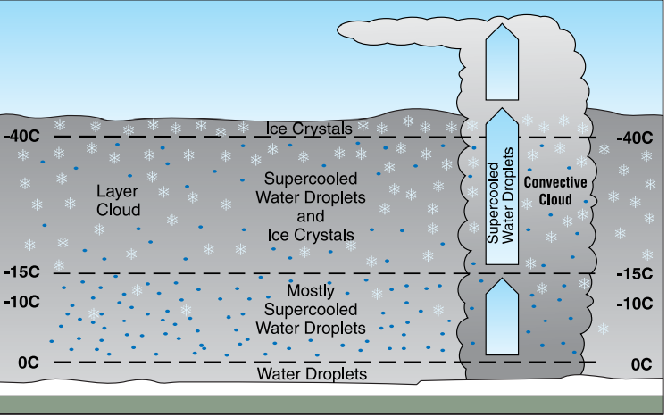
Figure 7-4 Distribution of water droplet-ice crystals in cloud
These factors allow the icing intensities to change rapidly with time so that it is possible for aircraft only minutes apart to encounter entirely different icing conditions in the same area. Despite this, some generally accepted rules have been developed:
1)Within large cumulus and cumulonimbus clouds:
- At temperatures between 0°C and -25°C, severe clear icing likely.
- At temperatures between -25°C and -40°C, light rime icing likely; small possibility of moderate to severe rime or mixed icing in newly developed clouds.
- At temperatures below -40°C, little chance of icing
2)Within layer cloud:
A- The most significant icing layer is generally confined to the 0°C to -15°C temperature range.
B- Icing is usually less severe than in convective cloud due to the weaker updrafts and smaller droplets.
C-Icing layers tend to be shallow in depth but great in horizontal extent.

5- Other Forms of Icing
(a) Freezing Rain and Ice Pellets
Freezing rain occurs when liquid water drops that are above freezing fall into a layer of air whose temperature is colder than 0°C and supercool before hitting some object. In this case, warm air (above 0°C) is forced up and over colder air at the surface. Rain that falls into the cold air supercool, resulting in freezing rain that can last for hours especially if cold air continues to drain into the area from the surrounding terrain. When the cold air is sufficiently deep, the freezing raindrops can freeze completely before reaching the surface causing ice pellets.
Pilots should be aware, however, that ice pellets at the surface imply freezing rain aloft. Such conditions are relatively common in the winter and tend to last a little longer in valleys than over flat terrain.

(b) Freezing Drizzle or Snow Grains
Freezing drizzle is different from freezing rain in that the water droplets are smaller. Another important difference is that freezing drizzle may develop in air masses whose entire temperature profile is below freezing. In other words, freezing drizzle can occur without the presence of a warm layer (above 0°C) aloft. In this case, favorable areas for the development of freezing drizzle are in moist maritime air masses, preferably in areas of moderate to strong upslope flow. The icing associated with freezing drizzle may have a significant impact on aviation. Similar to ice pellets, snow grains imply the presence of freezing drizzle aloft.

(c) Snow
Dry snow will not adhere to an aircraft surface and will not normally cause icing problems. Wet snow, however, can freeze hard to an aircraft surface that is at subzero temperatures and be extremely difficult to remove. A very dangerous situation can arise when an aircraft attempts to take off with wet snow on the flight surfaces. Once the aircraft is set in motion, evaporation cooling will cause the wet snow to freeze hard causing a drastic reduction in lift as well as increasing the weight and drag. Wet snow can also freeze to the windscreens making visibility difficult to impossible.

(d) Freezing Spray
Freezing spray develops over open water when there is an outbreak of Arctic air. While the water itself is near or above freezing, any water that is picked up by the wind or is splashed onto an object will quickly freeze, causing a rapid increase in weight and shifting the center of gravity.

(e) Freezing Fog
Freezing fog is a common occurrence during the winter. Fog is simply “a cloud touching the ground” and, like its airborne cousin, will have a high percentage of supercooled water droplets at temperatures just below freezing (0°C to -10°C). Aircraft landing, taking off, or even taxiing, in freezing fog should anticipate rime icing.

