8- Visibility
Reduced visibility is the meteorological component which impacts flight operations the most. Topographic features all tend to look the same at low levels making good route navigation essential. This can only be done in times of clear visibility.
1-Types of Visibility
There are several terms used to describe the different types of visibility used by the aviation community.
(a) Horizontal visibility - the furthest visibility obtained horizontally in a specific direction by referencing objects or lights at known distances.
(b) Prevailing visibility - the ground level visibility which is common to one-half or more of the horizon circle.
(c)Vertical visibility - the maximum visibility obtained by looking vertically upwards into a surface-based obstruction such as fog or snow.
(d) Slant visibility - visibility observed by looking forward and downwards from the cockpit of the aircraft.
(e) Flight visibility - the average range of visibility at any given time forward from the cockpit of an aircraft in flight
2-Causes of Reduced Visibility
(a) Lithometers
Lithometers are dry particles suspended in the atmosphere and include haze, smoke, sand and dust. Of these, smoke and haze cause the most problems. The most common sources of smoke are forest fires. Smoke from distant sources will resemble haze but, near a fire, smoke can reduce the visibility significantly.

(b) Precipitation
Rain can reduce visibility; however, the restriction is seldom less than one mile other than in the heaviest showers beneath cumulonimbus clouds. Drizzle, because of the greater number of drops in each volume of air, is usually more effective than rain at reducing the visibility, especially when accompanied by fog. Snow affects visibility more than rain or drizzle and can easily reduce it to less than one mile. Blowing snow is a product of strong winds picking up the snow particles and lifting them into the air.
(c) Fog
Fog is the most common and persistent visibility obstruction encountered by the aviation community. A cloud based on the ground, fog, can consist of water droplets, supercooled water droplets, ice crystals or a mix of supercooled droplets and ice crystals.
(1) Radiation Fog
Radiation fog begins to form over land usually under clear skies and light winds typically after midnight and peaks early in the morning. As the land surface loses heat and radiates it into space, the air above the land is cooled and loses its ability to hold moisture. If an abundance of condensation nuclei is present in the atmosphere, radiation fog may develop before the temperature-dewpoint spread reaches zero. After sunrise, the fog begins to burn off from the edges over land but any fog that has drifted over water will take longer to burn off.

(2) Precipitation or Frontal Fog
Precipitation fog, or frontal fog, forms ahead of warm fronts when precipitation falls through a cooler layer of air near the ground. The precipitation saturates the air at the surface and fog forms. Breaks in the precipitation usually results in the fog becoming thicker.

(3) Steam Fog
Steam fog forms when very cold arctic air moves over relatively warmer water. In this case moisture evaporates from the water surface and saturates the air. The extremely cold air cannot hold all the evaporated moisture, so the excess condenses into fog. The result looks like steam or smoke rising from the water, and is usually no more than 50 to 100 feet thick. Steam fog, also called arctic sea smoke, can produce significant icing conditions.

(4) Advection Fog
Fog that forms when warm moist air moves across a snow, ice or cold-water surface.

(5) Ice Fog
Ice fog occurs when water vapor sublimates directly into ice crystals. In conditions of light winds and temperatures colder than -30°C or so, water vapor from manmade sources or cracks in ice-covered rivers can form widespread and persistent ice fog. The fog produced by local heating systems, and even aircraft engines, can reduce the local visibility to near zero, closing an airport for hours or even days.
(d) Snow Squalls and Streamers
Snow squalls are relatively small areas of heavy snowfall. They develop when cold arctic air passes over a relatively warm water surface, such as Lake Winnipeg, before freeze-up. An injection of heat and moisture from the lake into the low levels of the atmosphere destabilizes the air mass. If sufficient destabilization occurs, convective clouds begin to develop with snow beginning shortly thereafter. Snowsqualls usually develop in bands of cloud, or streamers, that form parallel to the direction of flow. Movement of these snow squalls can generally be tied to the mean winds between 3,000 and 5,000 feet. Not only can snowsqualls reduce visibility to near zero but, due to their convective nature, significant icing and turbulence are often encountered within the clouds.

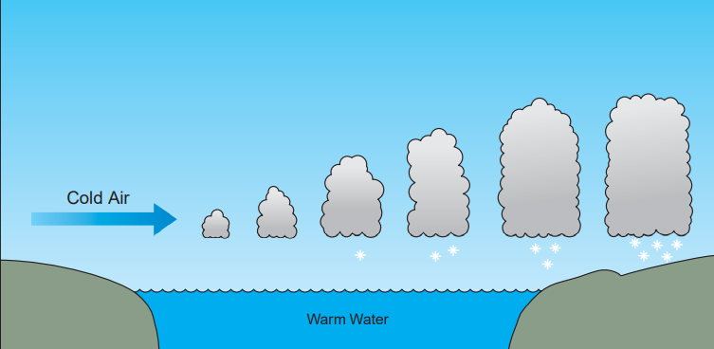
Figure 7-6 Snowsqualls building over open water

