Lecture one
Electromagnetic radiation

1- Electromagnetic spectrum:
Electromagnetic radiation travels in wave form, and all electromagnetic waves travel at the same speed, (speed of light). This is 2.99793 ± 1 × 10⁸ m sec⁻¹ in a vacuum and very nearly the same speed in air. Visible light, gamma rays, x-rays, ultraviolet light, infrared radiation, microwaves, television signals, and radio waves constitute the electromagnetic spectrum. The human eye is sensitive to electromagnetic waves with frequencies between 4.3 × 10¹⁴ vibrations per second (usually written as cycles per second and abbreviated cps) and 7.5 × 10¹⁴ cps. Hence, this band of frequencies is called the visible region of the electromagnetic spectrum. The eye, however, does not respond to frequencies of electromagnetic waves higher than 7.5 × 10¹⁴ cps. Such waves, lying beyond the violet edge of the spectrum, are called ultraviolet light. The human eye also does not respond to electromagnetic waves with frequencies lower than 4.3 × 10¹⁴ cps. These waves, having frequencies lower than the lowest frequency of visible light at the red end of the spectrum and higher than about 3 × 10¹² cps, are called infrared light or infrared radiation. Just beyond the infrared portion of the spectrum are microwaves, which cover the frequencies from about 3 × 10¹⁰ cps to 3 × 10¹² cps. The x-ray region of the electromagnetic spectrum consists of waves with frequencies ranging from about 3 × 10¹⁶ cps to 3 × 10¹⁸ cps, and is adjacent to the ultraviolet region in the spectrum. The gamma-ray region of the spectrum has the highest frequencies of all, ranging upward from about 3 × 10¹⁹ cps. Radiowaves have the lowest frequencies in the spectrum, extending downward from about 3 × 10⁵ cps. Electromagnetic waves are often described in terms of their wavelength rather than their frequency. The following general formula connects frequency ˜ν and wavelength:
$$=\frac{c}{\tilde{v}}$$
Where c represents the speed of light in a vacuum. This Equation is valid for any type of wave and is not restricted to electromagnetic waves. It is customary to use wavenumber ν to describe the characteristics of infrared radiation. It is defined by:
$$v= \tilde{\frac{v}{c}} = \frac{1}{}$$

However, a frequency unit called gigahertz (GHz) is commonly used. One GHz is equal to 10⁹ cycles per second. Figure 1, shows the complete electromagnetic spectrum along with each region’s corresponding frequency, wavenumber, and wavelength.

table 1: the electromagnetic spectrum in terms of wavelength in μm, frequency in GHz, and wavenumber in cm⁻¹
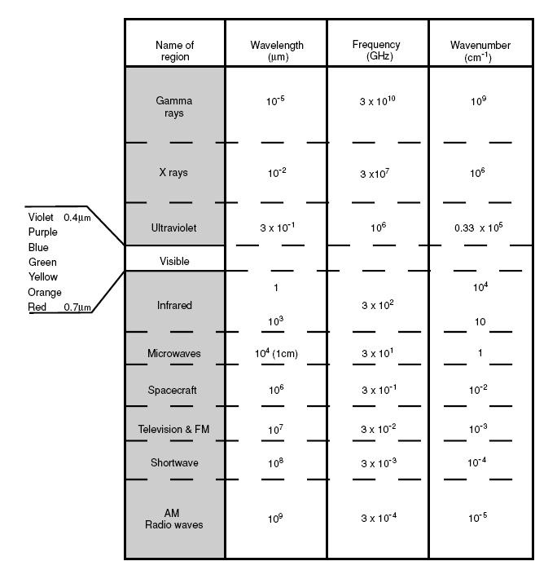

2- Solid angle:
A solid angle is defined as the ratio of the area σ of a spherical surface intercepted at the core to the square of the radius, r, as indicated in Fig. 1. It can be written as:
$$=\frac{σ}{R^{2}} …………………..(1)$$

Units of solid angle are expressed in terms of the steradian (sr). For a sphere whose surface area is 4πR², its solid angle is 4π sr. solid angle is the space included inside a conical surface.
The concept of plane angles is extended in to the three – dimensional space. For plane angle that have one layer:
$dθ= \frac{ds}{r}$
$$when ds=1, r=1 , dθ=1 radian$$
To obtain a differential elemental for solid angle,$d$ we construct a sphere whose central point is denoted as O. Assuming a line through point O moving in space and intersecting an arbitrary surface located at a distance R from point O, and then as is evident from Fig.2, the differential area in polar coordinates is given by:
$$dσ=\frac{Rdθ}{R sinθ d∅} ………………..(2)$$

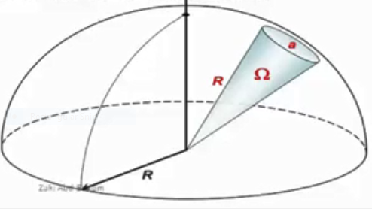
Fig.2: Definition of a solid angle Ω, where a denotes the area, and r is the distance.

When the small plane area is not perpendicular with the normal and makes angle $θ$ with the axis thus:
$d=\frac{d \cos{θ}}{R^{2}}$
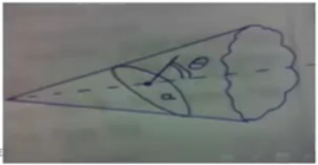
Notes:
The zenith angle is the angle between the sun and the vertical. The zenith angle is similar to the elevation angle but it is measured from the vertical rather than from the horizontal.
The azimuth angle is the compass direction from which the sunlight is coming. At solar noon, the sun is always directly south in the northern hemisphere and directly north in the southern hemisphere. The azimuth angle varies throughout the day. At the equinoxes, the sun rises directly east and sets directly west regardless of the latitude, thus making the azimuth angles 90° at sunrise and 270° at sunset. In general however, the azimuth angle varies with the latitude and time of year.

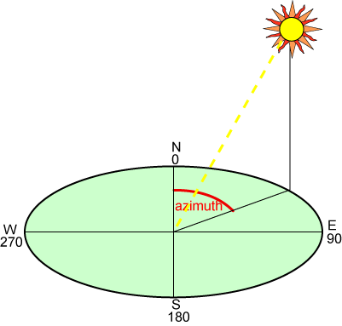
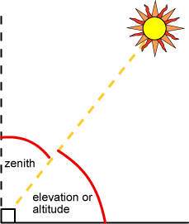

Hence, the differential solid angle is
$d=\frac{d}{R^{2}} = \frac{Rsinθ d∅ . Rdθ }{R^{2}}=sinθ dθ d∅…………..(3)$
Where θ and φ denote the zenith and azimuthal angles, respectively, in polar coordinates.

3-Flux and intensity:
Flux measured in watts per square meter and is measure of the net radiant energy passing through a given area, independent of the direction of the energy.
Intensity on other hand is measure in watt per square meter per steradian. That means it’s a measure of the mount of radiant energy passing through a given area in the direction of a given solid angle. Intensity can be also consider as a function of direction. (theta). To get form intensity to flux we need to determine the total net intensity passing through a given surface area, to do this we need to integrate by cos ( theta) d( solid angle):
Flux= integrat( intensity * cos(theta) * d( solid angle))
The cos(theta) term is there because the given surface area we are used might be at an oblique angle to some of the rays that intensity is describing , so they will see a shortened view of the size of the surface area and not as much will pass through.

