Lec (10) Immunology
Immunological Tolerance
Immunological tolerance is a lack of response to antigens that is induced by exposure of lymphocytes to these antigens. When lymphocytes with receptors for a particular antigen encounter this antigen, any of several outcomes is possible. The lymphocytes may be activated to proliferate and to differentiate into effector and memory cells, leading to a productive immune response; antigens that elicit such a response are said to be immunogenic. The lymphocytes may be functionally inactivated or killed, resulting in tolerance; antigens that induce tolerance are said to be tolerogenic. In some situations, the antigen-specific lymphocytes may not react in any way; this phenomenon has been called immunological ignorance, implying that the lymphocytes simply ignore the presence of the antigen. Normally, microbes are immunogenic and self antigens are tolerogenic.
The choice between lymphocyte activation and tolerance is determined largely by the nature of the antigen and the additional signals present when the antigen is displayed to the immune system. In fact, the same antigen may be administered in different ways to induce an immune response or tolerance. This experimental observation has been exploited to analyze what factors determine whether activation or tolerance develops as a consequence of encounter with an antigen.
The phenomenon of immunological tolerance is important for several reasons. First, as we stated at the outset, self antigens normally induce tolerance, and failure of self-tolerance is the underlying cause of autoimmune diseases. Second, if we learn how to induce tolerance in lymphocytes specific for a particular antigen, we may be able to use this knowledge to prevent or control unwanted immune reactions. Strategies for inducing tolerance are being tested to treat allergic and autoimmune diseases and to prevent the rejection of organ transplants. The same strategies may be valuable in gene therapy to prevent immune responses against the products of newly expressed genes or vectors and even for stem cell transplantation if the stem cell donor is genetically different from the recipient.
Immunological tolerance to different self antigens may be induced when developing lymphocytes encounter these antigens in the generative (central) lymphoid organs, a process called central tolerance, or when mature lymphocytes encounter self antigens in peripheral (secondary) lymphoid organs or peripheral tissues, called peripheral tolerance (Fig. 1). Central tolerance is a mechanism of tolerance only to self antigens that are present in the generative lymphoid organs—namely, the bone marrow and thymus. Tolerance to self antigens that are not present in these organs must be induced and maintained by peripheral mechanisms. We have only limited knowledge of how many and which self antigens induce central or peripheral tolerance or are ignored by the immune system.
Tolerance in T cells, particularly CD4+ helper T lymphocytes, is discussed first because many of the mechanisms of self-tolerance were defined by studies of these cells. In addition, CD4+ helper T cells orchestrate virtually all immune responses to protein antigens, so tolerance in these cells may be enough to prevent both cell-mediated and humoral immune responses against self proteins. Conversely, failure of tolerance in helper T cells may result in autoimmunity manifested by T cell–mediated attack against self antigens or by the production of autoantibodies against self proteins.
CENTRAL T LYMPHOCYTE TOLERANCE
The principal mechanisms of central tolerance in T cells are death of immature T cells and the generation of CD4+ regulatory T cells (Fig-2). The lymphocytes that develop in the thymus consist of cells with receptors capable of recognizing many antigens, both self and foreign. If a lymphocyte that has not completed its maturation interacts strongly with a self antigen, displayed as a peptide bound to a self major histocompatibility complex (MHC) molecule, that lymphocyte receives signals that trigger apoptosis. Thus, the self-reactive cell dies before it can become functionally competent. This process, called negative selection ,is a major mechanism of central tolerance. The process of negative selection affects self-reactive CD4+ T cells and CD8+ T cells, which recognize self peptides displayed by class II MHC and class I MHC molecules, respectively. It is not known why immature lymphocytes die upon receiving strong T cell receptor (TCR) signals in the thymus, whereas mature lymphocytes that get strong TCR signals in the periphery are activated.
Some immature CD4+ T cells that recognize self antigens in the thymus with high affinity do not die but develop into regulatory T cells and enter peripheral tissues (Fig. 2). What determines whether a thymic CD4+ T cell that recognizes a self antigen will die or become a regulatory T cell is also not known.
Immature lymphocytes may interact strongly with an antigen if the antigen is present at high concentrations in the thymus and if the lymphocytes express receptors that recognize the antigen with high affinity. Antigens that induce negative selection may include proteins that are abundant throughout the body, such as plasma proteins and common cellular proteins.

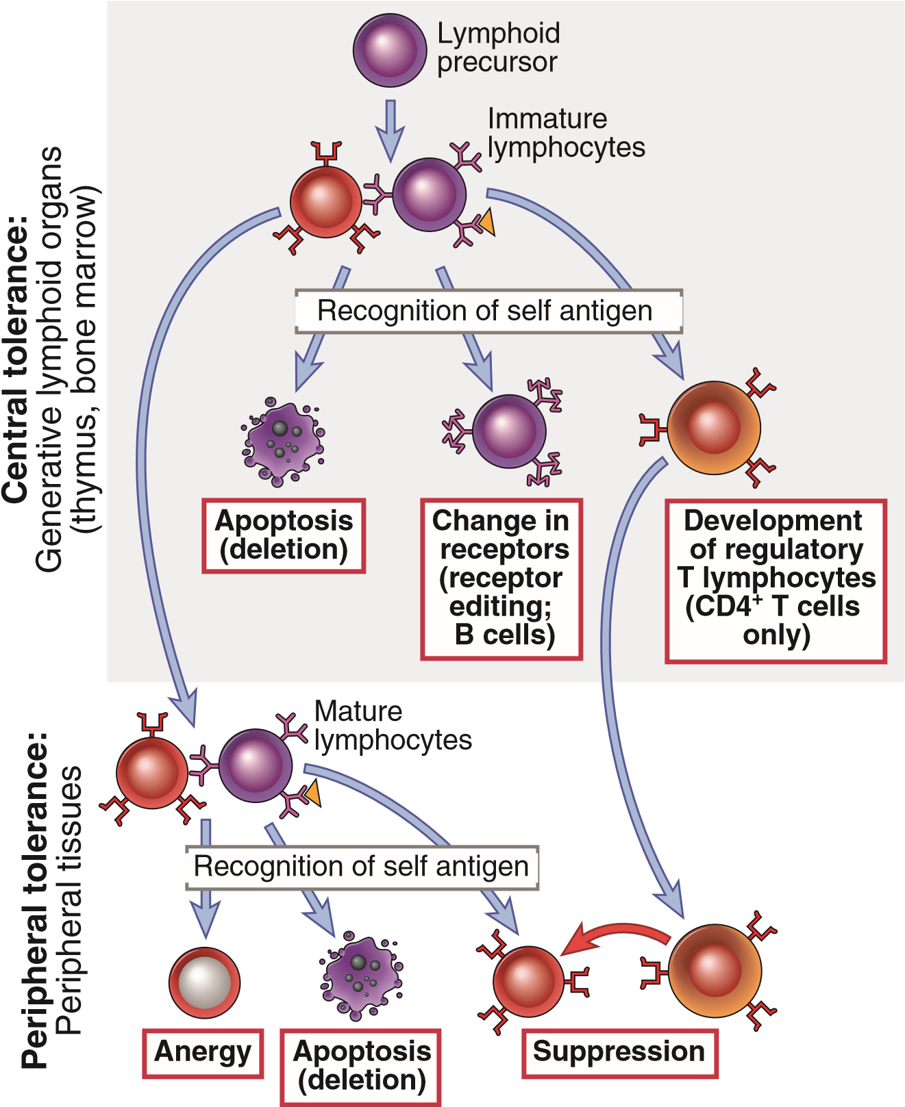
FIGURE 1 Central and peripheral tolerance to self antigens. Central tolerance: Immature lymphocytes specific for self antigens may encounter these antigens in the generative (central) lymphoid organs and are deleted; B lymphocytes change their specificity (receptor editing); and some T lymphocytes develop into regulatory T cells. Some self-reactive lymphocytes may complete their maturation and enter peripheral tissues. Peripheral tolerance: Mature self-reactive lymphocytes may be inactivated or deleted by encounter with self antigens in peripheral tissues, or suppressed by regulatory T cells.

PERIPHERAL T LYMPHOCYTE TOLERANCE
Peripheral tolerance is induced when mature T cells recognize self antigens in peripheral tissues, leading to functional inactivation (anergy) or death, or when the self-reactive lymphocytes are suppressed by regulatory T cells (Fig. 3). Peripheral tolerance is clearly important for preventing T cell responses to self antigens that are not present in the thymus, and it also may provide backup mechanisms for preventing autoimmunity in situations where central tolerance is incomplete.
Antigen recognition without adequate costimulation results in T cell anergy or death, or makes T cells sensitive to suppression by regulatory T cells. naive T lymphocytes need at least two signals to induce their proliferation and differentiation into effector and memory cells: Signal 1 is always antigen, and signal 2 is provided by co stimulators that are expressed on antigen-presenting cells (APCs), typically as part of the innate immune response to microbes (or to damaged host cells) It is believed that dendritic cells in normal uninfected tissues and peripheral lymphoid organs are in a resting (or immature) state, in which they express little or no costimulators, such as B7 proteins These dendritic cells may constantly process and display the self antigens that are present in the tissues. T lymphocytes with receptors for the self antigens are able to recognize the antigens and thus receive signals from their antigen receptors (signal 1), but the T cells do not receive strong costimulation because there is no accompanying innate immune response. The presence or absence of costimulation is a major factor determining whether T cells are activated or tolerized.
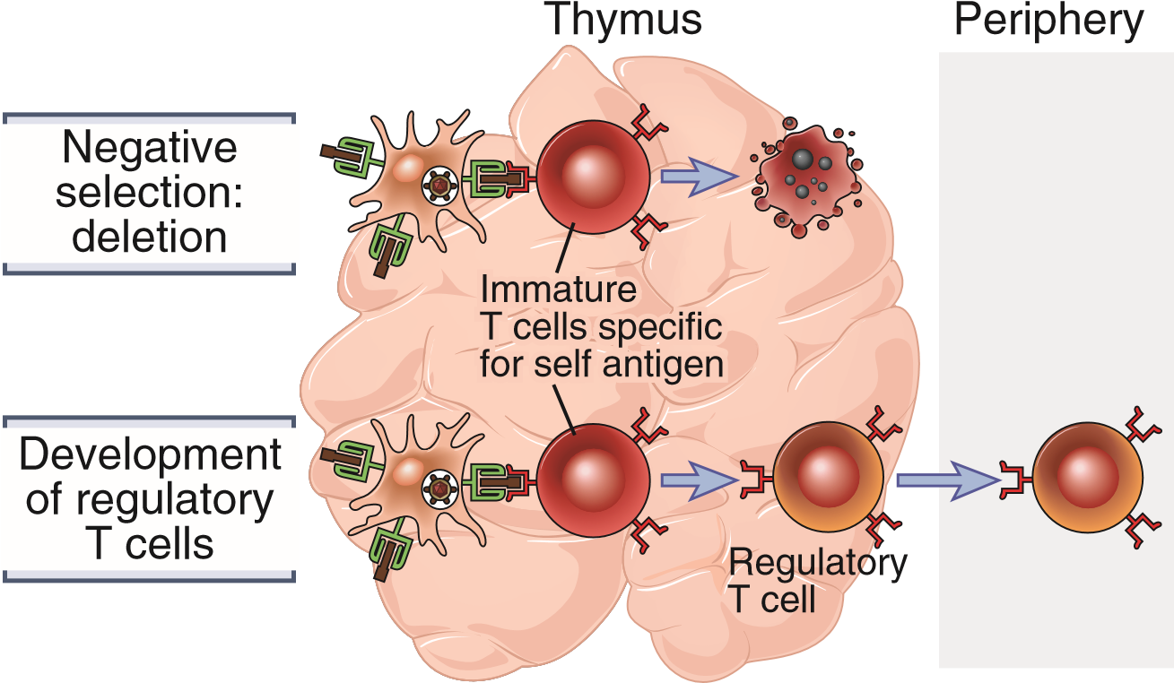
Fig2: Central T cell tolerance. Strong recognition of self antigens by immature T cells in the thymus may lead to death of the cells (negative selection, or deletion), or the development of regulatory T cells that enter peripheral tissues.
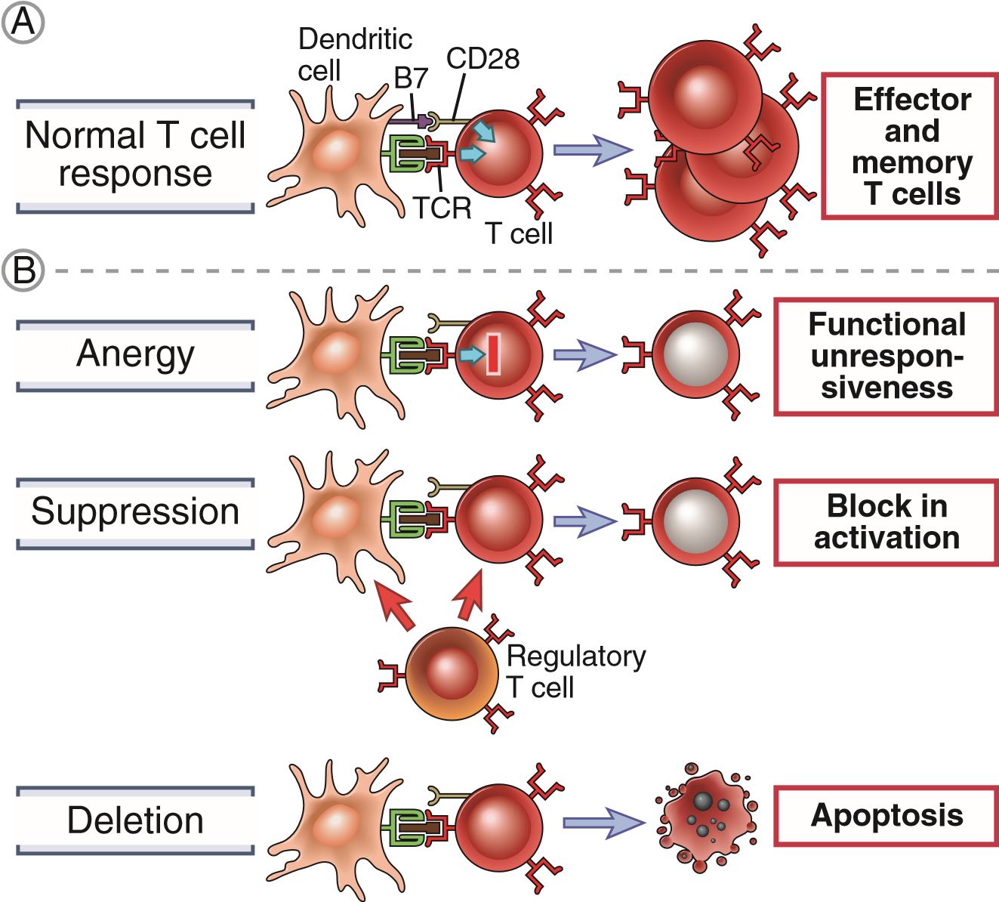

Fig3: Peripheral T cell tolerance. A, Normal T cell responses require antigen recognition and costimulation. B, Three major mechanisms of peripheral T cell tolerance: cell-intrinsic anergy, suppression by regulatory T cells, and deletion (apoptotic cell and death).

