LAB // 1
Comparative anatomy is the study of similarities and differences in the anatomy of different species. It indicates that various organisms share a common ancestor. Also, it helps scientists in classifying organisms based on similar characteristics of their anatomical structures. Two major facts of comparative anatomy are:
1. Homologous structures - structures which are similar in different species because the species have common origin. They may or may not play the same function. An example is the forelimb structure shared by cats and whales.
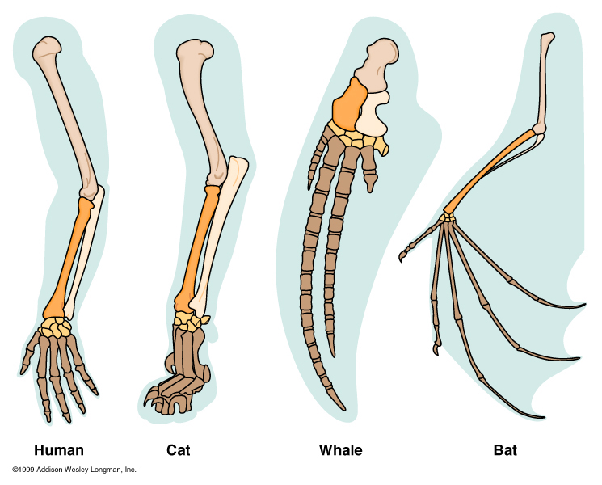

2. Analogous structures - It shows that the basic structures of wings of butterfly, bird and bat are different. In other words, they are anatomically different, although externally they look alike. Wings in these animals are used for similar function (flying) but they are differing anatomically and in embryonic origin.
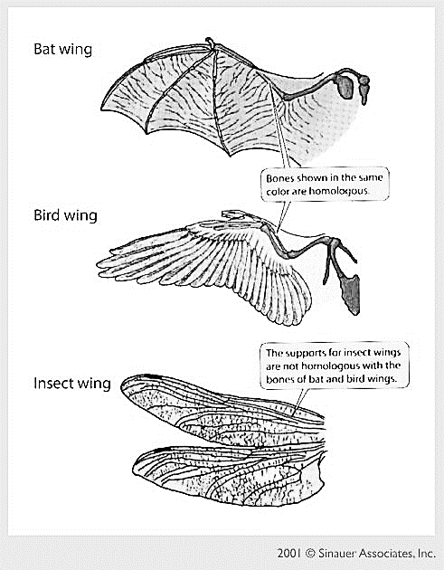
Phylum Chordate
Chordate: phylum of animals having a notochord, as the main internal skeletal support at some stage of their development. Most chordates are vertebrates (animals with backbones), but the phylum also includes some small marine invertebrate animals.

Major Characteristics of Phylum Chordate
1. A single, hollow nerve cord runs just under the dorsal surface of the animal.
In vertebrates, the dorsal nerve cord differentiates into the brain and spinal cord.
2. Notochord is a flexible rod present at some developmental stage in all chordates. The notochord is located just below the nerve cord. The notochord may continue throughout the life cycle of some chordates or be replaced during embryonic development.
3. Pharyngeal slits connect the pharynx and the esophagus, with the outside.
4. Chordates have a post anal tail that extends behind the anus, at least during
their embryonic development.

Minor Characteristics of Phylum Chordata
- Chordates are bilaterally symmetrical, which means there is a line of symmetry that divides their body into similar halves.
- Segmentation results from repetition of body parts, allowing further specialization and differentiation.
- Cephalization means that the concentration of sensory organs, feeding organs, and neural centers near the anterior end of the animal.
- They have a true body cavity or coelom.
Sub phylum: Hemichordata
The name "hemichordate" means "half chordate”. There is a primitive structure in the collar region that is similar to a notochord.
* Body cavity a true coelom.
* Bilaterally symmetrical.
* Body divided into three sections, a proboscis, a collar and a trunk.
* There are branchial openings, or "gill slits," that open into the pharynx.
* There is a dorsal nerve cord, in addition to a smaller ventral nerve cord.
Example: Balanoglssus
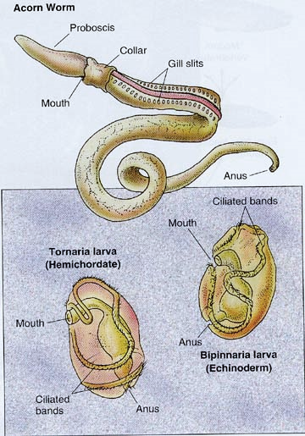

Sub phylum: Urochordata
- Small marine animals with larvae that swim freely and adults that connect themselves to the ocean floor.
- Larva has notochord in the tail. It disappears during development.
- Respiratory system contains gills in the pharyngeal wall.
- Nervous system is represented by a single dorsal ganglion in the adult.
- Coelom is absent. Example: Acedia

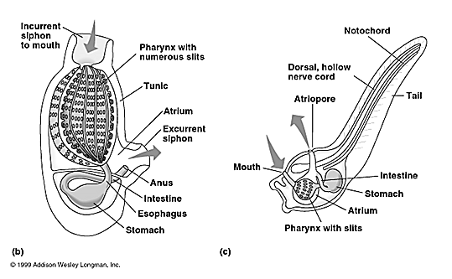

Sub phylum: Cephalochordata
- Body is fish -like and is useful for drilling and swimming.
- Notochord extends from the anterior end to posterior end.
- coelom is present.
- Respiration by gills.
- A single, dorsal, hollow nerve cord, usually with an enlarged anterior end (brain). Example: Amphioxus.

