LAB //4

Amphibia
Phylum: Chordata
Sub phylum: Vertebrata
Super class: Tetrapoda
Class: Amphibia
Order: Anura
Genus: Rana ridibunda
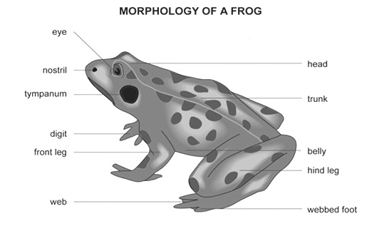
Frogs belong to a group of animals called amphibians. Amphibian means two-lives. Frogs begin their lives in the water as eggs and then tadpoles and when they are fully developed they live on land.
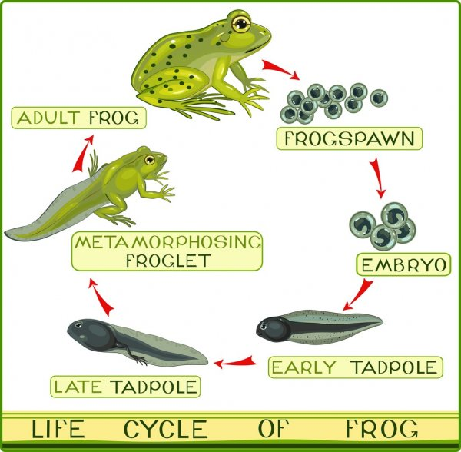
Frogs are found all over the world, they can be found near any fresh water, lakes, and marshes. The body of a frog can be divided into a head, a short neck, and a trunk. Frogs have very powerful back legs and webbed feet that help them jump great distances, as well as, swim. Frog eyes are present on the side of their heads allowing them to see all directions and can even see behind them without moving their heads. Each eye has three eyelids: an upper and lower lid and a transparent lid that protects the frog's eyes. Frog ears are behind their eyes, frogs can hear using big round ears on the sides of their head called a tympanum which transfers sound vibrations to the inner ear. Frogs breathe through their nostrils while also absorbing about half the air they need through their skin. A frog’s skin is usually moist and thin, it does not have scales, hair, or other protective features. Instead of drinking water, they absorb it through their skin. Glands in the skin secrete mucus to help keep the skin moist. Frogs also have glands that produce poison to help them escape from predators.
Digestive system
Alimentary canal: - it is long, coiled tube which starts from mouth to anus. It consists of following organs:
Bucco-pharyngeal cavity: The buccal cavity and pharynx together is called bucco-
pharyngeal cavity, it lies between upper jaw and lower jaws. Upper jaw is immovable but lower jaw is movable.
There are two types of teeth. Maxillary teeth- they are found in upper jaw, all these teeth are very small and similar in size. Vomerine teeth are present on either side of roof buccopharyngeal cavity, they help to capture prey from slipping out.

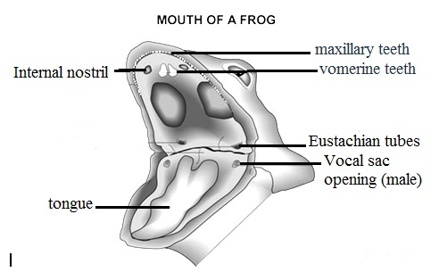

Tongue: It is thick, fleshy, and muscular; it can be thrown out and return in. It arises from in front of lower jaw. The tongue secrets a kind of sticky substance so that insects or prey coming and sticks in tongue.
Vocal sac: In male frog on either side of the tongue on the lower jaw there are two pores called vocal sacs, which produce croaking sound.

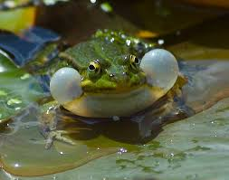

Pharynx: Posterior part of buccopharyngeal cavity is called pharynx, which opens into oesophagus.
Oesophagus: It is wide, short muscular tube which opens into stomach.
Stomach: The stomach is large, thick walled muscular. Anterior part of stomach is called cardiac part and posterior part is called pyloric part.
Intestine: It is long, coiled part which starts from pyloric constriction. Intestine is divided into two parts:
a- Small intestine: it consists of:
Duodenum: Duodenum is the anterior part of Small intestine; it is U-shaped structure which joined the stomach to the coiled ileum.
Ileum: Is coiled part, it is internally highly folded; foldings is called villi, which increase absorptive surface.
b- Large intestine: Also called rectum, is short and opens outside through cloaca and the opening is called cloacal aperture.
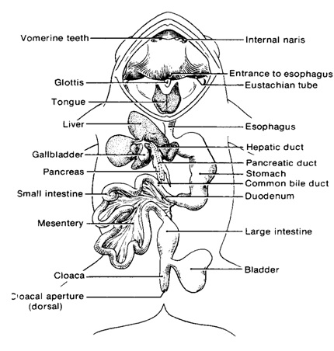

Digestive glands
1. Gastric glands: They are present on the stomach wall. They secret HCL and enzyme pepsinogen.
2. Liver: It is large gland. It has two lobe-right lobe and left lobe. Left lobe is again divided into two lobes. There is a small sac like thin walled bladder present on right lobe called gall bladder which stores bile. Liver secrets bile through bile-duct which opens into the duodenum.
3. Pancreas, and an important digestive gland that secretes pancreatic juice into the duodenum.
Respiratory system
The respiration through the lungs is called pulmonary respiration. There is a pair of lungs. The lungs are thin walled elastic sacs. They are present within thoracic cavity on either side of heart. Numerous small air sacs are present in the lungs called alveoli.
The alveoli are very thin walled and supplied by blood vessels. The air enters into the external nares, internal nares, buccopharyngel cavity, glottis, trachea, lung and alveoli where the gas exchange takes place.
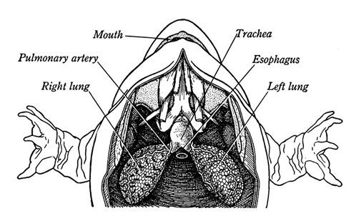
Urinary system
The frog's urinary system organs include the kidneys, ureter, bladder and cloaca. The kidneys are reddish-brown and located on either side of the backbone. The bladder, a thin membranous sac, is usually deflated unless filled with urine.
Urine is produced in the kidneys and passed through tubes called ureters directly to the cloaca for excretion, or to the urinary bladder for storage before moving to the cloaca.

Reproductive system
In frog sexes are separate. Male and female frogs can be morphologically distinguished. The male frog has vocal cords which enable them to make a croaking noise to attract the females during breeding season. Male reproductive organs consist of a pair of yellowish ovoid testes, which are found adhered to the upper part of kidneys by a double fold of peritoneum called mesorchium. Each testis opens into the kidneys by numerous fine ducts called vasa efferentia. Sperms produced by the testis are carried through the ureters which in the male are called urinogenital ducts. This duct opens into the cloaca. The cloaca is a small, median chamber that is used to pass faecal matter, urine and sperms to out the body.
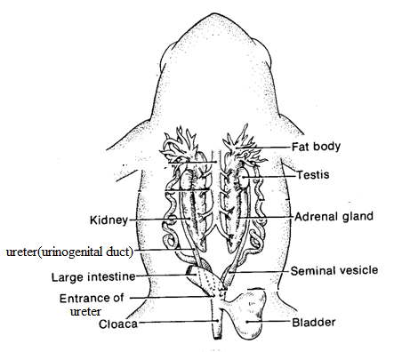
The female reproductive system consists of a pair of ovaries and a pair of oviducts. Each ovary like testes adhered to the kidneys by a double fold of peritoneum called mesovarium. Ovary is lobulated sac like structures composed of ovarian follicles consists of countless ova; the colour of the ovary is yellowish with small black spots. The ovoiducal funnel or ostium is located on the dorsal side of the lung. The oviducal funnel leads into the oviduct. This oviduct is straight and thin-walled for a short distance, then it becomes highly coiled and thick-walled which runs behind the kidney. The posterior portion of the oviduct becomes very thin walled. It is sac-like and is called ovisac where the ova are stored. The ovisac opens into the cloaca by its apertures lying anteriorly to the openings of ureters. The cloaca opens to the exterior by a cloacal aperture.
The fat bodies in frogs are yellowish to orange in color. They have a finger-like shape. The fat bodies are needed for hibernating and for mating. They are located near the testes in males and near the ovaries in females.
Egg fertilization happens outside the female's body instead of inside. The female releases her eggs and the male releases his sperm at the same time. The eggs are immediately fertilized before dropping into the water. A jellylike substance surrounds the egg when dropped into the water, and it swells on contact to protect the eggs from predators and harmful bacteria.
