LAB // 5
Reptilia
Phylum: Chordata
Sub phylum: Vertebrata
Super class: Tetrapoda
Class: Reptilia
Order: Squamata
Class Reptilia, is divided into four orders - Crocodilia, Rhynchocephalia, Squamata and Testudines. Most of the reptiles are tetrapods they are four-legged animals with 5 fingers, but there are exceptions like snakes which are legless reptiles, they move along the ground by flexing their body and can move very quickly. Reptiles are considered as the first animals with the ability to live and multiply on land. Reptiles have a dry skin covered with small; thin horny scales develop from the epidermis of the skin (or) bony structures scutes that form from the dermis. Snakes have scales, whereas turtles and crocodiles have scutes. These structures prevent water loss.
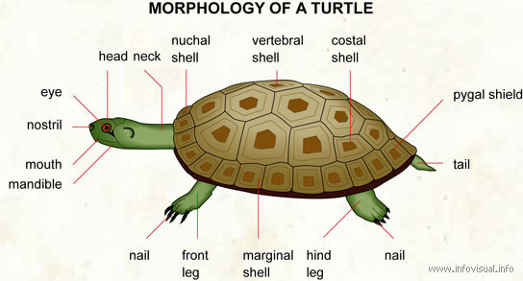
In the case of snakes, the complete outer layer of skin is shed in one layer. Snake scales are not discrete but extensions of the epidermis hence they are not shed separately, but are ejected as a complete contiguous outer layer of skin during each moult.The old skin breaks near the mouth and the snake wriggles out, aided by rubbing against rough surfaces. Turtle have a shell which is made up of 60 different bones all connected together, the shell is covered with plates (scutes) that are derivatives of skin and offer additional strength and protection. Glands are absent in the skin of Reptiles.
The reptile's senses of sight, smell, and hearing are similar to those of other vertebrates, though the levels of development of these senses vary among reptile groups. Snakes lack ears and can detect only ground vibrations or airborne vibrations of low frequency. Snakes and lizards have a specialized, chemically sensitive organ, called Jacobson's organ, located in the roof of their mouths. These animals can detect the presence of chemicals in their surroundings by flicking their tongues out and in rapidly.
Digestivesystem The mouths of reptiles are large. Snakes have a very flexible lower jaw, the two halves of which are not tough attached, and numerous other joints in their skull. These modifications allow them to open their mouths wide enough to swallow their prey whole, even if it is wider than they are.
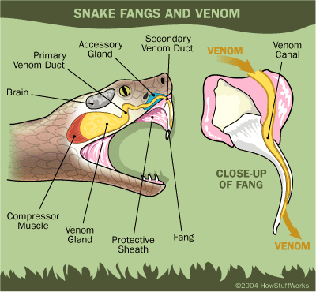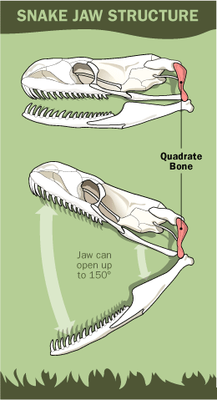

The tongues of reptiles are as varied as the species. The tongue has many functions including the capture of prey, transport the food to the back of the mouth and providing taste. All turtles lack teeth. Snakes, lizards and crocodilians all have teeth. Oral glands include the premaxillary, sublingual, lingual, and mandibular glands, not all of the oral glands are found in all reptile species. In snake the venom gland lies along the lower jaw and empties near grooved, multiple teeth within the mouth. Directly inside the mouth is the buccal cavity, this leads to the esophagus. The esophagus of snakes has more internal folds than other reptiles, which allows for the swallowing of large, whole prey. The stomach is a j-shaped organ, stomach secrete digestive enzymes and gastric juices that breakdown proteins. The food then passes through the pyloric valve into the small intestine. The small intestine is a long narrow coiled tube where absorbance of nutrients takes place. The small intestine is divided into three regions: the duodenum, the ileum, and jejunum. The liver, producing bile and excretes digestive enzymes into the duodenum. Also, the pancreas produces insulin and digestive enzymes secrete them into the duodenum.
At the junction of the small intestines and large intestines is the caecum. The large intestine absorbs the water from the food before moving to the cloaca chamber.
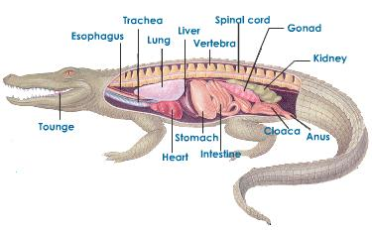

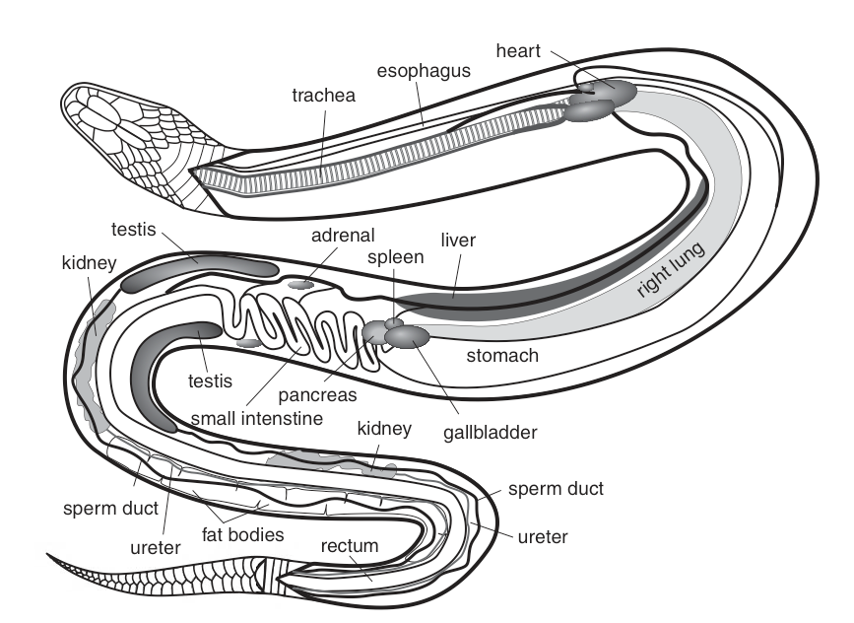
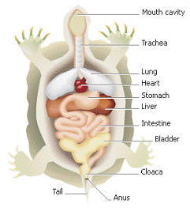

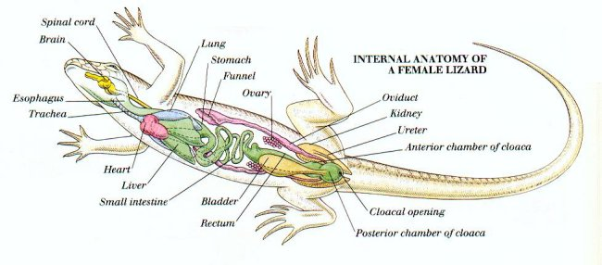
Respiratorysystem
The lungs of reptiles are large, and they are often divided internally into several chambers. The lining of the lungs may be folded into numerous small sacs called alveoli. Alveoli greatly increase the internal surface area of the lungs, thus increasing the amount of oxygen that can be absorbed. In most snakes, only the right lung actively functions. The left lung is either reduced to a small nonfunctional sac or absent entirely. A reptile fills its lungs by expanding its rib cage. This expansion reduces the pressure within the thorax and draws air into the lungs. When the ribs return to their resting position, pressure within the thorax increases, and air is forced out of the lungs.
Excretory system
The excretory system is made up of the paired elongated dark red and irregular in shape kidneys composed of glomerular nephrons. Each kidney has two lobes Anterior and posterior lobe. Ureters carry the urine (fluid in turtles and crocodiles; semisolid with insoluble urates in the other) to a thin walled urinary bladder which opens on the ventral side of cloaca. In males the ureters join at its posterior end with its corresponding vas deferens and both open by a common urino-genital aperture. A thin walled urinary bladder opens on the ventral side of cloaca.

Reproductive system

The male reproductive system consists of paired white elongated testes. Testes lie in the abdominal cavity in front of kidneys. Each testis is attached to the dorsal body wall by a double fold of peritoneum the mesorchium. Right testis is a little ahead of the left one. From the inner end of each testis arises a much convoluted tube-epididymis. Epididymis is continued behind as long, narrow, coiled and delicate vas deferens. It passes backwards along the ventral surface of the kidney of its side and joins with the ureter to form urino-genital sinus which opens into the cloaca.
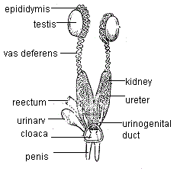

The female system is made up of large paired ovaries. Ovaries are irregular bodies situated assymetrically and hanging from the dorsal wall of the body cavity by mesovaria. Right ovaiy is a little anterior to the left one. Oviducts are paired with funnel-shaped ostia . Oviducts extend in front of the overies. The oviduct is divided into four regions: infundibulum; magnus (secretes albumin); uterus (secretes shells) and vagina. The oviduct opens at the end into the cloaca near the opening of the ureter. Most reptiles are oviparous after the eggs are fertilized internally; they are deposited outside of the mother’s body to complete their development.
