Gel Filtration Chromatography
Gel filtration is a technique of liquid chromatography which separates molecules according to their sizes and shape. Used in separation of macromolecules such as proteins, peptides, nucleic acids and carbohydrates.Also known as Size-Exclusion Chromatography (SEC)
,Gel - Permeation Chromatography and Molecular sieve chromatography
Advantages of Gel filtration:
It’s the best method for separation of molecules differing in molecular weight because it doesn’t depend on temperature, pH, ionic strength and buffer composition. So separation can be carried out under any conditions.
1- Fastest for buffer exchange
2-Very gentle, high yields
3-The elution volume is related to the molecular weight
4-Little equipment is required
5-Removes dimers and aggregates
Disadvantages of Gel filtration
1-Limited sample volume
2-Poor selectivity compared with SDS-PAGE
Principle:
Separation is achieved by the differential exclusion or inclusion of solutes as they pass through stationary phase consisting of heteroporous (pores of different sizes) cross linked polymeric gels or beads.
A column of gel particles or porous matrix is in equilibrium with a suitable mobile phase for the molecules to be separated Large molecules that are larger than the largest pore can’t penetrate gel pores move around the beads excluded from gel pores pass through the column quickly elute first.
Smaller molecules will get distributed in between the mobile phase of in and outside the molecular sieve and will then pass through the column at a slower rate, hence appear later in effluent.
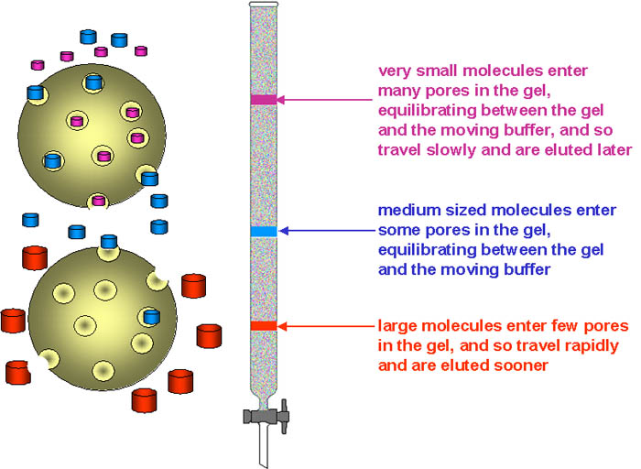
Applications of gel-filtration:
1- Purification. 2-Desalting or buffer exchange.
3-Protein-ligand binding studies. 4-Protein folding studies.
5- Concentration of sample. 6- Copolymerisation studies.
7-Relative molecular mass determination.
Stationary phase:
The stationary phase consists of beads containing pores that span a relatively narrow size range. Usually gel is polysaccharides (dextran) or other polar polymers formulated into small beads. Theses beads varying in degrees of cross-linking of the polysaccharide within the bead. Beads allowing smaller molecules to pass through their pores, while larger molecules are excluded.

Types of stationary phase:
1- dextran 2-polyacrylamide
3- agarose 4-dextran-polyacrylamide (Sephacryl™)
5-(Sepharose™ and BioGel A™)
6-Sephadex G-25 is most common gel used in gel-filtration chro.
Each is available with a different ranges of pore size in the beads, permitting separation of macromolecules of different size.
Different types of matrix forming stationary phase:
- Cross-linked dextran polymer (Sephadex G-10 to G-200):
It is a strongly hydrophilic polymer, and swells in water before a column is prepared, the gel must be full hydrated.
Cross-linked polyacrylamide (Biogel P-2 to G-300):-
They are hydrophilic but are chemically more stable than dextran gels.
- Agarose-the largest pore size: They are also hydrophilic but are sold in the swollen form.
- Mixed gels of polyacrylamide and agarose (Ultragel): The polyacrylamide provide a three-dimensional structure which supports the interstitial agarose gel.
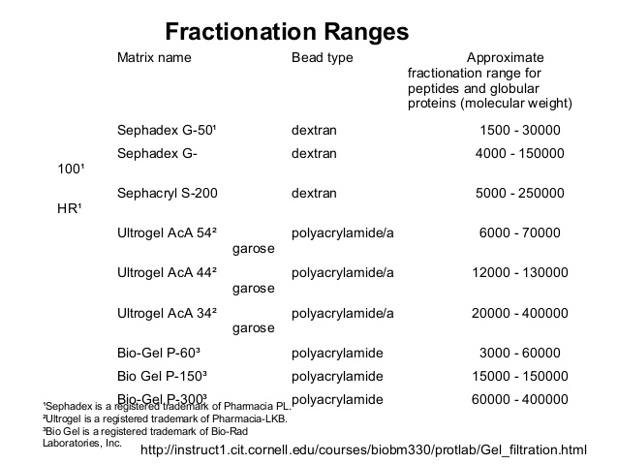
The gel types according to the material to be separated
1-Desalting and other group separations
Sephadex G-25 Fine or Superfine grades
2- Fractionation
Use a pre-packed column -Superdex or Superdex prep grade
3- Native proteins: Superdex 200
4-Recombinant proteins: Superdex 75
5-Peptides: Superdex Peptide or Superdex 30
Volumes:
The volume outside the gel matrix is known as the void volume, Vo. This is the volume required to elute a substance so large that it cannot penetrate the pores at all. Such a substance is completely excluded by the gel. For Sephadex G-75, proteins with molecular weights greater than 70,000 are completely excluded.
Exclusion volume or void volume (Vo): volume between gel beads
(Vo = elution volume of large molecules they do not enter the pores)
Internal pore volume Vi: volume inside the beads
(Vi = elution volume of small molecules)
Elution volume (Ve): volume required to elute a particular molecule
Total volume (Vt ): is total volume of mobile phase in the column
Vt = Vi+Vo
Column size
1-Desalting and other group separations
Volume four times the expected sample volume / Length is not so important
2-Fractionation
Volume ca 20-200 times the expected sample volume/ Length 30-100 cm

Increasing resolution:
- Check the column efficiency
Clean and/or re-pack -
- Check that the separation is in the fractionation range
- Reduce the sample volume
Reduce the flow rate-
- Change to a gel with smaller beads
- Connect two columns in series
Notes on use of gel filtration chromatography:
- The choice of matrix depends on the range of size of molecules to be separated and the goal of the separation. Different bead types have pores of different sizes.
- The matrix beads normally come in dry form and must be swollen before use. It is important not to use a magnetic stirrer when preparing the beads, or the beads can be fragmented. It takes several days to swell beads like the Sephadex that you will use today. One short cut, however, is to autoclave the solution. This causes the beads to swell more rapidly without damaging them.
- Never allow a gel filtration column to dry out. If it dries out, the column must be re-poured. It is crucial for good separation that the column be consistent from top to bottom (without any bubbles).
Procedure:
- Add the sample to the top of the resin by allowing the solution to gently run down the wall of the column.
- Place the effluent tube in the first test tube in the test tube rack (this will be fraction 1) and open the clamp.
- Do not disturb the top of the resin. Allow the sample to enter the resin and then gently add a few drops of the NaCl. Allow NaCl to penetrate the column and then gently add NaCl to fill the column.
4-Collect fractions until all the colored material has eluted from the column. Close the clamp. Collect 3 mL of effluent in each tube. After 3 mL has been collected in the first tube (fraction 1), switch to the second tube (fraction 2) and collect the next 3 mL, etc.
5-Read the absorbance at 400 nm using NaCl as blank.
6- Record all your results in the table.
7- Plot a graph of absorbance at 400nm against fraction number.
Example:
Consider the separation of a mixture of: Glutamate dehydrogenase (molecular weight 290,000), Lactate dehydrogenase (molecular weight 140,000), Serum albumin (MW 67,000), Ovalbumin (MW 43,000), and cytochrome c (MW 12,400) on a gel filtration column packed with Bio-Gel P-150 (fractionation range 15,000 - 150,000).
When the protein mixture is applied to the column, glutamate dehydrogenase would elute first because it is above the upper fractionation limit. Therefore it is totally excluded from the inside of the porous stationary phase and would elute with the void volume (V0). Cytochrome c is below the lower fractionation limit and would be completely included, eluting last. The other proteins would be partially included and elute in order of decreasing molecular weight. Vt = Vi+Vo

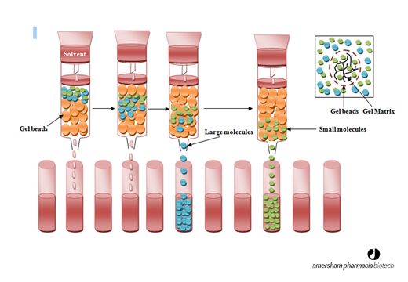

Gel filtration chromatography:
Column preparation
1- Dissolve (10g) of gel powder in 100 ml D.W
2-Left the powder to settle down, remove the supernatant and repeat dissolving in water for several times until it was become completely clear.
3- Left it for 24 h in refrigerator
4- Degas the gel by using vacuum pump
5- The gel is filled in a glass column to give a dimension of 1.5 x 57 cm
after pouring the gel into column it left to package for 24h in refrigerator
6- Equilibrated the column with equilibration buffer (example :0.2 molar of phosphate buffer with pH=7) which depend on the type of desired protein in order to reach this pH we can use diluted HCL or NaOH, and don't left the top of gel to dry, so it should be immersed continuously in buffer
7- Add 3ml of dialyzed protein to the top of column and left it to 30 min. in order to penetrate the gel.
8- Use the fraction collector to collect 50 fractions(test tubes have 5ml of elution buffer).
9- Read the optical density of each tube by UV spectrophotometer at flow rate 30ml / hr. in order to measure the concentration of protein in the fraction.
10- Draw the curve of proteins then measure the desired enzyme or protein activity in curve peaks and choose the best one then collect the content of their tubes for dialyses by concentrating the purified protein and start with next step of purification.

