Lecture (15)
Historical Background of Numerical Weather Prediction (NWP)
الخلفية التاريخية للتنبؤ الجوي العددي
15.1 Introduction
The story goes that in 1904 Wilhelm Bjerknes was the first to point out that the future state of the atmosphere could be predicted by integrating the partial differential equations that govern the behaviour of the atmosphere, using as initial fields the observed state of the atmosphere at a particular time. However, the equations are too complicated for analytic solutions to be found and one must resort to numerical methods. We refer now to such integrations as numerical weather prediction, commonly abbreviated NWP.
Bjerknes proposed a “graphical calculus,” based on weather maps, for solving the equations. Although his methods continued to be used and developed until the 1950s, both the lack of faster calculating methods and the dearth of accurate observational data limited their success as forecasting techniques.
The first attempt at NWP was carried out by Lewis Frey Richardson during the First World War. At this time the calculations had to be carried out by hand and were very tedious and time-consuming. The result was a spectacular failure, but the details were published in what has become one of the most famous books in meteorology (Richardson, L. F. (1922). Weather prediction by numerical process.).
Richardson estimated that it would require a team of 64,000 persons to carry out a 24 hour forecast in 24 hours. This together with the unrealistic nature of his calculation, which predicted a surface pressure change of 145 mb in 6 hours, cast doubt on the practicality of the method! Several later developments changed this pessimistic view. Courant, Friedrichs and Lewy (1928) found that space and time increments chosen to discretize the differential equations have to meet a certain stability requirement. Later, mainly through the work of Rossby and his collaborators in the late 1930s, it was found that the large-scale motions in the atmosphere could be represented approximately by a rather simple equation expressing the conservation of absolute vorticity following the motion of air columns. Finally, at the end of World War II the first electronic computer ENIAC (Electronic Numerical Integrator and Computer) was constructed. This computer was used by Charney, Fjørtoft and von Neumann in the late 1940s for the first successful numerical forecast, based on integration of the absolute vorticity conservation equation.
The Princeton mathematician John Von Neumann was among the earliest computer pioneers. Engaged in computer simulations of nuclear weapons explosions, he immediately saw parallels to weather prediction. (Both are non-linear problems of fluid dynamics.) In 1946, soon after the ENIAC became operational, von Neumann began to advocate the application of computers to weather prediction. As a committed opponent of Communism, Von Neumann hoped that weather modeling might lead to weather control, which might be used as a weapon of war. Soviet harvests, for example, might be ruined by a US-induced drought.
In the last four decades, progress in the accuracy and sophistication of NWP models has been swift, partly through the development of improved numerical algorithms for solving the equations and also because of the astonishing technological developments in computer engineering.

15.2 The Intelligence of Charney
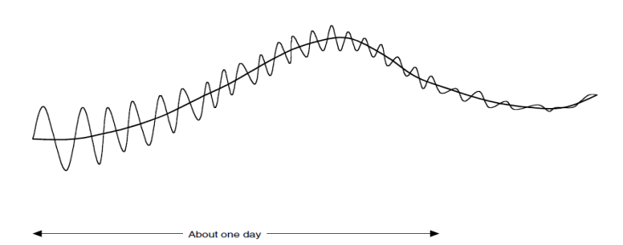
Jule G. Charney (1917-1981) was one of the giants in the history of numerical weather prediction, revealed that the huge error of Richardson was due mostly to the fact that the initial conditions were not balanced, and therefore included fast moving gravity waves which masked the initial rate of change of the meteorological signal in the forecast (Figure 15.1). Moreover, if the integration had been continued, it would have suffered "computational blow-up" due to the Courant-Friedricks-Lewy (CFL) condition.

Fig 15.1 Schematic of forecast with slowly varying weather-related variations and superimposed high-frequency gravity waves

Charney analysed the primitive equations using the technique of scale analysis, and was able to simplify them in such a way that the gravity wave solutions were completely eliminated. The resulting equations are known as the quasi-geostrophic system. In the special case of horizontal flow with constant static stability, the vertical variation can be separated out and the quasi-geostrophic potential vorticity equation reduces to a form equivalent to the nondivergent barotropic vorticity equation
$$\frac{d(ζ+f)}{dt}=0 (15.1)$$
where $ζ$ is the vorticity of the motion and f is the planetary vorticity. The barotropic equation had, of course, been used by Rossby in his analytical study of atmospheric waves, but nobody seriously believed that it was capable of producing a quantitatively accurate prediction of atmospheric flow.

15.3. From barotropic to multi-level models and primitive equations
Several baroclinic models were developed in the few years after the ENIAC forecast. They were all based on the quasi-geostrophic system of equations. The limitations of the filtered equations were recognized at an early stage. In his 1951 paper ‘The mechanism of meteorological noise’, Karl-Heinz Hinkelmann [14] tackled the issue of suitable initial conditions for primitive equations integrations. Hinkelmann had been convinced from the outset that the best approach was to use these equations. He knew that they would simulate the atmospheric dynamics and energetics more realistically than the filtered equations. Moreover, he felt certain, from his studies of noise, that high frequency oscillations could be controlled by appropriate initialization.
Routine numerical forecasting was introduced in the Deutscher Wetterdienst in 1966; this was the first ever use of the primitive equations in an operational setting. A six-level primitive equation model was introduced into operations at the National Meteorological Center in Washington in June, 1966. In 1972 a 10-level primitive equation model was introduced.
Previous models had been essentially dynamical, without any adequate representation of the wide range of ‘physical’ processes that determine the weather. The new model incorporated a sophisticated parameterization of physical processes and with it the first useful forecasts of precipitation were produced.

15.4. General circulation models and climate modeling
A declaration issued at the World Economic Forum in Davos, Switzerland in 2000 read: Climate change is the greatest global challenge facing humankind in the 21st century. There is no doubt that the study of climate change and its impacts is of enormous importance for our future. Global climate models are the best means we have of anticipating likely changes.
Phillips (1956) carried out the first long-range simulation of the general circulation of the atmosphere. He used a two-level quasi-geostrophic model on a beta-plane channel with rudimentary physics. The computation, done on the IAS computer (MANIAC I), used a spatial grid of 16 × 17 points, and the simulation was for a period of about one month.

15.5. Numerical weather prediction today
It is no exaggeration to describe the advances made over the past half century as revolutionary. Thanks to this work, meteorology is now firmly established as a quantitative science, and its value and validity are demonstrated daily by the acid test of any science, its ability to predict the future. Operational forecasting today uses guidance from a wide range of models. In most centres a combination of global and local models is used.

References
Smith, R. K. and W. Ulrich, 2008: Lectures on numerical meteorology.
Randall D. A., 2000: General circulation model development: Past, present, and future. Academic Press.
Thaer O. Roomi, 2013: A Basic regional-scale model for numerical weather Prediction. PhD Thesis, Al-Mustansiriyah University, Baghdad, Iraq.
Lynch, P., 2008: The origins of computer weather prediction and climate modeling. Journal of Computational Physics, 227, 3431–3444.

