ECOLOGY
Lecture (11-12).

Biomes
Biomes are the world's major habitats. These habitats are identified by the vegetation and animals that populate them. The location of each land biome is determined by the regional climate.

- LAND BIOMES (TERRESSTRIAL)
- Tropical rain forests
- Savannas.
- Deserts.
- Chaparrals.
- Grasslands.
- Forests.
- Taigas.
- Tundra: biomes are characterized by extremely cold temperatures and treeless, frozen landscapes. The vegetation consists of short shrubs and grasses. Animals of this area are musk oxen, lemmings, reindeer, and caribou.

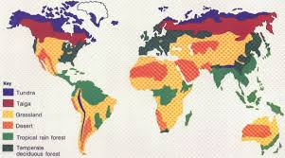

- THE AQUATIC BIOMES
- Freshwater Regions: is defined as having a low salt concentration—usually less than 1%.
- Wetlands: Wetlands are areas of standing water that support aquatic plants. Marshes, swamps.
- Marine Regions:
- Oceans
- Estuaries: Estuaries are areas where freshwater streams or rivers merge with the ocean.
- Coral Reefs

