Lab STAINING Practical Microbiology

Microbial smear : It is a very small amount of microbial growth ( broth or solid ) spreaded on a clean slide and drying by air .
Fixation : The process of passing the smear after drying several times over benzene burner to fix the microbes on slide and prepare it for staining .
Note :The reason of fixation process is to kill the microbes, fix the microbe cells to the slide and prevent their removal during washing steps .
Steps of microbial smear preparation :
1.Handle a clean slide by its edge, label the target place at the bottom side o the slide by drawing a circle with a diameter about 2 cm using a marker .
2.Sterile the loop until reaching the red heat .
3.If the bacterial culture was broth, shake the culture and transfer loopful of broth to the center of the slide and spread over the target circle .
While if the bacteria were grown on solid medium , place loopful of water on the slide then transfer inoculums to the water and homogenize the smear.
4.Sterile the loop.
5.Leave the smear to dry at room temperature ( by air ) .
6.After drying , Pass the slide over the flame to fix the smear ( avoid prolonged heating of the slide ) .
Note : It is preferred that the microbial culture used in the staining process is a recent one , since the old one gives false results .
Stain ( dyes ) : Is a chemical compound which is composed of positive and negative ions, one of them carries the color of the stain , this is called ( chromophore ) .

Types of Stains ( according to charge ) :
1.Basic dyes ( cationic dye ) : these dyes are positively charged because the the chromophore is the positive ion, so they attract to the bacterial cell wall which is negatively charged .
e.g : methylene blue , safranine , crystal violet , malachite green
2,Acidic dyes ( anionic dyes ) : : these dyes are negatively charged because the the chromophore is the negative ion, so they not attract to the bacterial cell wall which is negatively charged , therefore they do not stain the cell , this process is called " negative staining "
e.g : nigrocin , india ink , erocin , rose Bengal
These stains do not penetrate the bacterial cell wall but they make the background around the cells dark or opaque, so these stains show the shape and size of cells and the extracellular structures such as capsule or flagella .
***********
Types of Stains ( according to purpose of use ) :
1.Simple stains.
2.Differential stains.
3.Special stains.
1.Simple stains : In this process only one stain is used for staining . The most commonly used stains for simple staining are crystal violet , methylene blue , carbol fuchsin.
This method of staining is useful determining basic morphology and the presence or absence of certain kinds of granules.

Steps of simple staining :
1.Prepare a fixed smear .
2.Stain the smear with crystal violet by putting a couple of the stain drops and let for 1 min.
3.Wash off by tap water gently, leave it to dry at room temperature ( by air ) .
4.Put one drop of cedar oil on the fixed smear , examine directly under oil immersion lens .
2.Differential staining : In this process, more than one stain and some chemical solutions are used, it is the most important stain in bacteriology named according to " Hans Christian Gram " in 1884
This technique separates bacteria into two groups :
Gram positive bacteria and Gram negative bacteria
Steps of Gram staining :
1.Prepare a fixed smear .
2.Cover the smear with crystal violet and let it stand for 1 min .
3.Wash off the stain with tap water gently .
4.Cover the smear with Gram's iodine solution and let it stand for 1 min .
5. Wash off the stain with tap water gently .
6.Cover the smear with 95% alcohol by putting a couple of drops of the solution on the smear and let it stand for 30 sec .
7. Wash off the stain with tap water gently .
8.Cover the smear with safranin ( the counter stain ) let it stand for 1 min .
9. Wash off the stain with tap water gently .
10.Let it dry by air .
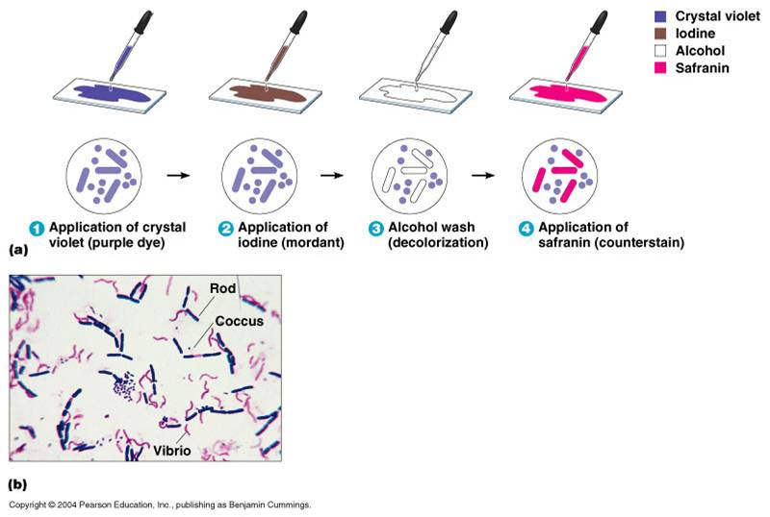
11.Examine the slide under oil immersion lens to see :
Either Gram positive bacteria ( appear purple )
Or Gram negative bacteria ( appear red )

Stains and solutions used in Gram staining :
- Crystal violet : it stains all cells with purple color, it called ( primary stain )
- Gram's iodine solution : it combines with crystal violet and forms an insoluble complex ( I-C.V. complex ) . This complex is not removed from G+ve bacterial cells, but it removed from G-ve bacterial cells by alcohol solution , therefore it called " mordant solution " .
- 95% alcohol : it is an organic solvent which is used in concentration about 95% and removes or decolorizes the purple color of the primary stain from G-ve cells, but it can't removes this stain from G+ve cells . This process called " decolorization " and ethanol called " decolorizer agent " .Aceton can be used as alternative decolorizer .
- Safranin : this stain is used to re-stain the cells which lost the primary stain after treating with alcohol .These cells are colored with red color . This stain is called " counter stain " or " secondary stain " .

Factors affecting the efficiency of Gram staining process :
1.Thickness of bacterial smear .
2.Concentration and purity of the solutions and reagents .
3.The nature and age of bacterial culture .
4.The amount of washing water .
--------------------------------------------------------------------------------------

3.Special staining : Acid fast stain used for Mycobacterium tuberculiosis.

