4-METEOROLOGY AND AIR POLLUTION
4.1. Learning objective
After the completion of this chapter, the student will be able to:
1. Describe the importance of metrology regarding to air pollution
2. Identify the importance of environmental and adiabatic laps rate
3. State the role of inversion on the concentration of air pollutants
4. Analyze plumes behavior in different environmental conditions

Introduction to the chapter
Meteorology specifies what happen to puff or plume of pollutants from the time it is emitted to the time it is detected at some other location. The motion of the air causes a dilution of air pollutant concentration and we would like to calculate how much dilution occurs as a function of the meteorology or atmospheric condition.
Air pollutants emitted from anthropogenic sources must first be transported and diluted in the atmosphere before these undergo various physical and photochemical transformations and ultimately reach their receptors. Otherwise, the pollutant concentrations reach dangerous level near the source of emission. Hence, it is important that we understand the natural processes that are responsible for their dispersion. The degree of stability of the atmosphere in turn depends on the rate of change of ambient temperature with altitude.
4-I. VERTICAL DISPERSION OF POLLUTANTS
As a parcel of air in the atmosphere rises, it experiences s decreasing pressure and thus expands. This expansion lowers the temperature of the air parcel, and therefore the air-cools as it rises. The rate at which dry air-cools as it rises is called the dry adiabatic lapse rate and is independent of the ambient air temperature. The term adiabatic means that there is no heat exchange between the rising parcel of air under consideration and the surrounding air. The dry adiabatic lapse rate can be calculated from the first law of thermodynamics (1°C per 100m).
As the air parcel expands, it does work on the surroundings. Since the process is usually rapid, there is no heat transfer between the air parcel and the surrounding air. Saturated adiabatic lapse rate, (Γs)
Unlike the dry adiabatic lapse rate, saturated adiabatic lapse rate is not a constant, since the amount of moisture that the air can hold before condensation begins is a function of temperature.
A reasonable average value of the moist adiabatic lapse rate in the troposphere is about 6°C/Km.

Example
An air craft flying at an altitude of 9 km draws in fresh air at - 40°C for cabin ventilation. If that fresh air is compressed to the pressure at sea level, would the air need to be heated or cooled if it is to be delivered to the cabin at 20°C.
Solution
As the air is compressed, it warms up it is even easier for the air to hold whatever moisture it may have, had .so there is no condensation to worry about and the dry adiabatic lapse rate can be used, at 10°C per km, compression will raise the air temperature by
10x9=90°C making it -40+90°c=50°C It needs to be the air conditioned
The air in motion is called wind, air that is rushing from an area of high pressure towards an area of low pressure. When the weatherman reports the wind to us, he uses a measuring system worked out in 1805 by Adoniral Beaufort.
For example, a “moderate breeze” is a wind of 13 to 18 miles an
Hour (see annex 2). Obviously, air quality at a given site varies tremendously from day to day, even though the emissions remain relatively constant. The determining factors have to do the weather: how strong the winds are, what direction they are blowing, the temperature profile, how much sun light available to power photochemical reactions, and how long it has been since the last strong winds or precipitation were able to clear the air. Air quality is dependent on the dynamics of the atmosphere, the study of which is called meteorology
4-2. Temperature lapse rate and stability
The ease with which pollutants can disperse vertically into the atmosphere is largely determined by the rate of change of air temperature with altitude. For some temperature profiles, the air is stable, that is, air at a given altitude has physical forces acting on it that make it want to remain at that elevation. Stable air discourages the dispersion and dilution of pollutants. For other temperature profiles, the air is unstable. In this case, rapid vertical mixing takes place that encourages pollutant dispersal and increase air quality. Obviously, vertical stability of the atmosphere is an important factor that helps determine the ability of the atmosphere to dilute emissions; hence, it is crucial to air quality. Let us investigate the relationship between atmospheric stability and temperature. It is useful to imagine a “parcel” of air being made up of a number of air molecules with an imaginary boundary around them. If this parcel of air moves upward in the atmosphere, it will experience less pressure, causing it to expand and cool. On the other hand, if it moves dawn ward, more pressure will compress the air and its temperature will increase.
As a starting point, we need a relationship that expires an air parcel’s change of temperature as it moves up or down in the atmosphere. As it moves, we can imagine its temperature, pressure and volume changing, and we might imagine its surrounding adding or subtracting energy from the parcel. If we make small changes in these quantities, and apply both the ideal gas law and the first law of thermodynamics, it is relatively straightforward to drive the following expression.
dQ=C_{p} dt –vdp……………………. (2.1)
Where:
dQ = heat added to the parcel per unit mass (J/kg)
C_{p} = Specific heat at a constant pressure (1005J/Kg - ºC)
dt= Incremental temperature change(ºC)
v = volume per unit mass (m³/kg)
dp = Incremental pressure change in the parcel (Pa)
Let us make the quite accurate assumption that as the parcel moves, there is no heat transferred across its boundary, that is, that this process is adiabatic. This means that dQ = 0; so, we can rearrange (2.1) as
The above equation gives us an indication of how atmospheric temperature would change with air pressure, but what are really interested in is how it changes with altitude. To do that we need to know how pressure and altitude are related. Consider a static column of air with a cross section A, as shown in figure 2.1. A horizontal slice of air in that column of thickness dZ and density ρ will have mass ρAdZ. If the pressure at the top of the slice due to the weight of air above it is P(Z+dZ), then the pressure at the bottom of the slice, P(Z) will be P(z+dz) plus the added weight per unit area of the slice itself:
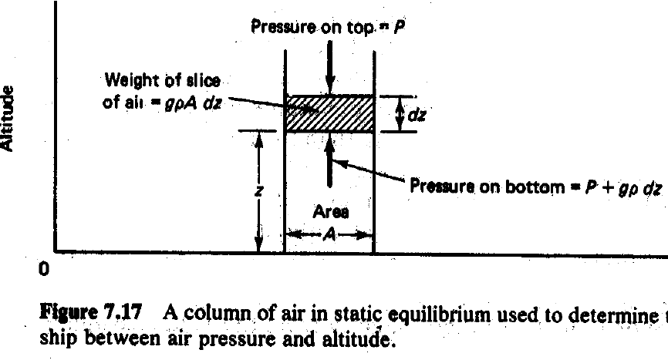

(P z) =P (z+ dz)= gρAdz /A ………… (2.3)
Where:
g is the gravitational constant. We can write the incremental pressure
dP for incremental change in elevation, dz as:

dP = p (z + dz) –p(z) = -g ρ dz …………………… (2.4)

Expressing the rate of change in temperature with altitude as a product, and substituting in (2.2) and (2.3) gives:
dP/ dT = C_{p} / V 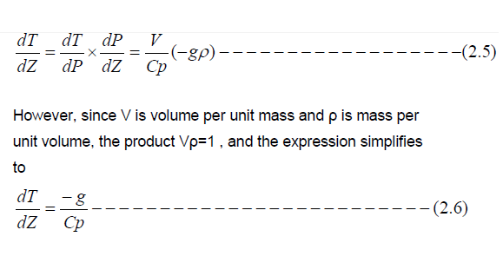
The negative sign indicates that temperature decreases with increasing altitude. Substituting the constant g =9.806m/s2, and the constant –volume specific heat of dry air at room temperature, Cp 1005J/kg. 0C in (2.6) yields
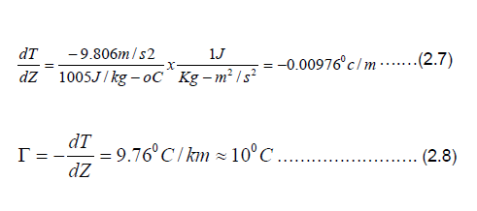
4-3 ATMOSPHERIC STABILITY
The ability of the atmosphere to disperse the pollutants emitted in to it depends to a large extent on the degree of stability. A comparison of the adiabatic lapse rate with the environmental lapse rate gives an idea of stability of the atmosphere. When the environmental lapse rate and the dry adiabatic lapse rate are exactly the same, a raising parcel of air will have the same pressure and temperature and the density of the surroundings and would experience no buoyant force.
Such atmosphere is said to be neutrally stable where a displaced mass of air neither tends to return to its original position nor tends to continue its displacement
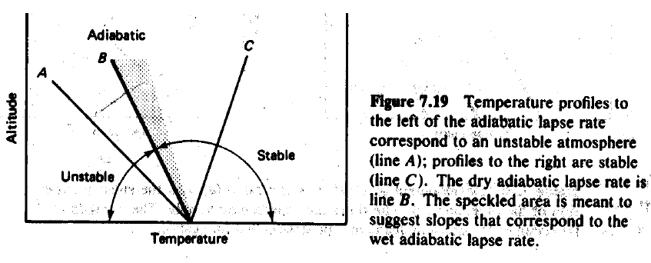

When the environmental lapse rate (-dT/dz.) Env is greater than the dry adiabatic lapse rate, Γ the atmosphere is said to be super adiabatic. Hence a raising parcel of air, cooling at the adiabatic rate, will be warmer and less dense than the surrounding environment. As a result, it becomes more buoyant and tends to continue it’s up ward motion. Since vertical motion is enhanced by buoyancy, such an atmosphere is called unstable. In the unstable atmosphere the air from different altitudes mixes thoroughly. This is very desirable from the point of view of preventing pollution, since the effluents will be rapidly dispersed throughout atmosphere. On the other hand, when the environmental lapse rate is less than the dry adiabatic lapse rate, a rising air parcel becomes cooler and denser than its surroundings and tends to fall back to its original position. Such an atmospheric condition is called stable and the lapse rate is said to be sub adiabatic. Under stable condition there is very little vertical mixing and pollutants can only disperse very slowly. As result, their levels can build up very rapidly in the environment. When the ambient lapse rate and the dry adiabatic lapse rate are exactly the same, the atmosphere has neutral stability. Super adiabatic condition prevails when the air temperature drops more than 1°C /100m; sub adiabatic condition prevail when the air temperature drops at the rate less than 1°c/100m.

Inversion
Atmospheric inversion influences the dispersion of pollutants by restricting vertical mixing. There are several ways by which inversion layers can be formed. One of the most common types is the elevated subsidence inversion, This is usually associated with the sub-tropical anti cyclone where the air is warmed by compression as it descends in a high pressure system and achieves temperature higher than that of the air under Neath. If the temperature increase is sufficient, an inversion will result
• It lasts for months on end
• Occur at higher elevation
• More common in summer than winter
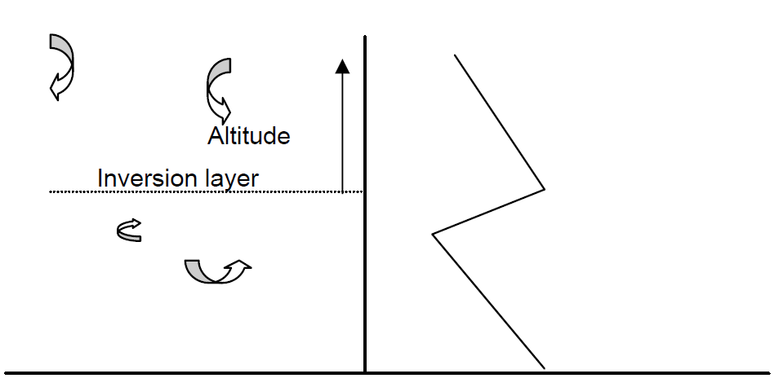
The subsidence is caused by air flowing down to replace air, which has flowed out of the high-pressure region.
4-4 Radiation Inversion
The surface of the earth cools down at night by radiating energy toward space. On cloudy night, the earth’s radiation tends to be absorbed by water vapor, which in turn reradiates some of that energy back to the ground. On the clear night, however, the surface more readily radiate energy to space, and thus ground cooling occurs much more rapidly. As the ground cools, the temperature of the air in contact with the ground also drops. As is often the case on clear winter nights, the temperature of this air just above the ground becomes colder than the air above it, creating an inversion. Radiation inversions begins to form at dusk.

As the evening progresses, the inversion extends to a higher and higher elevation, reaching perhaps a few hundred meters before the morning sun warms the ground again, breaking up the inversion. Radiation inversion occurs close to the ground, mostly during the winter, and last for only a matter of hours. They often begin at about the time traffic builds up in the early evening, which traps auto exhaust at ground level and causes elevated concentration of pollution for commuters. Without sunlight, photochemical reactions cannot take place, so the biggest problem is usually accumulation of carbon monoxide (CO). In the morning, as the sun warms the ground and the inversion begins to the break up, pollutants that have been trapped in the stable air mass are suddenly brought back to earth in a process known as fumigation. Fumigation can cause short lived high concentrations of pollution at ground level. Radiation inversions are important in another context besides air pollution. Fruit growers in places like California have long known that their crops are in greatest danger of frost damage on winter nights when the skies are clear and a radiation inversion sets in. Since the air even a few meters up is warmer than the air at crop level, one way to help protect sensitive crops on such nights is simply to mix the air with large motor driven fans.
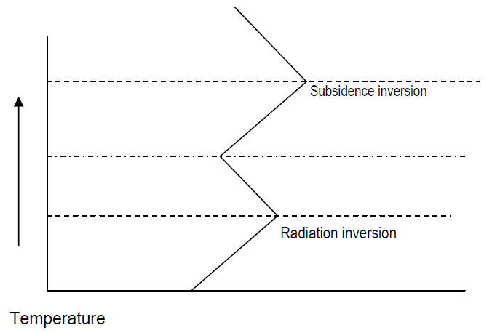
The third type of inversion, known as advective inversion is formed when warm air moves over a cold surface or cold air. The inversion can be a ground based in the former case, or elevated in the latter case. An example of an elevated advective inversion occurs when a hill range forces a warm land breeze to follow at high levels and cool sea breathes flows at low level in the opposite direction.

