Physical and Chemical Nature of Nanoparticles Lec. 2 Prof.Dr.Neihaya Heikmat

Physical and Chemical Nature of Nanoparticles
When the size of the nanomaterial is reduced, and the nanoscale level is reached, it is possible that the same material will display totally different properties (chemical and physical properties).
When we look at nanosized particles of substances, there are four main things that change from macroscale objects.
- First.
due to the small mass of the particles, gravitational forces are negligible.
Instead, electromagnetic forces are dominant in determining the behavior of atoms and molecules.
- Second.
at nanoscale sizes, we need to use quantum mechanical descriptions of particle motion and energy transfer instead of the classical mechanical descriptions.
- Third.
nanosized particles have a very large surface area to volume ratio.
- Fourth.
At this size, the influences of random molecular motion play a much greater role than they do at the macroscale.
The discovery that the properties of a substance can change with size has helped us to expand our understanding of the nature of matter and to develop new products that take advantage of the novel properties of materials at the nanoscale.

- Physical Properties of Nanoparticles
Physical properties of NPs include: shape, size, specific surface area, agglomeration, aggregation, state of size distribution, surface morphology/topography, and structure including crystallin, defect structure.
The size, shape, surface area, and size distribution of NPs are important in their uptake by organisms.
- Chemical Properties of Nanoparticles
Chemical properties include the elemental composition of nanomaterials and its surface chemistry such as zeta potential, solubility and photocatalytic properties.
The chemical properties of a material are determined by the type of motion of its electrons.

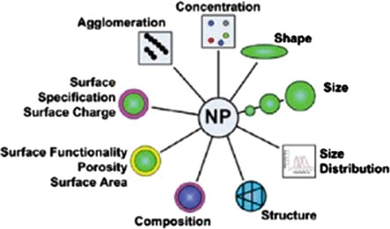
- Size and Shape
The size and shape can be identified as the most important parameter to define the nanomaterial in general.
NPs below 20–30 nm in size are characterized by an excess of energy at the surface and are thermodynamically. Particles were unstable because of the interfacial tension, acting as a driving force, which leads to a spontaneous reduction of the surface area.
The design of NPs has gained a lot of attention, resulting in particles with various shapes such as spheres, rods, tubed, fibers, and disks, etc. and more extraordinary geometries such as worms, squares, urchins, and ellipsoids.
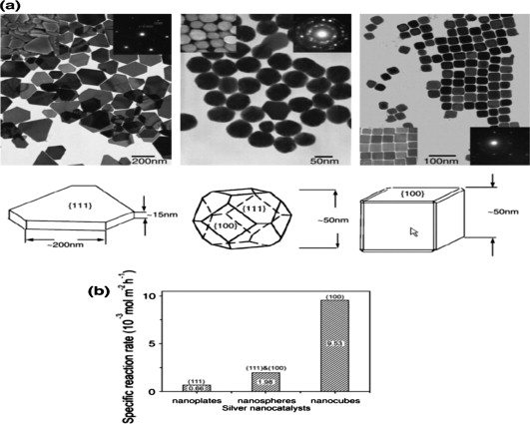

- Increased surface-to-volume ratio
One of the distinguishing properties of nanomaterials is that they have an increased surface area.
It has already been stated that a nanomaterial is formed of at least a cluster of atoms, often a cluster of molecules.
It follows that all types of bonding that are important in chemistry are also important in nanoscience.
- Surface energy
Atoms and molecules that exist at the surface or at an interface are different from the same atoms or molecules that exist in the interior of a material.
Atoms and molecules at the interface have enhanced reactivity and a greater tendency to agglomerate: surface atoms and molecules are unstable; they have high surface energy.

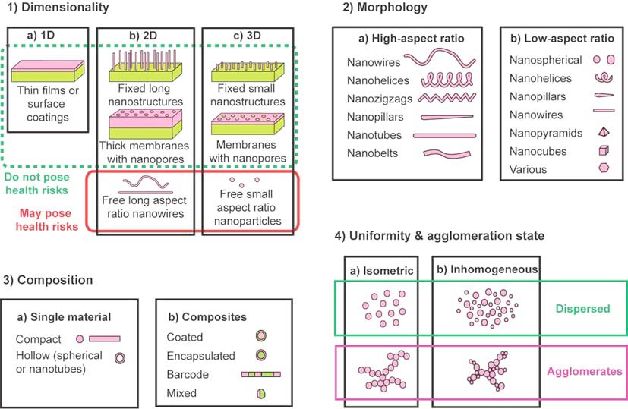

- Electrical properties
Some nanomaterials exhibit electrical properties that are absolutely exceptional.
Their electrical properties are related to their unique structure. Two of these are fullerenes and carbon nanotubes.
For instance, carbon nanotubes can be conductors or semiconductors depending on their nanostructure.
- Optical properties
Some nanomaterials display very different optical properties, such as color and transparency, compared to bulk materials.
Nanomaterials in general can have peculiar optical properties as a result of the way light interacts with their fine nanostructure. Optical properties also depend on size and shape of nanoparticles.
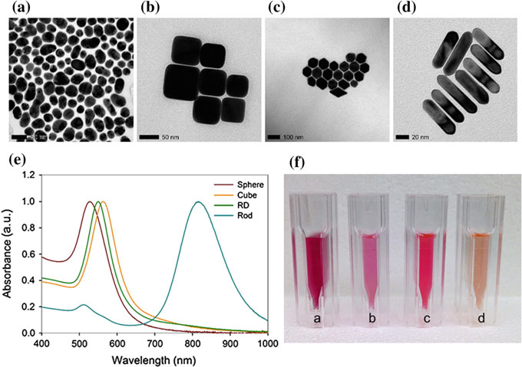
Difference in the optical properties of gold NPs for different shapes

- Magnetic properties
In general, the magnetic behavior of a material depends on the structure of the material and on its temperature. The typical size of expected magnetic domains is around 1 μm.
When the size of a magnet is reduced, the number of surface atoms becomes an important fraction of the total number of atoms, surface effects become important, and quantum effects start to prevail.
- Mechanical properties
Some nanomaterials have inherent exceptional mechanical properties which are connected to their structure.
One such material is carbon nanotubes: these are extremely small tubes having the same honeycomb structure of graphite, but with different properties compared to graphite. They can be single-walled or multi-walled.
Carbon nanotubes are 100 times stronger than steel but six times lighter!!
- Thermal properties
The fact that in a nanomaterial a larger fraction of the atoms is at the surface influences some physical properties such as the melting point.
Given the same material, its melting point will be lower if it is nano-sized.
Surface atoms are more easily removed than bulk atoms, so the total energy needed to overcome the intermolecular forces that hold the atom ‘fixed’ is less, thus the melting point is lower.

