LECTURE 8

Laboratory Diagnosis of Microorganisms
Infectious diseases
Infectious diseases are disorders caused by organisms such as bacteria, viruses, fungi and parasites. Many organisms live in and on our bodies. They're normally harmless or even helpful, but under certain conditions, some organisms may cause disease.
Some infectious diseases can be passed from person to person. Some are transmitted by bites from insects or animals. And others are acquired by ingesting contaminated food or water or being exposed to organisms in the environment.
The methods that used for identification of microorganisms include:
- Phenotypic (morphology)
- Direct exam
- Isolation of pathogen (culture)
- Biochemical tests
- Immunological (serological analysis)
- Genotypic (genetic techniques)

Blood Stream Infections (BSI)
Blood stream infection (BSI) is a serious problem that needs immediate attention and treatment. It is a cause of high mortality especially if caused by multidrug resistant bacteria.
Bacteria and other microorganisms can enter the blood stream as
1- a severe complication of infections (like pneumonia or meningitis), 2- during surgery (especially when involving mucous membranes such as the gastrointestinal tract)
3- due to catheters and other foreign bodies entering the arteries or veins (including during intravenous drug abuse).
4-Transient bacteremia can result after dental procedures or brushing of teeth.

Conditions which increase the chances of developing
bacteremia include:
- Immune suppression, either due to HIV infection or drug therapy
- Antibiotic therapy which changes the balance of bacterial types in the body.
- Prolonged or severe illness.
- Alcoholism or other drug abuse
- Malnutrition
- Diseases or drug therapy that cause ulcers in the intestines, e.g.
chemotherapy for cancer.

Symptoms of bacteremia may include:
- fever over (38.3 °C)
- chills
- abdominal pain
- nausea
- vomiting
- diarrhea
- shortness of breath
- confusion
Blood culture
Blood culture is usually the most sensitive method for detection microorganisms in the blood. Blood is cultured to detect and identify bacteria or other cultivable microorganisms (yeasts, filamentous fungi). The presence of such organisms in the blood is called bacteremia or fungaemia, and is usually pathological. In the healthy subjects, the blood is sterile.

Blood collection
Blood should be taken before antibiotics are administered. The best time is when the patient is expected to have chills or a temperature spike. It is recommended that two or preferably three blood cultures be obtained, separated by intervals of approximately 1 hour (or less if treatment cannot be delayed). The advantages of repeated cultures are as follows:
— The chance of missing a transient bacteremia is reduced.
- The pathogenic role of “saprophytic” isolates (e.g. Staphylococcus epidermidis) is confirmed if they are recovered from multiple vein punctures.
- Because the number of bacteria per milliliter of blood is usually low, it is important to take a reasonable quantity of blood: 10 ml per vein puncture for adults; 2–5 ml may suffice for children.
- Two tubes should be used for each vein puncture: the first a vented tube for optimal recovery of strictly aerobic microorganisms, the second anon-vented tube for anaerobic culture.
- The skin at the vein puncture site must be meticulously prepared using a bactericidal disinfectant.

Blood-culture media
The blood-culture broth (brain heart infusion broth) and tryptic soy broth (TSB) should be able to support growth of all clinically significant bacteria.
The blood should be mixed with 10 times its volume of broth (5ml of blood in 50 ml of broth) to dilute any antibiotic present and to reduce the bactericidal effect of human serum.

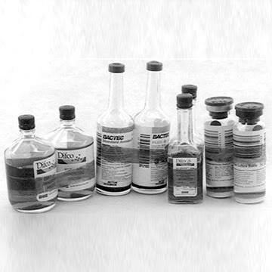
Incubation time
Blood-culture bottles should be incubated at 35–37 C for 7 days. In some cases, incubation may be prolonged for an additional 7 days, e.g. if Brucella or other fastidious organisms are suspected, in cases of endocarditis, or if the patient has received antimicrobials. A sterile culture usually shows a layer of sediment red blood covered by a pale yellow
transparent broth.
Growth is evidenced by:
—a floccular deposit on top of the blood layer
— uniform or subsurface turbidity
— haemolysis
— coagulation of the broth
— a surface pellicle
— production of gas
— white grains on the surface or deep in the blood layer.

BacT/ALERT system: is an automated microbial detection system based on the colorimetric detection of CO2 produced by growing microorganisms. It has a blood culture bottle with supplemented brain heart infusion broth (BHI) containing activated particles that significantly increase the yield of microorganisms over standard blood culture media. In addition, resins or charcoal may be added to commercial media to absorb and inactivate antimicrobial agents within the patient's blood. BacT/ALERT system has greatly simplified handling in the microbiological laboratory and provides faster detection for many organisms in a short time than is possible with conventional systems.

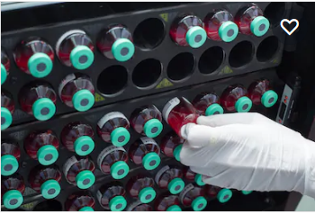

Whenever visible growth appears, the bottle should be opened aseptically, a small amount of broth removed with a sterile loop or Pasteur pipette, and a Gram-stained smear examined for the presence of microorganisms.
Subcultures are performed by streaking a loopful on appropriate media: MacConkey agar, Blood agar and chocolate agar.
Some microorganisms may grow without producing turbidity or visible alteration of the broth. Other organisms, e.g. pneumococci, tend to undergo autolysis and die very rapidly. For this reason some laboratories perform routine subcultures on chocolate agar after 18–24 hours of incubation.

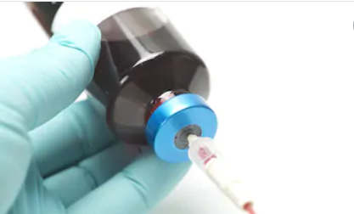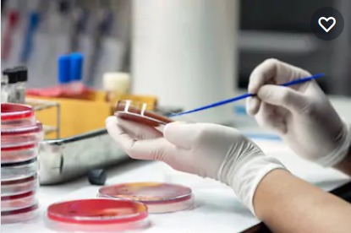
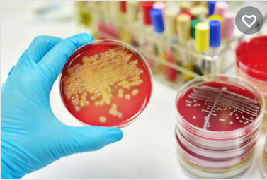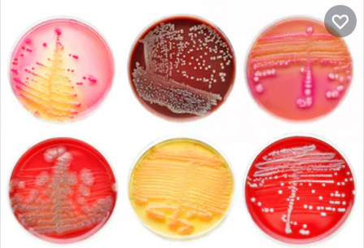

Common causes of bacteraemia:
Gram-negative organisms | Gram-positive organisms
Escherichia coli | Staphylococcus aureus
Klebsiella spp. | Staphylococcus. epidermidis
Enterobacter spp. | a-Haemolytic (viridans) streptococci
Pseudomonas aeruginosa | Streptococcus pneumoniae
Salmonella typhi | Enterococcus. faecalis
Salmonella spp. other than S. typhi | Streptococcus pyogenes
Proteus spp. | Streptococcus agalactiae

