**Lab(1)**

**Introduction**

**Parasitology**: is the study of relationships between parasites and their host **Parasites** : are living organisms, which depend on a living host for their nourishment and survival .

all parasitic organisms are eukaryotes . parasites can be classified as: (**Ectoparasite**: inhabit only the body surface of the host without penetrating the tissue e.g. lice, ticks ,)

or (**Endoparasite** which lives within the body of the host e.g. malaria, giardia ). parasites may be simple unicellular protozoa or complex multicellular metazoa.

**Host**: an organism, which harbors the parasite and provides nourishment and is relatively larger than the parasite .

**Definitive host**: the organism in which the adult or sexually mature stage of the parasite lives.

**Intermediate host** : the organism in which the parasite lives during a period of its development only.

**Vector**: a living carrier that transports a pathogenic organism from an infected to non infected host (e.g. the female *Anopheles* mosquito that transmits malaria)

**Host – parasite relationships :**

**Symbiosis:** both host and parasite dependent upon each other, none of them suffers any harm from the association .

**Commensalism:** only the parasite derives benefit from association without causing any injury to the host .

**parasitism:** the parasite derives benefites and the host is always harmed due to the association.

**Transmission of parasites:**

1-Food or water contamination ( *Amoeba*,*Giardia*).

2-Vectors (Sand fly Leishmaniasis, *Tsetse* fly Trypanosomiasis).

3-Sexual contact (*Trichomonas*).

4-Inhalation of contaminated dust or air (egg of Enterobiousvermicularis).

5-Skin penetration (Acanthamoeba).

**Parasitic damage to host:**

1-Trauma (damage to tissues , intestine, liver, eye).

2-abortion

2-Diarrhea

3-Tissue response (localized inflammation , eosinophilia).

4-Blood loss ( anemia caused by severe infection with plasmodium falciparum).

5- Meningoencephalitis

**Types of specimens which can be examined for diagnosis of parasites:**

**1-Natural secretions:**

* stool (*Entamoebahistolytica* )
* urin(*Trichomonasvaginalis*).

**2-Blood:** (*Plasmodium spp.*).

**3-Vaginal secretions:** (*Trichomonasvaginalis*).

**4-Biobsy of liver or spleen:**(*Leishmaniadonovani*)

**Detection of parasites :**

1-Clinical diagnosis: depends on symptoms

2-Laboratory diagnosis :

1. Microscopic examination

* wet preparation
* flotation

b. Serological exam

c. Animal inoculation

d. Intra-dermal sensitivity exam

e. Culture method

f. Tap technique

g. X-ray technique

**Lab (2)**

Kingdom : Protista

Subkingdom : Protozoa

Phylum :Sarcomastigophora

Class:lobosea

Genus :**1-*Entamoeba histolytica*(**pathogenic amoeba)

**2-*Entamoeba coli*** (non-pathogenic amoeba)

3***-Entamoeba hartmanii(*** non-pathogenic protozoa)

**1-*Entamoeba histolytica***

**Disease name** : Amebic dysentery or Amebiasis

**Site of infection** : Large intestine

***Entamoebahistolytica*** : pathogenic amoebahave two stages Trophozoite (vegetative and diagnostic stage ) and Cyst ( infective and diagnostic stage ) .

**Morphology of trophozoite**

Trophozoite of*E. histolytica* is (15-30) micrometer in diameter, has asingle nucleus with a small centrally placed karyosome . The nuclear chromatin is evenly distributed along the periphery of the nucleus . The fine granular endoplasm may contain ingested RBCs

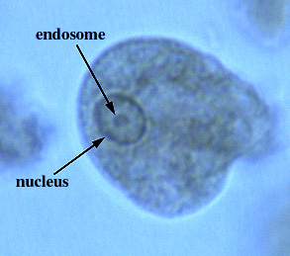

***Entamoebahistolytica*(trophozoite)**

**Morphology of cyst**

Cyst of  *E. histolytica* is (10-15) micrometer in diameter and contain one to four nuclei . Chromatoid bodies are usually present in young cysts as elongated bars with bluntly rounded ends. Glycogen is usually diffuse, but in young cysts it is often present as a concentrated mass, staining reddish brown with iodine.

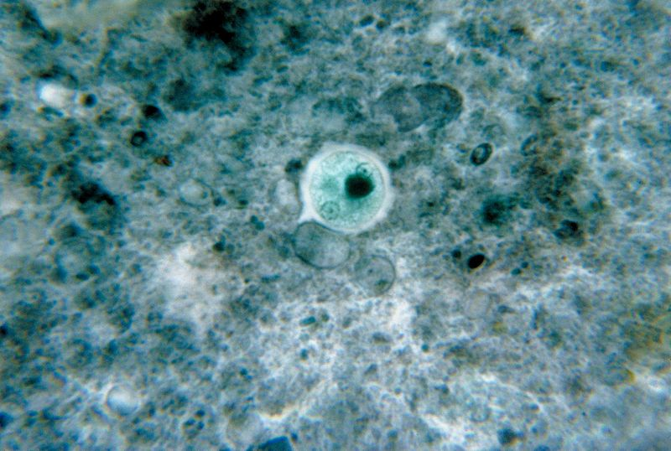

***Entamoebahistolytica*(cyst)**

**Life cycle**

Infection occurs by ingestion of cysts on focally contaminated food or hands. The cyst is resistant to the gastric environment and passes into small intestine where it decysts. The metacyst divides into four and then eight amoebae which move to the large intestine. The majority of the organisms are passed out of the body with the feces but with chronic infection some amoeba invade the mucosal tissue forming flask-shaped lesions. The organisms encyst for mitosis and are passed through with feces.(there are no intermediate or reservoir host).

**Symptoms :**including diarrhea with blood and mucus, fever and dehydration.

**Laboratory diagnosis:**

1-Laboratory diagnosis by finding the characteristic cysts in an iodine stained or formolether concentration method or a permanent stained preparation . Direct microscopy should be done by mixing asmall amount of the specimen in 0.9% sodium chloride solution

2-The tests of indirect fluorescent antibody test (IFAT), or (ELISA) .

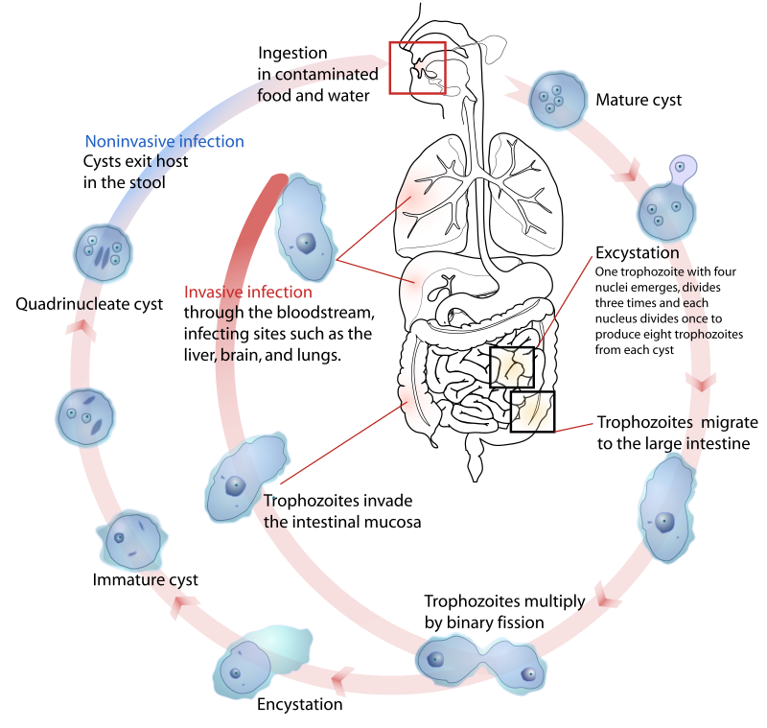

**Life cycle of*Entamoebahistolytica***

**2-*Entamoeba coli***

*Entamoebacoli* are anon-pathogenic ameba with world wide distribution. Its life cycle is similar to that of *E.histolytica*but it does not have an invasive stage and does not ingest red blood cells.

**Morphology of trophozoite**

Trophozoite is larger than of *E.histolytica* .It exhibits blunt pseudopodia with sluggish movement. A permanently stained preparation shows a nucleus with a moderately large eccentric karyosome with the chromatin clumped on the nuclear membrane. The cytoplasm appears granular containing vacuoles with ingested bacteria and other food particles.

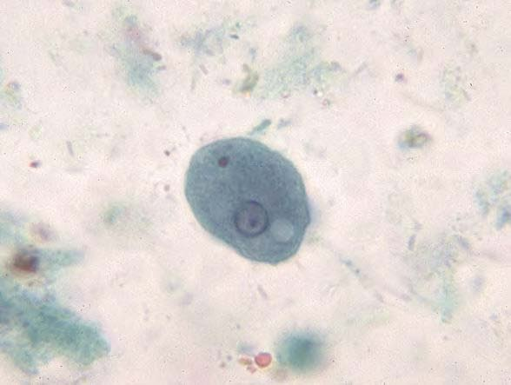

***Entamoebacoli*** (**trophozoite)**

**Morphology of cyst**

Cyst of *E.coli*contain (1-8) nuclei with irregular peripheral chromatin, karyosomes not central. Chromatoid bodies are not frequently seen but when present they are usually splinter-like with pointed ends. Glycogen is usually diffuse but in young cyst is occasionally found as a well-defined mass, which stains reddish brown with iodine.

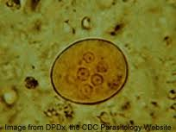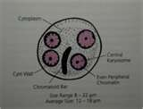

***Entamoeba coli* (cyst)**

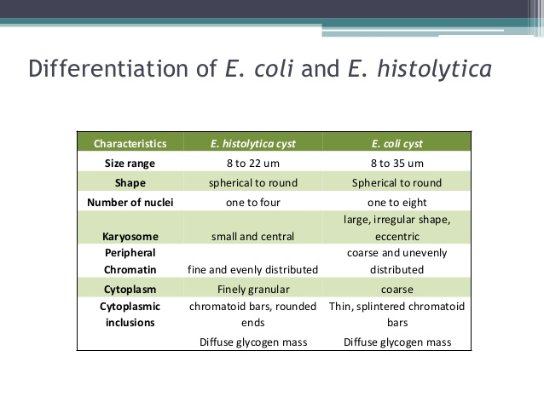

1. ***EntamoebaHartmanni***

• Morphologically similar to E.histolytica but trophozoites&cysts are smaller

•• Trophozoiteshas one nucleuswith peripheral chromatin and small karyosome, never contain ingested red blood cells

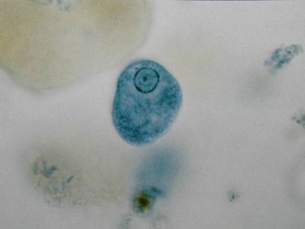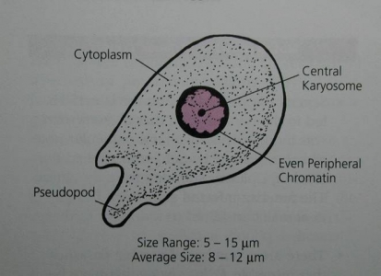

***Entamoebahartmanii*troph.**

**Cyst: contain 4 nuclei(mature) blunt chromatoid bodies in mature cyst**

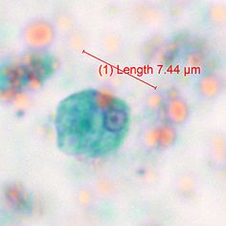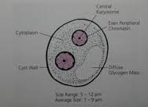

**Entamoebahartmanii cyst**

**life cycle**

similar to that of E. histolytica but it does not have an invasive stage

the cyst can survive outside the body and can be transmitted to humans via ingestion of contaminated food or water.

may also be spread directly by person-to- person contact (fecal-oral route)

whilst the cysts are in the small intestine, the trophozoites emerge, pass down into the colon and then multiply. Cysts and trophozoites are excreted in the feces.

**Diagnosis**

1. finding the characteristic cysts in a wet preparation or an iodine stained, formol-ether concentration method.
2. detecting the characteristic trophozoites in a wet preparation or a permanent stained preparation

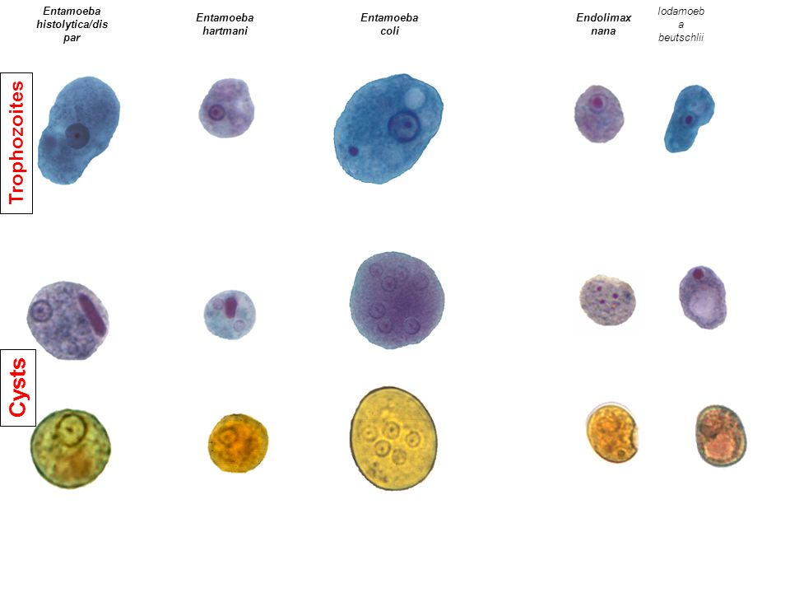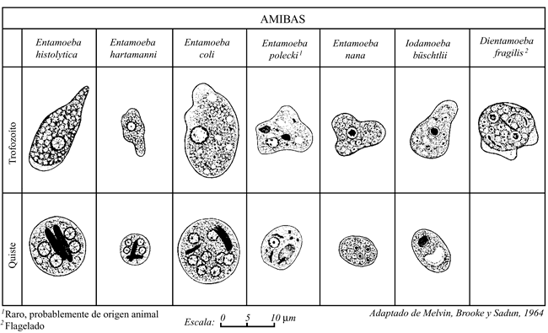

**Lab 3**

Kingdom : Protista

Subkingdom : Protozoa

Phylum :Sarcomastigophora

Class: Lobosea

1-*Endolimax nana* (non-pathogenic amoeba)

2-*Iodamoeba butschlii* (non-pathogenic amoeba)

3-*Entamoeba gingivalis* (non-pathogenic amoeba)

#### 4- *Naegleriafowleri*(pathogenic free living amoeba)

#### 5- [*Acanthamoeba spp*](http://www.tulane.edu/~wiser/protozoology/notes/free.html#acan)*.* (pathogenic free living amoeba)

**1--*Endolimax nana***

**Site of infection:intestine**

Transmission via cyst form(infected stage); contaminated food and water

**Morphology of trophozoite**

TrophozoiteMotilityis sluggish with blunt hyaline pseudopodia. The nucleus exhibits a large karyosome with no peripheral chromatin on the nuclear membrane.

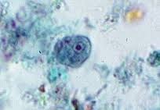

**Morphology of cyst**

Cyst can be spherical or ovoid in shape and contain (4) pinpoint nuclei, which are highlighted by the addition of iodine. Chromatoid bodies are not found and glycogen is diffuse.

[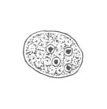](http://www.google.iq/url?sa=i&rct=j&q=&esrc=s&source=images&cd=&ved=0ahUKEwiVk-vkpY7LAhWNhhoKHTlWCf8QjRwIBw&url=http://diagnosticparasitology.weebly.com/amebas.html&psig=AFQjCNEYamzj8dmxHrfWvPCOn4zjA0oEYg&ust=1456330732870299)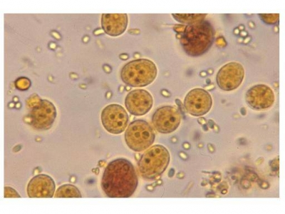

Diagnosis: Microscopic examination of the stool finding trophozoite or cyst(Diagnostic stage)

**4-*Iodamoeba butschlii***

Site of infection: intestine

The transmission of this parasite is by fecal-oral route and infection is asymptomatic.

**Morphology of trophozoite**

TrophozoiteiS actively motile. On a permanently stained fecal smear ,a nucleus with a large karyosome is evident. Chromatoid bodies form striations around the karyosome. The cytoplasm appears granular containing vacuoles with ingested bacteria and debris.

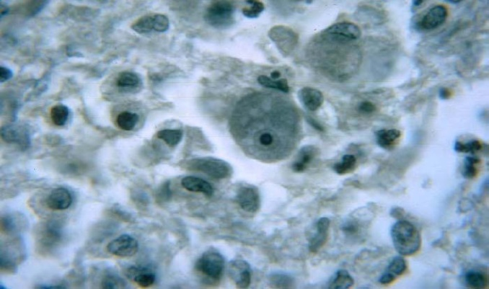

***Iodamoebabutschlii* (trophozoite)**

**Morphology of cyst**

Cyst have one nucleus in mature cysts usually eccentrically placed. Chromatoid bodies are not present and glycogen is present as acompact well defined mass staining dark brown with iodine.

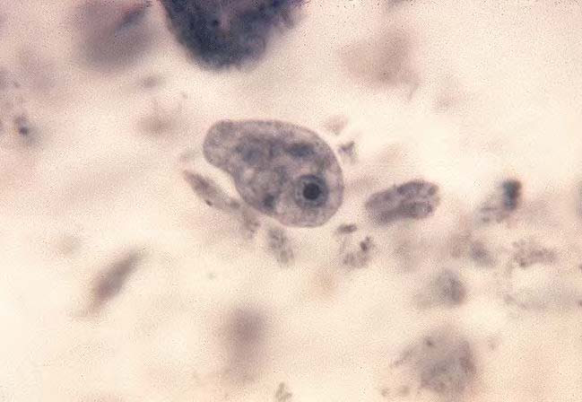

***Iodamoebabutschlii* (cyst)**

**Laboratory Diagnosis**  
Laboratory diagnosis is made by finding the characteristic cysts in an iodine stained, formolether concentration method. Trophozoites are difficult to detect in a wet preparation.

**5-*Entamoeba gingivalis***

*Entamoebagingivalis*is found in mouth near the base of the teeth(site of infection). It has only trophozoite(diagnostic and infective stage).

**Morphology of trophozoite**

Trophozoite contain single small spherical nucleus, contains irregular distributed small masses of chromatin, central or eccentric karyosome. They are several food vacuoles in endoplasm contain largely dark bodies .

 4- *Naegleriafowleri*

Naegleriafowleri is a [thermophilic](https://en.wikipedia.org/wiki/Thermophilia" \o "Thermophilia) (heat-loving), free-living [amoeba](https://en.wikipedia.org/wiki/Amoeba). It is found in warm and hot freshwater ponds, lakes and rivers, and in the very warm water of hot springs. As the water temperature rises, its numbers increase.

Disease name: primary amebic meningoencephalitis (PAM)

Definitive host: None, free-living organism

Accidental host: Humans and other mammals

**Morphology**

In all three stages, there is one nucleus with a large karyosome and no peripheral chromatin

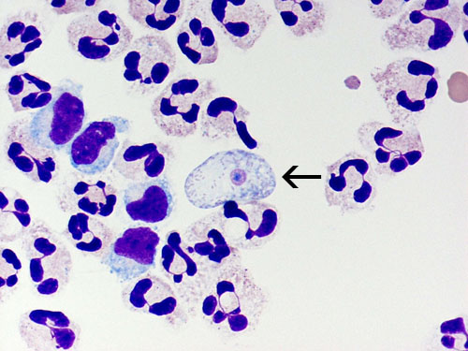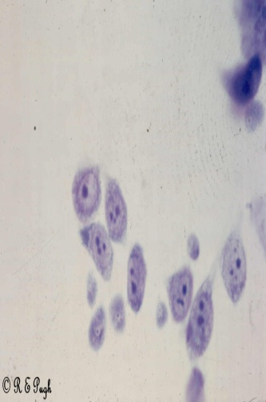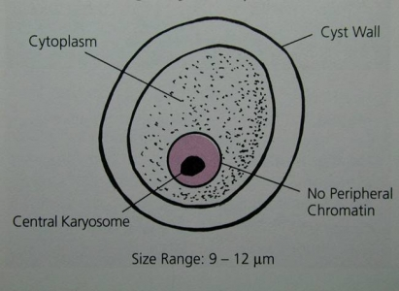

1. Trophozite is the feeding, dividing, and infective stage for humans they are motile. Movement occurs by the organism blunt pseudopodia.
2. Flagellate:The flagellate is pear-shaped and has two flagellum.

3-Cyst:The spherical cyst is single-walled with a single nucleus.

**Life cycle**

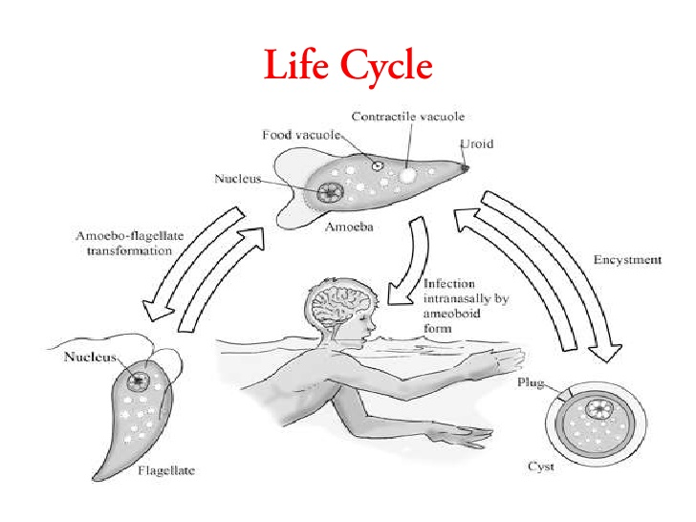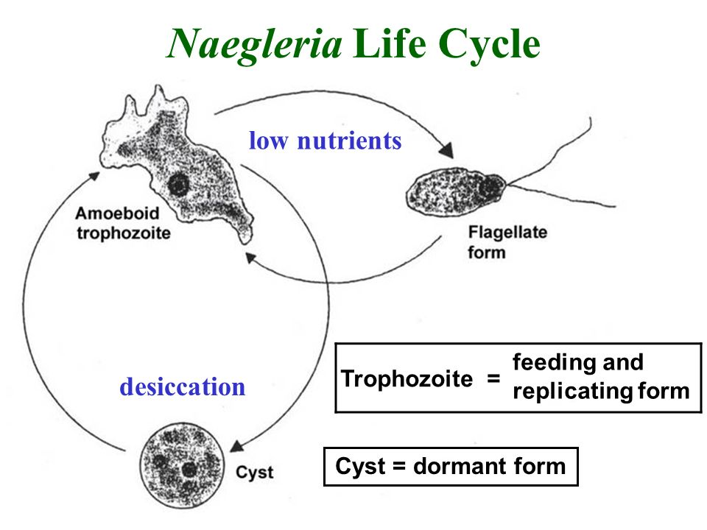

Symptoms -Headaches, nausea, vomiting, fever, seizures, and death

Symptoms - Dramatic and rapidly progressive. Headache, fever, nausea & vomiting occur within 1 to 2 days. Meningoencephalitis, irrational behavior, coma & death usually occur within 9 days of exposure.

Diagnosis - Usually made at autopsy. CSF contain motile amoebae. Early diagnosis is critical. Amoebae in CSF specimens can be cultured on non-nutrient agar containing bacteria.

**Acanthamoeba spp.**

**Disease name:**chronic granulomatous amebic encephalitis (GAE)

Morphology:

Acanthamoeba has only two stages, cysts  andtrophozoites , in its life cycle. No flagellated stage exists as part of the life cycle.

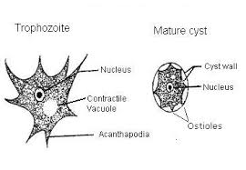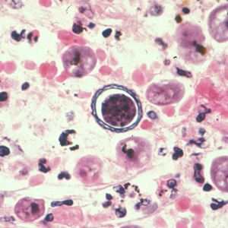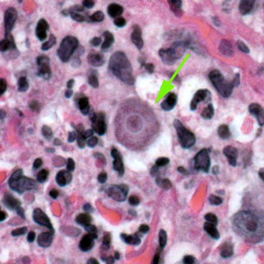

*Acathoamoeba* cyst *Acantho*.troph.

Life cycle:

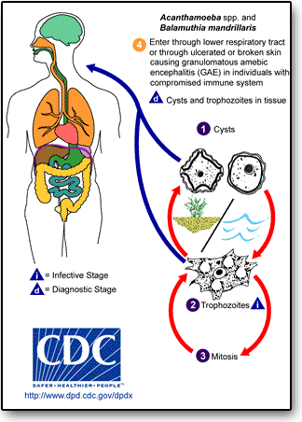

Symptoms

chronic granulomatous amebic encephalitis (GAE)

[amebic keratitis](http://www.tulane.edu/~wiser/protozoology/notes/free.html#AK)

granulomatous skin and lung lesions

**Diagnosis:**

Tests useful in the diagnosis of GAE include brain scans, biopsies, or spinal taps. In disseminated disease, biopsy of the involved sites (e.g. , skin, sinuses) can be useful in diagnosis,In the case of eye infection diagnosis is based on symptoms, growth of the ameba from a scraping of the eye, and/or seeing the ameba by a process called confocal microscopy.

**Lab (4)**

Kingdom: Protista

Subkingdom: Protozoa

Phylum: Sarcomastigophora

2-Subphylum: Ciliophora

Class: Ciliata

Order: Euciliata

Genus: *Balantidium coli*

3- Subphylum: Mastigophora (Flagellates)

Class:Zoomastigophora

Order: Diplomonadida

Genus: *Giardia lamblia* ,*Dientamoebafragilis, Chilomastix mesnili*

***Balantidium coli***

**Disease name**: Balantidiasis , Balantidial dysentery

**Site of infection**: Large intestine, cecum and terminal ileum

**Morphology of trophozoite:**

 They are covered in cilia and have boring or rotary motility. *Balantidium coli* is known for being the largest protozoan parasite of humans , the two nuclei are clearly visible.  The macronucleus is long and kidney-shaped, and the spherical micronucleus is nestled next to it.

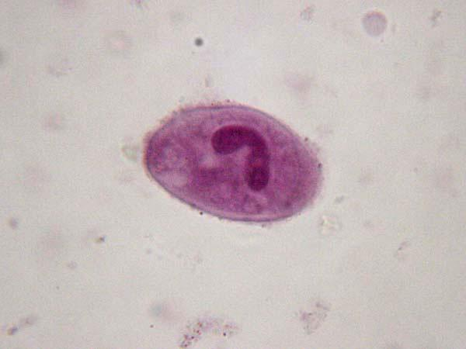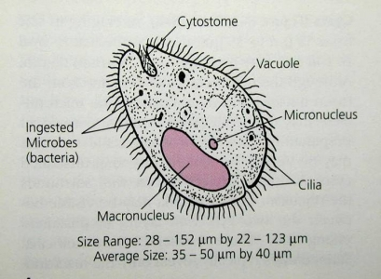

Cyst

Cysts are smaller than trophozoites, measuring Cysts are round and have a tough, heavy cyst wall made of one or two layers.  Usually only the macronucleus and perhaps cilia and contractile vacuoles are visible in the cyst

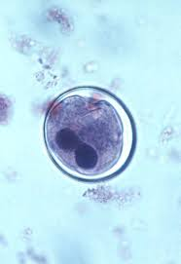 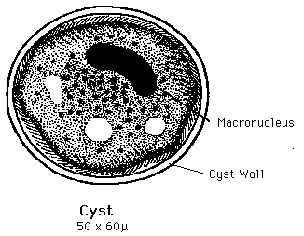

**Life cycle**

Infective stage:Cyst Diagnostic stage: Cyst,trophozoite

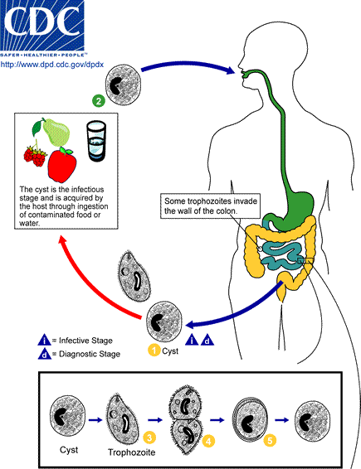

**Symptoms:**

who are infected with B. coli remain asymptomatic. trophozoites can invade the mucosa of the large intestine (cecum and colon) and cause ulcerations. Other bacteria in the intestine may enter the ulcer leading to secondary infections. Common symptoms chronic diarrhea, occasional dysentery (diarrhea with passage of blood or mucus), nausea, foul breath, colitis (inflammation of the colon), abdominal pain, weight loss, deep intestinal ulcerations, and possibly perforation of the intestine.

**Diagnosis**

Examination of stool samples, looking for trophozoites and cysts ,Trophozoites are readily identified because of their large size and the fact that B. coli is the only ciliate that parasitizes humans.

***Giardia lambilia***

Disease name :Giardiasis

Site of infection: small intestine

**Morphology:**

Trophozoite: It is flattened pear shaped with two nuclei ,two slender axostyles and eight flagella (four pairs of flagella).They attach themselves to the surface of jejuna or duodenal mucosa by their disc like suckers wich are found on their ventral surface.

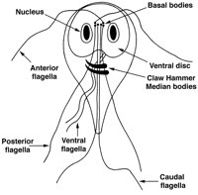 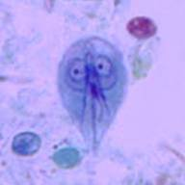

Cyst: It is ellipsoid in shape,contain four nuclei. Longitudinal fibrils consisting of the remains of axonesmesand parabasal bodies may also seen.

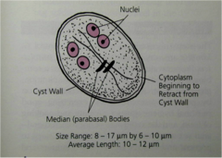 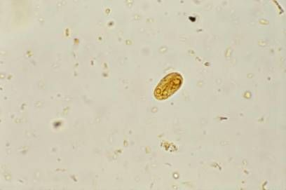

*Giardia lamblia* cyst stained with iodine

**life cycle**

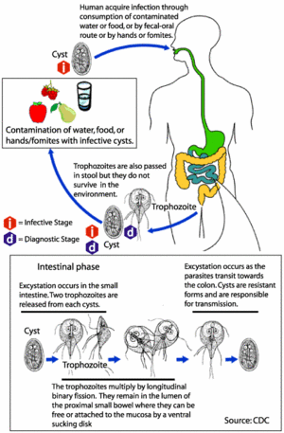

Symptoms: are abdominal pain, flatulence and watery diarrhea no blood no mucus is normally seen.

Laboratory diagnosis

1-Trophozoites and cyst are found by examination of saline wet preparation of fresh diarrheic stool.

2- duodenal or jejuna aspirate

3-Elisa to detect IgMin serum provides the evidence of current infection.

4- Biobsy from the upper intestine.

***Dientamoeba fragilis***

is currently classified as an amoeba flagellate, even though it lacks a flagella

Diagnostic stage :the trophozoite in feces. There is no cyst stage.

**Morphology**

The trophozoites contain one or two nuclei. with little or no peripheral chromatin; karyosome is divided into 4 to 8 distinct granules.

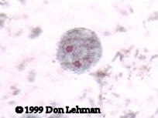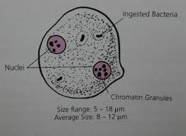

**Life cycle**:

The parasite doesn’t form a cyst and the trophozoite cannot survive passage through small intestine, It may be transmitted from host to host within the egg of pinworm and whip worm

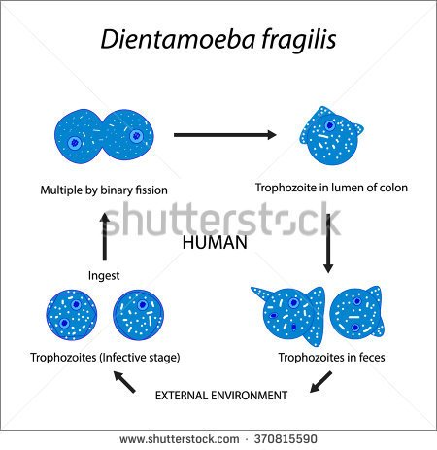

**symptoms**

infection is usually asymptomatic; can be associated with diarrhea, anorexia, abdominal pain.

**Diagnosis**: . D. fragilis are best detected in permanent -stained fecal smears, May rarely ingest rbc’s.

***Chilomastix mesnili***

A non-pathogen .

Site of infection :Large intestine in cecum and colon.

Transmission - by ingestion of mature cysts(infective stage).

**Morphology**

**Trophozoite** - 4 flagella (3 anterior, 1 associated with the cytostome; one nucleus, always located anteriorly

The trophozoites of C. mesnili are also pear-shaped. The single nucleus usually has a prominent karyosome. The anterior flagella are difficult to see. The oral groove (cytostome) is sometimes seen near the nucleus.

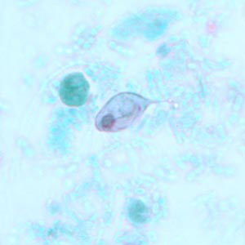 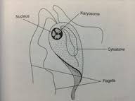

Trophozoite of C. mesnili from a stool specimen,

stained with trichrome.

**Cyst** - lemon shape; 1 nucleus;

The cyst of Chilomastix mesnili, shown on the right, is pear-shaped. There is a single nucleus.

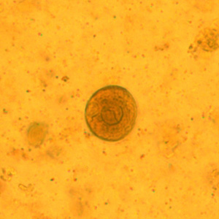 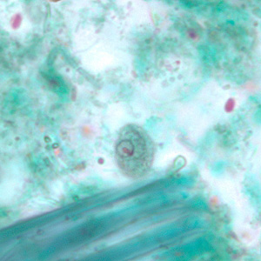

Cyst of C. mesnili in a concentrated wet mount of stool, Cyst of C. mesnili in a stool specimen,

stained with iodine. stained with trichrome

**Life cycle**

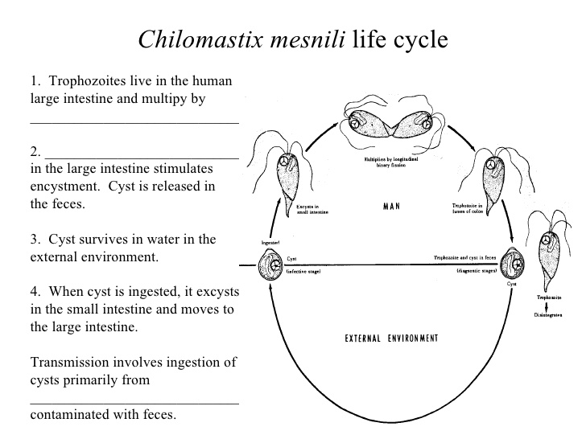

**Diagnosis**

The test recommended for the detection of Chilomastix mesnili is stool examination which includes formalin concentration methods for the detection of cyst forms and trichrome staining for cyst and trophozoite forms. An inexperienced technologist can mistaken Chilomastix mesnili for Giardia lamblia.

LAB 5

Kingdom: Protista

Subkingdom: Protozoa

Phylum: Sarcomastigophora

3- Subphylum: Mastigophora (Flagellates)

Class: Zoomastigophora

Order: Diplomonadida

Genus: *Trichomonas vaginalis* pathogenic

*Trichomonas tenax* nonpathogenic

*Trichomonas hominis* nonpathogenic

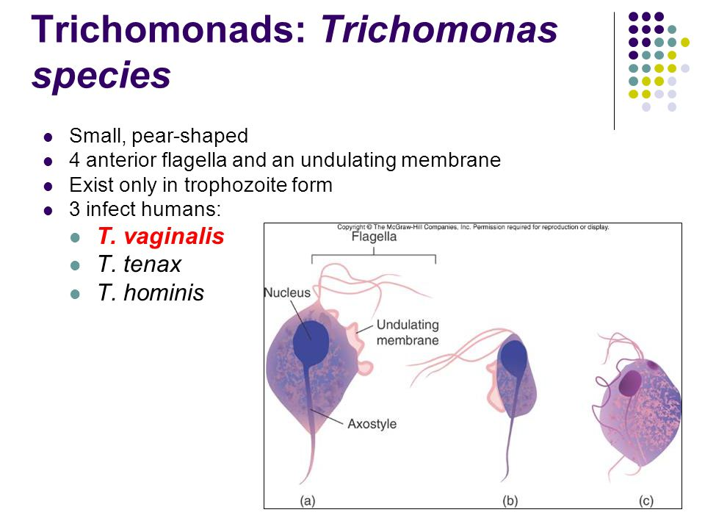

1-Trichomonas vaginalis

It existsonly in trophozoite form

Transmission is by sexual intercourse

Disease name: Trichomoniasis

Site of infection: the urethra &vagina of women and the urethra & prostate gland of man

Morphology:

Pear shaped organisimwith central nucleus and four anterior flagella and

Undulating membrane extends about two-thirds of its length.

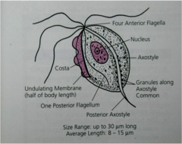 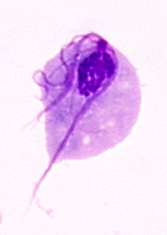

Trichomonas vaginalis trophozoite

Life cycle:

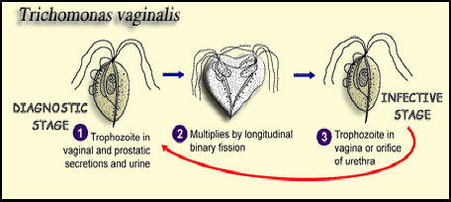

Symptoms:

Women

* A [vaginal discharge](http://patient.info/health/vaginal-discharge-and-vaginal-bleeding) is common. This is typically greeny-yellow and may be 'frothy'. The discharge usually has an unpleasant smell.
* vagina iching and uncomfortable.
* It may be sore when you pass urine.
* No symptoms occur in some women. However, they can still pass on the infection even if you have no symptoms.

**Men**

* Discharge from the penis is common.
* It may be sore when you pass urine.
* You may pass urine frequently (due to irritation inside the penis).
* No symptoms occur in most infected men. However, you can still pass on the infection even if you have no symptoms.

Diagnosis:

cell cultures

antigen tests (antibodies bind if the*Trichomonas* parasite is present, which causes a color change that indicates infection)

tests that look for *Trichomonas* DNA

examining samples of vaginal fluid (for women) or urethral discharge (for men) under a microscope

*Trichomonas tenax*

Site of infection: mouth especially in carious teeth & gum

Transmission :is by the use of contaminatide utensilis with trophozoite or direct from mouth to mouth

Morphology:

Shape Oval to pear ,one nuclei vesicular filled with chromatin granules,

Flagella Five total, all originating anteriorly :four extends anteriorly

One extends posteriorly Other structures Undulating membrane extending 2/3 of body length Thick axostyle Small anterior cytosome opposite undulating membrane

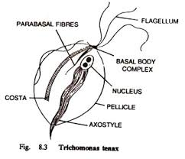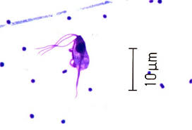

**Life cycle**

Trichomonas tenax trophozoites survive in the body as mouth scavengers that feed primarily on local microorganisms. Located in the tartar between the teeth,tonsillar crypts pyorrheal pockets, and gingival margin around the gums,T. tenax trophozoites multiply by lonitudinal binary fission. These trophozoites are unable to survive the digestive process.

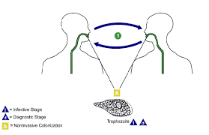

**Symptoms**

The typical Trichomonas tenax infection does not produce any notable

symptoms.

**Diagnosis**

The specimen of choice for diagnosing Trichomonas tenax trophozoite is mouth scrapings. Microscopic examination of tonsillar crypts and pyorrheal pockets of patients suffering from T. tenax infections often yields the typical trophozoites. Tartar between the teeth and the gingival margin of the gums are the primary areas of the mouth that may also potentially harbor this organism. T. tenax may also be cultured onto appropriate media .

***Trichomonas hominis***

site of infection :Large intestine(descending colon and cecum )

|  |
| --- |
| is often identified in human diarrheic stools. Because of the fecal-oral transmission rout, infection with T. hominis is more frequently reported in children than in adults.  **Morphology:**  The trophozoite of T. hominis has a pyriform shape and has an axostyle, and four anterior flagella. There is an undulating membrane that runs the entire length of the body. |

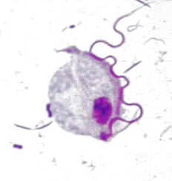

Life cycle

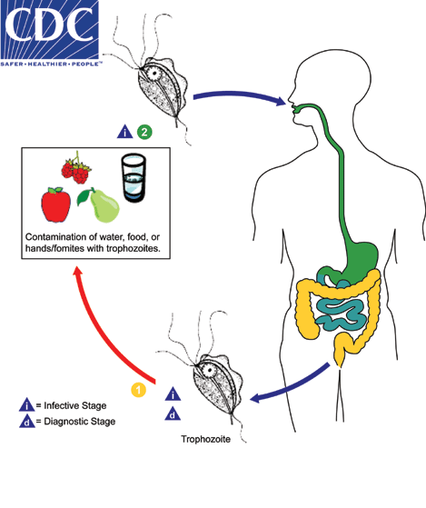

The presence of trophozoites in stool specimens can however be an indicator of fecal contamination of a food or water source, and thus does not rule-out other parasitic infections.

Class: Ampicompleaxa

Order: Eucoccidia

Genus:1-*Toxoplasma gondii*

2- *Cryptosporidium parvum*

3- *Isospora belli*

4- *Cyclospora cayetanensis*

Class:Microsporea

Order:Chytridiopsida

Familiy:cougourdellidae

Genus:*Microsporidium*

1-*Toxoplasma gondii*

Disease name :Toxoplasmosis

Site of infection: brain, eye, skeletal muscle, neural tissue

Definitive host: Cats

**Morphology:**

1-Tachyzoite: crescent shaped organisms, with one end pointed and the

other end rounded. The nucleus is ovoid and situated near the blunt end of the parasite.

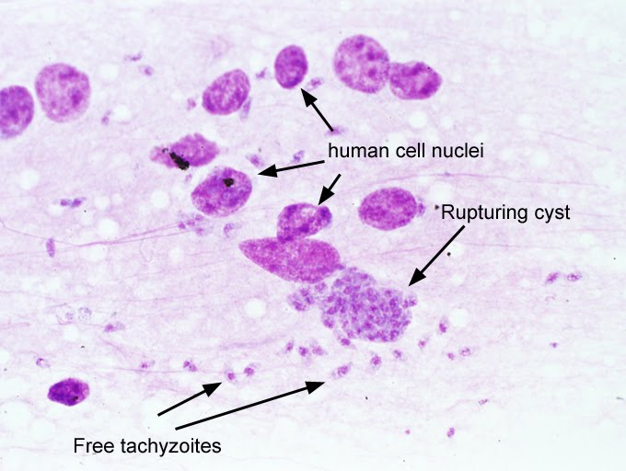 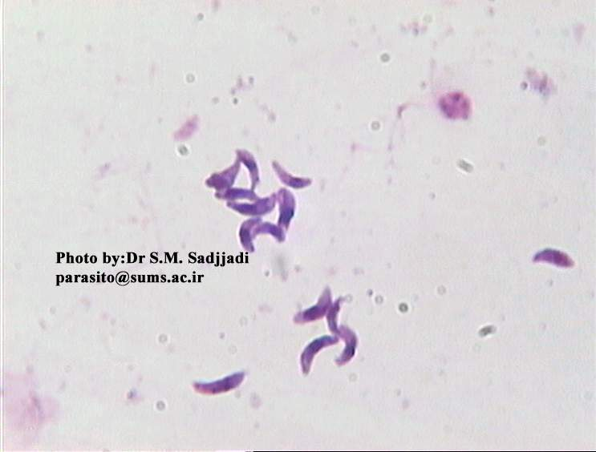

2- Bradyzoites: differ structurally only slightly from

tachyziote. They have situated toward the posterior end whereas the nucleus

in tachyzoite is more centrally located The tissue cysts is formed during the chronic phase of the infection and can be found in the muscle and various other tissues and organs include the Brain

3- Oocysts: which is sepherical or ovoid contain 4sporozoites (infective stage)

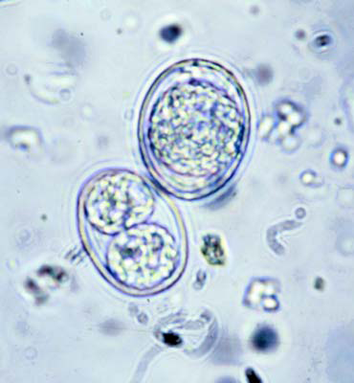 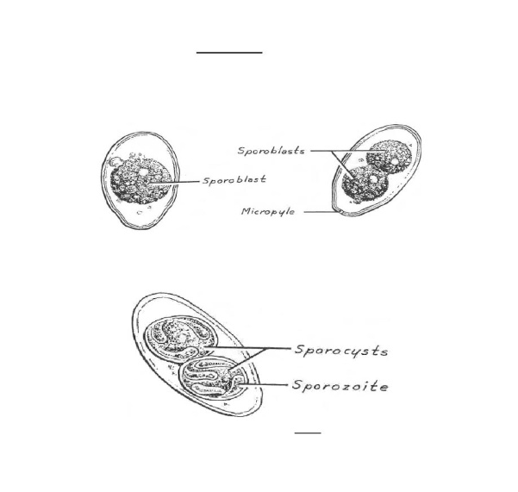

**Life cycle:**

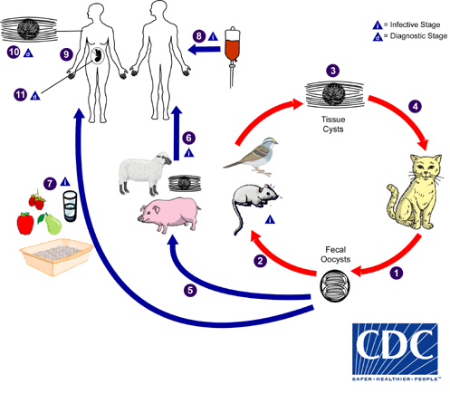

Infective stage:

1- Oocyst from contaminated hands or food with cat feces.

2- (Bradyzoites) tissue cyst in uncooked meat.

3-Trasplasental transfer of (trachyzoites).

4- Blood transfusion or organ transplantation.

Diagnostic stage:

Tissue cyst tachyzoites (acute infection),bradyzoite(chronic infection)

**Symptoms**

Abortion, hydrocephalus or micocephaly, Blindness

**Laboratory Diagnosis**

1. Serological Techniques
2. Isolation Techniques:

Culture of parasites in animals is the best overall method but it can take up to six weeks before the result is available and is thus a disadvantage. Tissue culture is more rapid taking three or four days to obtain a result, but is not as sensitive

3.Direct identification of the parasite from peripheral blood, amniotic fluid or in tissue section.

***2-Cryptosporidium parvum***

*Cryptosporidium* species, are coccidian protozoa

Disease name Cryptosporidiosis

Site of infection : the epithelial cells of the intestinal tract

Infective stage :Oocyst

**Morphology:** spherical or ovoidal in shape , containing four crescentic sporozoites and 1-6 large dark granules

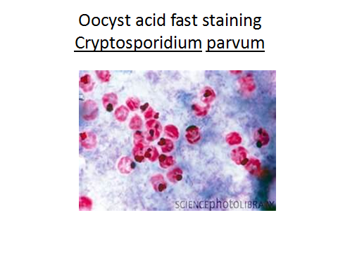 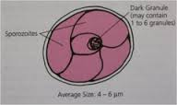

**Life cycle**

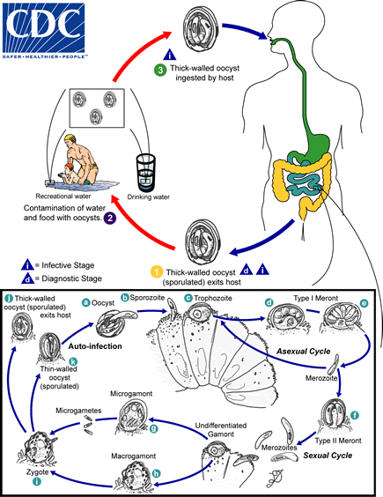

**Symptoms**

The infection produces a persistent, watery, offensive diarrhea often accompanied by abdominal pain, nausea, vomiting and anorexia

**Diagnosis**:

Detecting oocyst in the stool

Serological test

***Isospora belli***

*Disease name:isosporiasis*

Site of infection: epithelial cells in the small intestine

**Morphology**

the immature oocyst , the shape is elongated,

ovoid &flask shape(like a bottle with short neck).It has two membranes outer and

inner ,they are hyaline ,transparent &colorless and the tip of narrow end, there is

micropyle. Within the oocyst there is sporoblast(zygote)with nucleus. After

maturation in the feces within 2-3 days or in 2.5% potassium dichromate solution

,the mature oocyst contain two spherical sporocyst, each with four crescent

(banana shaped)sporozoites, whichit is the infective stage of the parasite

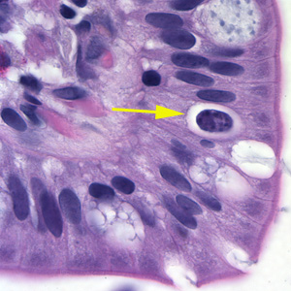

An oocyst of Cystoisospora belli in the epithelial cell of a mammalian host stained with hematoxylin and eosin. The oocyst is marked with yellow arrow.

**Life Cycle**

The life cycle of *I. belli* involves an asexual (schizogonic stage) and a sexual (sporogonic stage)

. 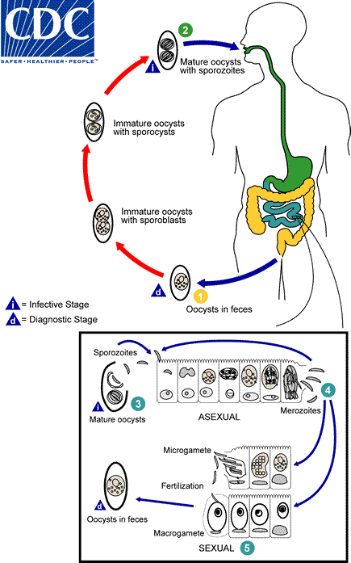

**Symptoms**

infection is generally asymptomatic or a self-limiting gastro-enteritis.

However, in chronic infections, severe non-bloody diarrhea with cramp-like abdominal pain can last for weeks and result in fat malabsorption and weight loss. Eosinophilia may be present (atypical of other protozoal infections).

**Laboratory Diagnosis**

Oocysts are thin walled, transparent and ovoid in shape. They can be demonstrated in feces after a formal ether concentration

Alternatively, oocysts can be seen in a fecal smear stained by a modified Ziehl-Neelsen method, where they stain a granular red color against a green background, or by phenolauramine

.

***Cyclospora cayetanensis***

Disease name: cyclosporaiasis

Site of infection: *Cyclospora cayetanensis*

**Morphology**

Cyclospora oocysts are round and generally between 8 and 10 microns. They look similar to cryptosporidium oocysts, but are larger . The oocyst coat of cyclospora is often described as “wrinkled .Each oocyst has two sporocysts that each have two sporozoites

. 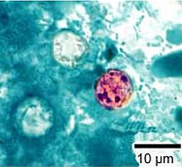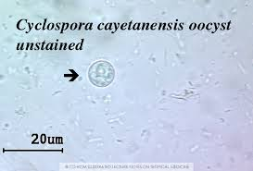

***Cyclospora cayetanensis* oocysts**

**Life cycle**

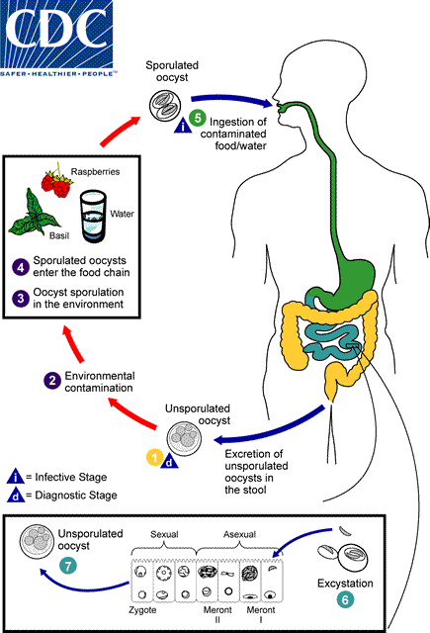

**Symptoms:** about a one week incubation period, then symptoms appear, such as watery diarrhea, anorexia, weight loss, fever, abdominal pain, nausea and vomiting, myalgias, and fatigue. Untreated infections last for about 10-12 weeks and can relapse.

**DIAGNOSIS**

The diagnosis is made by microscopic identification of oocysts in stool specimens

**Microsporidium**

Disease name: Microsporidiosis

**Morphology**

Microsporidia spores are all round and oblong and those associated with human infection (an important feature for diagnosis as some species are often mistaken for bacteria). All have a characteristic coiled polar tube

 spores containing a tubular extrusion apparatus (polar tubule) for injecting infective spore contents into the host cell

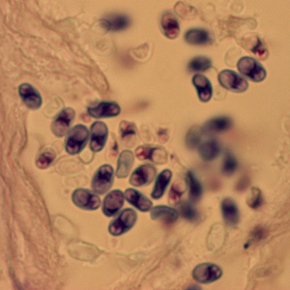

Microsporidium spores stained with giemsa stain

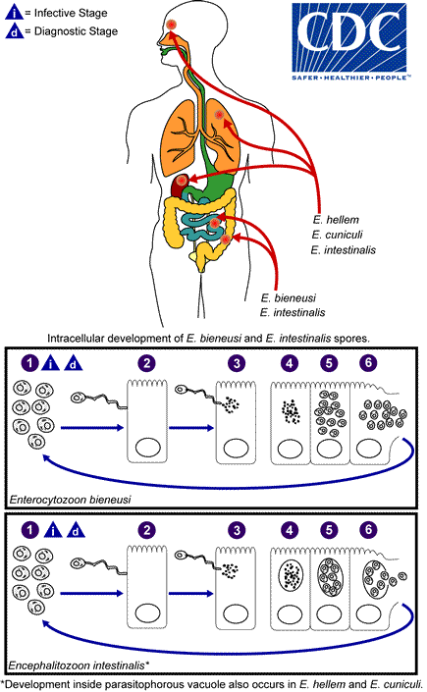

Symptoms:

Microsporidiosis can cause chronic [diarrhea](http://www.medicinenet.com/diarrhea/article.htm), [kidney disease](http://www.medicinenet.com/kidney_disease_quiz/quiz.htm), and infection of the sinuses and eyes.

Diagnosis:

light microscopic examination of stool specimens and urine or cytological examination of other body fluids.

**LAB7**

**Blood and Tissue flagellates:** it include flagellated protozoa that contain

1-flagella 2-nuclues 3-kinetoplast

**Morphology of tissue and blood flagelates**

1-Amastigote:oval in shape, one eccentric nuclei, kinetoblast anterior to the nuclei and no flagellum.

2-Promastigote:one central nuclei, kinetoblast anterior to nuclei ,free flagellum

3-Epimastigote:Short undulating membrane kinetoblast central anterior to the nuclei

4-Trypomastigote:elonguated undulating membrane, one central nuclei and kinetoblast posterior to nuclei

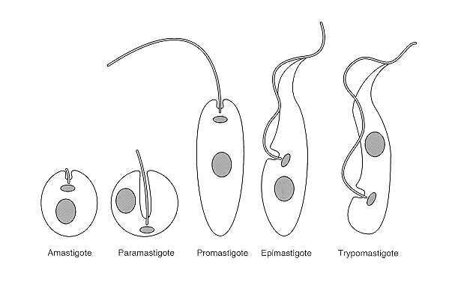

Kingdom: Protista

Subkingdom: Protozoa

Phylum:Sarcomastigophora

Class:Zoomastigophora

Order: Kinetoplastida

Family: Trypanosomatidae

Genus:1-*Leishmania spp.*

2-*Trypanosoma spp.*

***Leishmania spp.***

1-*Leishmania tropica*

2-*Leishmania donovani*

3-*Leishmania braziliensis*

**Disease name:**

- *Leishmania tropica* causes Baghdad boil ( cutaneous leshmaniasis).

*-Leishmania donovani* causes kalazar or black fever (visceral leshmaniasis).

*-Leishmania braziliensis* causes subcutaneous (mucocutaneous leshmaniasis).

**Site of infection:**

*-Leishmania tropica* ( skin )

*-Leishmania donovani* ( liver, spleen, lymph node, bone marrow )

*-Leishmania braziliensis* ( mucocutaneous tissue of skin, nose, mouth )

**Definitive host** : human

**Intermediate host (vector)** : *Phlebotomus* female ( sand fly)

**Morphology:**

*Leishmania* exist as

Promastigotes(flagellated extracellular) in the sandfly vector .The flagellated Promastigote form is spindle shaped, the flagellum, a nucleus and kinetoplast are clearly visible.

Amastigotes( intracellular) within mononuclear phagocytes of their vertebrate hosts, amastigotes appear round or oval bodiesin with a well defind nucleus and kinetoplast. The various species are not distinguishable morphologically from one another.

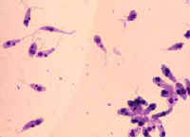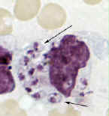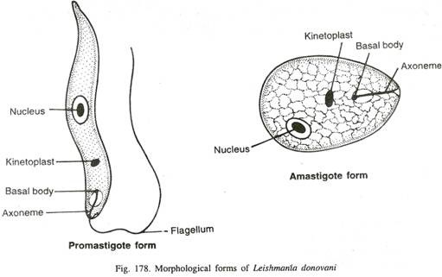

**Life cycle:**

Infective stage: metacyclic promastigotes.

Diagnostic stage:amastigotes

[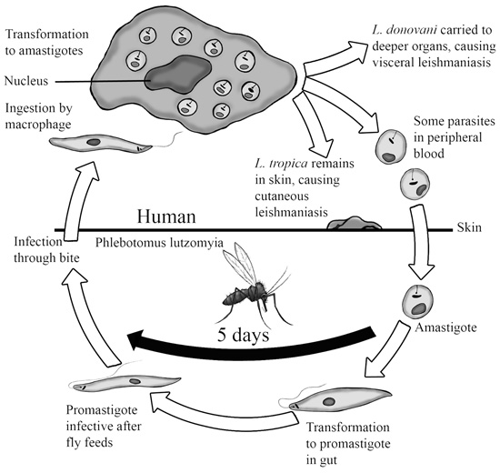](http://www.google.iq/url?sa=i&rct=j&q=&esrc=s&source=images&cd=&cad=rja&uact=8&ved=0ahUKEwi51tSsuLvLAhXGK5oKHV6uB8gQjRwIBw&url=http://rowdysites.msudenver.edu/~churchcy/BIO3270/Images/Protozoans/Leishmania.htm&psig=AFQjCNGfxFuE3Jn0Z6g7aHPHKyUQuxj_og&ust=1457882103913221)

**Diagnosis:**

1-Direct smear of blood and lymph.

2-Serology.

3-Cuturing in N.N.N.(Nove MacNeal-Nicole).

4-Biobsy from liver,Spleen and bone marrow.

**Lab(8)**

***Trypanosoma spp.***

Trypanosomes are hemoflagellates and three species of the genus *Trypanosoma* are responsible for disease in humans

**1-African trypanosomiasis (sleeping sickness)**

There are two clinical forms of African trypanosomiasis

A – *Trypanosoma brucei gambiense* causes ( Gambian trypanosomiasis chronic sleeping sickness).

B- *Trypanosoma brucei rhodesiense* causes (Rhodesians trypanosomiasis acute sleeping sickness).

**Site of infection**: blood ,lymph, spleen, liver, cerebrospinal fluid

**Vector Tsetse genus**: *Glossina spp.*

The parasite undergo several forms depending on the host

In vertebrate host (human) which is definitive host :trypomastigote

In invertebrate host (insect) which is intermediate host: trypomastigote and epimastigote

**Morphology**

The parasite is an elongated cell with single nucleus which usually lies near the centre of the cell, single flagellum which appears to arise from a small granule kinetoplast. two forms of trypomastigote can be seen in peripheral blood: one is long slender, 30 μm in length, and is capable of multiplying in the host, the other is stumpy, not dividing, 18 μm in length.

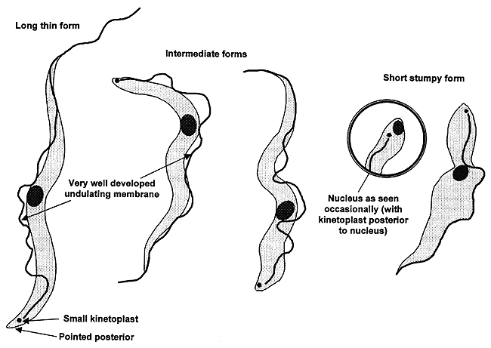

**Life Cycle**

Transmission from one vertebrate to another is carried out by blood-sucking invertebrates

Metacyclic S-shape trypomastigotes (infective stage)

Trypomastigote in blood (diagnostic stage)

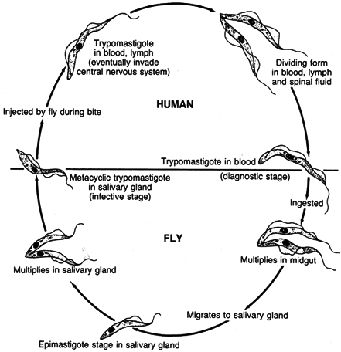

**Symptoms:**

The early stages of African trypanosomiasis may be asymptomatic and there is a low grade parasitiaemia. This period may last for several weeks to several months. The disease may terminate untreated at this stage or go on to invade the lymph glands. Invasion of the lymph glands is usually accompanied by a high irregular fever with shivering, sweating and an increased pulse rate.Trypanosomes may invade the central nervous system giving symptoms of meningoencephalitis, confusion, apathy, excessive sleeping and incontinence.

**Laboratory diagnosis of African Trypanosomiasis is by**:

• Examination of blood for the parasites

• Examination of aspirates from enlarged lymph glands for the parasites

• Examination of the CSF for the parasite

• Detection of trypanosomal antibodies in the serum

**2-Amarican trypanosomiasis**

*Trypanosoma cruzi* causes ( chagas disease).

**Site of infection**: muscular muscle, kidneys, thyroid gland, sexual organs

**Vector Bug genus**: *Tritoma*

**Morphology:**

*Trypanosoma cruzi* has a single form (monomorphic), about 20μm in length, and characteristically curved (C-shape). The kinetoplast is large, considerably larger than the *Trypanosoma brucei* species.The flagellum is medium in length. *Trypanosoma cruzi* in man only occurs in the amastigote phase in muscular tissue and cell..

**Lifecycle of*****Trypanosoma cruzi***

[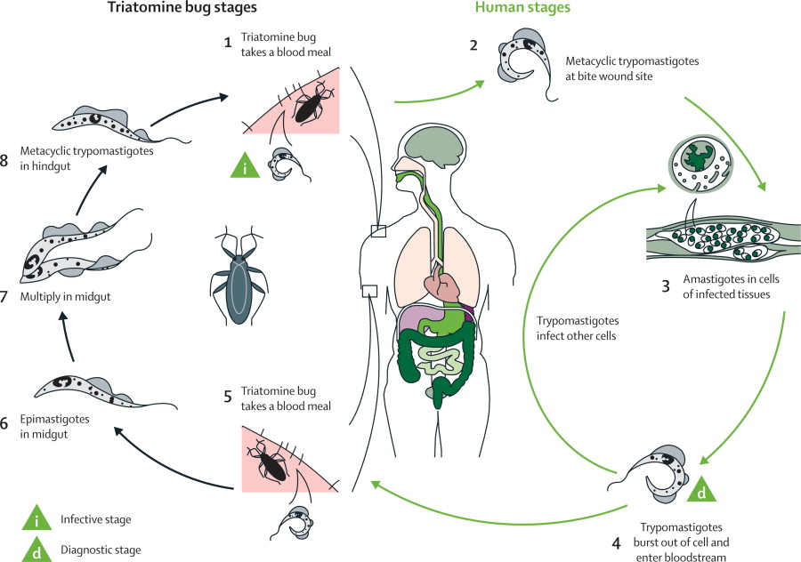](http://www.google.iq/url?sa=i&rct=j&q=&esrc=s&source=images&cd=&ved=0ahUKEwjzu73kv7vLAhWja5oKHSXGDbcQjRwIBw&url=http://www.thelancet.com/journals/laninf/article/PIIS1473-3099(08)70230-5/fulltext?rss=yes&psig=AFQjCNExF1AkGOdgnZ8UeCdgKzwGiIgXNg&ust=1457883820576839)

**Symptoms:**

In an acute infection there may be fever, malaise, increased pulse rate, and enlargement of lymph glands, liver, and possibly spleen .Chronic infection include signs of cardiac muscle damage leading to heart failure.

**Laboratory diagnosis** of South American trypanosomiasis is by:

• Examination of blood.

• Xenodiagnosis

• Blood culture

• Serolog.

**Lab (9)**

**Kingdom**: Protista

**Subkingdom**: Protozoa

**Phylum**: Sarcomastigophora

**Class**: Ampicomplexa (sporozoa)

**Order**: Eucoccida

**Family**: Plasmodidae

**Genus**: *Plasmodium vivax* (benigntertian malaria).

*Plasmodium malaria* (quartian malaria).

*Plasmodium ovale* (ovale tertian malaria).

*Plasmodium falsiparm* (malignant tertian malaria).

**Disease name:** Malaria

**Site of infection:** Red blood cell and Liver tissue cell

***Plasmodium* requires two hosts:**

-**Definitive invertebrate host:** (vector Anopheles mosquitoes female).

-**Intermediate vertebrate host:** (mammals, birds and lizards).

**Morphology:**

|  |  |  |  |  |
| --- | --- | --- | --- | --- |
|  | P.falciparum | P.malaria | P. vivax | P.ovalae |
| Trophzoite | ring forms | band form | amoeboid form | compact rings in cells |
| **Schizont** | (8 – 36) merozoites. | (6–12) large  merozoites | (16). merozoites | (6-12) merozoites |
| **Microgametocyte** | Larger than RBC,  kidney shaped with blunt round ends | Smaller than RBC,round compact | Fills  enlarged RBC, small round or oval,compact with central nucleus | Of the size of RBC  round, compact |
| **Macrogametocyte** | more slender and longer than the  male | Round or oval with peripheral nucleus | large round or oval with peripheral nucleus | Round or oval with peripheral nucleus |

[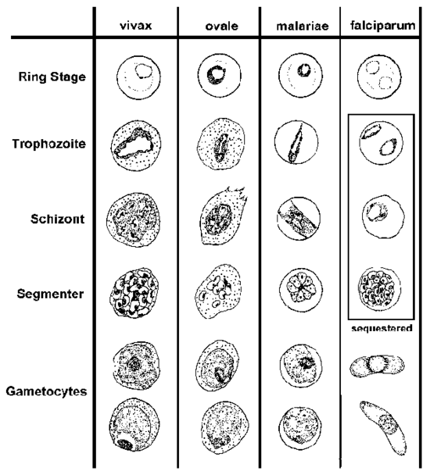](http://www.google.iq/url?sa=i&rct=j&q=&esrc=s&source=images&cd=&cad=rja&uact=8&ved=0ahUKEwjw_OCh_8_LAhVDVBQKHa-WBcYQjRwIBw&url=http://tommytoy.typepad.com/tommy-toy-pbt-consultin/diseases-and-infections/&psig=AFQjCNHEFChmmqaFD0k3cyh-0fyXBRA3XA&ust=1458588251435714)

**Life cycle:**

**sexual cycle**

occurs in mosquito (9-21 days) ,fusion of micro and macrogametes are infective for mosquito→ zygote→ookinete (~24 houre) →oocyst

Asexual replication (sporogony) → sporozoites released → migrate through hemocoel→ invade salivary glands

**Asexual cycle**

**1-Exoerythrocytic schizogony ( Liver stage)**

Sporozoites injected during mosquito feeding→ merozoites(uninucleate asexual stages) invade liver cells .After this initial replication in the liver (exo-erythrocyticschizogony ) the parasites undergo asexual multiplication in the erythrocytes.

**2-Erythrocytic schizogony ( Blood stage)**

Merozoites infect red blood cells and forms the ring stage in it and transform into trophozoites that mature into schizonts ( multinucleated asexual stages) , which rupture releasing merozoites . Some parasites differentiate into asexual erythrocytic stages (gametocytes) repeated erythrocytic schizogony (48hr) in *Pf., Pv., Po.*and(72 hr) in *Pm.*

[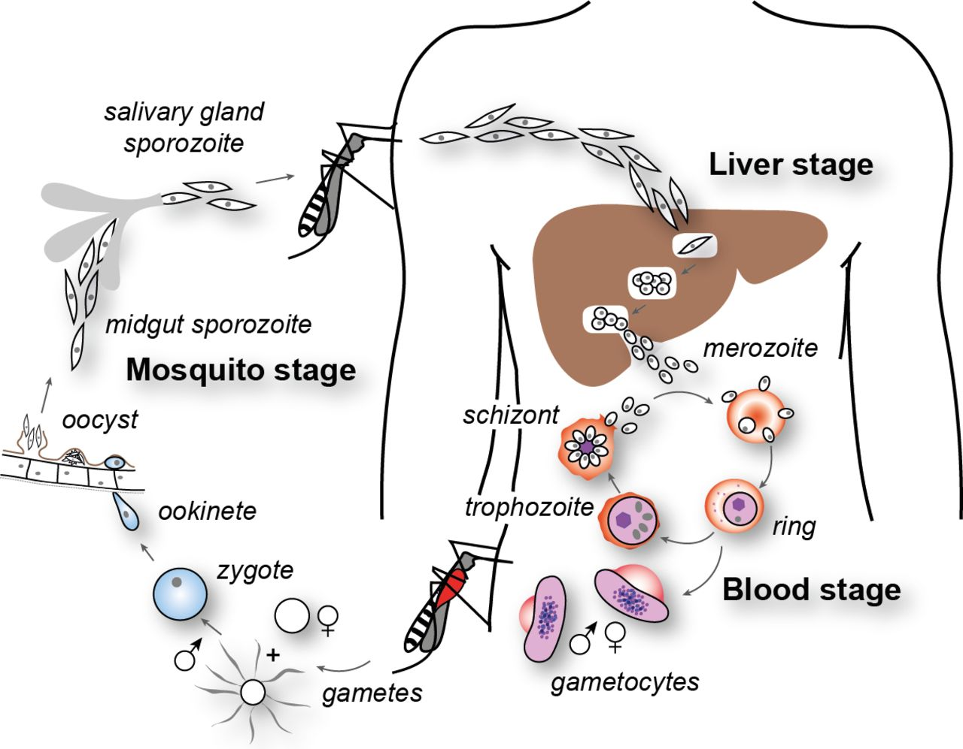](http://gamespewdaily.com/2016/03/19/asp-net-page-life-cycle/)

**Symptoms:**

- **Fever**: Often irregular. The regular pattern of fever does not occur until the illness has continued for a week or more.

-**Anemia**: The anemia is hemolytic in type. It is more severe in infections with *P. falciparum* because in this infection cells of all ages can be invaded.

-**Splenomegaly** : The spleen enlarges early in the acute attack of malaria.

-**Jaundice**: Amild jaundice due to hemolysis may occur in malaria.

**Diagnosis:**

1-Thin blood films stained with Giemsa stain.

2-Antibody test.