The First Experiment
Introduction:
The science of thermodynamics:
Thermodynamics can be defined as the study of energy, energy transformations and its relation to matter; this science began with efforts to convert heat into energy with the discovery of the steam machine.
Today, this science deals with various forms of energy and its transformations. These transformations are formulated in what is known as the first and second laws of thermodynamics, two natural laws that have been in place since the creation of the universe.
Human knowledge of these laws has led to the emergence of many useful applications in life, for example, in the field of chemical industries. There is a need to determine heat requirements and equilibrium conversion ratios for chemical reactions, as well as to determine the energy requirements for pumps and compressors, and to determine the equilibrium relationship in the transfer of matter between different phases.

Dimensions and Units:

Any physical quantity can be characterized by dimensions. The arbitrary magnitudes assigned to the dimensions are called units. There are two types of dimensions, primary or fundamental and secondary or derived dimensions.
- Primary dimensions are: mass, m; length, L; time, t; temperature, T
- Secondary dimensions are the ones that can be derived from primary dimensions such as: velocity (m/s2), pressure (Pa = kg/m.s2).
There are two unit systems currently available SI (International System) and USCS (United States Customary System) or English system. We, however, will use SI units exclusively in this course.

Some Definitions:
System: It is the amount of matter in a space that we are studying.
Surrounding: It is the space of matter outside the thermodynamic system.
Boundaries: the real or imaginary surface that separates the system from its surroundings. Mathematically, the boundary has zero thickness, no mass, and no volume.
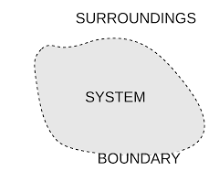

Types of Systems: It can be divided into:
- Close System: It is the one that contains a certain mass of matter and the substance does not exist or enter this system, that is, the substance does not exchange with the surrounding medium, for example, a closed tank with fixed boundaries that contains a limited mass of gas or liquid, On the other hand, a closed system can exchange energy with the surrounding medium in the form of heat or work, and in this case it is not necessary for the volume of the system to remain constant and part of the system boundaries may move. For example, a vertical cylinder with a moving piston is considered to contain a mass of gas called (working fluid gas), the system here consists of the cylinder, piston and gas. If the cylinder is heated from the outside, the piston moves up (the volume of the system changes) and the gas moves (represent a part of the system boundaries), which is the inner surface of the piston.
- Isolated System: It is a system in which there is no exchange of mass or energy with the surrounding medium.
- Open System: It is a properly selected region in space. It usually encloses a device that involves mass flow. Both mass and energy can cross the boundary, such as compressors, pumps, and steam machines. These systems are characterized by the exchange of both energy and matter with the surrounding medium.
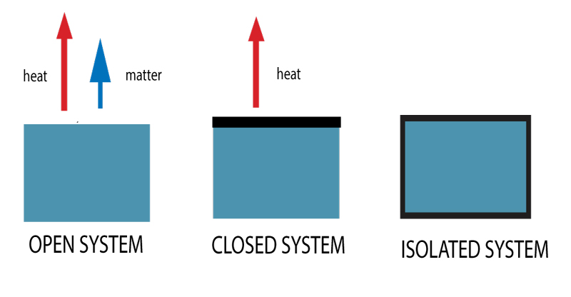
Properties of systems:
The thermodynamic system is characterized by several properties. Examples of properties are pressure (P), temperature (T), volume (V), and mass (M). The properties of systems can be divided into two main parts:
Extensive properties: The value of the extended properties depends on the amount of matter in a system such as volume, mass, total energy of the system.
Intensive properties: It is like temperature, pressure and density, does not depend on the quantity of matter, and is widely treated in thermodynamics with qualitative or unit-related properties such as specific volume, which is defined as the volume of a unit mass or v/m.
Some notes:
- Generally, uppercase letters are used to denote extensive properties (except mass m), and lower case letters are used for intensive properties (except pressure P, temperature T).
- Extensive properties per unit mass are called specific properties, e.g. specific volume (v=V/m).

Thermodynamics Process:
The change that occurs in the system in its initial and final states is called a thermodynamic process; the set of intermediate states that the system goes through during the process is called the process path. The description of the change includes the determination of the initial and final state of the system and the process path, as well as the interference between the system and the surrounding medium.
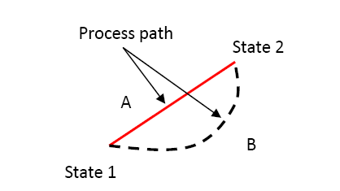
Processes that occur in systems can be classified into two main types:
- reversible Process: Where the direction of these processes can be reversed at any local point or moment with a very small change in the process conditions, so both the system and the surrounding medium return to their initial state.
- Irreversible processes: It is not possible to reverse the direction of change in these processes without a permanent change in the surrounding medium by recovering this heat. Therefore, the process of cooling water here is not reversible.

State Variables and State Function:
In thermodynamics, a state variable is a property of a system that depends only on the current, equilibrium state of the system and thus do not depend on the process path, for example, temperature and pressure. While a state function is a function defined for system relating several state variables. It describes the equilibrium state of a system, thus also describing the type of system. For example, a state function could describe an atom or molecule in a gaseous, liquid, or solid form.

