Lab. 2
Sub phylum: Vertebrata
Superclass: Pisces
Class: Cyclostomata (Agnatha)
Example: Lamprey
- Has a long body .
2- Has a round mouth that is surrounded by suckers with horny teeth. Its tongue is covered with teeth as well.
3- A lamprey's skull and spinal cord are made of cartilage.
4- Lamprey has a notochord - a flexible rod supporting its body.
5- Lampreys do not have scales. Their skins are covered with mucus.
6- It has seven gills on each side of its body.
- A lamprey does not have paired fins, but it has two dorsal fins (back fins) and a caudal fin (tail fin).
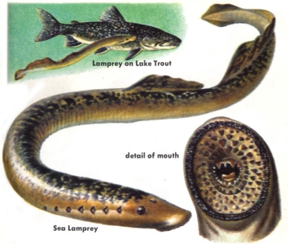

Class: Chondrichthyes
- Fishes with cartilaginous endoskeleton.
- Body is covered with placoid scales.
- Gills are five - seven pairs with no operculum.
4-Tail heterocercal means, tail lobes are unequal in shape. 5- Air bladder or lungs absent.

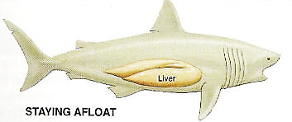

Class: Osteichthyes

- Fishes with bony endoskeleton.
- Body is covered with cycloid and ctenoid scales.
- Gills four pairs with operculum.
- Tail homocercal, means tail lobes are equal in shape.
- Air bladder is present and in some fishes lungs are also seen.

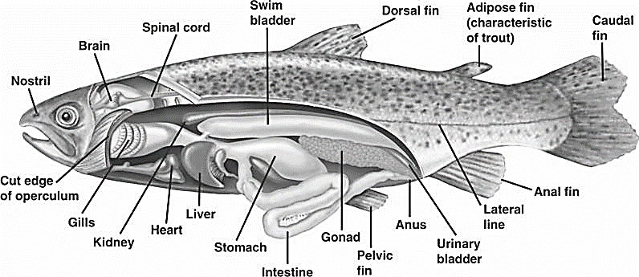

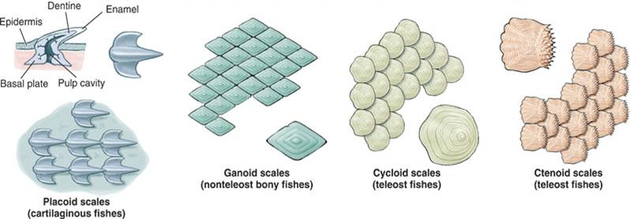

Types of scales

Superclass: Tetrapod
- Tetrapod have four limbs
- Various adaptations of the skeleton and muscles that enable special support and movement on land
- Adaptations to the cranial bones that allows the head to remain fixed while the animal moves
- An olfactory organ that plays a role in taste and smell
- An absence of internal gills.

Class: Amphibia
1) Amphibians spend part of their lives on water and another part on land.
3) The skin is smooth, thin, hairless and contains mucus glands and poison glands.
4) A bone endoskeleton with varying numbers of vertebrae.
5) Four limbs which may vary in size with the forelimbs much smaller than the hind limbs, some are legless.
6) The mouth is usually large with small teeth in upper or both jaws; two nostrils open into the anterior part of the mouth cavity.

Class: Reptilia
1- Reptiles have backbone and spines.
2-Reptiles have scales on their bodies and have a dry skin.
3-Reptiles have lungs and need air to breathe.
4-Reptiles either have four legs or have no legs at all.
5-Reptiles have ear holes instead of ears.

Class: Aves
1) Body usually spindle shaped, with four divisions: head, neck, trunk, and tail.
2) Limbs paired; forelimbs usually modified for flying; posterior pair variously adapted for perching, walking, and swimming; foot with four toes.
3) Epidermal covering of feathers and leg scales.
4) Fully bony skeleton with air cavities.
5) Each jaw covered with a keratin, forming a beak.

Class: Mammalia
1) Body covered with hair which is made of keratin.
2) Mammary glands are used to produce milk to feed their young.
4) The diaphragm that separates the thoracic cavity from the abdominal cavity.
4) Teeth are imbedded in the jaw bone and come in a variety of forms.
5) Well developed brain.
6) The mouth has a false palate as a roof, meaning that the nostrils do not lead directly into his mouth.

