Bacterial taxonomy Lec .9 Phylum Actinobacteria
The High G + C Gram-Positive Bacteria were grouped in this phylum; figure 1 demonstrates the phylogenetic position of this phylum.

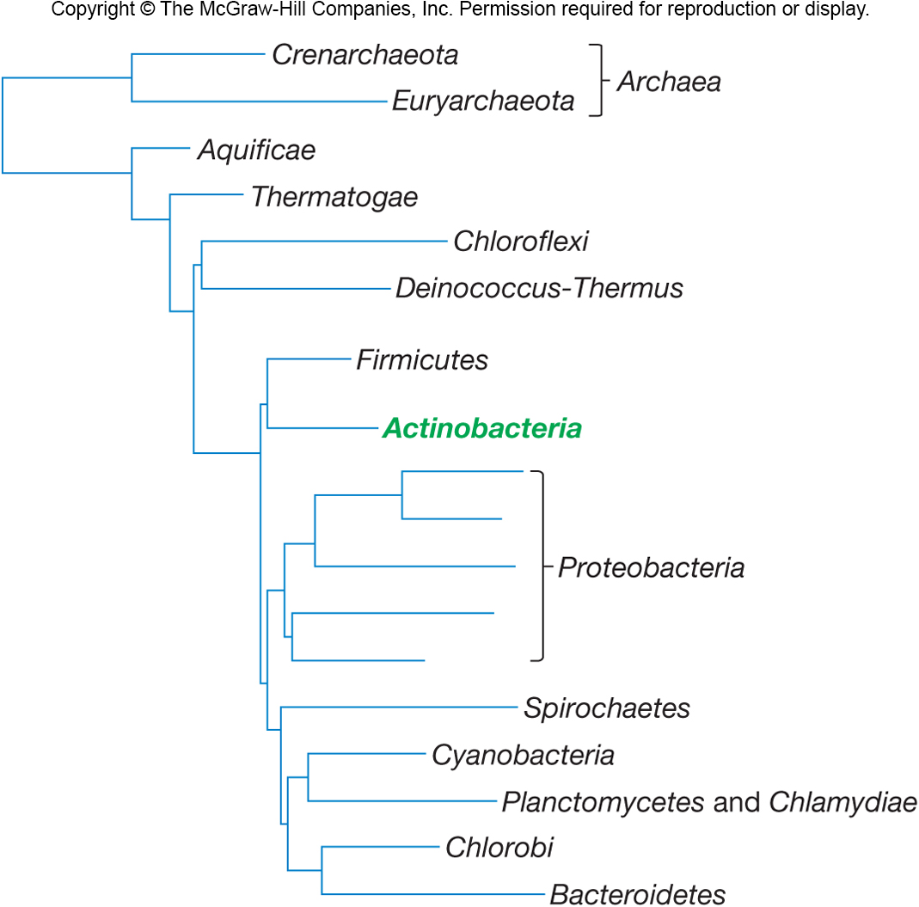
Figure .1 Phylogenetic position of Actinobacteria

16S rRNA evidence of this phylum shows 1 class only (Actinobacteria), classified into five subclasses distributed to six orders with14 suborders categorized to 44 families (figure.2) .
Phylum Actinobacteria Consists of Actinomycetes and their high G + C Gram-positive relatives.

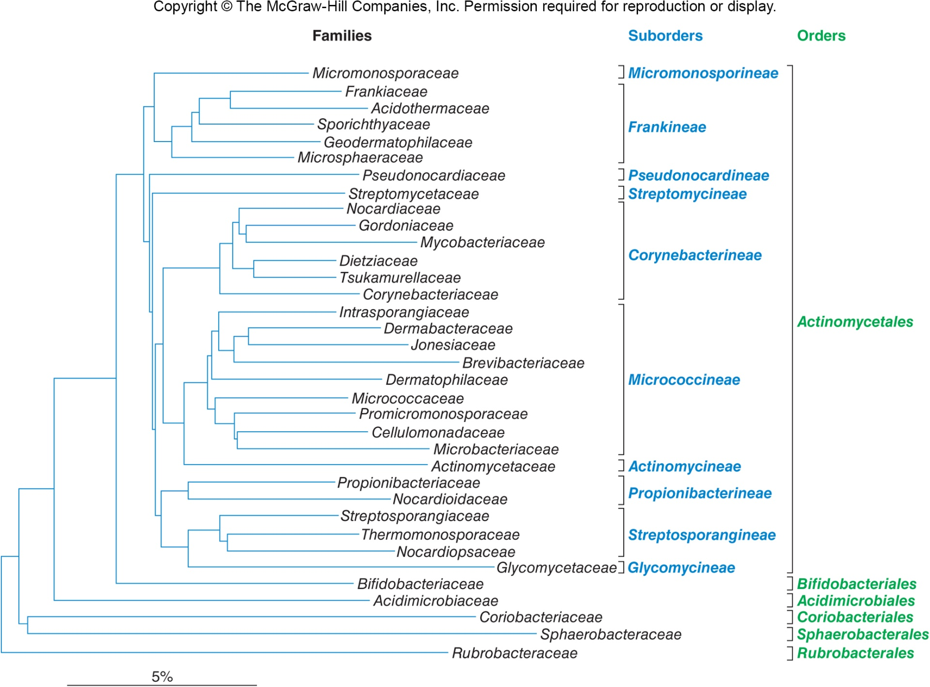
Figure.2 Classification of Actinobacteria

In this lecture we will explain two orders of phylum Actinobacteria :Actinomycetales and Bifidobacteriales
General Properties of the Actinomycetes
- Gram-positive, aerobic bacteria that produce filamentous cells called hyphae and differentiate into asexual spores.
- Adapt to climates similar to fungi.
- Source of most currently used antibiotics.
- Also produce metabolites that are anticancer, antihelminthic, and immunosuppressive.
- Complex life cycle.
- Most are not motile and motility is restricted to flagellated spores
Characteristics Used in Actinomycetes Taxonomy
According to peptidoglycan structure and sugar content other than N-acetylglucosamine and N-acetylmuramic acid, four major cell wall types were characterized.
Life Cycle of Actinomycetes
Involves development of filamentous cells (hyphae) and spores .Hyphae can form branching network .Aerial mycelium can form.
Ecological Significance of Actinomycetes
Widely distributed in soil .Play important role in mineralization of organic matter.Most are free living, but a few are pathogens
Actinomycetales order is divided into 10 suborders (fig.2)
Suborder Actinomycineae
This group contains one family Actinomycetaceae with five genera
Irregularly shaped, Gram-positive rods ,swelling, club shapes, or other deviations from normal rod morphology.Aerobic or facultative metabolism
Genus Actinomyces
Scientific classification
Domain Bacteria
Phylum Actinobacteria
Class Actinobacteria
Order Actinomycetales
Family Actinomycetaceae
Genus Actinomyces
- Straight or slightly curved rods and slender filaments with true branching : may have swollen, clubbed, or clavate ends (fig.3).
- Facultative or obligate aerobes (require CO₂).
- Peptidoglycan contains lysine and not diaminopimelic acid or glycine.
- Normal inhabits of oral mucosa.
Cause of lumpy jaw in cattle, ocular infection, actinomycoses, and peridontal disease in humans.
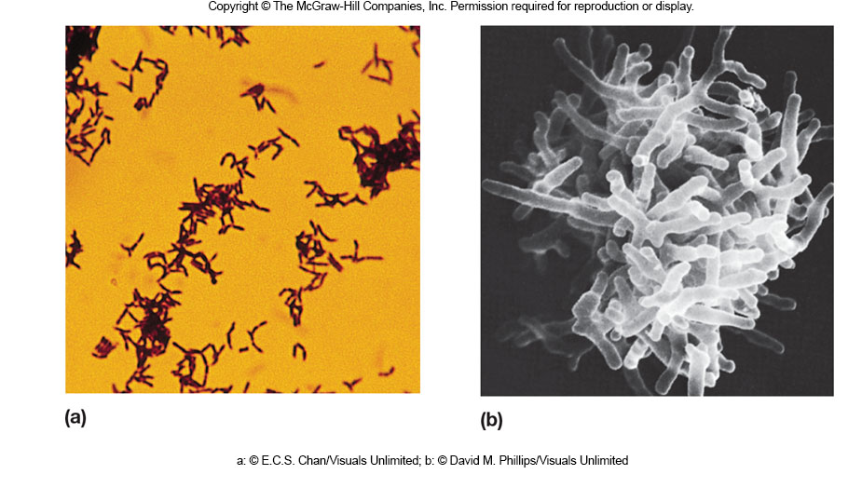
Figure.3 Actinomyces

Suborder Micrococcineae
Genus Micrococcus
Scientific classification
Domain Bacteria
Phylum Actinobacteria
Class Actinobacteria
Order Actinomycetales
Family Micrococcaceae
Genus Micrococcus
- Aerobic, catalase-positive rods that occur in pairs, tetrads, or irregular clusters (fig.4)
- Usually non motile
- Often pigmented yellow, orange, or red
- Widespread in soil, water, and on human skin
- Does not undergo morphological differentiation
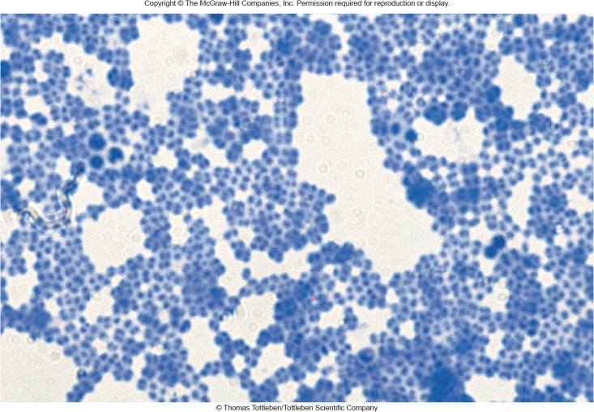
Figure .4 Micrococcus

Suborder Corynebacterineae
This suborder has seven families with many known genera such as ; Corynebacterium , Mycobacterium , Nocardia
Genus Corynebacterium
Scientific classification
Domain Bacteria
Phylum Actinobacteria
Class Actinobacteria
Order Actinomycetales
Family Corynebacteriaceae
Genus Corynebacterium
Species C. diphtheriae
- Aerobic and facultative, catalase positive . Straight to curved rods with tapered ends and club shaped (fig.5 b).
- After snapping division bacteria often remain partially attached resulting in palisade arrangements of cells(fig.5 a).
- Form metachromatic granules.
- Cell walls have meso-diaminopimelic acid.
- Some are harmless soil and water saprophytes.
- Many are animal and human pathogens.
Most common and important genus is C. diphtheriae which causes diphtheria in human.

