Biofilm bacteria
Biofilms are densely packed communities of microbial cells that grow on living or inert surfaces and surround themselves with secreted polymers. Many bacterial species form biofilms, and their study has revealed them be complex and diverse. The structural and physiological complexity of biofilms has led to the idea that they are coordinated and cooperative groups, analogous to multicellular organisms.
Biofilms are communities of microorganisms in a matrix that joins them together and to living or inert substrates. Or biofilms are collections of microorganisms (i,.e bacteria, yeasts, and protozoa) that form on a hard surface, characterized by structural heterogeneity, genetic diversity, complex community interactions, and an extracellular matrix of polymeric substances.
Surface-attached communities of bacteria, encased in an extracellular matrix of secreted proteins, carbohydrates, and/or DNA, that assume phenotypes distinct from those of planktonic cells.
Researchers have estimated that 60-80 percent of microbial infections in the body are caused by bacteria growing as a biofilm – as opposed to planktonic (free-floating) bacteria. When bacteria are under stress—which is the story of their lives—they team up and form this collective called a biofilm. If you look at naturally occurring biofilms, they have very complicated architecture. They are like cities with channels for nutrients to go in and waste to go out. Some external biofilm, namely chronic wounds and dental plaque, can be manually removed. Because of their inaccessibility and heightened resistance to certain antibiotic combinations and dosages, internal biofilm are more difficult to eradicate.
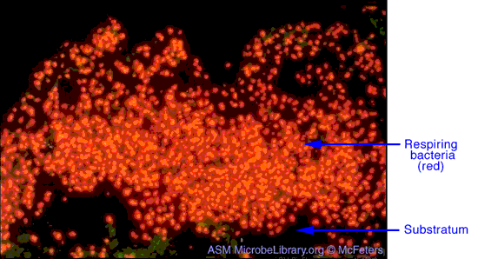
History of biofilm research
Perhaps because many biofilms are thick enough to be visible to the naked eye, the microbial communities were among the first to be studied by early microbiologists. Anton van Leeuwenhoek scraped the plaque biofilm from his teeth and observed what he described as the “animalculi” inside them under his primitive microscope.
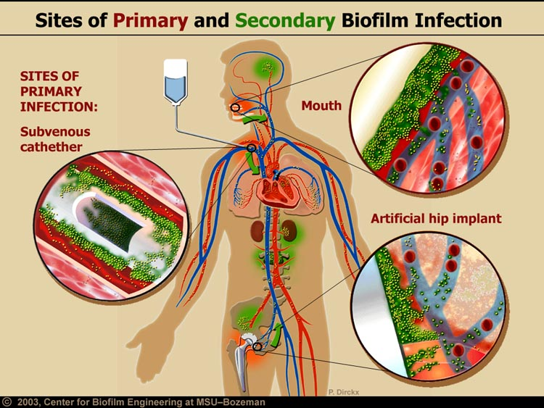
Common sites of biofilm infection once biofilm reach the bloodstream they can spread to any moist surface of the human body.
In the years which followed, researchers have concentrated primarily on planktonic (free-floating) bacteria, the kinds of microbes studied by the likes of Louis Pasteur and Robert Koch. It was not until the 1970s that scientists began to appreciate that bacteria in the biofilm mode of existence constitute such a major component of the bacterial biomass in most environments. In the 1980s and 1990s, scientists began to understand how elaborately organized a bacterial biofilm community can be.
Formation of biofilms in nature
Biofilms offer their member cells several benefits; Microbes growing in a biofilm are: more resistant to antibiotics, predation, desiccation, changes in environmental factors (pH, temperature). They also have better access to solution nutrients because the solution is constantly flowing over the biofilm.

Uses of biofilms
- Biofilms can be beneficial in (wastewater treatment, skin barrier).
- Often used to purify water in water treatment plants.
- Used to break down toxic chemicals like poly ethylene (PE) in Environment.
- Used to produce useful biological compounds, including medicines.
While Problems Caused by Biofilms:
- Tend to clog pipes (pipeline corrosion) and water filters, medical implants, tartar.
- Can cause numerous diseases, including many diseases prevalent in hospitals.
- Can form almost anywhere that water is present, including catheters, kitchen counters, etc.
Biofilm characteristics
- Submerged biofilms seems to form columns and mushroom like projections that separated by water-filled channels.
- Floating biofilms form a skin or pellicle at the air- liquid interface – shows organization of cells with the matrix at the outside.
- Films that form on the surface of solid media such as agar or other surfaces.
- The gradient originates in the surface layers of the biofilms where there is complete consumption of oxygen and glucose.
- Proximity of cells leads to horizontal transfer of genes for resistance. Biofilms increase the opportunity for gene transfer between/among bacteria. Gene transfer can convert a previous a virulent commensals organism into a highly virulent pathogen.
Biofilm constitutes
Adherent cells are frequently embedded within a self-produced matrix of extracellular polymeric substance (EPS). Biofilm EPS, which is also referred to as "slime," is a polymeric jumble of DNA, proteins, Flagella, Hydrophobic Cell Walls, Sticky Polymers and polysaccharides. Dead cells have also been identified in biofilms.
Biofilm form in places with access to water, Attach to a solid surface using several means: Flagella, Hydrophobic Cell Walls, Sticky Polymers. Adhesions are molecules that attached to bacterial fimbriae. Conjugative pili greatly accelerate initial adhesion and biofilm development by E. coli. Gram-negative bacteria have adhesions at the tip of its fimbriae. E. coli responds to levels of nutrients and osmolarity.
Life cycle of biofilm communities
The sequential stages of biofilm development are:
1- Microbial attachment to the surface.
2- Growth, and aggregation of cells in to microcolonies.
3- Maturation and dissemination of progeny cells for new colony formation (Detachment), and in each step bacteria may recruit different components and molecules including flagella, type IV pili, DNA and exo polysaccharides.

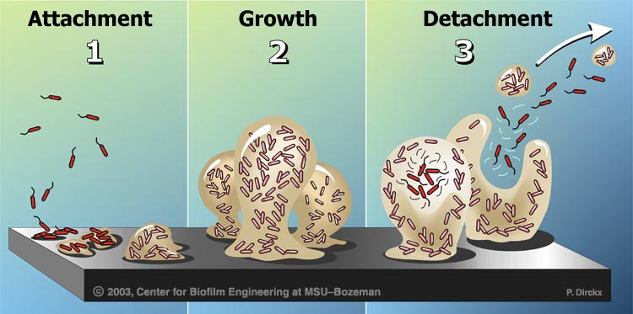
Attachment/colonization
Biofilms form when bacteria adhere to surfaces in aqueous environments and begin to excrete a slimy, glue-like substance that can anchor them to a variety of materials including metals, plastics, soil particles, medical implant materials, and human or animal tissue. The first bacterial colonists to adhere to a surface initially do so by inducing weak, reversible bonds called van der Waals forces, If the colonists are not immediately separated from the surface, they can anchor themselves more permanently using cell adhesion molecules, proteins on their surfaces that bind other cells in a process called cell adhesion.
These bacterial pioneers facilitate the arrival of other pathogens by providing more diverse adhesion sites. They also begin to build the matrix that holds the biofilm together. If there are species that are unable to attach to a surface on their own, they are often able to anchor themselves to the matrix or directly to earlier colonists. The expression of 800 genes have been shown to be altered when a single bacterial species joins a biofilm, and the genes that allow a biofilm to develop are activated after enough cells attach to a solid surface.
The ability of a cell to perform this "initial attachment event" controlled by both environmental factors, including nutrient levels, temperature, pH, and genetic factors, including the presence of genes encoding motility functions, environmental sensors, adhesions, etc.
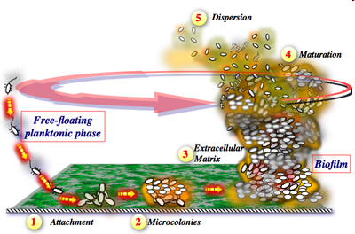
Growth and development
After the initial colonization, the biofilm grows through a combination of cell division and recruitment. The next stage of biofilm formation is known as development and it is the stage in which the biofilm is established and may only change in shape and size.
Once a biofilm has more fully formed, it often contains channels in which nutrients can circulate. Cells in different regions of a biofilm also exhibit different patterns of gene expression. Because biofilms often develop their own metabolism, they are sometimes compared to the tissues of higher organisms, in which closely packed cells work together and create a network in which minerals can flow.
After the initiation of biofilm formation along the system and within a few seconds, the progression of phenotypic changes in the bacteria remarkably alters protein expression to further produce species-specific adhesions that irreversibly anchor the cell to the surface Within a few (12) minutes. The adherent cells up regulate genes that direct production of accumulation proteins and polysaccharides, which firmly attach the cells to the substratum and to each other as they undergo exponential binary division.
Then the cells begin to grow and spread as a monolayer on the surface. As the cells continue to divide, the daughter cells spread outward and upward from the attachment point to form cell clusters. The production of exo-polysaccharides (EPS) or slime embeds the aggregating cells to form micro-colonies. Typically, the micro-colonies are composed of 10% to 25% cells and 75% to 90% EPS matrix, with a consistency similar to a viscous polymer hydrogel.
Cellular density typically increases to a steady state within 1-2 weeks, depending on the species and local environmental conditions. Expanded growth evolves in to complex 3-D structures of tower- and mushroom-shaped cell clusters. Adjoining micro colonies are connected by water channels that serve as a primitive circulatory system for delivery of nutrients and removal of wastes.
The thickness of the biofilm is variable and uneven, as determined by the balance between growth of the biofilm and detachment of cells. Depending on the initial number of attached organisms, the multilayered cell clusters develop as patchy networks or form a contiguous layer over the surface.
Detachment and external colonization
The formation of biofilm is a universal strategy for microbial survival. In order to colonize new surfaces and to prevent density-mediated starvation within the mature biofilm, the cells must detach and disseminate. Dispersal is accomplished by shedding, detachment, or shearing.
Shedding occurs when daughter cells from actively growing bacteria in the upper regions of the microcolonies released from the cell clusters. Increased cell density induced cell-cell signaling to direct chemical degradation of the EPS, sending clumps of biofilm into the circulation.
Movement
Biofilm bacteria can move in numerous ways that allow them to easily infect new tissues. Biofilms may move collectively, by rippling or rolling across the surface, or by detaching in clumps. Sometimes, in a dispersal strategy referred to as “swarming/seeding”, a biofilm colony differentiates to form an outer “wall” of stationary bacteria, while the inner region of the biofilm “liquefies”, allowing planktonic cells to “swim” out of the biofilm and leave behind a hollow mound.
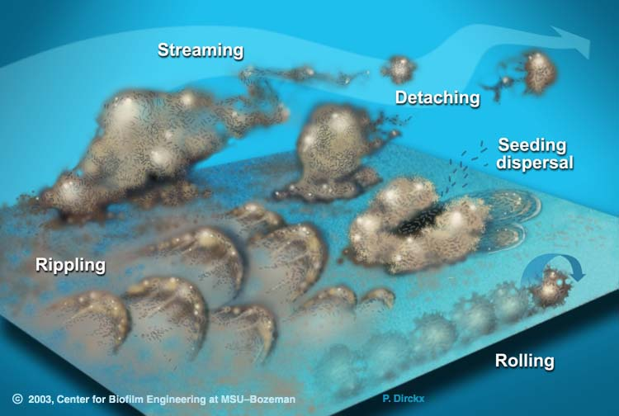
Biofilm migration, Biofilm bacteria can move in numerous ways: collectively, by rippling or rolling across the surface, or by detaching in clumps. Individually, through “swarming and seeding” dispersal.
Advantages of biofilm
Biofilm communities provide several advantages to their members including easy access to food and nutrients and resistance to antibiotics.
Antibiotic resistance
This development of a biofilm allows for the cells inside becoming more resistant to the body's natural antimicrobials as well as the antibiotics administered in a standard fashion. In fact, depending on the organism and type of antimicrobial and experimental system, biofilm bacteria can be up to a thousand times more resistant to antimicrobial stress than free-swimming bacteria of the same species.
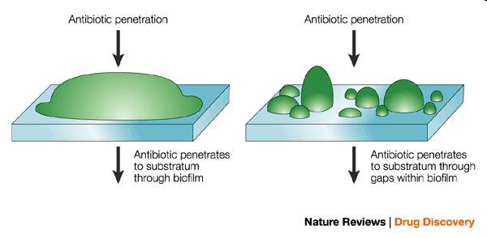
The nature of resistance of biofilms remains an enigma, whilst it recognized that reaction-diffusion limitation properties of the biofilm matrix towards the majority of treatment agents will impede access, this cannot be the sole explanation of the observed resistance. Rather, it will delay the death of cells within the community to various extents. Similarly, it is recognized that biofilm communities are phenotypically heterogeneous and that their eradication will reflect the susceptibility of the most resistant phenotype. The nutrient and gaseous gradients that generate this heterogeneity will, however, be destroyed as a result of antimicrobial treatments and cause the phenotype of the survivors to alter from slow growing resist cells to fast- growing susceptible one.
Amongst the hypotheses, explain these resistances are that multidrug efflux pumps could up regulated on expression of a biofilm phenotype, whilst this is an appealing and simple explanation, because of its ability to explain the breadth of agents to which biofilm are resistant. Alternative hypotheses attempt to explain the diversity of agents by invoking a common cause of death for which singular resistance mechanisms could be applied. It is therefore suggested that an altruistic majority of sub-lethally damaged cells in a population commit suicide (apoptosis), thereby providing some protection to the survivors.
A proportion of cells (persisters) suggested to be defective, or repressed, in their suicide response, and survives. The persisters thereby benefit from the self-sacrifice of their compatriots and maintain the gene pool.
A more recent hypothesis suggests that extracellular signals, "alarmones", released from killed cells might prime recipients into a state of resistance. Thus, in biofilm communities deep lying cells might be alerted into a resistant state by the premature death of peripheral cells.

Biofilm &Quorum sensing
The bacteria that become part of a biofilm engage in quorum sensing, a type of decision-making process in which behavior is coordinated through a “chemical vocabulary.” If a bacterium can sense that it is surrounded by a dense population of other pathogens, it is more inclined to join them and contribute to the formation of a biofilm.
Quorum sensing can occur within a single bacterial species as well as between diverse species, and can regulate a host of different processes, essentially serving as a simple communication network. A variety of different molecules can be used as signals.
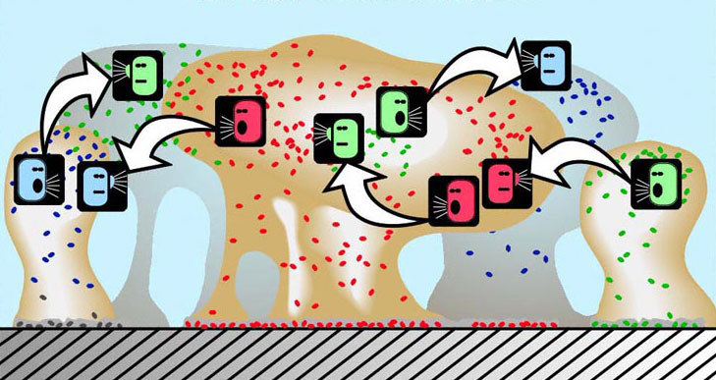
Quorum sensing Sessile cells in a biofilm “talk” to each other via quorum sensing to build micro-colonies and to keep water channels open.
Prevalence of biofilm
According to a recent public statement from the National Institutes of Health, more than 65% of all microbial infections are caused by biofilms…. If one recalls that such common infections as urinary tract infections (caused by E. coli and other pathogens), catheter infections (caused by Staphylococcus aureus and other gram-positive pathogens), child middle-ear infections (caused by Haemophilus influenzae, for example), common dental plaque formation, eye and material contact with it, and gingivitis, all of which are caused by biofilms, are hard to treat or frequently relapsing.
In just a short period of time, researchers studying internal biofilms have already determined they cause a number of chronic infections and diseases. Notable diseases include:
Chronic sinusitis – A study found that biofilms are present on the removed tissue of two-thirds of patients undergoing surgery for chronic inflammation of the sinuses.
Chronic wounds – Biofilm implicated in chronic wounds. There is a work offering strategies for managing wounds.
cystic fibrosis – The lungs of individuals with cystic fibrosis are colonized and infected by bacteria from an early age. These bacteria, which often spread amongst individuals with CF, thrive in the altered mucus, which collects in the small airways of the lungs. Over time, both types of bacteria and their individual characteristics change in individuals with CF. In the initial stage, common bacteria such as Staphylococcus aureus and Hemophilus influenza colonize and infect the lungs.
Endocarditis – Inflammation of the smooth membranes, which line the inside of the heart, caused by a complex biofilm composed of both bacterial and host components.
Inner ear infections – The majority of ear infections are caused by biofilm bacteria. These infections, which can be either acute or chronic, are referred to collectively as otitis media (OM).
kidney stones – Biofilms also cause the formation of kidney stones. The stones cause symptoms of disease by obstructing urine flow and by producing inflammation and recurrent infection that can lead to kidney failure. These stones are produced by the interplay between infecting bacteria and mineral substrates derived from the urine.
- Bacterium --> biofilm --> mineralization
- Causative organisms have urease / urea --> NH4 + H2CO3
- Biofilm concentrates urease --> crystal formation
Osteomyelitis – biofilms may also cause osteomyelitis, a disease in which the bones and bone marrow become infected. This is supported by the fact that microscopy studies have shown biofilm formation on infected bone surfaces from humans and experimental animal models.
Periodontal disease – Perhaps the most well-known and studied biofilm bacteria. Hundreds of microbial biofilm colonize the human mouth, causing tooth decay and gum disease. Plaque is a biofilm on the surfaces of the teeth. This accumulation of microorganisms subjects the teeth and gingival tissues to high concentrations of bacterial metabolites, which results in dental disease. Dental plaque is composed of more than 500 species.
Prosthetic joints and heart valves – Pathogenic biofims commonly found on medical devices such as joint prostheses and heart valves.
Urinary tract infections – Intracellular Escherichia coli can mature into biofilms, creating pod-like bulges on the bladder surface. Explains how bladder infections can persist in the face of robust host defenses.
Veterinary diseases – Biofilms also implicated in a wide array of veterinary diseases.

Microarrays
- Technological progress in microscopy, molecular genetics and genome analysis has significantly advanced our understanding of the structural and molecular aspects of biofilms, especially of extensively studied model organisms such as Pseudomonas aeruginosa.
- Used to assess the genes present in different stages of biofilm formation

Agents for the destruction of biofilms
Industrial biocides: (alexidine, chlorhexidine, polyhexamethylene biguanides), monophenylethers (phenoxyethanol) and quaternary amonium compounds (cetrimide, benzalkoniums) and have demonstrated biochemical bases for the activities and associated mammalian cell toxicities of thiol interactive agents (bronopol, isothiazolones).
Searching for alternatives
Several researchers are finding solutions for the cure of Biofilms , yet it is experimental, concerning biomedical biofilms, nanotechnology is emerging as one of the most auspicious methodologies for its prevention and control.
The main nano approaches that have demonstrated the most promising results include: silver nanoparticles, drug delivery nanocarriers or phage therapy.

