Cloud Physics Lab
LAB 5: Formation of Cloud Droplets
Kohler Theory

Introduction:
Kohler theory or equation combines the curvature effect and solute effect discussed in the previous lab. Kohler equation gives equilibrium vapor pressure that a drop will have for a given drop radius. The two competing effects: the curvature or Kelvin effect that depends on the inverse of the drop radius, and the solute or Raoult’s effect that depends on the inverse of the drop radius cubed. Kohler equation applies to individual drops. Each drop has its own Kohler curve because each drop has its own amount of solute of a given chemical composition. No two Kohler curves are alike, just as no two snowflakes are alike. In this Lab students investigate the process of cloud droplet nucleation by analyzing the importance of supersaturation, radius of curvature, CCN solute mass and temperature.

Objective:
- Plot and study Kohler curve for different solutes and mass at a given temperature.
- Plot and study Kohler curve of NaCl for different temperatures.

Theory:
Kohler Equation
From the previous lab it has been shown that:
the a/r term is a curvature term representing the increase in the saturation vapor pressure due to the curvature of the surface and the b/r³ term is the solution term. a ~ 3.3x10⁻⁷/T (in m) and b ~ 4.3x10⁻⁶ im_{s}/M_{s} (in m³).
The critical supersaturation S* and the corresponding radius, r*, are given by:
Figure 1 gives an example of typical Kohler curve. The curve is the supersaturation of a particle as a function of the particle radius. The radius increases as the particle takes on water.
Interpretation of figure:
- S* is the supersaturation of the particle, not the atmosphere.
- At smallest r_{d} (~10’s nm), the Raoult’s solute effect is stronger than the Kelvin effect.
- As r_{d} gets bigger as water is added to the particle, the Kelvin effect (+1/ r_{d} ) starts to win out over the solute term . As a result, S_{k} becomes positive.
- As r_{d} gets very large, then the surface begins to look “flat” and the solution becomes so dilute that the liquid water approaches “pure” and S_{k} approaches 0, which means that e_{eq} approaches e_{s} .
- S* is called the critical supersaturation. The particle cannot activate and grow into a cloud drop until the atmospheric supersaturation, S, exceeds S*.
- S* occurs at the critical radius r*, for activation. Drops that reach this radius can activate and grow into a cloud drop. Those that don’t won’t.
- The greater solute mass (m_{s}), the lower S* and the greater r* (see figure 2).
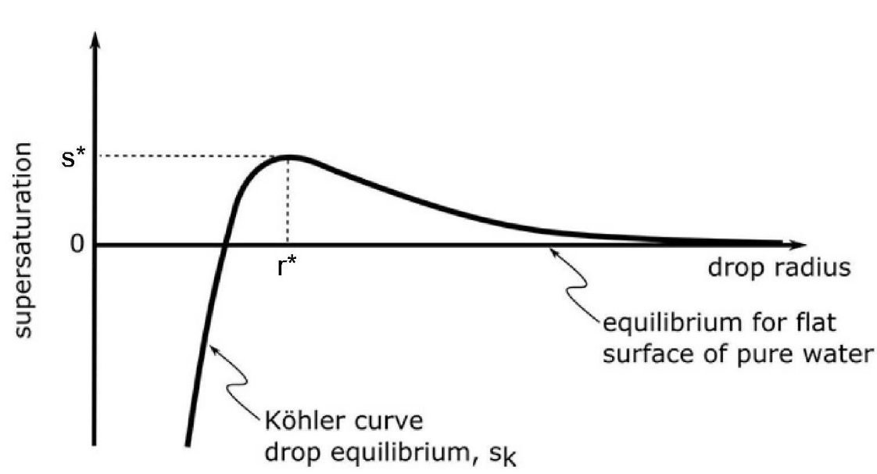
Figure 1: Typical Kohler curve.

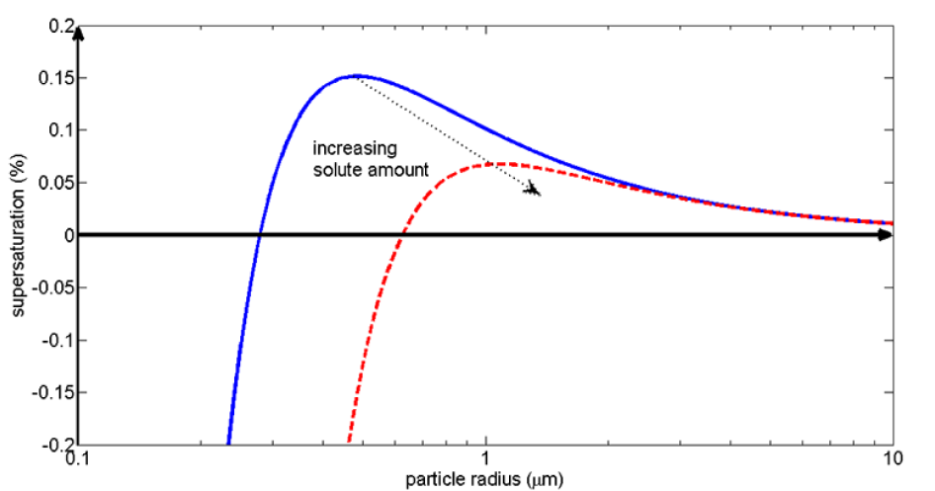
Figure 2: Koehler curve for two drops: m_{s} =1×10⁻¹⁷g (blue solid line), m_{s} =5×10⁻¹⁷g (red dashed line).
To see what happens to the drop in the atmosphere, we need to compare the Koehler curve for each drop to the ambient supersaturation of the environment.
- The Koehler curve is the equilibrium supersaturation, S_{k}, for each drop and it varies as a function of the drop size.
- The ambient supersaturation, S, is the amount of water vapor available in the environment.
- When S_{k} =S, the drop is in equilibrium with the environment. The drop will always try to achieve this equilibrium condition by growing (condensing ambient water vapor) or shrinking (evaporating water) until it reaches the size at which S_{k} =S, if it can!
- Another way to think about S_{k} is that it is telling us something about the evaporation rate for each drop size and temperature. For the drop to be in equilibrium with the environment, the condensation rate of atmospheric water vapor must equal the evaporation rate of the drop. If S_{k} < S, then net condensation will occur and the drop will grow. If S_{k} > S, then net evaporation will occur and the drop will shrink.

Materials and Procedures:
- Run the Matlab script Lab5a.m to plot Kohler curve for sodium chloride (NaCl) and ammonium sulfate [(NH₄)₂(SO₄)] for different solute masses.
- Run the Matlab script Lab5b.m to plot Kohler curve for sodium chloride (NaCl) at different temperature.

Analysis and Conclusions:
- Discuss how does supersaturation ratio behave for each plot of NaCl and (NH₄)₂(SO₄).
- How different masses can affect Kohler curve.
- Discuss the behavior of the saturation ratio when temperature is changed.
- Use file results1.txt to find how S* and r* are affected by the change of solute type and mass. Why?
- Use file results2.txt to find how S* and r* are affected by the change of temperature. Why?

Questions:
- What did you learn about Kohler theory by completing the activity?
- Does the ambient supersaturation depend on the radius of the cloud droplet?
- What does happen to the cloud droplet if the ambient supersaturation is always greater than the entire Koehler curve for a drop?
- What does happen to the cloud droplet if the ambient supersaturation intersect the Koehler curve for a drop?
- What if a droplet was at the critical radius and saturation ratio and the humidity were to slightly increase?
- What would happen to a droplet if it had a radius and saturation ratio that put it to the left of the Kohler curve? What if the droplet had a radius and saturation ratio that was to the right of the Kohler curve?

