Chapter 3
Absorption Spectra
1- Emission spectrum of hydrogen:
In the latter half of the 19th century something remarkable was being noticed by a few scientists. Energized elements (active elements) would emit specific visible colors of light, and the colors were specific to the element, but no one identified, why this was happening? For example, if we energize hydrogen gas with an electric current, the $H_{2}$ molecule is split in to hydrogen atoms.
$$\left(molecules\right)H_{2}→2H (atoms)$$
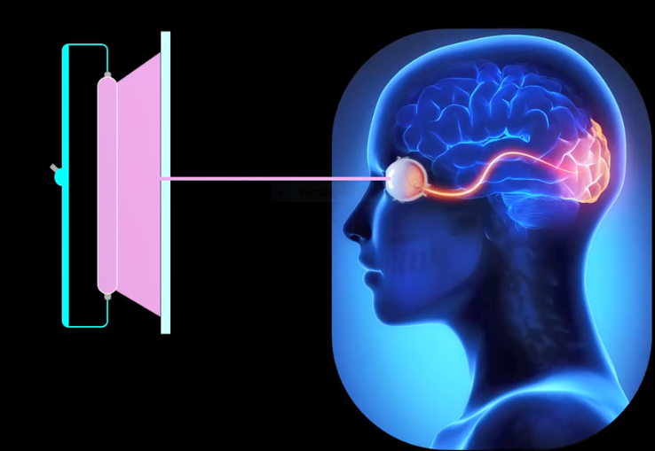
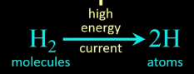

Those energized hydrogen atom emit a specific color spectrum of four colors. Our nervous system however is not able to see the four individual colors, our brain integrates those four colors in to one specific color so that’s the color we use. But when we diffract or split hydrogen’s pale pinkish color, we can then see the colors that are actually being emitted by hydrogen atoms: violet, blue, a sort of turquoise and red all at specific wavelengths.

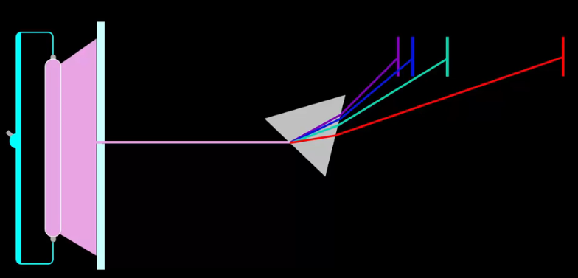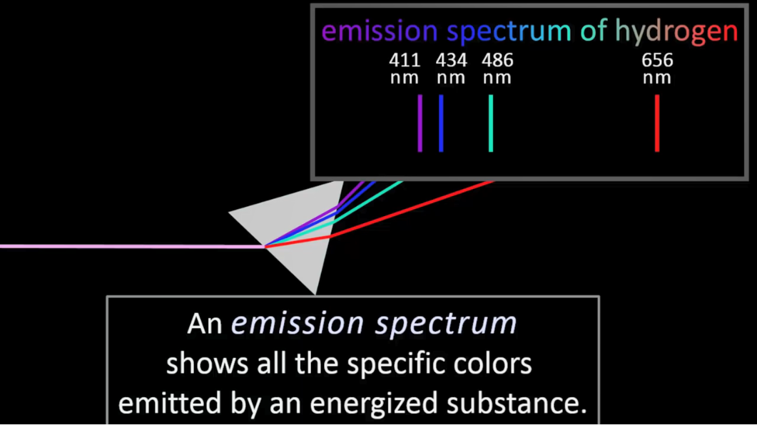
2. Bohr model:
In 1913 using the atom’s vast empty space provided by Ruther ford’s nuclear model of the atom. Niels Bohr used these spectral colors to create a model of the atom that explained the existence of the emitted colors and explained the behavior of the electrons in the atom.
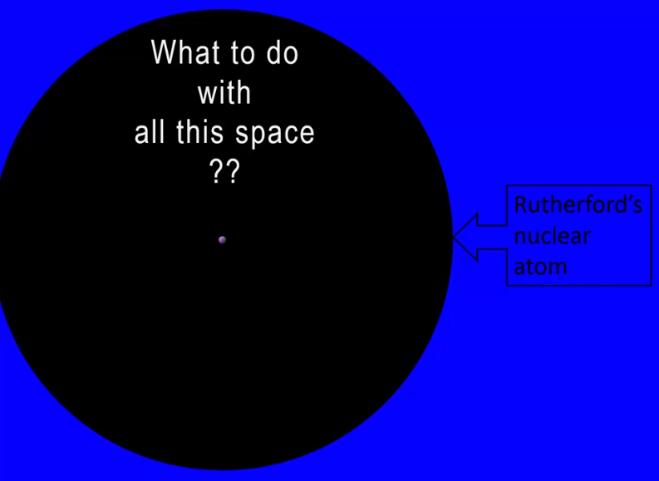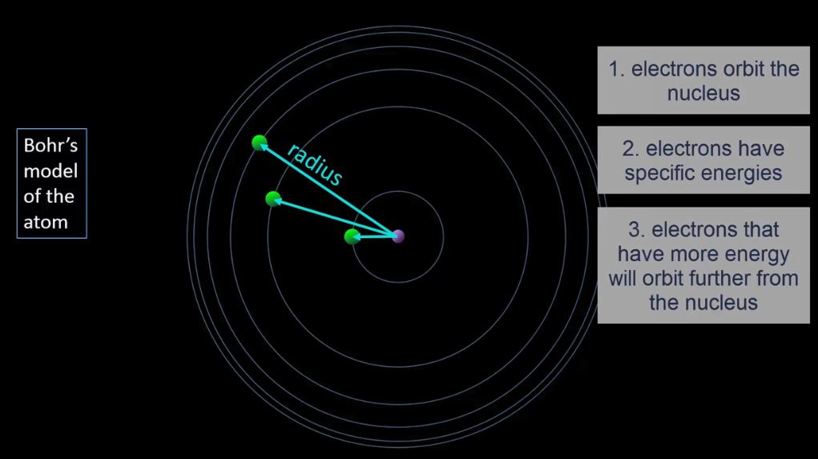
In Boh’s atomic model:
- Electrons orbit the nuleus.
- The electron have different energized
- Electrons that have more energy will orbit further from the nucleus.
This model however presented a very large obstacle for early 20th century physics. It was known that an accelerating charge, which is what these orbiting electrons are will emit energy in the form of light. Constant loss of energy would mean the electron would not be able to maintain an orbit, it would spiral down in to the nucleus due to the strong attractive force of the nucleus. But Bohr said no that would not happen.
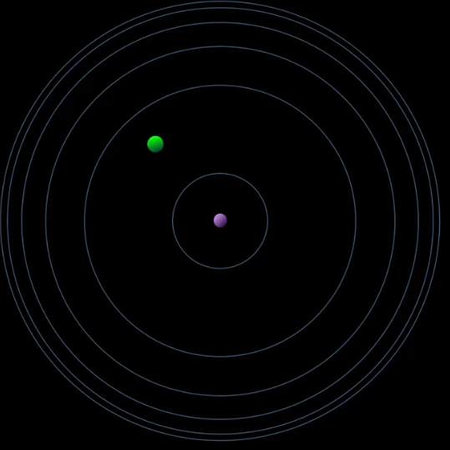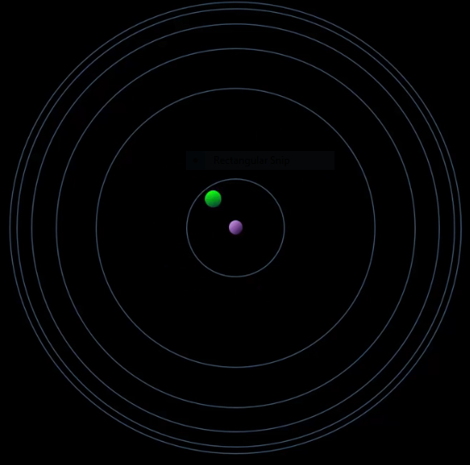
In his model, energy could be absorbed by an electron, putting it in a higher energy orbit, and the electron would only then emit light energy. When the energized electron transitioned from a higher to lower energy change of electron.
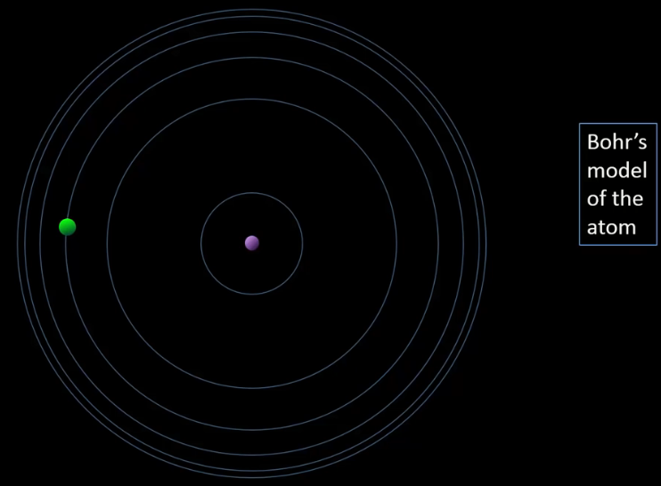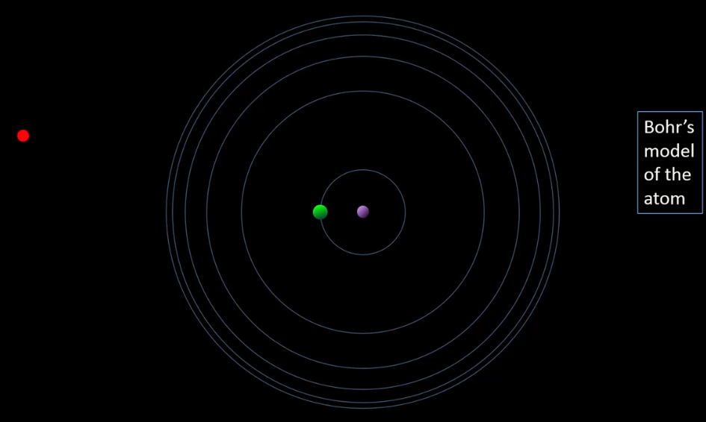
The emission spectrum of any one electron is constant and so Bohr concluded the electrons can only exist at specific discrete energies in order to produce such specific discrete emission spectra. The electron could not exist at energies in between those discrete energies and this is meant by term quantized electron. Let’s take a closer look at this last idea, which was a contribution to atomic structure that still holds true in our current quantum mechanical model of the atom.
Bohr numbered his orbits with integers, symbolizing each orbit with the letter n, representing the electrons energy. The letter n and the numbering came out of earlier mathematical analyses of alkali metals emission spectra by Johannes Rydberg in 1888 and so using integers is not arbitrary.
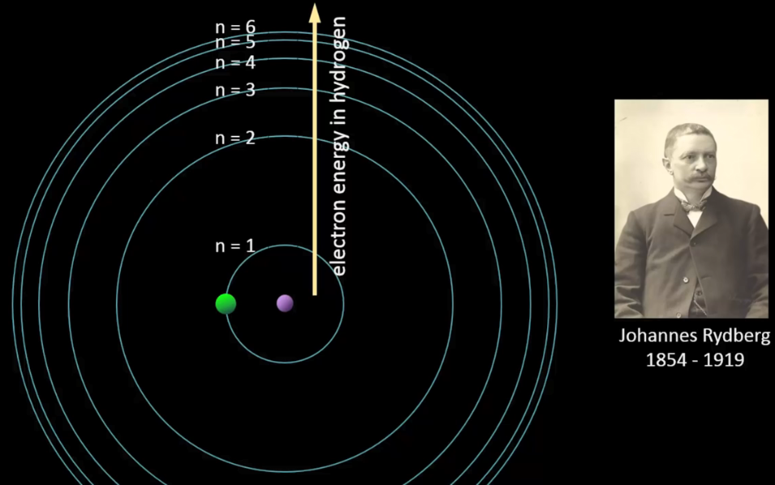
They have mathematical significance, which we will see a bit later on. If we focus on a section of the orbits, we get a diagram of the allowed electron energies in hydrogen. Boher found that these energies gives us hydrogens emission spectrum. An electron transitioning from n=3 to n=2 emits a red photon, from 4 to 2 gives a bluish-green color, 5 to 2 gives blue and 6 to 2 gives violet.
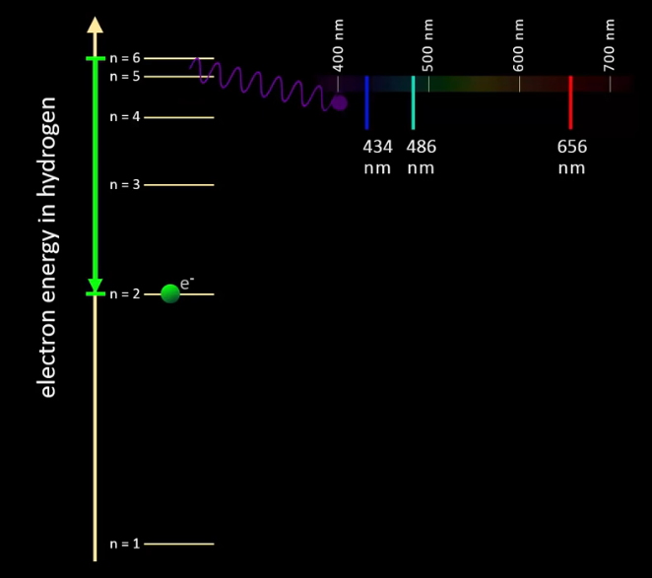
Notice that in the transition the electron does not exist in between those two allowed energies. If electron could exist at any energy, then the changes in electron energy, here represented by delta E, would result in emitting a large spectrum of colors, a continuous rainbow. But only discrete colors are seen, and so the electron must remain at discrete energies.
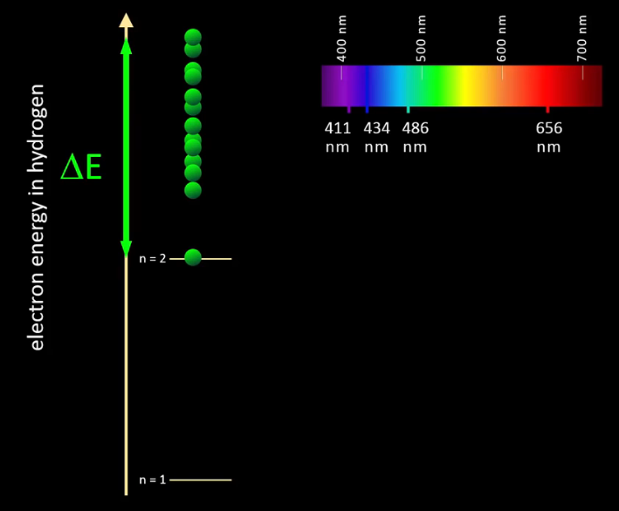
Again, this is called a quantized electron, an electron that can only exist at discrete energies. Bohr was very bold to tell the world that the electron was quantized but there was the work of two other bold scientist’s to support him.
In 1900 in order to solve a problem in the analysis of ultraviolet light Max Planck came up with the idea of quantized light energy. Being that light, in other words electromagnetic waves, cannot have just any energy, they can only exist at discrete energies, which incidentally got him a Nobel Prize. Five years later in 1905, Einstein took that a giant step further with his photoelectric effect. Experimentally showing that light has momentum and momentum is a property derived from mass, but light has no mass, so the quantized light wave was behaving as if it was a particle, which we call a photon. So, with the existence of quantized light behaving like a particle with mass. In 1913 Bohr looked at the other side of that coin, and found that a particle with mass, such as the electron, could behave as if was quantized. Yes you guessed it, this got him a Nobel Prize.
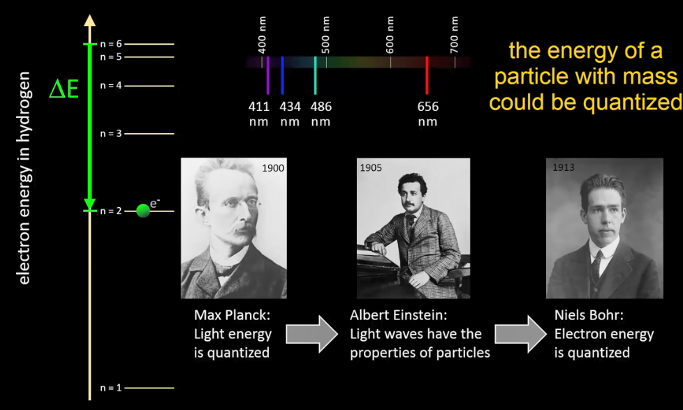

Let’s take a more mathematical look at the emission of red light from hydrogen. Let’s mark the energy transition of an electron with an arrow and $∆$E. The energy of any electromagnetic wave can be calculated with $hc$ divided by$λ$, which is a combination of these two equations, by substituting cover lambda for nu.
$$E=hv , E=h\frac{c}{λ} , because υ= \frac{c}{λ}$$
$$E=photo energy , h=planck^{'}s constant , c=speed of light , υ=nu=frequency of the light wave , λ=lambda=wavelength of the light wave$$

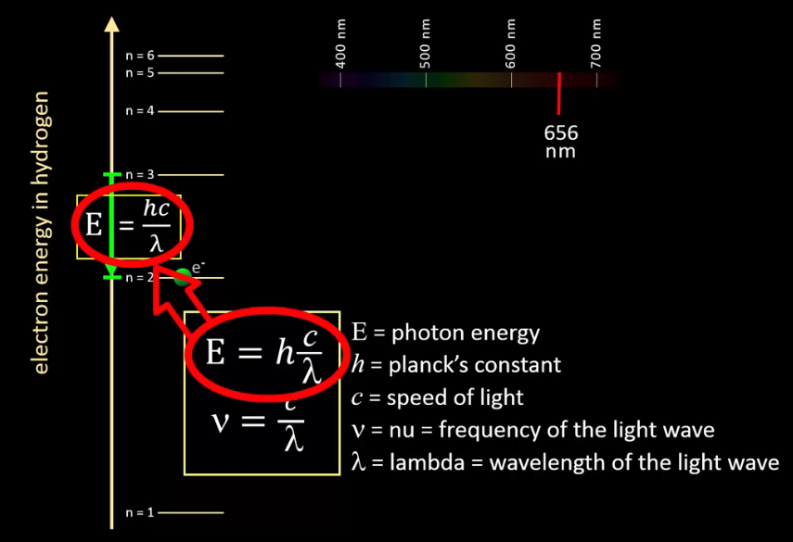
Given that we have the wavelength of the emitted red light, and h and c are constants, we can determine the energy of that red photon. Planck’s constant, h , times the speed of light, c , divided by the wavelength expressed in meters to keep units constant, gives a photon energy of 3.03*10⁻¹⁹ joules.

$$E= \frac{hc}{λ} = \frac{(6.626*{10}^{-34}js)(3*\frac{{10}^{8}m}{s})}{656*{10}^{-9}m} = 3.03*{10}^{-19 }j$$

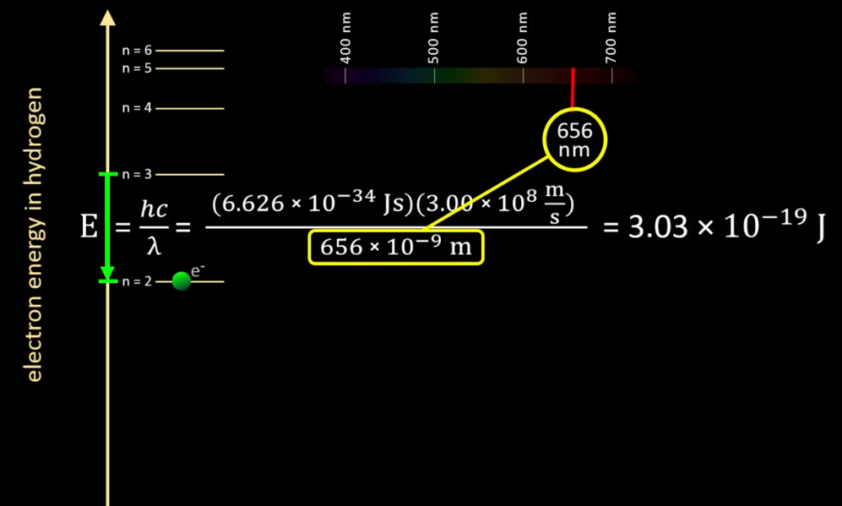

In Bohr’s model, that would also be the energy difference of the electron transitioning from n=3 energy to n=2 energy. The energy of an electron in hydrogen at any given n can be calculated using this equation derived from Rydberg’s analysis of atomic emission spectra.
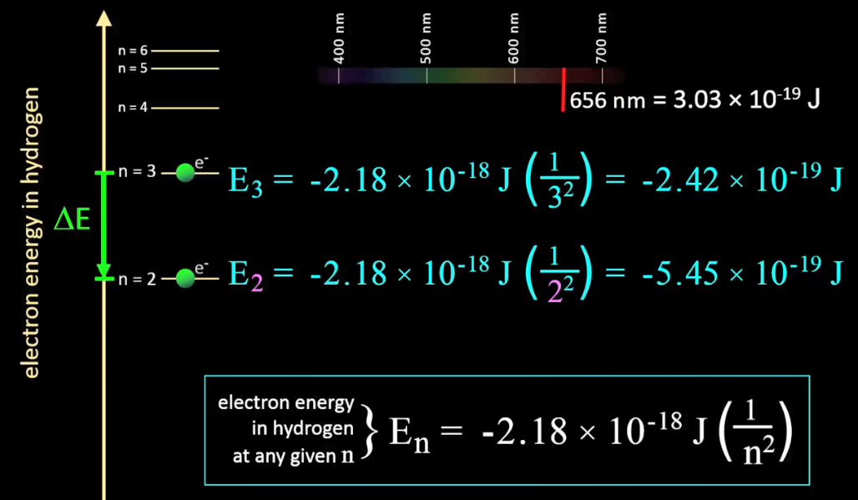
{Electron energy in hydrogen at any given n} E_{n}= -2.18*10⁻¹⁸ j (1/n²)
E₃= -2.18*10⁻¹⁸ j (1/3²) = -2.42*10⁻¹⁹j
Let’s plug in the two integers from n to find the electron’s energy at n=2 and n=3. We may see something interesting. For an electron at n=3, its energy is -2.42*10⁻¹⁹ joules. For an electron at n=2, its energy is -5.45*10⁻¹⁹ joules.
The Difference between these two energies is the energy lost by the electron as it transitions from n=3 to n=2, which would be the energy of the emitted light.
$$∆E=[ -2.42*{10}^{-19} J-\left(-5.45*{10}^{-19}J\right)]=3.03*{10}^{-19}J$$

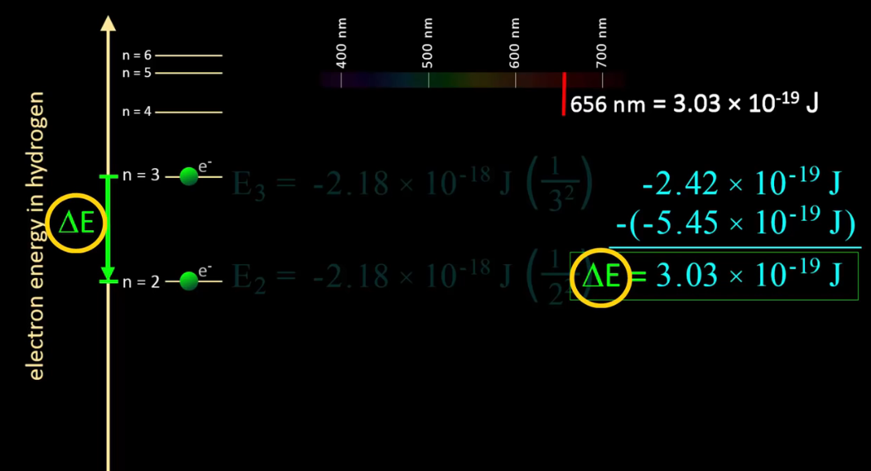
We can see mathematically that the energy lost by an energized electron when transitioning to an allowed energy level is emitted as light. So by determining the energies of emitted light, Bohr was able to work backwards and arrange the allowed energies of electrons by the magnitude of the transitions occurring to produce the observed emission spectrum. Note that the intervals between each succeeding n decreases as electron energy gets higher.
However an electron’s most probable distance from the nucleus does increase as the energy of the electron increases and perhaps Bohr’s most important contribution to the eventual quantum mechanical model of 13 years later, is that the electron is quantized it can only exist at specific energies so there are a couple of items that you may have been wondering about:
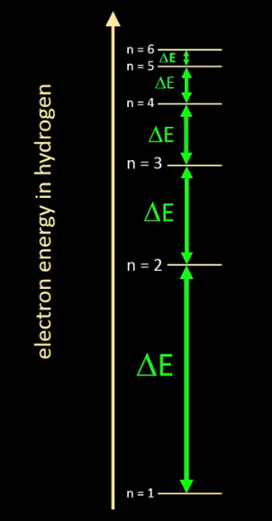
Why are the electron energies negative? Well, mathematically an electron’s energy is defined as zero where it is an infinite distance from the nucleus. So an energy sufficiently less than zero is low energy to be held by the attractive force of the nucleus. You may notice that these energies are very tiny which is reasonable since it is only the energy of a single electron. You may have also noticed that the energy of light is likewise very tiny, but that is also reasonable given that it is the energy of a single photon.
, and wavelengths increase.

