**Experiment No. (7)**

**(( Study the relationship between solar radiation and hours of brightness ))**

**The theoretical part:**

Knowing the amounts of solar radiation reaching the surface of the earth is considered the backbone for testing the sites of solar energy projects and for designing and evaluating the performance of systems that use solar energy in their applications.

The importance of measuring both solar radiation and the period of sunshine from a practical point of view is in the uses of solar cells and in heating greenhouses. The importance of radiation measurements on inclined surfaces in the designs of buildings (the estimation of the heat load in them) and in the designs of different solar energy systems. Solar radiation on agricultural products.

There are several attempts made by a number of researchers to find the relationship between the period of sunshine and the amount of total solar radiation falling on a unit of horizontal area, the most important of which are Angstrom equation represented in the following form:



Whereas:

(R): The total solar radiation falling on the unit horizontal areas of the earth's surface.

( $R_{°}$) : Solar radiation falling on a unit horizontal area of the outer surface of the atmosphere.

(n) : Actual sunshine period.

(N) : Theoretical (astronomical) period of sunshine.

(a,b) : Constants vary from place to place.

Using this equation, it is possible to extract the amount of total solar radiation falling on the unit horizontal areas for any region of the earth and for any required time period, given the period of sunshine in that region and for the required period of time.

And to find the value of the constants (a,b), can draw the relationship between  graphically where represent values of 

on the y-axis and On the x-axis and from the relationship Graphs we can find the constants(a,b) where is the cut-off part of the y-axis constant value(a) The slope of the curve represents the value of the constant(b).

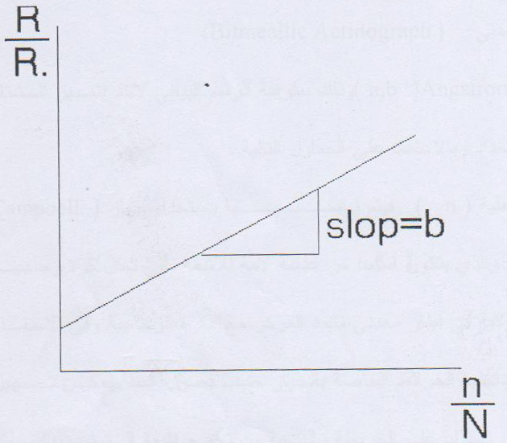

To find the value of the incident solar radiation per unit horizontal area of the outer surface of the Earth's atmosphere( $R_{°}$) Special tables are used where extracted in( $R_{°}$) Depending on the latitude 

of the station or the area under study.

As for the number of hours of Qatari sunshine(N) It is extracted from a special table(WMO) ( Paper,24) It shows the relationship between the number of hours on the surface of the sun, latitude, months of the year, and the location of the Earth.

**practical part:**

1- Get to know my device

A - Measuring the number of hours on the surface of the sun



B - bimetallic device 

2- Find the values of an equation constant

This is done by graphing one of the winter months and one of the summer months for the Mosul and Baghdad stations, and based on the following tables The number of actual sun surface hours is measured(n) It is measured using a device



Which mainly consists of a lens The ray is shaped like a glass ball with a radius of approx.(10 cm) It is located in a concentric metal frame with a glass ball, and in the inner curvature of the frame there are three grooves inside which the maps of the device are fixed according to the seasons. The hours of the sun’s surfaces can be recorded from knowing the burning generated on the map and resulting from the collection of sunlight by the light lens.

As for the values(R) It is measured by a bimetallic device



Which consists of two thin strips of metal, one painted in black and the other in white, mounted next to each other and connected to a mechanical system of levers that transfers the discrepancy between the expansion of the two strips when exposed to solar radiation to a sun arm by drawing a graphic line on a special model inserted around a rotating cylinder.

